

CAPSTONE PROJECT REPORT
Report 3 – Software Requirement Specification

Ho Chi Minh City, October 2026
Table of Contents
I. Record of Changes 3
II. Software Requirement Specification 5
1. Product Overview 5
2. User Requirements 5
2.1 Actors 5
2.2 Use Cases 7
3. Functional Requirements 13
3.1 System Functional Overview 13
3.2 Authentication & User Account 43
3.3 Retailer Registration & Assessment 50
3.4 Product & Category Management 56
3.5 Promotion & Batch Discount Management 61
3.6 Purchase Order & Offline Synchronization 67
3.7 FEFO–MLOR Allocation & Availability 80
3.8 Warehouse Receiving & Batch Inventory 86
3.9 Picking & Retailer Receipt Confirmation 92
3.10 Payment & Loyalty Management 98
3.11 Sales Groups & Operational Reporting 109
3.12 System Configuration & Notifications 113
3.13 Delivery Operations 116
4. Non-Functional Requirements 119
4.1 External Interfaces 119
4.2 Quality Attributes 120
5. Requirement Appendix 127
5.1 Business Rules 127
5.2 Common Requirements 135
5.3 Application Messages List 137

I. Record of Changes
Date | A, M, D * | In charge | Change Description
29/09/2026 | A | Tran Ngoc Khiet | Version 1.0  Add:  - 1. Product Overview  - 2.1 Actors
12/10/2026 | A | Tran Ngoc Khiet | Version 1.1  Add:  - 2.2 Use Cases  - 3.2 -> 3.12 Features  - 4. Non-Functional Requirements  Modify:  - New system context diagram  - 2.1 Actors: Update actors
17/10/2026 | M | Tran Ngoc Khiet | Version 1.2:  Add:  - 5.2 Common Requirements  - 5.3 Application Messages List
18/10/2026 | A | Nguyen Thien Nhan | Version 1.3:  Add:  - 5.1 Business Rules BR-01–BR-58: daily allocation at 00:00 with Administrator run approval. Version 1.4 adds BR-59–BR-65 for near-expiry offers, effective line MLOR and customer acceptance; aligns functions, data and diagrams.
18/10/2026 | M | Nguyen Thien Nhan | Version 1.4: Add offer-specific accepted MLOR, line types and validation. Align daily run, approval/reservation, data model, diagrams and scope; remove internal transfers and stock holds.
19/10/2026 | M | Nguyen Thien Nhan | Version 1.5: Mentor review — final-price payment timing, manual refunds, complaint receivable adjustments, bounded replacement attempts, MLOR definition and unchanged one-time resubmission priority.
25/10/2026 | A | Vo Minh Son | Version 1.6:  Add:  - Add UC-87 🡪 UC-91  Modify:  - 2.2: Update UC-77
27/10/2026 | M | Vo Minh Sơn | Version 1.7:  Add:  - 3.6.6 Respond to Quotation and Choose Payment Method  - Function type of each function in 3.2 -> 3.13  Modify:  - 3.1.1 Screen flows  - 3.1.2 Screen Descriptions: quotation, payment and delivery failure screen  - 3.1.3 Screen Authorization  - 3.2.1, 3.2.2 Login: one Mobile App, Microsoft pop-up, Retailer OTP  - 3.6, 3.7.2, 3.10.1: quotation, prepaid bank transfer or credit, PO before picking  - 5.1 Business Rules: BR-13, BR-21, BR-37, BR-45, BR-49, BR-51, BR-66  - 5.2 Common Requirements: CR-13
27/10/2026 | M | Vo Minh Son | Version 1.8:  Add:  - Acceptance criteria (AC tables) and traceability for every function in 3.2 – 3.13  - Prototype screen layouts for all screen functions  - 3.5.4 Manage Shelf-Life Discount Rules and Batch Pricing  - UC-92 – UC-98; BR-71 – BR-80; entities 58 – 61  - 5.4 Traceability Matrix  - 5.5 Scope Reconciliation with Registration  Modify:  - 3.2 – 3.13: explicit primary/secondary/system actors; all PENDING business rules resolved  - 3.13.1 fully specified  - 4. Non-Functional Requirements: metric, threshold and measurement method for every NFR  - 2.2.2: UC-16, UC-23, UC-34 – UC-36, UC-58, UC-74, UC-77  - 5.1: BR-11, BR-34, BR-41, BR-55, BR-60
28/10/2026 | A, M | Truong Le Huy Hoang | Version 1.8:  Add: Conceptual and Physical ERD  Modify: Entities Description table content according to latest Conceptual and Physical ERD
28/10/2026 | M, A | Truong Le Huy Hoang | Version 1.9 revised against the five main flows: confirm cutoff 00:00; distinguish staffed reminders and proposal computation; retire earlier-order replacement and shortage priority carry-over; preserve quotation→payment gate→PO→picking; clarify dispatch, actual receipt, missing/damaged caps and stock-lock overlap; support timely-transfer/late-verification and resolved-shortage completion from F4/F5; consume gift holds at fulfillment completion. Keep percentage-only discounts, existing payment roles and conditional scope pending decisions. Update AC/NFR/traceability/reconciliation. Embedded diagrams and screenshots are unchanged.
03/11/2026 | A, M, D | Tran Ngoc Khiet | Version 1.10:  - Modify: Restructured 3.1.5 Entity Relationship Diagram into five flow-based sub-sections (3.1.5.1 Sourcing, Retailer and Master Data; 3.1.5.2 Sales Order Creation; 3.1.5.3 Allocation; 3.1.5.4 Purchase Order and Shipment; 3.1.5.5 Finance and Loyalty).  - Add: Conceptual, Logical and Physical ERD per flow with figure captions, and an entity descriptions table per flow.  - Delete: Previous single-section Conceptual/Physical ERD and combined Entities Description table.
08/11/2026 | A, M,D | Vo Minh Son | Version 1.11:  Add:  - 2.1 Actors: PayOS (external payment gateway)  - 2.2 Use Cases: UC-12A View allocation attempts and retry, UC-99 Withdraw sales order request, UC-100 Complete sales order and post loyalty points  - 3.6.3 Withdraw Sales Order Request  - 3.7.2 Commit Reservation, Issue Quotation and Retry Attempts  Modify:  - Product Overview, 2.1 Actors, 2.2 Use Cases: real-time per-SO allocation in AcceptedAt order (no 00:00 cutoff, order review or plan approval); Retailer places its own sales orders; Prepaid via PayOS or Credit; PO only after Paid or valid Credit  - 3.1 System Functional Overview: screens, screen authorization, non-screen functions and entities updated to the new flow  - 3.2.2 Login with Google Account (replaces Microsoft Entra ID)  - 3.5.2 Manage Shelf-Life Discount Rules and Batch Pricing (renumbered from 3.5.4; percentage only)  - 3.6.1, 3.6.2, 3.6.4, 3.6.6, 3.7.1, 3.7.4, 3.8.2, 3.9.1, 3.10.1, 3.12: sales order, quotation with ExpiresAt, PayOS webhook, Credit revalidation, picking list per PO and warehouse, payment receipts with partial payment and unapplied credit  - Non-Functional Requirements: Google Identity and PayOS interfaces, real-time allocation reliability and performance  - 5.1 – 5.5: Business Rules, Common Requirements, Messages, Traceability Matrix and Scope Reconciliation updated  Delete:  - 3.5.2 Near-Expiry Batch Offer, 3.5.3 Select and Accept a Near-Expiry Offer, 3.6.3 Process Purchase Order Request (old), 3.7.2 Review Run Proposals (old)  - UC-10, UC-12, UC-85, UC-86  - BR-16, BR-25, BR-35, BR-37, BR-59, BR-60, BR-62 – BR-65; CR-15; MSG051, MSG052  - Cash collection, bank-transfer proof verification, 00:00 allocation run and near-expiry offers
08/11/2026 | A, M | Truong Le Huy Hoang | - Add: Context Diagram v1.6, based on latest Topic Registration File (v2.0) and updated workflows after Review 2  - Modify: 1. Product Overview’s description
09/11/2026 | A | Tran Ngoc Khiet | Add ERD link
*A - Added M - Modified D - Deleted

II. Software Requirement Specification

1. Product Overview
FSCM supports one distributor operating multiple warehouses through a web portal and role-based mobile app. It covers retailer management, Category/SKU MLOR, batch inventory and QR traceability, inventory counting, Retailer self-ordering and Sales-assisted online/offline ordering.
Each valid SO triggers real-time weighted FEFO–MLOR allocation without Admin approval. The system applies quantity promotions and percentage-only shelf-life discounts, atomically reserves complete orders and issues final quotations. Retailer acceptance plus verified full Prepaid payment or eligible Credit creates the PO and picking lists. All warehouse portions must be ready before dispatch.
FSCM also manages actual receipts, invoice-level payment allocation, complaints, replacements, verified manual refunds and loyalty. Internal transfers, automatic backorders, COD, route optimization and Retailer-store inventory are excluded.
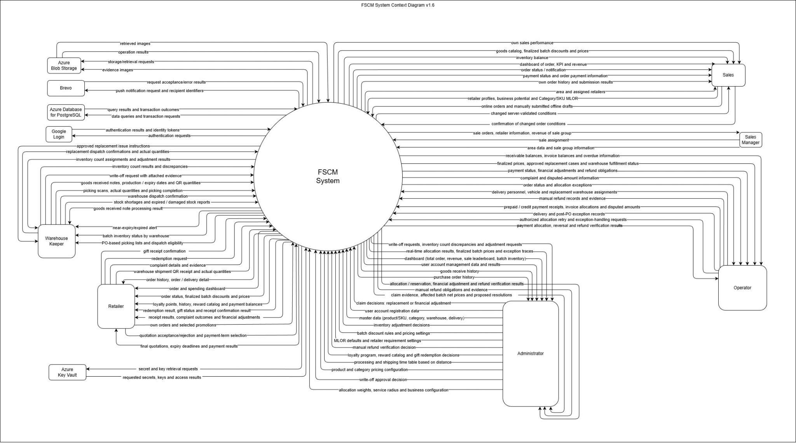
Figure 1. FSCM System Context diagram

2. User Requirements

2.1 Actors
# | Actor | Description
1 | Retailer | Uses a provisioned account to track own orders/shipments, confirm QR receipt, submit complaints, view payment obligations and loyalty, and request gifts. Places its own sales orders online once Active. Cannot self-register or manage store inventory.
2 | Sales | Declares potential retailers for approval; creates/synchronizes orders for active assigned retailers, views the allocation result and quotation of each SO and own performance.
3 | Sales Manager | Manages sales areas, groups and assignments; reviews retailer and sales information, team orders, revenue, and sales leaderboard.
4 | Warehouse Keeper | Records receipts, views assigned batch stock and approved picking lists, scans quantities, marks readiness and confirms dispatch; reports shortages and write-off evidence.
5 | Operator | Does not review or approve orders. Monitors allocation attempts and retries TechnicalFailed/Conflict attempts, handles operational exceptions/complaints, assigns vehicles and delivery persons, and confirms payment receipts within authority.
6 | Administrator | Manages users, master data, allocation settings and loyalty; approves retailers, write-offs and complaint adjustments, unlocks batches and may retry failed allocation attempts. There is no approval of allocation plans or final prices: reservation and quotation run automatically after a successful allocation. Financial/gift authority follows the detailed rules.
7 | Google Identity (OIDC) | External Google identity service (OpenID Connect) used by FSCM for authentication requests and identity token/authentication results.
8 | Azure Blob Storage | External object storage for evidence images and other files; handles storage and retrieval requests.
9 | Azure Notification Hubs | External push-notification service receiving notification requests and recipient identifiers and returning request outcomes.
10 | Azure Database for PostgreSQL | Managed database service used for data queries, transactions, and returning stored data and transaction results.

2.2 Use Cases

2.2.1 Diagram(s)
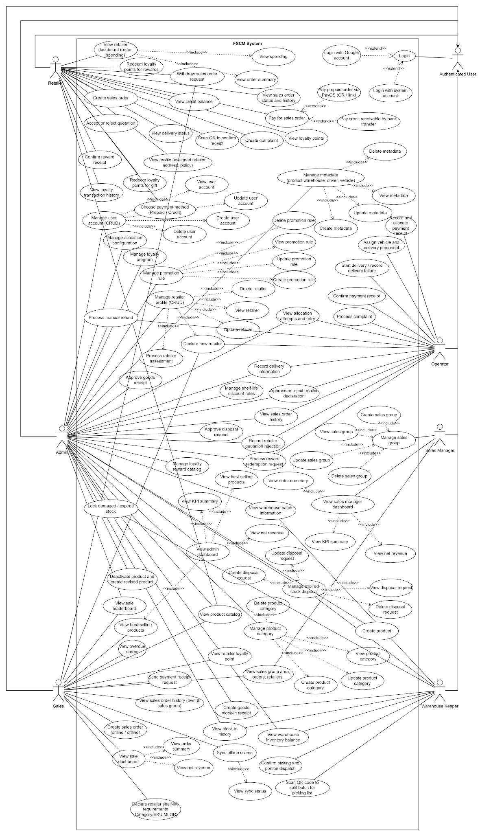
Figure 2. FSCM use-case overview by role

2.2.2 Descriptions
ID | Use Case | Actors | Use Case Description
UC-01 | View admin dashboard | Admin | Displays administrative operational indicators, order summaries, net revenue, KPI information and best-selling product information available to the Administrator.
UC-02 | Manage user account (CRUD) | Admin | Allows the Administrator to maintain system user accounts and their account information through create, view, update and delete operations permitted by the system.
UC-03 | Manage metadata (warehouse, driver, vehicle ) | Admin | Allows the Administrator to maintain operational master data for warehouses, drivers and vehicles.
UC-04 | Create goods stock-in receipt | Admin, Warehouse Keeper | Creates a goods receipt for products received into a warehouse, including the batch-related information required for inventory tracking.
UC-05 | View purchase order history | Admin, Operator | Displays historical purchase orders and their recorded processing information.
UC-06 | View stock-in history | Admin, Warehouse Keeper | Displays historical goods receipts and stock-in records for traceability.
UC-07 | Manage promotion rule | Admin | Allows the Administrator to create, view, update and delete promotion rules used by the system.
UC-08 | Manage retailer profile (CRUD) | Admin | Allows authorized staff to maintain retailer information and supporting retailer assessment information.
UC-09 | View sale leaderboard | Admin, Sales | Displays the sales ranking used to compare Sales Representative performance.
UC-10 | Process purchase order | Admin, Operator | Reviews and processes a submitted purchase order according to its current workflow state.
UC-11 | Process stock-in request | Admin | Reviews and processes a stock-in request before or during warehouse receiving operations.
UC-12 | View allocation attempts and retry | Admin, Operator | Lists allocation attempts by date, status and SO, shows the B1–B4 trace and price explanation (read-only) and retries TechnicalFailed or AllocationConflict attempts with an idempotency key (3.7.2).
UC-13 | Process initiate new retailer request | Admin, Operator | Reviews a request to register or activate a newly declared retailer.
UC-14 | Update purchase order status (when delivery) | Operator | Updates the order delivery-related status as the order progresses through delivery.
UC-15 | Create new retailer assessment | Operator, Sales | Records assessment information collected for a retailer, such as potential, store characteristics or purchasing capability.
UC-16 | Verify prepaid bank transfer and create PO | Operator, Admin | Verifies the Retailer's prepaid bank-transfer proof against the approved quotation amount before its deadline; on success the sales order becomes a PO and picking slips are released (3.6.6, BR-51, BR-72).
UC-17 | Process goods report / complaint from retailer | Operator | Reviews and handles a goods-related complaint or issue reported by a retailer after receipt.
UC-18 | Manage sales group | Sales Manager | Allows the Sales Manager to maintain sales groups and their organizational information.
UC-19 | View sales group area, orders, retailers | Sales Manager, Sales | Displays the sales group scope, including assigned areas, retailers and orders accessible to the actor.
UC-20 | View sales manager dashboard | Sales Manager | Displays aggregated sales-group performance, order summaries, net revenue and KPI information for the Sales Manager.
UC-21 | Create sales order | Retailer, Sales | Creates a sales order (Retailer for itself, Sales for an assigned retailer) with an idempotency key; the server recalculates price and the selected promotion, assigns DH and AcceptedAt and starts allocation immediately (3.6.1).
UC-22 | View retailer order history | Retailer | Displays the Retailer’s historical orders and recorded order statuses.
UC-23 | Record payment receipt for credit invoices | Operator, Sales | Records one payment receipt (amount, reference, evidence, duplicate check) and allocates it across one or more open Credit invoices; partial payment is allowed and any remainder becomes UnappliedCredit (3.10.1, BR-52). No cash and no COD
UC-24 | View purchase order history (only in sale group and personal) | Sales | Displays purchase orders limited to the Sales Representative’s permitted sales-group and personal scope.
UC-25 | View sale dashboard | Sales | Displays the Sales Representative’s sales information, including order summary and net revenue indicators.
UC-26 | Scan QR to confirm order delivery | Retailer | Scans issued batch QR labels to confirm that the retailer has received the delivered order quantities.
UC-27 | View retailer dashboard (order, spending) | Retailer | Displays the Retailer’s order summary and spending information.
UC-28 | View profile (assigned retailer, address, policy) | Retailer | Displays the retailer profile information assigned to the logged-in Retailer account, including address and applicable policy information.
UC-29 | Create report / complaint | Retailer | Creates a complaint or goods issue report related to received products or order fulfillment.
UC-30 | View warehouse inventory balance | Admin, Warehouse Keeper | Displays current warehouse inventory balances and availability information.
UC-31 | Confirm finish picking list | Warehouse Keeper | Confirms completion of the picking list and finalizes the recorded warehouse picking result.
UC-32 | Scan QR code to split batch for picking list | Warehouse Keeper | Scans a source batch QR and records a quantity split required to fulfill a picking-list item.
UC-33 | View warehouse batch information | Admin, Warehouse Keeper | Displays warehouse batch details such as product, quantity, expiry and current batch status.
UC-34 | Pay for purchase order | Retailer | Allows the Retailer, after accepting the quotation, to choose Prepaid (PayOS) or Credit (only with a valid Credit term, revalidated on the server) for a purchase order (3.6.6, BR-51, BR-73).
UC-35 | Pay credit receivable | Retailer | Pays an open Credit receivable by bank transfer; the payment is recorded as a payment receipt (UC-23) and may cover several invoices or part of one. The Retailer sees the receipt and remaining balance. Cash and COD are not used (BR-51).
UC-36 | Pay via PayOS | Retailer | Pays a Prepaid quotation through the PayOS link/QR shown in the app; the status updates from the PayOS webhook. Credit receivables are paid by transfer and recorded as payment receipts (3.6.6, 3.10.1).
UC-37 | Login | Authenticated User | Authenticates a user before access to protected FSCM functions is granted.
UC-38 | Login with system account | Authenticated User | Authenticates a user using the FSCM system account credentials.
UC-39 | Login with Google account | Authenticated User | Authenticates a user using the supported Google sign-in method.
UC-40 | Create sales group | Sales Manager | Creates a new sales group for organizing Sales Representatives and retailer coverage.
UC-41 | View sales group | Sales Manager | Displays sales-group information, assignments and related scope information.
UC-42 | Delete sales group | Sales Manager | Removes a sales group when deletion is permitted by the applicable business rules.
UC-43 | Update retailer | Admin | Updates permitted retailer profile information.
UC-44 | View retailer | Admin | Displays retailer profile, status and relevant business information.
UC-45 | Delete retailer | Admin | Removes a retailer record when deletion is permitted by the applicable business rules.
UC-46 | Update promotion rule | Admin | Updates an existing promotion rule when the rule is still editable.
UC-47 | View promotion rule | Admin | Displays promotion rule configuration and eligibility information.
UC-48 | Delete promotion rule | Admin | Deletes a promotion rule when deletion is permitted.
UC-49 | Create promotion rule | Admin | Creates a promotion rule with its applicability and discount configuration.
UC-50 | Update metadata | Admin | Updates warehouse, driver or vehicle master data.
UC-51 | View metadata | Admin | Displays warehouse, driver or vehicle master data.
UC-52 | Delete metadata | Admin | Deletes warehouse, driver or vehicle master data when deletion is permitted.
UC-53 | Create metadata | Admin | Creates warehouse, driver or vehicle master data.
UC-54 | Update user account | Admin | Updates permitted information or settings of an existing user account.
UC-55 | View user account | Admin | Displays user-account information and assigned access information.
UC-56 | Delete user account | Admin | Removes or deactivates a user account when permitted by account-management rules.
UC-57 | Create user account | Admin | Creates a system account for an authorized system role subject to account-creation restrictions.
UC-58 | Scan and apply batch promotion | Admin, Operator | Identifies near-expiry batch stock and maintains the remaining-shelf-life discount rules applied to allocated batches (3.5.4, BR-79). Near-expiry offers are out of scope (5.5 R-07).
UC-59 | Manage product category | Admin | Maintains the hierarchical product-category structure used to organize products.
UC-60 | Update product category | Admin | Updates an existing product category or its position in the category hierarchy.
UC-61 | View product category | Admin | Displays product categories and their hierarchical relationships.
UC-62 | Delete product category | Admin | Deletes a product category when it is not protected by dependency or business rules.
UC-63 | Create product category | Admin | Creates a new product category and optionally assigns it under a parent category.
UC-64 | Process retailer assessment | Admin | Reviews collected retailer assessment information and records the assessment result for future prioritization.
UC-65 | Manage write-off request | Admin, Warehouse Keeper | Allows authorized staff to create, view, update and delete write-off requests for unusable or expired stock before final processing.
UC-66 | Create write-off request | Admin, Warehouse Keeper | Creates a write-off request identifying affected batch quantities, reason and supporting information.
UC-67 | Update write-off request | Admin, Warehouse Keeper | Updates an editable write-off request and its supporting details.
UC-68 | View write-off request | Admin, Warehouse Keeper | Displays a write-off request, affected items, evidence and current processing status.
UC-69 | Delete write-off request | Admin, Warehouse Keeper | Deletes a write-off request when it has not reached a state that prevents deletion.
UC-70 | Process write-off request | Admin | Reviews a submitted write-off request and records the processing decision for the affected inventory.
UC-71 | View best-selling products | Admin, Sales | Displays products ranked by sales performance based on completed or otherwise eligible order data.
UC-72 | View net revenue | Admin, Sales Manager, Sales | Displays revenue calculated after applicable promotion discounts rather than gross pre-discount value.
UC-73 | View KPI summary | Admin, Sales Manager | Displays summarized KPI results for the relevant administrative or sales-management scope.
UC-74 | Process delivery | Admin, Operator | Assigns a vehicle and delivery person to each PO shipment, starts delivery after dispatch and records failed delivery attempts with reason and evidence (3.13.1, BR-76).
UC-75 | View order summary | Sales Manager, Sales, Retailer | Displays summarized order counts or order values for the actor’s permitted scope.
UC-76 | View retailer loyalty point | Sales | Displays the loyalty-point balance and loyalty status of the retailer currently being served by the Sales Representative.
UC-77 | Redeem loyalty points for gift | Retailer | Retailer requests a gift with points/gift stock held. Approval retains holds; authorized fulfillment completion consumes them once. Rejection/cancellation of unused uncompleted requests releases holds (BR-75). No purchase-order discount is created.
UC-78 | Cancel purchase order | Sales | Cancels an eligible purchase order and records the cancellation information required by the workflow.
UC-79 | Upload cancellation evidence | Sales | Uploads the file or image evidence required to support the purchase-order cancellation.
UC-80 | Sync offline orders | Sales | Synchronizes locally queued offline purchase orders with the server when network connectivity is available.
UC-81 | View sync status | Sales | Displays offline-order synchronization states, including pending, synchronizing and synchronized records.
UC-82 | View loyalty points | Retailer | Displays the Retailer’s current loyalty points and related loyalty information.
UC-83 | View delivery status | Retailer | Displays the current delivery status of the Retailer’s order.
UC-84 | View spending | Retailer | Displays the Retailer’s recorded spending for the applicable period or dashboard scope.
UC-85 | Review daily allocation run | Administrator | Review proposal revisions, prices, MLOR and shortages; approve or request recalculation. Only approval after revalidation reserves stock.
UC-86 | Select near-expiry offer | Sales | Record customer acceptance of the offer-specific MLOR and price on a distinct order line; no stock is held at selection.
UC-87 | Declare retailer shelf-life requirements (Category/SKU MLOR) | Sales | Records the minimum life on receipt requirements for an assigned retailer at Category and SKU level. A SKU-level requirement takes priority over its Category requirement; the product default applies when neither is configured.
UC-88 | Create product | Admin | Creates a new SKU in Draft status with its identity, category, shelf-life information and initial price, then publishes it once all required information is complete.
UC-89 | View product catalog | Admin, Sales, Retailer | Displays Published products with filtering by category and SKU search within the actor’s permitted visibility. Draft and Inactive products are not shown as purchasable items.
UC-90 | Deactivate product and create revised product | Admin | Marks an existing Published product as Inactive and creates a new product from it to reflect a required change, as Published product details are locked and cannot be edited in place.
UC-91 | View credit balance | Retailer | Displays the Retailer’s current outstanding credit balance and payment history under the approved payment terms.
UC-92 | Respond to quotation | Retailer | Accepts or rejects the quotation issued after a successful allocation and reservation, before its ExpiresAt and, on acceptance, chooses the payment method (3.6.6, BR-51, BR-72).
UC-93 | Review complaint and approve financial adjustment | Admin, Operator | The Operator reviews a receipt complaint and evidence; the Administrator accepts or rejects it, posting a capped adjustment at actual net price (3.10.4, BR-67 – BR-69).
UC-94 | Record and verify manual refund | Operator, Admin | Records the external refund transfer and evidence for a refund obligation; the Administrator verifies or requests supplements (3.10.4, BR-74).
UC-95 | Manage system configuration | Admin | Maintains allocation weights, service distance, transit table, quotation expiry, PayOS payment deadline, cache-age limit and loyalty rate; changes apply to later allocation attempts only (3.12.1, BR-57).
UC-96 | Manage loyalty program and gift catalog | Admin | Maintains the loyalty program, earning rate and gift catalog with gift stock (3.10.3, BR-54, BR-75).
UC-97 | Process gift redemption request | Admin | Approves/rejects gift requests and records delivery/completion within authorized scope (3.10.3, BR-75). Holds become used at actual fulfillment completion. Whether Retailer confirmation is mandatory remains R-16; do not assume staff confirmation satisfies a separately required Retailer confirmation.
UC-98 | Lock unusable batch quantity | Admin, Warehouse Keeper | Locks damaged or unusable batch quantity with reason and evidence so that it is excluded from allocation and dispatch until written off or unlocked (3.8.2, BR-71).
UC-99 | Withdraw sales order request | Retailer, Sales | Withdraws an SO while its allocation is not committed (status Withdrawn); an unsynchronised offline draft is deleted locally (3.6.3).

3. Functional Requirements

3.1 System Functional Overview

3.1.1 Screens Flow
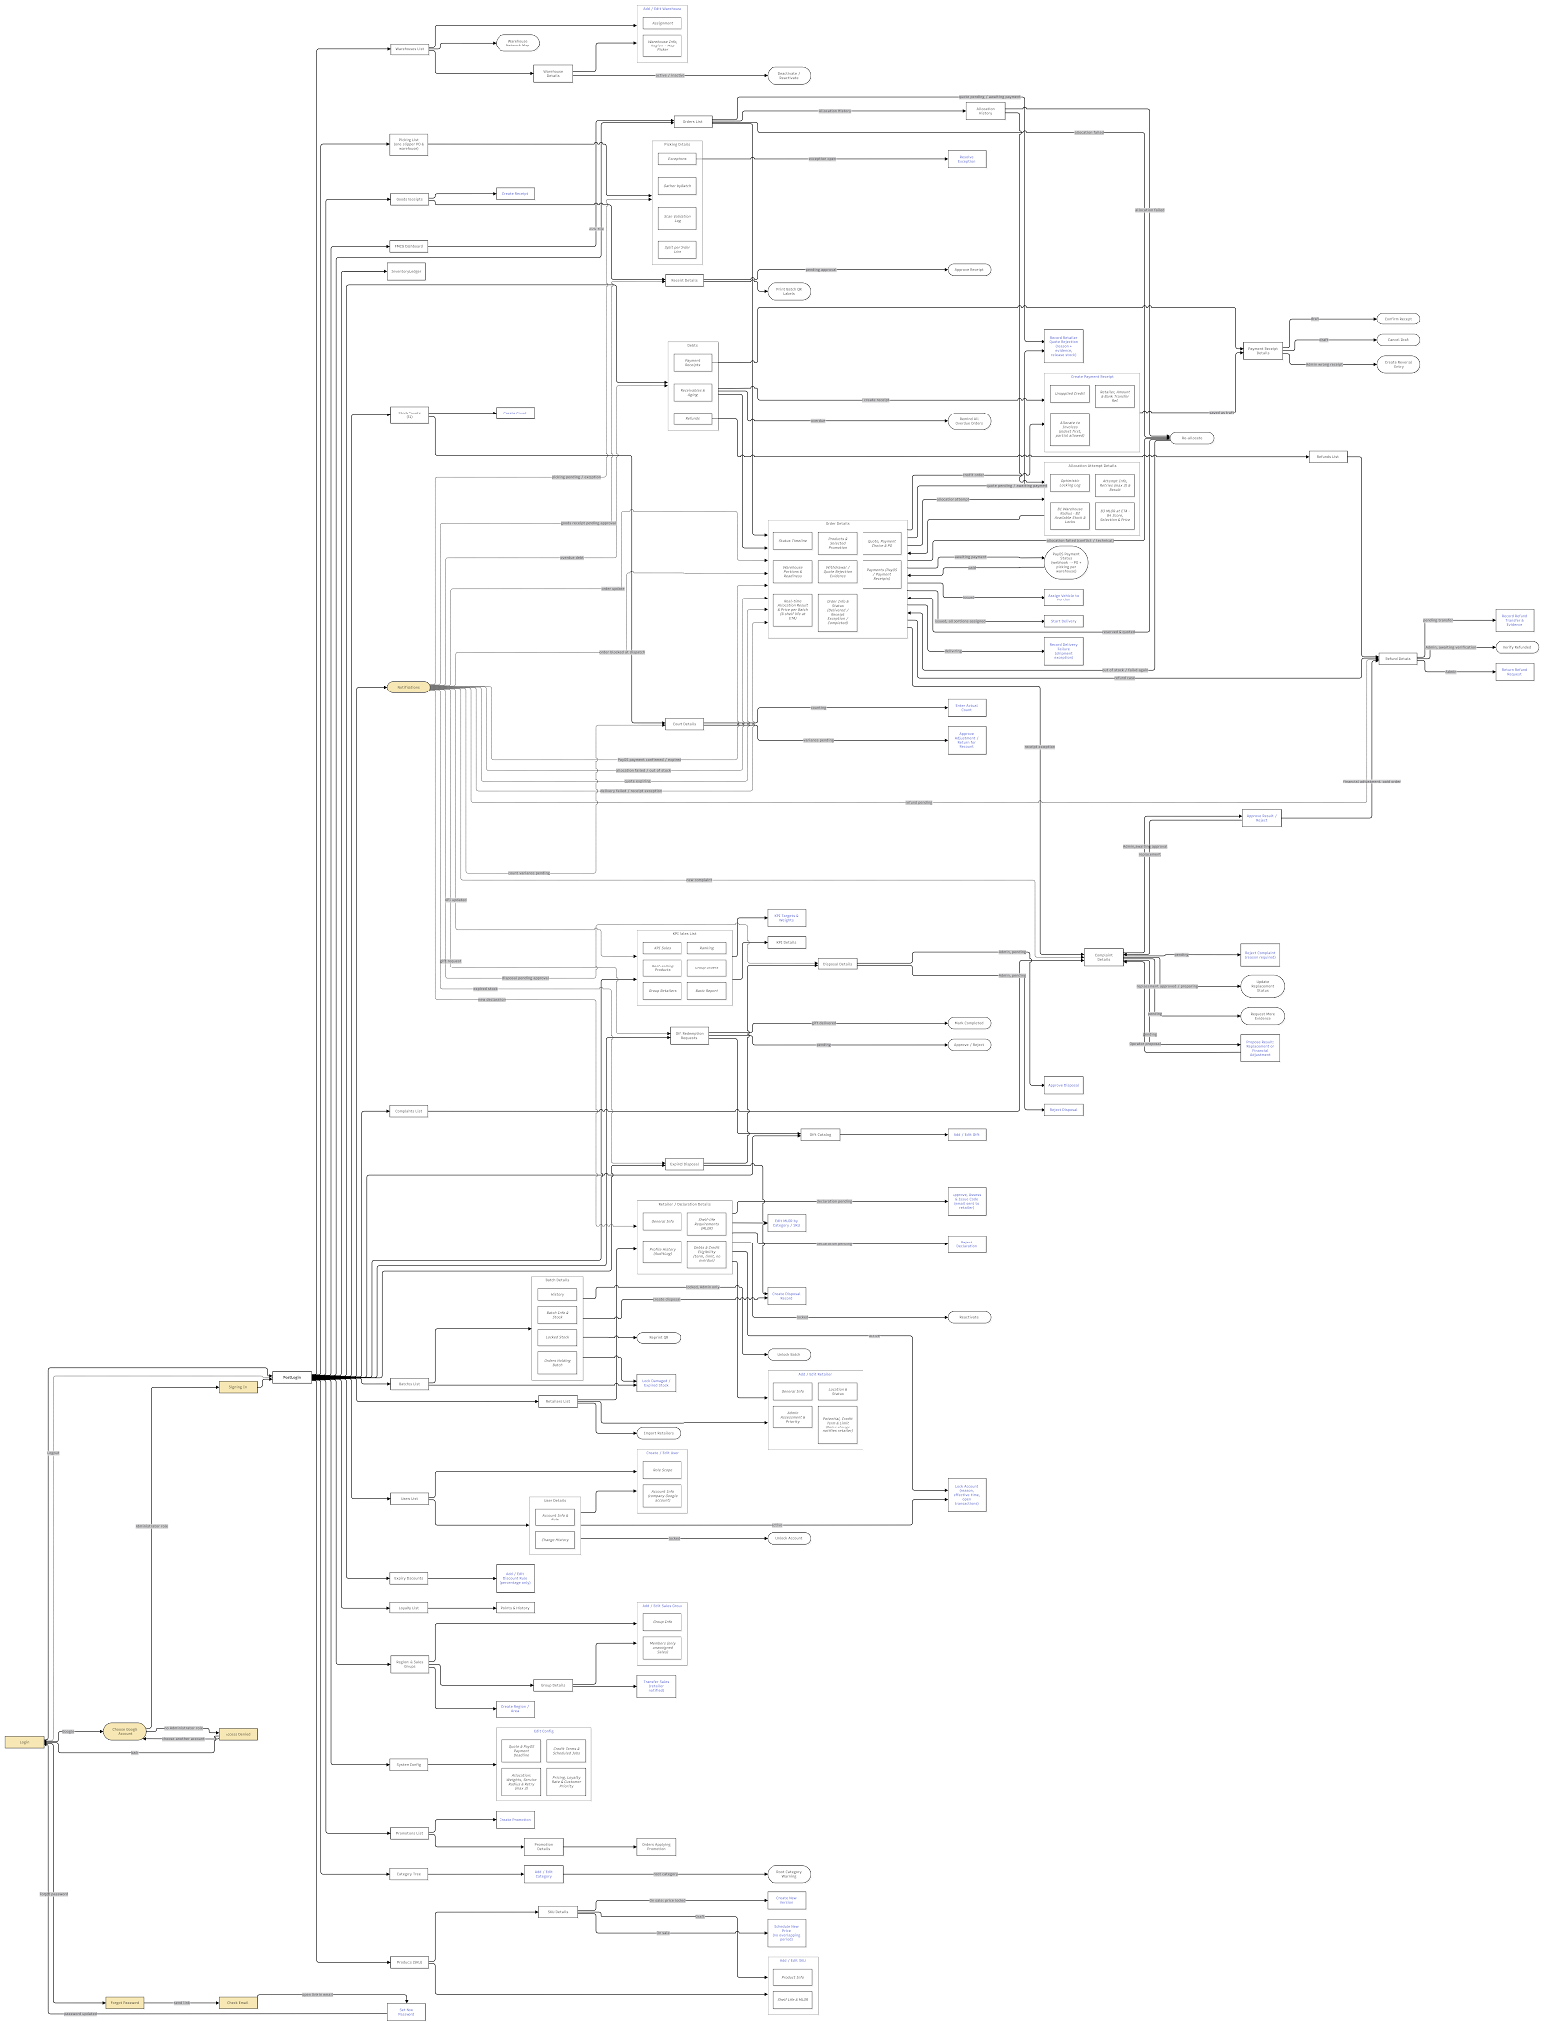
Figure 3.1. Admin Screen Flow Diagram
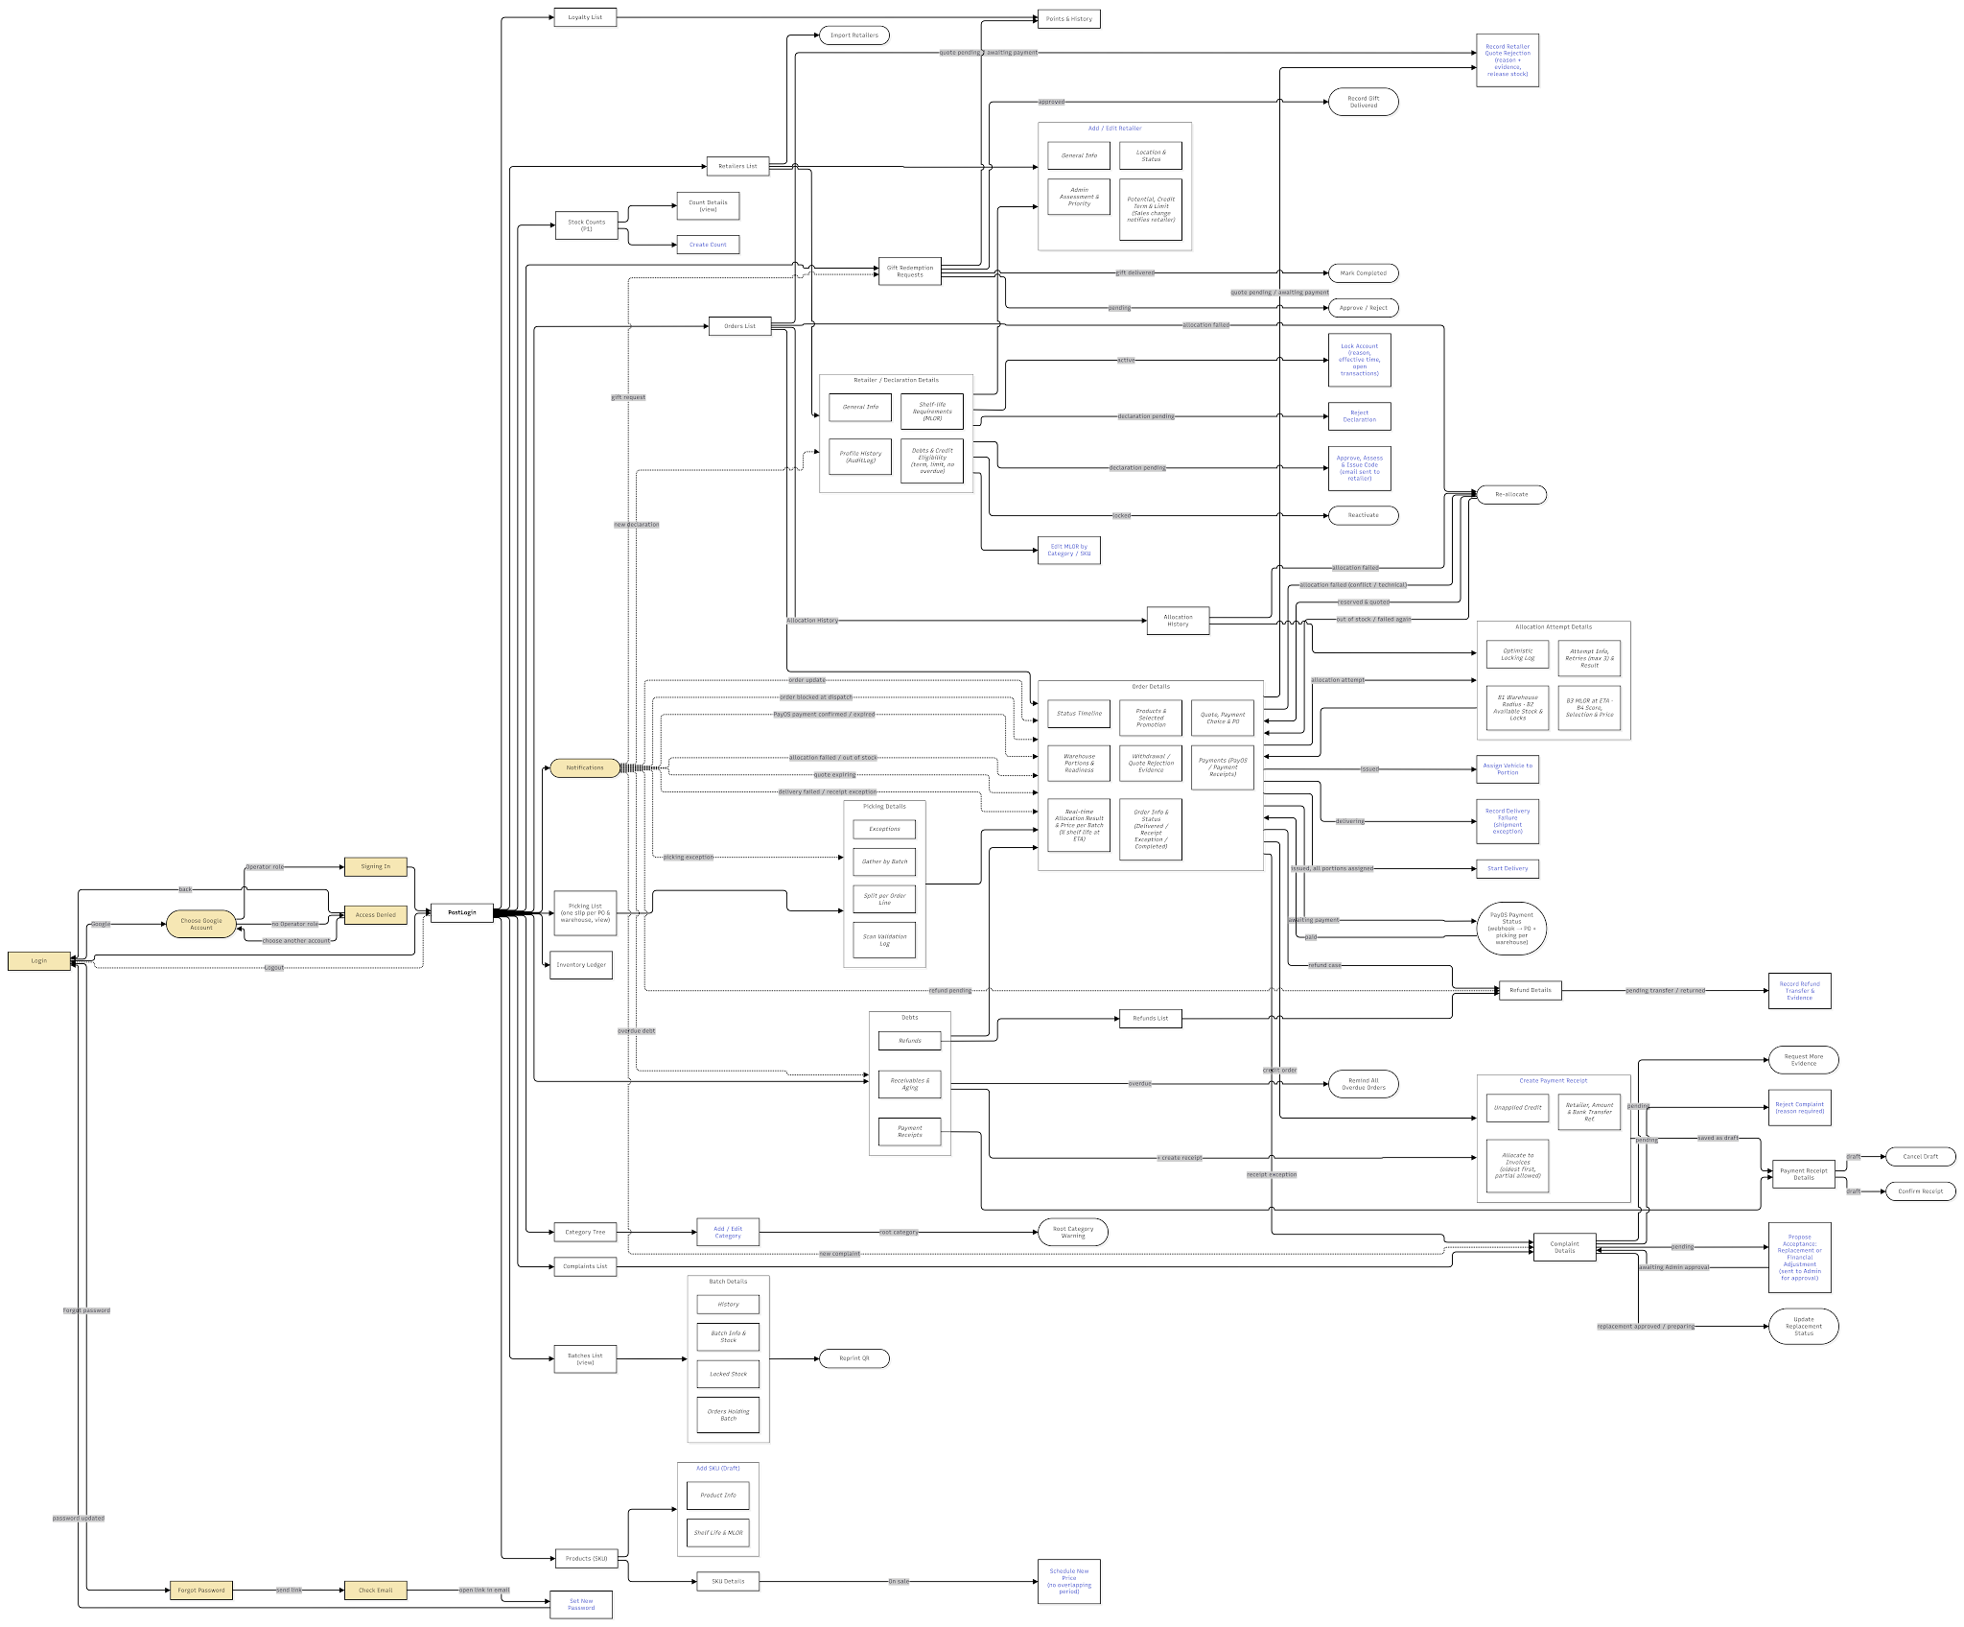

Figure 3.2. Operator Screen Flow Diagram
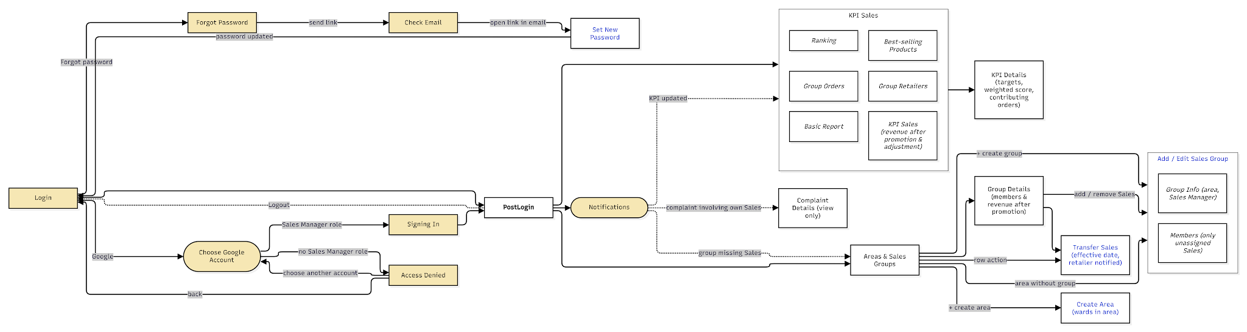

Figure 3.3. Sale Manager Screen Flow Diagram
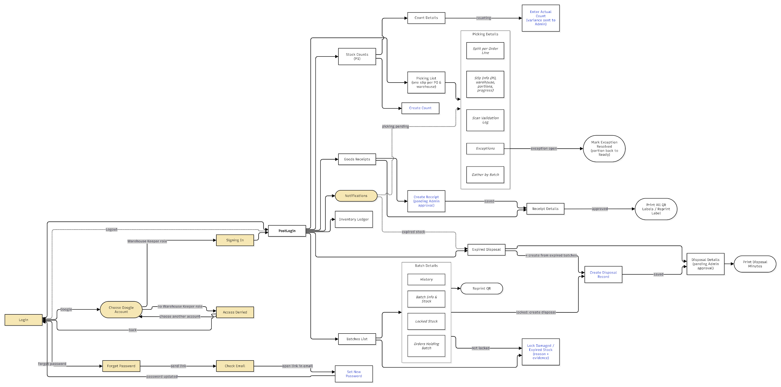

Figure 3.4A. Warehouse Keeper Web Portal Screen Flow Diagram
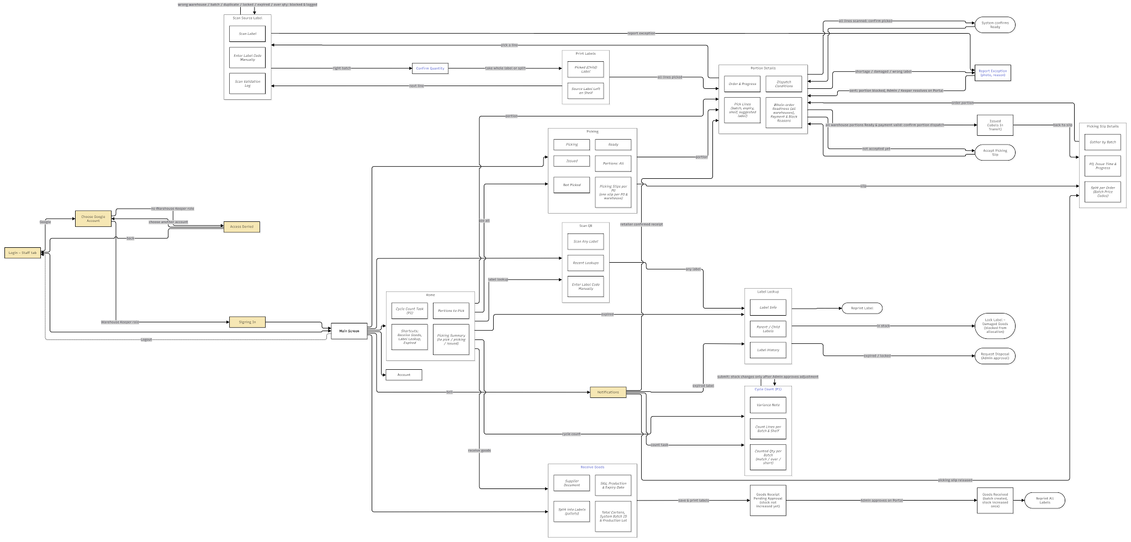
Figure 3.4B. Warehouse Keeper Mobile Screen Flow Diagram
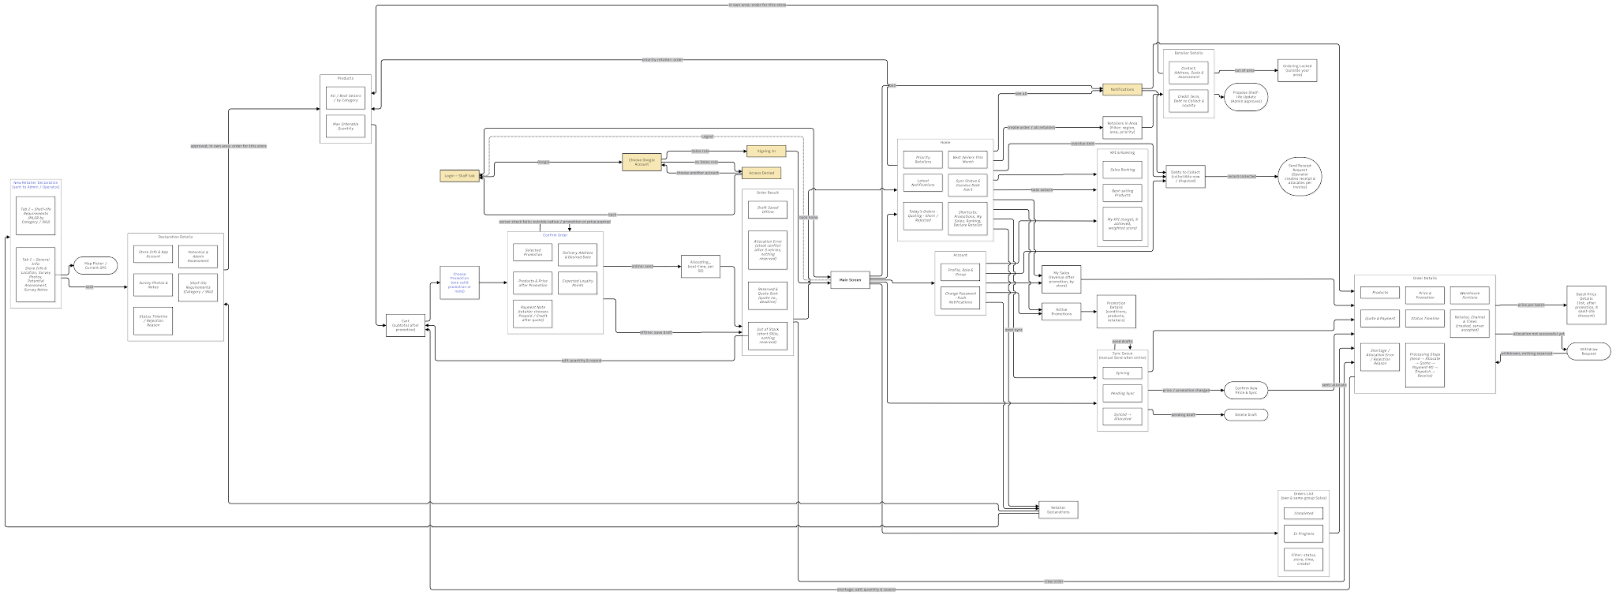
Figure 3.5. Sale Screen Flow Diagram
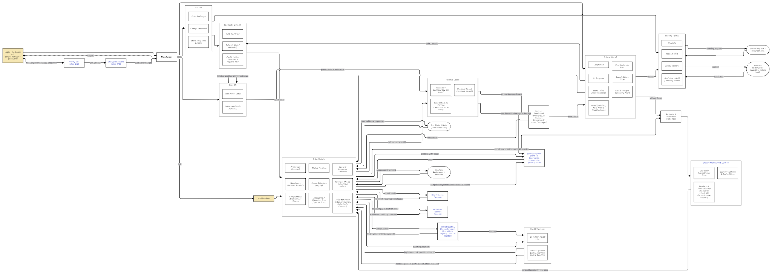
Figure 3.6.Retailer Screen Flow Diagram

3.1.2 Screen Descriptions
# | Feature | Screen | Description
1 | Authentication | Login (Web Portal) | Administrator, Operator, Sales Manager and Warehouse Keeper sign in with Google (company Google account). A link opens Forgot Password for accounts that still use a system password.
2 | Authentication | Forgot Password, Check Email, Set New Password (Web Portal) | The user enters the registered email, opens the reset link sent by email and sets a new password (at least 8 characters, letters and digits, different from the old one).
3 | Authentication | Google Sign-in Pop-up (Web Portal) | Pop-up opened over the Login screen by Sign in with Google. The user chooses a Google account; FSCM verifies the ID token and maps it to an existing Active staff account, then opens the Web Portal with that role. An unmatched account is denied and no account is created.
4 | Authentication | Login (Mobile App) | Shared login of the Mobile App with two tabs. Staff: company email and password, or Sign in with Google; the app opens the Sales or Warehouse part according to the role of the account. Customer: phone number and password; opens the Retailer part. Wrong password and locked account show an error message.
5 | Authentication | Google Sign-in Pop-up (Mobile App) | Pop-up opened over the Staff tab by Sign in with Google. The user chooses a company account; an account with the Sales or Warehouse Keeper role signs in to its part of the app and the pop-up closes. Other accounts are denied in the pop-up and can choose another account or close the pop-up.
6 | Authentication | Verify OTP, Change Password (Mobile – Retailer) | First login on the Customer tab with the issued password: the Retailer enters the 6-digit OTP sent by SMS, then sets a new password (at least 8 characters, letters and digits, different from the issued password, entered twice) before opening the Orders List.
7 | Authentication | PostLogin (Web Portal) | Main layout after sign-in: sidebar menu filtered by role, notification bell and Logout.
8 | Authentication | Main Screen (Mobile App) | Bottom tab bar with the notification bell, depending on the role. Sales: Home, Orders, Sync, Account. Warehouse Keeper: Home, Picking, Scan QR, Receive Goods, Account. Retailer: Orders, Scan QR, Account. Logout returns to the shared Login.
9 | Authentication | Users List | Lists user accounts with search and filters by role and status (UC-02, UC-55)
10 | Authentication | User Details | Shows account information, role and scope; opens Edit or deactivates the account (UC-56).
11 | Authentication | Create / Edit User | Form with two sections: Account Info (name, role, phone or email, status) and Role Scope (warehouse, sales group or retailer). The Administrator role cannot be assigned (UC-54, UC-57).
12 | Retailer Registration & Assessment | Retailer Declarations (Mobile – Sales) | Lists retailers declared by the Sales with search and filters Pending, Approved and Rejected.
13 | Retailer Registration & Assessment | New Retailer Declaration (Mobile – Sales) | Form with two tabs: General Info (store, contact, location, survey photos, potential assessment, notes) and Shelf-life Requirements (MLOR in % by category, with SKU values overriding their category). Submitted for Admin approval (UC-15).
14 | Retailer Registration & Assessment | Map Picker | Pop-up to pick a store or warehouse location on a map, or take the current GPS position.
15 | Retailer Registration & Assessment | Declaration Details (Mobile – Sales) | Shows Store Info, Potential & Admin Assessment, Shelf-life Requirements, Survey Photos & Notes and Status Timeline; an approved store can be ordered for directly.
16 | Retailer Registration & Assessment | Retailers List | Lists retailers and pending declarations with filters by area, potential class, priority and status; Import Retailers opens a pop-up (UC-08, UC-13, UC-44).
17 | Retailer Registration & Assessment | Retailer / Declaration Details | Tabs General Info, Shelf-life Requirements (effective MLOR per SKU and its source) and Debts. A pending declaration is approved or rejected here (UC-43, UC-64).
18 | Retailer Registration & Assessment | Approve & Assess Potential | Form to confirm the potential class (A/B/C) and priority, then approve; approval assigns the 8-digit retailer code and app account.
19 | Retailer Registration & Assessment | Reject Declaration | Form to enter the reason for rejecting a declaration; the Sales sees the reason.
20 | Retailer Registration & Assessment | Add / Edit Retailer | Form with four sections: General Info, Location & Status, Potential & Credit (payment term), Admin Assessment & Priority (UC-43).
21 | Retailer Registration & Assessment | Edit MLOR by Category / SKU | Form to change the retailer MLOR in % per category and per specific SKU.
22 | Retailer Registration & Assessment | Select Retailer (Mobile – Sales) | Lists retailers of the assigned area sorted by priority, with search and filters; retailers outside the area are locked.
23 | Retailer Registration & Assessment | Retailer Details (Mobile – Sales) | Tabs General Info and Shelf-life Requirements of a retailer; starts an order or proposes an MLOR update to the Administrator.
24 | Product & Category Management | Category Tree | Hierarchical product categories with their sub-categories and products (UC-59, UC-61).
25 | Product & Category Management | Add / Edit Category | Form with code, name, parent category, status and description (UC-60, UC-62, UC-63).
26 | Product & Category Management | Products (SKU) | Lists SKUs with filters by category and status (Draft, On sale, Discontinued).
27 | Product & Category Management | SKU Details | Shows product information, shelf life, near-expiry threshold, default MLOR and stock by batch. A Draft is edited or published; an on-sale SKU is discontinued or copied into a new version.
28 | Product & Category Management | Add / Edit SKU, Create New Version | Form with two sections: Product Info and Shelf Life & MLOR. Only a Draft can be edited; a price change of an on-sale SKU creates a new version.
29 | Product & Category Management | Products (Mobile – Sales) | Products for the selected retailer in tabs All and Best Sellers, with price, maximum quantity, MLOR for that retailer and promotion hints.
30 | Promotion & Batch Discount | Promotions List | Lists promotions with filters by type and status (UC-07, UC-47).
31 | Promotion & Batch Discount | Promotion Details | Shows conditions, eligible retailers, validity and the orders the promotion was applied to; it can be paused or edited (UC-46, UC-48).
32 | Promotion & Batch Discount | Create Promotion | Form for Type 1 (per SKU: minimum quantity and % discount) or Type 2 (product group), eligible retailers and validity (UC-49).
33 | Promotion & Batch Discount | Expiry Discounts | Lists expiry discount rules by Category or SKU: range of % shelf life left at the pricing point (run time), discount in % (below 100%), validity and status (UC-58).
34 | Promotion & Batch Discount | Add / Edit Discount Rule | Form to set scope (Category or SKU), range of % shelf life left at the pricing point, discount in % only (below 100%), validity and status; overlapping ranges are rejected.
35 | Promotion & Batch Discount | Active Promotions, Promotion Details (Mobile – Sales) | Running promotions and the products they apply to.
36 | Purchase Order & Offline Sync | Home (Mobile – Sales) | Sync status, overdue debt alert, Create Order, today's orders, shortcuts, priority retailers, best sellers and latest notifications (UC-25, UC-75).
37 | Purchase Order & Offline Sync | Cart (Mobile – Sales) | Selected lines with quantities, prices and promotion per line; expected base price only.
38 | Purchase Order & Offline Sync | Applied Promotions (Mobile – Sales) | Shows the promotion applied to each line and the expected base price.
39 | Purchase Order & Offline Sync | Confirm Order (Mobile – Sales) | Sections Delivery Info, Products & Expected Price, Applied Promotions, a payment note and Expected Loyalty Points. Sales chooses neither a receive date nor a payment method: the Retailer chooses Prepaid (PayOS) or Credit after receiving the quotation. Submits online or saves the order on the device as a draft when offline (UC-21).
40 | Purchase Order & Offline Sync | Order Result (Mobile – Sales) | Shows the order code, status Allocating and the expected value.
41 | Purchase Order & Offline Sync | Orders List (Mobile – Sales) | Orders of the Sales and the group in tabs In Progress and Completed, with search and filters (UC-24).
42 | Purchase Order & Offline Sync | Order Details (Mobile – Sales) | Sections Retailer & Time, Processing Steps (Submit, Review, Run, Quotation, Acceptance · PO, Dispatch, Receipt), Products, Price & Promotions, Warehouse Portions, Payment, Shortage / Complaint and Status Timeline. A pending order can be cancelled; a short order offers Create New Order (UC-78, UC-79).
43 | Purchase Order & Offline Sync | Batch Price Details (Mobile – Sales) | Approved price per batch: list price, promotion, base price, % shelf life left at the pricing point, expiry discount (%) and final price.
44 | Purchase Order & Offline Sync | Sync Queue (Mobile – Sales) | Offline draft orders in tabs Pending Sync, Syncing and Synced. Drafts are never sent automatically: Sales taps Send All Drafts when the network is available; an order whose base price changed shows the old and new price with Confirm New Price & Send or Delete (UC-80, UC-81).
45 | Purchase Order & Offline Sync | Orders List | Lists all orders with AcceptedAt, status, payment and value; no Approve/Reject. A button opens Allocation Attempts; an order whose attempt is TechnicalFailed or AllocationConflict shows Retry (UC-05, UC-12).
46 | Purchase Order & Offline Sync | Order Details | Sections Order Info, Products, Promos & Expected Price, Batch Allocation & Price per Batch, Quotation & PO (quotation version, response deadline, PO number), Warehouse Portions & Readiness, Payments, Status Timeline and Withdraw / Cancel Evidence. An order awaiting payment shows the PayOS payment status (UC-10, UC-12, UC-14).
47 | Purchase Order & Offline Sync | Reject / Cancel Order | Pop-up to choose or enter the reason and attach evidence; shows the impact of cancellation (stock released, refund needed).
48 | FEFO–MLOR Allocation | Allocation Attempts | Read-only tabs B1 Warehouse filter, B2 Stock/lock filter, B3 MLOR, B4 Score, selection and price explanation, and Weighted vs Strict FEFO. Admin/Operator can Retry a TechnicalFailed or Conflict attempt; there is no approve or recalculate action (UC-12).
49 | FEFO–MLOR Allocation | Allocation Attempt Trace | Tabs Orders in Run, Batch & Price Plan, Weighted vs Strict FEFO, Report by Warehouse and Version History. The Administrator approves goods and prices, requests recalculation or closes the run (UC-85).
50 | FEFO–MLOR Allocation | Allocation Trace | Pop-up with one tab per order line showing steps B1–B5: candidate batches, distance and ETA checks, MLOR, scores and allocation.
51 | FEFO–MLOR Allocation | Retry Allocation Attempt | Form to enter the reason for a new plan version.
52 | Warehouse Receiving & Batch Inventory | Goods Receipts | Lists goods receipts by warehouse, date and status (UC-06).
53 | Warehouse Receiving & Batch Inventory | Receipt Details | Shows receipt lines with production date and expiry, batches and QR labels; the Administrator approves a pending receipt (UC-11).
54 | Warehouse Receiving & Batch Inventory | Create Receipt | Form with warehouse, supplier document and lines (SKU, expiry date, batch, lot, quantity, number of labels) (UC-04).
55 | Warehouse Receiving & Batch Inventory | Receive Goods (Mobile – Warehouse) | Mobile form: supplier document, SKU, production and expiry date, quantity, auto-generated Batch ID, production lot and number of labels.
56 | Warehouse Receiving & Batch Inventory | Goods Received (Mobile – Warehouse) | Confirms the receipt and lists the printed QR labels.
57 | Warehouse Receiving & Batch Inventory | Batches List | Lists batches by warehouse with expiry, % shelf life left, on-hand, reserved, locked and available quantities (UC-30).
58 | Warehouse Receiving & Batch Inventory | Batch Details | Sections Batch Info & Stock, Locked Stock, Orders Holding Batch and History; batch stock can be locked or a disposal record created (UC-33).
59 | Warehouse Receiving & Batch Inventory | Lock Damaged / Expired Stock | Form to lock a quantity of a batch with reason and note.
60 | Warehouse Receiving & Batch Inventory | Scan QR (Mobile – Warehouse) | Scans any label, or accepts the label code typed manually when the label cannot be read; shows recent lookups.
61 | Warehouse Receiving & Batch Inventory | Label Lookup (Mobile – Warehouse) | Shows the batch, current quantity, parent / child labels and history of a label; the keeper can reprint the label, lock a damaged label or request a write-off.
62 | Warehouse Receiving & Batch Inventory | Expired Disposal | Lists disposal (write-off) records with status (UC-65, UC-68).
63 | Warehouse Receiving & Batch Inventory | Disposal Details | Shows batches, quantities, reason and value; the Administrator approves or rejects a pending record (UC-70).
64 | Warehouse Receiving & Batch Inventory | Create Disposal Record | Form listing expired and locked batches; the user selects batches, method and reason. Batches still reserved for orders cannot be selected (UC-66).
65 | Picking & Retailer Receipt | Picking List | Lists picking lists per PO and warehouse with keeper, number of portions, quantity and progress.
66 | Picking & Retailer Receipt | Picking Details | Tabs Gather by Batch, Split per Order Line and Exceptions of a picking slip; an open exception is marked as resolved here.
67 | Picking & Retailer Receipt | Home (Mobile – Warehouse) | Picking summary (not picked, picking, shipped), shortcuts and portions to pick.
68 | Picking & Retailer Receipt | Picking List (Mobile – Warehouse) | Picking lists by PO and warehouse with filters All, Not Picked, Picking, Ready and Shipped.
69 | Picking & Retailer Receipt | Picking Slip Details (Mobile – Warehouse) | Sections PO & Progress and Lines by Batch with batch price codes (PB / BG).
70 | Picking & Retailer Receipt | Picking Details (Mobile – Warehouse) | Sections Order & Progress, Order Readiness & Block Reasons, Pick Lines and Dispatch Conditions (UC-31).
71 | Picking & Retailer Receipt | Scan Source Label (Mobile – Warehouse) | Scans the source label or accepts the label code typed manually; shows an error for a wrong batch, duplicate or locked label (UC-32).
72 | Picking & Retailer Receipt | Confirm Quantity (Mobile – Warehouse) | Form to enter the picked quantity; taking part of a label creates a child label.
73 | Picking & Retailer Receipt | Print Labels (Mobile – Warehouse) | Shows the picked (child) label and the source label that stays on the shelf, with print and reprint.
74 | Picking & Retailer Receipt | Report Exception (Mobile – Warehouse) | Form to report shortage, damage or wrong label for a line with quantity, note and photo; the portion cannot become Ready until handled.
75 | Picking & Retailer Receipt | Shipped (Mobile – Warehouse) | Shows that the portion is dispatched, with dispatch time and portion status.
76 | Picking & Retailer Receipt | Orders List (Mobile – Retailer) | Points summary, best sellers in the area, debt and delivering alerts, and orders in tabs In Progress and Completed (UC-22, UC-27, UC-84).
77 | Picking & Retailer Receipt | Order Details (Mobile – Retailer) | Sections Quotation & Response Deadline (Accept / Reject), Warehouse Portions, Items & Batches, Price per Batch, Promotions, Payment & Points, Complaints, Delivery Info and Status Timeline. An order awaiting payment opens PayOS Payment (UC-83).
78 | Picking & Retailer Receipt | Scan QR (Mobile – Retailer) | Scans a parcel label, or accepts the label code typed manually, to open Receive Goods for that order; a label of another store shows an error.
79 | Picking & Retailer Receipt | Receive Goods (Mobile – Retailer) | Labels grouped by warehouse portion, scanned by camera or entered by code; after scanning all labels of a portion the retailer enters received and damaged quantities and confirms the portion; the screen then shows the shortage and the amount on hold (UC-26).
80 | Picking & Retailer Receipt | Order Received (Mobile – Retailer) | Confirms all portions are received and shows the paid amount and any amount on hold.
81 | Picking & Retailer Receipt | Send Complaint (Mobile – Retailer) | Form: portion, line / batch, reason, quantity, note and photos (at least a photo or a note); a second complaint for the same batch is not allowed (UC-29).
82 | Picking & Retailer Receipt | Account (Mobile – Retailer) | Store profile, loyalty points, payments and debts, assigned Sales, change password and logout (UC-28).
83 | Picking & Retailer Receipt | Complaints List | Lists complaints with disputed amount and status (UC-17).
84 | Picking & Retailer Receipt | Complaint Details | Shows portion, batch, shipped / received / short / damaged quantities, net price of the batch, disputed amount, evidence and the effect if accepted.
85 | Picking & Retailer Receipt | Accept & Adjust Amount, Reject Complaint | Forms to propose acceptance (Operator), approve the financial adjustment (Administrator) or reject with a reason.
86 | Payment & Loyalty | Debts List | Receivables of credit orders with due date, disputed amount and status; a tab opens Refunds.
87 | Payment & Loyalty | Record Payment Receipt, PayOS Payment Status | Record Payment Receipt records one receipt (amount, reference, evidence) and allocates it across open Credit invoices, allowing partial payment and UnappliedCredit. PayOS Payment Status shows Prepaid payments confirmed by webhook; there is no manual transfer verification (UC-16, UC-23).
88 | Payment & Loyalty | Refunds List, Refund Details | Refund obligations from paid cancellations and accepted complaints, with amount, transfers and history.
89 | Payment & Loyalty | Record Refund Transfer & Evidence, Return Refund Request | Forms to record a manual transfer with evidence, and for the Administrator to return an unverified request.
90 | Payment & Loyalty | Debts to Collect (Mobile – Sales) | Unpaid orders of the assigned retailers with overdue filter, disputed amount and Record Collected.
91 | Payment & Loyalty | Payments (Mobile – Retailer) | Tabs Paid by Period, Debts to Pay & Disputed Amount, and Refunds (UC-34–UC-36).
92 | Payment & Loyalty | Choose Payment Method (Mobile – Retailer) | Opened by Accept Quotation: the Retailer chooses Prepaid (PayOS) or Credit (shown only when the retailer has a payment term) and confirms. Credit is revalidated on the server and turns the order into a PO; Prepaid opens PayOS Payment.
93 | Payment & Loyalty | Reject Quotation (Mobile – Retailer) | Form to choose the reason for rejecting the quotation; the order is cancelled and its reserved stock released.
94 | Payment & Loyalty | PayOS Payment (Mobile – Retailer) | Shows the amount, PayOS link/QR and payment deadline. The status changes to Paid automatically when the PayOS webhook is verified; no proof image or manual verification is needed.
95 | Payment & Loyalty | Loyalty Points (Mobile – Retailer) | Available, held and pending points; tabs Redeem Gifts, My Gifts and Points History with the source of each entry (UC-82).
96 | Payment & Loyalty | Confirm Redemption (Mobile – Retailer) | Pop-up to choose gift quantity and submit the request. Required points remain held through approval and become used only at authorized completion after actual delivery; cancelled unused requests release holds once (BR-75).
97 | Payment & Loyalty | Loyalty List, Points & History | Retailers with their current points; the details show the points history (UC-76).
98 | Payment & Loyalty | Gift Redemption Requests | Lists held/approved/delivered/completed gift requests. Approval retains holds; authorized completion after actual delivery consumes them once. Cancellation respects actual fulfillment stage; see BR-75 and pending actor decision R-16.
99 | Payment & Loyalty | Gift Catalog, Add / Edit Gift | Gifts with points, stock and status; a gift with no stock is shown as Out of stock.
100 | Sales Groups & Reporting | Dashboard | Administrator indicators: orders, net revenue, pending items, orders by status, revenue by Sales and best sellers (UC-01).
101 | Sales Groups & Reporting | KPI Sales List | Tabs KPI Sales, Ranking, Best-selling Products, Group Orders, Group Retailers and Basic Report (UC-09, UC-20, UC-71–UC-73, UC-75).
102 | Sales Groups & Reporting | KPI Details, KPI Targets & Weights | KPI result of one Sales; form to set targets and weights.
103 | Sales Groups & Reporting | Regions & Sales Groups | Lists regions and groups with members, retailers and manager (UC-18, UC-41).
104 | Sales Groups & Reporting | Group Details | Members, retailers and orders of a group (UC-19).
105 | Sales Groups & Reporting | Add / Edit Sales Group, Transfer Sales, Create Region | Forms to maintain groups and members, move a Sales to another group and create a region (UC-40, UC-42).
106 | Sales Groups & Reporting | My Sales (Mobile – Sales) | Order count and revenue after promotions for a chosen period, by retailer and by order (UC-72).
107 | Sales Groups & Reporting | KPI & Ranking (Mobile – Sales) | Tabs My KPI, Sales ranking and Best-selling Products (UC-09, UC-71, UC-73).
108 | System Configuration & Notifications | Warehouses List, Warehouse Details | Warehouses with type, location, keeper, minimum stock and status; details show the service radius on a map (UC-51).
109 | System Configuration & Notifications | Add / Edit Warehouse | Form with Warehouse Info + Map Picker and Assignment (UC-50, UC-53).
110 | System Configuration & Notifications | Warehouse Network Map | Pop-up map of warehouses and retailers.

3.1.3 Screen Authorization

Screen | Admin | Operator | Sales Manager | Warehouse Keeper | Sales | Retailer
Login, Forgot Password, Google Sign-in (Web Portal) | X | X | X | X
Login – Staff tab, Google Sign-in (Mobile App) |  |  |  | X | X
Login – Customer tab, Verify OTP, Change Password (Mobile App) |  |  |  |  |  | X
Notifications | X | X | X | X | X | X
Dashboard | X
Users List, User Details | X
Create / Edit / Deactivate User | X
Retailer Declarations, Declaration Details (Mobile – Sales) |  |  |  |  | X
New Retailer Declaration |  |  |  |  | X
Retailers List, Retailer / Declaration Details | X | X
Approve & Assess / Reject Declaration | X
Add / Edit Retailer, Edit MLOR, Import | X
Select Retailer, Retailer Details (Mobile – Sales) |  |  |  |  | X
Category Tree, Products (SKU), SKU Details | X
Create / Edit / Publish SKU and Category | X
Promotions List, Promotion Details | X
Create / Edit / Pause Promotion | X
Expiry Discounts | X
Add / Edit Discount Rule | X
Create Order screens, Active Promotions (Mobile – Sales) |  |  |  |  | X
Orders List, Order Details, Batch Price Details (Mobile – Sales) |  |  |  |  | X
Cancel Pending Order, Create New Order |  |  |  |  | X
Sync Queue (Mobile – Sales) |  |  |  |  | X
Orders List, Order Details (Web Portal) | X | X
Withdraw / Cancel Order (no Approve / Reject) | X | X
Cancel Order (exception after picking started: Admin) | X | X
Allocation Attempts, Attempt Trace | X | X
View Attempts, Retry Attempt | X
Goods Receipts, Receipt Details, Create Receipt | X |  |  | X
Approve Receipt | X
Receive Goods (Mobile – Warehouse) |  |  |  | X
Batches List, Batch Details | X | X |  | X
Lock / Unlock Stock | X |  |  | X
Scan QR, Label Lookup (Mobile – Warehouse) |  |  |  | X
Reprint Label, Lock Label, Request Write-off |  |  |  | X
Expired Disposal, Disposal Details, Create Disposal Record | X |  |  | X
Approve / Reject Disposal | X
Picking List, Picking Details (Web Portal) | X | X |  | X
Resolve Exception | X |  |  | X
Picking screens (Mobile – Warehouse) |  |  |  | X
Scan and Split Label, Report Exception |  |  |  | X
Confirm Picked, Confirm Portion Dispatch |  |  |  | X
Orders List, Order Details, Account (Mobile – Retailer) |  |  |  |  |  | X
Scan QR and Receive Goods |  |  |  |  |  | X
Send Complaint |  |  |  |  |  | X
Accept / Reject Quotation, Choose Payment Method, Pay via PayOS |  |  |  |  |  | X
Complaints List, Complaint Details | X | X
Propose Acceptance / Reject Complaint | X | X
Approve Financial Adjustment | X
Debts List, Refunds | X | X
Record Payment Receipt, Record Refund Transfer | X | X
Verify / Return Refund | X
Debts to Collect (Mobile – Sales) |  |  |  |  | X
Record Collected |  |  |  |  | X
Payments, Loyalty Points (Mobile – Retailer) |  |  |  |  |  | X
Redeem Gift, Cancel Pending Request |  |  |  |  |  | X
Loyalty List, Points & History | X | X
Gift Redemption Requests | X | X
Approve / Reject / Complete Request | X | X
Gift Catalog, Add / Edit Gift | X
Regions & Sales Groups, Group Details | X |  | X
Add / Edit Group, Transfer Sales, Create Region | X |  | X
KPI Sales List, KPI Details | X |  | X
KPI Targets & Weights | X
Home, My Sales, KPI & Ranking (Mobile – Sales) |  |  |  |  | X
Warehouses List, Warehouse Details, Network Map | X
Add / Edit / Deactivate Warehouse | X
System Config, Edit Config | X
Assign Vehicle, Start Delivery, Record Delivery Failure | X | X
Data Access (all screens)
Query All Data | X | X
Query Own Data |  |  |  |  | X | X
Query Managed Data |  |  | X | X | X
Add New Data | X | X | X | X | X | X
Update All Data | X
Update Own Data |  |  |  | X | X | X
Update Managed Data |  | X | X | X

3.1.4 Non-Screen Functions

# | Feature | System Function | Description
1 | Authentication | Account Authentication | Trigger: the user selects Login. Checks sign-in by email and password (Web Portal and Staff tab of the Mobile App) or by phone number and password (Customer tab of the Mobile App), then loads the role and data scope and shows only the menus of that role.
2 | Authentication | Google Sign-in | Trigger: the user chooses an account in the Google pop-up. Verifies the Google ID token (issuer, audience, expiry) and maps the verified e-mail to an existing Active FSCM account and its role. No account is created automatically; an unmatched account, or on the Mobile App an account without the Sales or Warehouse Keeper role, is denied access.
3 | Authentication | Role-based Mobile Workspace | Trigger: successful sign-in on the Mobile App. After sign-in on the Mobile App, opens the part of the app for the role of the account (Sales, Warehouse Keeper or Retailer) and shows only its tabs and screens; logout clears the session and returns to the shared Login.
4 | Authentication | Password Reset Link | Trigger: the user submits Forgot Password. Sends a reset link to the registered email; the new password needs at least 8 characters with letters and digits, differs from the old one, and old sessions are signed out.
5 | Authentication | Retailer First-Login Verification | Trigger: first Customer sign-in with the issued password. When a Retailer signs in for the first time on the Customer tab with the issued password, sends a 6-digit SMS OTP valid for 5 minutes (resend after 45 seconds) and requires a new password (at least 8 characters, letters and digits, different from the issued password) before access; later sign-ins skip this step.
6 | Retailer Registration & Assessment | Potential Classification | Trigger: Sales submits a retailer declaration. Suggests potential class A, B or C from forecast revenue and purchasing capacity; the Administrator confirms the class and priority.
7 | Retailer Registration & Assessment | Retailer Code Assignment | Trigger: the Administrator approves a declaration. On approval of a declaration, assigns the 8-digit retailer code and creates the Retailer account for the Customer tab of the Mobile App.
8 | Retailer Registration & Assessment | Sales Area Restriction | Trigger: Sales opens the retailer list or starts an order. Locks retailers outside the area of the Sales group so that no order can be created for them.
9 | Purchase Order & Offline Sync | Order Quantity Limit | Trigger: Sales enters or changes a line quantity. Limits each SKU line to available stock minus the safety buffer, rounded down to a multiple of 10 cartons. Creating an order does not hold stock.
10 | Purchase Order & Offline Sync | Promotion Calculation | Trigger: the cart changes, and again when the server accepts the order. Applies Type 1 (per SKU) and Type 2 (product group) promotions on the list price; each line receives only the promotion with the highest discount. Paused or expired promotions are not applied.
11 | Purchase Order & Offline Sync | Offline Order Synchronization | Trigger: Sales taps Send in the Sync Queue. Saves offline orders on the device as drafts with a request code; drafts are sent only when Sales taps Send, never automatically, and a failed send is retried the same way. Retrying with the same request code never creates a duplicate order. If the base price or MLOR changed, the Sales confirms before the order is accepted. The server acceptance time sets the order priority.
12 | FEFO–MLOR Allocation | Real-time Allocation Trigger | Trigger: the server accepts a valid SO (online, or an offline draft on sync). Assign DH and AcceptedAt, set the SO to Allocating and enqueue it. A worker creates one allocation attempt per SO in AcceptedAt order (ties by order code) with an idempotency key; a duplicate trigger returns the existing attempt.
13 | FEFO–MLOR Allocation | Effective MLOR Resolution | Trigger: each order line is evaluated in an allocation attempt. For each order line uses the MLOR the retailer declared for that SKU; if none, the MLOR of its category; if none, the product default.
14 | FEFO–MLOR Allocation | Batch Allocation (B1–B5) | Trigger: an allocation attempt starts for one SO (or is retried). B1 takes usable, unexpired and unlocked batches; B2 keeps warehouses within the 20 km service radius and batches whose shelf life left at ETA meets the MLOR (ETA from the transit table by distance band); B3 scores S = 0.5·fE + 0.3·fD + 0.2·fQ and picks greedily with tie-break expiry/ETA, distance, Available, batch code; B4 applies all-or-nothing. If every line is filled, reserve the whole SO in one transaction with a conditional update on Version/Available; a version conflict retries up to 3 times, then the attempt ends Conflict (SO AllocationConflict); a technical error ends TechnicalFailed (SO AllocationFailed); a short line ends OutOfStock with no partial reservation.
15 | FEFO–MLOR Allocation | Expiry Discount Pricing | Trigger: batches are chosen for an order line. After the batches are chosen, applies the expiry discount rule matching the % shelf life left at the pricing point, that is the allocation time and not the ETA (a SKU rule overrides a Category rule; discount in % only, below 100%) and stores list price, promotion, base price, rule, discount and final price per batch line in a price version (BG).
16 | FEFO–MLOR Allocation | Reservation and Quotation | Trigger: an allocation attempt commits successfully (automatic, no approval step). Create the quotation from Σ Allocation.NetAmount with ExpiresAt, set the SO to Quoted and notify Retailer/Sales. No PO, picking list or shipment is created here; PO conversion under 3.6.6 does that once.
17 | FEFO–MLOR Allocation | Quotation Expiry | Trigger: response/payment deadline. Reconcile actual timely funds and pending verification under BR-72 before cancellation/release. Timely but verified-late money follows F4 EX10 only with a valid SO/reservation and safe fulfillment; no revival after cancellation.
18 | FEFO–MLOR Allocation | PO Conversion and Picking Release | Trigger: accepted quotation plus Prepaid payment Paid (verified PayOS webhook) or valid Credit (server revalidation of term, limit, overdue and outstanding). Create one PO idempotently and release one picking list per PO and warehouse once; do not reserve again.
19 | FEFO–MLOR Allocation | Algorithm Evaluation | Trigger: an allocation attempt finishes, or the periodic evaluation report is run. Compares the weighted result with strict FEFO on the same eligible batches (number of warehouses, average distance and shelf life left at ETA).
20 | Warehouse Receiving & Batch Inventory | Batch and Label Generation | Trigger: a goods receipt is saved and approved. Creates the batch code from warehouse, SKU and expiry date (production date must be before expiry and not in the future), adds later receipts with the same values to that batch and generates one QR label per pallet.
21 | Warehouse Receiving & Batch Inventory | Label Split | Trigger: the keeper confirms fewer cartons than a label holds. When fewer cartons are picked than a label holds, creates a child label linked to the parent and updates the parent quantity without reprinting it.
22 | Warehouse Receiving & Batch Inventory | Expired Batch Detection | Trigger: daily 00:00 expiry job (Normal → Near-date → Expired), independent of allocation, and current eligibility checks at allocation and dispatch. Exclude expired/locked quantities without changing physical OnHand.
23 | Warehouse Receiving & Batch Inventory | Write-off Posting | Trigger: the Administrator approves a disposal record. Deducts on-hand stock of a disposal record only after Administrator approval; a batch still reserved for orders cannot be written off.
24 | Picking & Retailer Receipt | Portion Ready Confirmation | Trigger: the keeper confirms picking of a portion. When the keeper confirms picking, the server checks the picked quantities against the plan before the portion becomes Ready; an open exception blocks it.
25 | Picking & Retailer Receipt | Dispatch Readiness Check | Revalidate at dispatch: the order is a PO; Prepaid is fully verified or Credit conditions remain valid; every expected warehouse portion is fully ready; no unresolved stock lock or fulfillment exception; batches still meet expiry, current ETA, MLOR and deadline. Any failure blocks dispatch; damage/shortage sets Needs handling and prevents shipment of all not-yet-dispatched portions until authorized resolution.
26 | Picking & Retailer Receipt | Dispatch Posting | Trigger: the keeper confirms dispatch. On dispatch confirmation, deducts on-hand and reserved stock and sets the labels to In transit; the order becomes Issued when all portions are dispatched.
27 | Picking & Retailer Receipt | Receipt Validation | Trigger: the retailer scans a label or confirms a portion. Accepts only labels of orders delivered to that store; records received and damaged quantities per portion, calculates shortage and the amount on hold at the batch price, and marks the order Delivered only after all portions are received.
28 | Picking & Retailer Receipt | Order Completion | Trigger: receipt, finalized fulfillment exception, settlement or complaint/refund resolution. Completed requires full actual receipt or authorized final delivery-exception resolution, adjusted settlement and no unresolved complaint/refund (BR-49). Preserve actual quantities and cancelled state. Later claims post separate corrections.
29 | Picking & Retailer Receipt | Complaint Adjustment | Trigger: the Administrator approves a complaint adjustment. For a complaint accepted by the Administrator, adjusts the receivable or creates a manual refund obligation equal to the affected quantity × the actual net price of that batch line; no goods are returned to stock automatically.
30 | Payment & Loyalty | Debt Due Date and Status | Snapshot the Credit term on the PO; later retailer changes do not alter it. DueDate = DeliveredDate (full actual receipt, or the authorized final resolution of a delivery exception) + snapshotted term. Prepaid orders create no receivable.
31 | Payment & Loyalty | Loyalty Point Posting | Trigger: valid Completed under BR-49. Post initial points once on adjusted eligible purchase value using the program snapshot; baseline 100,000 VND/point. Financially resolved fulfillment exceptions retain actual quantities. Later corrections are source-linked; refund verification does not repeat them.
32 | Payment & Loyalty | Gift Redemption Points | Request holds points/gift stock; approval retains them; authorized completion after actual delivery consumes them once. Reject/cancel unused uncompleted fulfillment releases holds once; completion actor decision remains R-16.
33 | Sales Groups & Reporting | Net Revenue and KPI Calculation | Trigger: an order status, payment or adjustment changes. Calculates revenue after promotions, expiry discounts and approved adjustments, excluding rejected, cancelled and unsynchronized orders; ranking and KPI use this figure and best sellers are counted in cartons.
34 | System Configuration & Notifications | Operational Notifications | Trigger: business event (quotation issued, payment confirmed or expired, allocation failed or conflict, picking or shipment exception, overdue, quotation expired). Notify roles under 3.12.2; there are no review reminders.
35 | System Configuration & Notifications | Status Timeline and Audit | Trigger: any status change. Records every status change of orders, allocation attempts, portions, complaints, refunds and redemptions with actor and time.

3.1.5 Entity Relationship Diagram

3.1.5.1 Sourcing, Retailer and Master Data

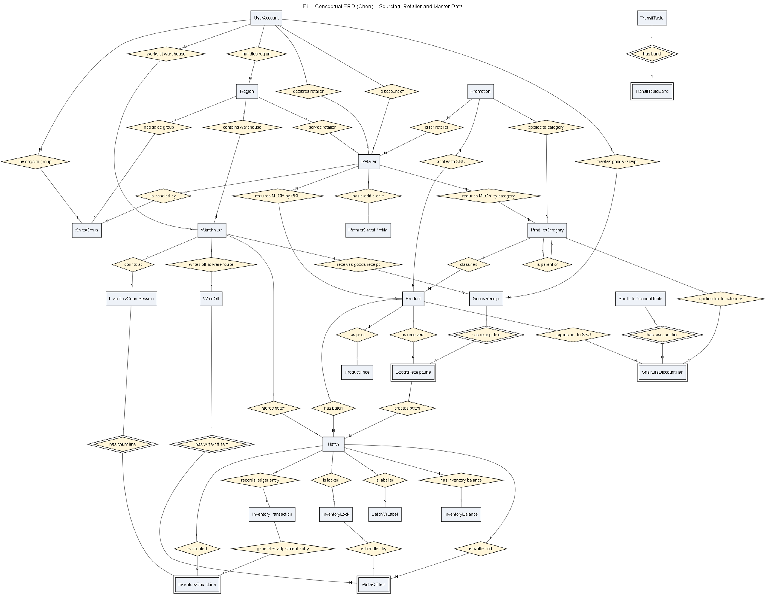
Figure 4.1. Sourcing, Retailer and Master Data Conceptual Entity Relationship Diagram

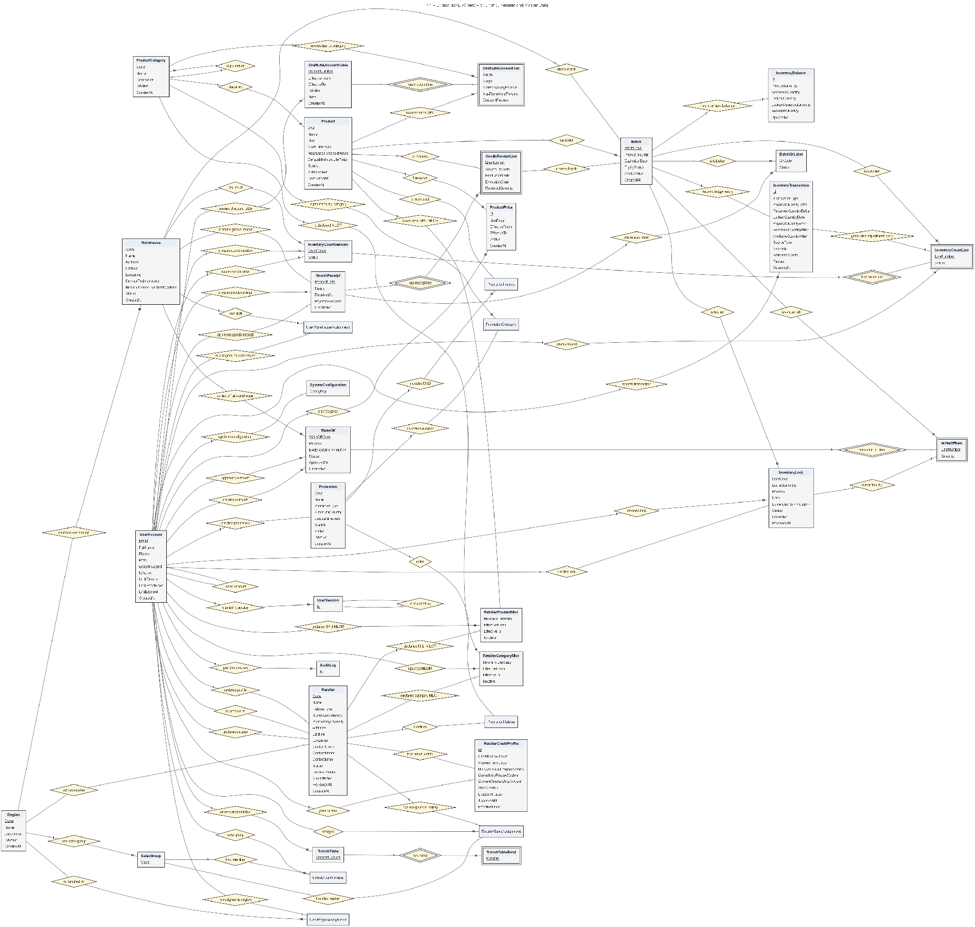
Figure 4.2. Sourcing, Retailer and Master Data Logical Entity Relationship Diagram

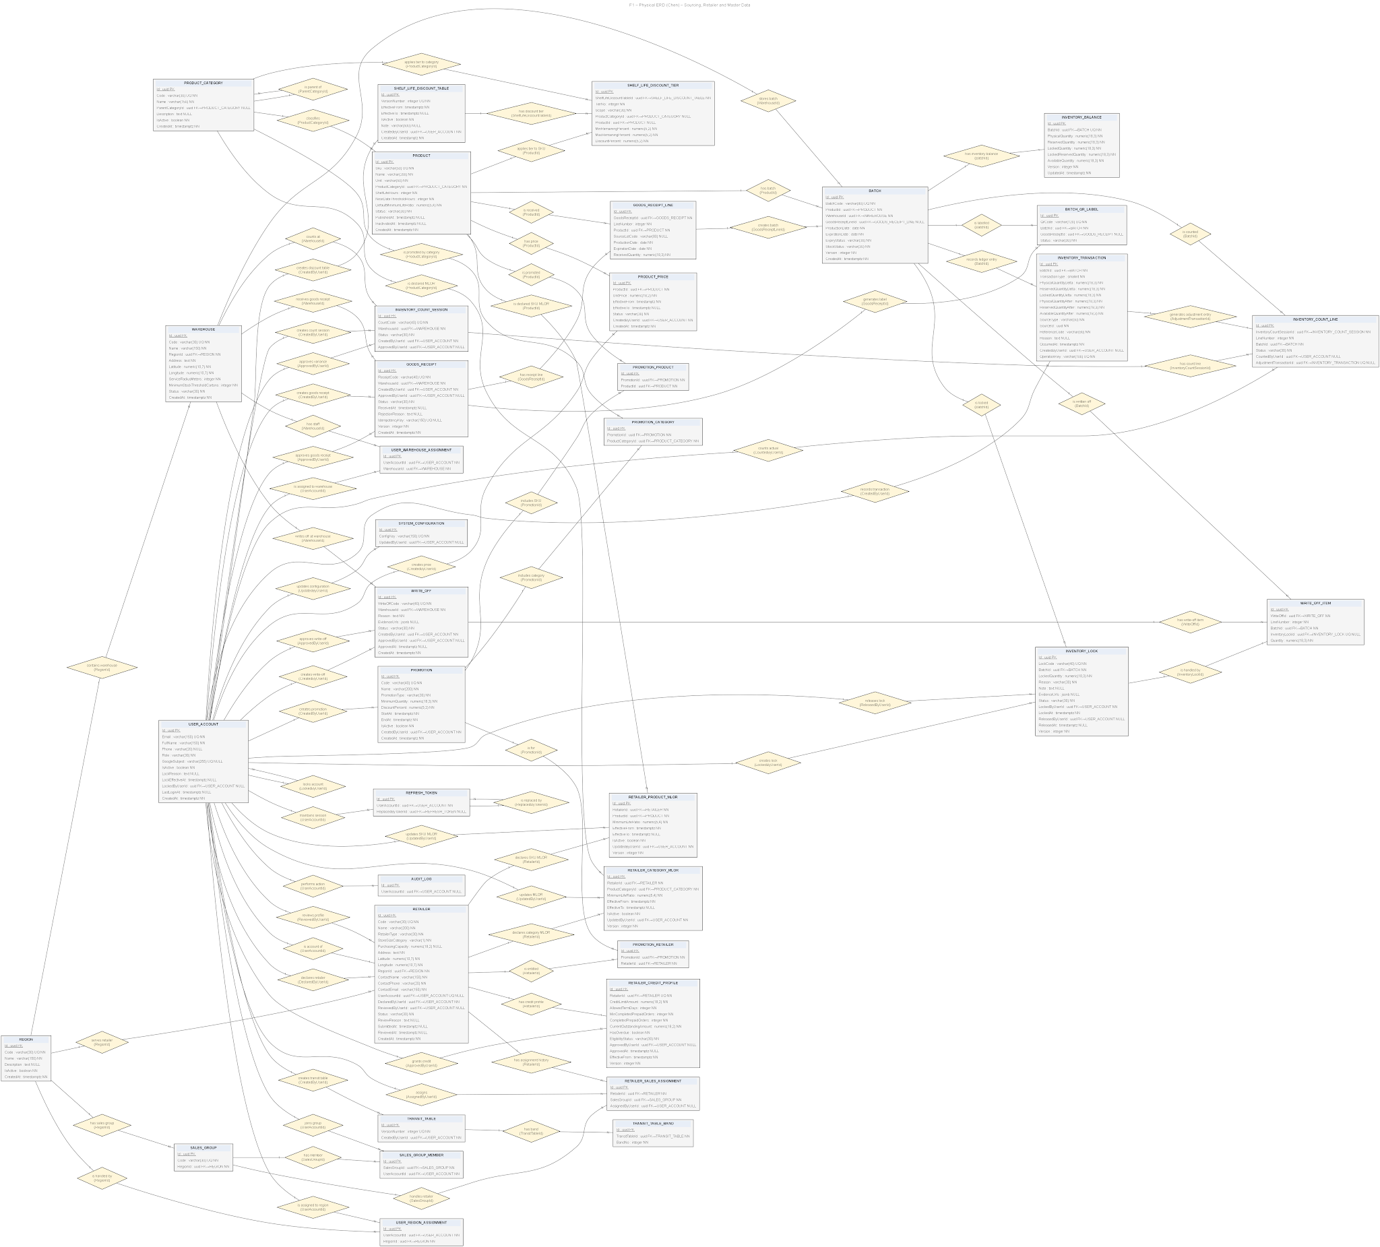
Figure 4.3. Sourcing, Retailer and Master Data Physical Entity Relationship Diagram

Table 3.1.5.1. Sourcing, Retailer and Master Data entity descriptions
# | Entity | Description
1 | Region | Defines a sales territory used to group warehouses, retailers and sales groups, and to scope user access.
2 | Warehouse | Represents a distributor warehouse with code, address, geo-coordinates, service radius, minimum-stock threshold and status, belonging to one region.
3 | UserAccount | Stores the identity, contact details, role and activation state of every system user, including optional Google subject and account-lock information.
4 | UserRegionAssignment | Associates a user account with a region, granting region-scoped visibility and operations.
5 | UserWarehouseAssignment | Associates a user account with a warehouse, granting warehouse-scoped operations.
6 | SalesGroup | Represents a sales group within a region used to organise sales staff and retailer coverage.
7 | SalesGroupMember | Links a user account to a sales group as a member.
8 | RetailerSalesAssignment | Keeps the history of which sales group handles a retailer, including who assigned it.
9 | ProductCategory | Organises products into a hierarchical category tree with optional parent category and active state.
10 | Product | Represents a sellable SKU with unit, category, shelf-life hours, near-date threshold, default minimum-life ratio and publication status.
11 | ProductPrice | Holds a product's unit price for an effective period, with status and the user who created it.
12 | RetailerCreditProfile | Stores a retailer's credit limit, allowed term days, outstanding amount, overdue flag and eligibility, with approval and versioning.
13 | RetailerCategoryMlor | Declares a retailer's minimum remaining shelf-life ratio for a product category over an effective period, with versioning.
14 | RetailerProductMlor | Declares a retailer's minimum remaining shelf-life ratio for a specific product over an effective period, with versioning.
15 | Promotion | Represents a quantity promotion with type, minimum quantity, discount percent, validity window and active state.
16 | PromotionProduct | Links a promotion to the products it applies to.
17 | PromotionCategory | Links a promotion to the product categories it applies to.
18 | PromotionRetailer | Links a promotion to the retailers that are entitled to it.
19 | ShelfLifeDiscountTable | Represents a versioned shelf-life discount table with effective window, active state and the user who created it.
20 | ShelfLifeDiscountTier | Defines a discount tier within a table by remaining shelf-life percent range and discount percent, scoped globally, by category or by SKU.
21 | GoodsReceipt | Represents an inbound goods receipt for a warehouse, with code, creator, approver, status and idempotency key.
22 | GoodsReceiptLine | A line of a goods receipt capturing product, source lot, production and expiration dates and received quantity.
23 | Batch | Represents a received batch of a product in a warehouse, with code, production and expiration dates, expiry and stock status.
24 | BatchQrLabel | Represents a QR label generated for a batch, optionally linked to the originating goods receipt, with status.
25 | InventoryBalance | Holds the current physical, reserved, locked and available quantities for a batch, with optimistic version.
26 | InventoryLock | Records unusable batch quantities with reason (damaged, expired, recall), evidence, responsible users and release details.
27 | InventoryTransaction | Preserves each inventory movement with physical, reserved and locked deltas and resulting balances, source reference and operation key.
28 | WriteOff | Represents a write-off document for a warehouse, with reason, evidence, status and approval details.
29 | WriteOffItem | A line of a write-off identifying the batch, optional inventory lock and quantity written off.
30 | InventoryCountSession | Represents a physical inventory count session for a warehouse, with code, status, creator and approver.
31 | InventoryCountLine | A line of a count session for a batch, with counted user, status and the adjustment transaction it generated.
32 | TransitTable | Represents a versioned transit-time table used to derive delivery lead time by distance band.
33 | TransitTableBand | Defines a distance band within a transit table and its associated transit days.
34 | RefreshToken | Stores a refresh token issued to a user session, with optional reference to the token that replaced it.
35 | SystemConfiguration | Holds a system configuration key-value entry and the user who last updated it.
36 | AuditLog | Records an auditable action performed by a user for traceability.

3.1.5.2 Sales Order Creation

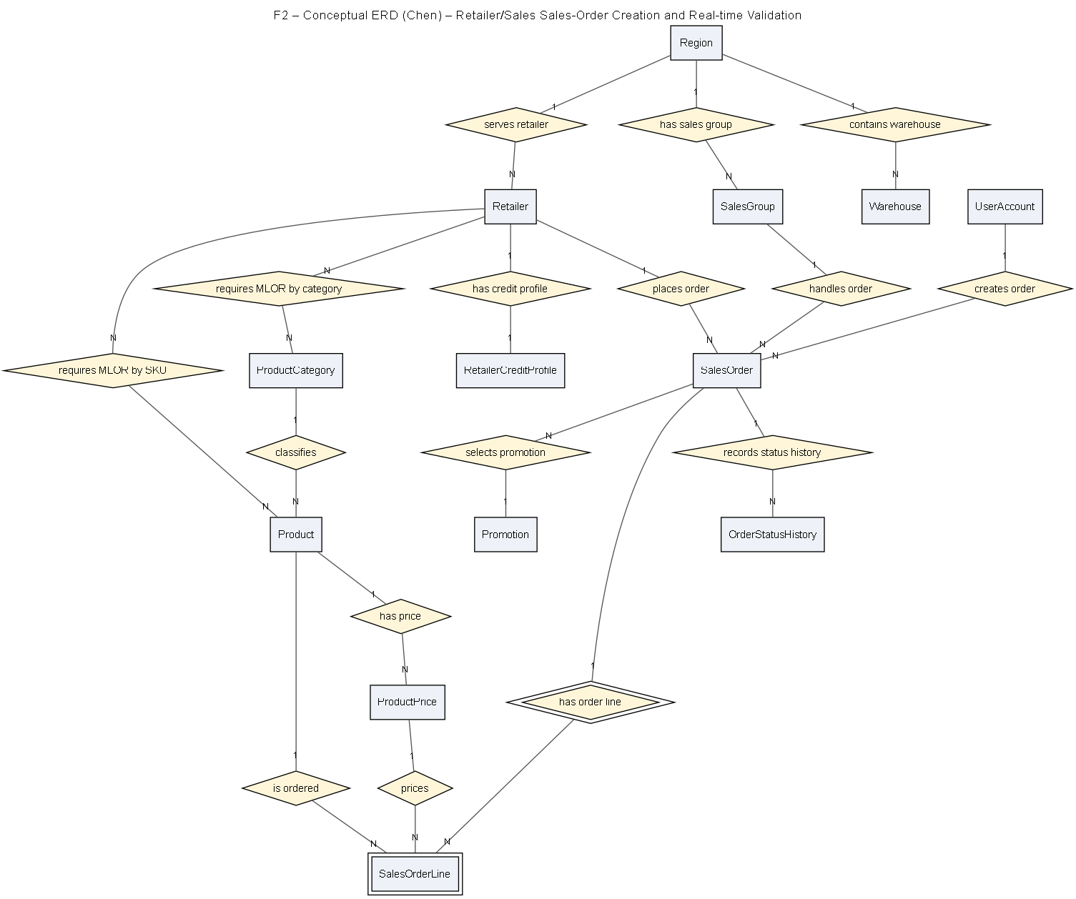
Figure 4.4. Sales Order Creation Conceptual Entity Relationship Diagram

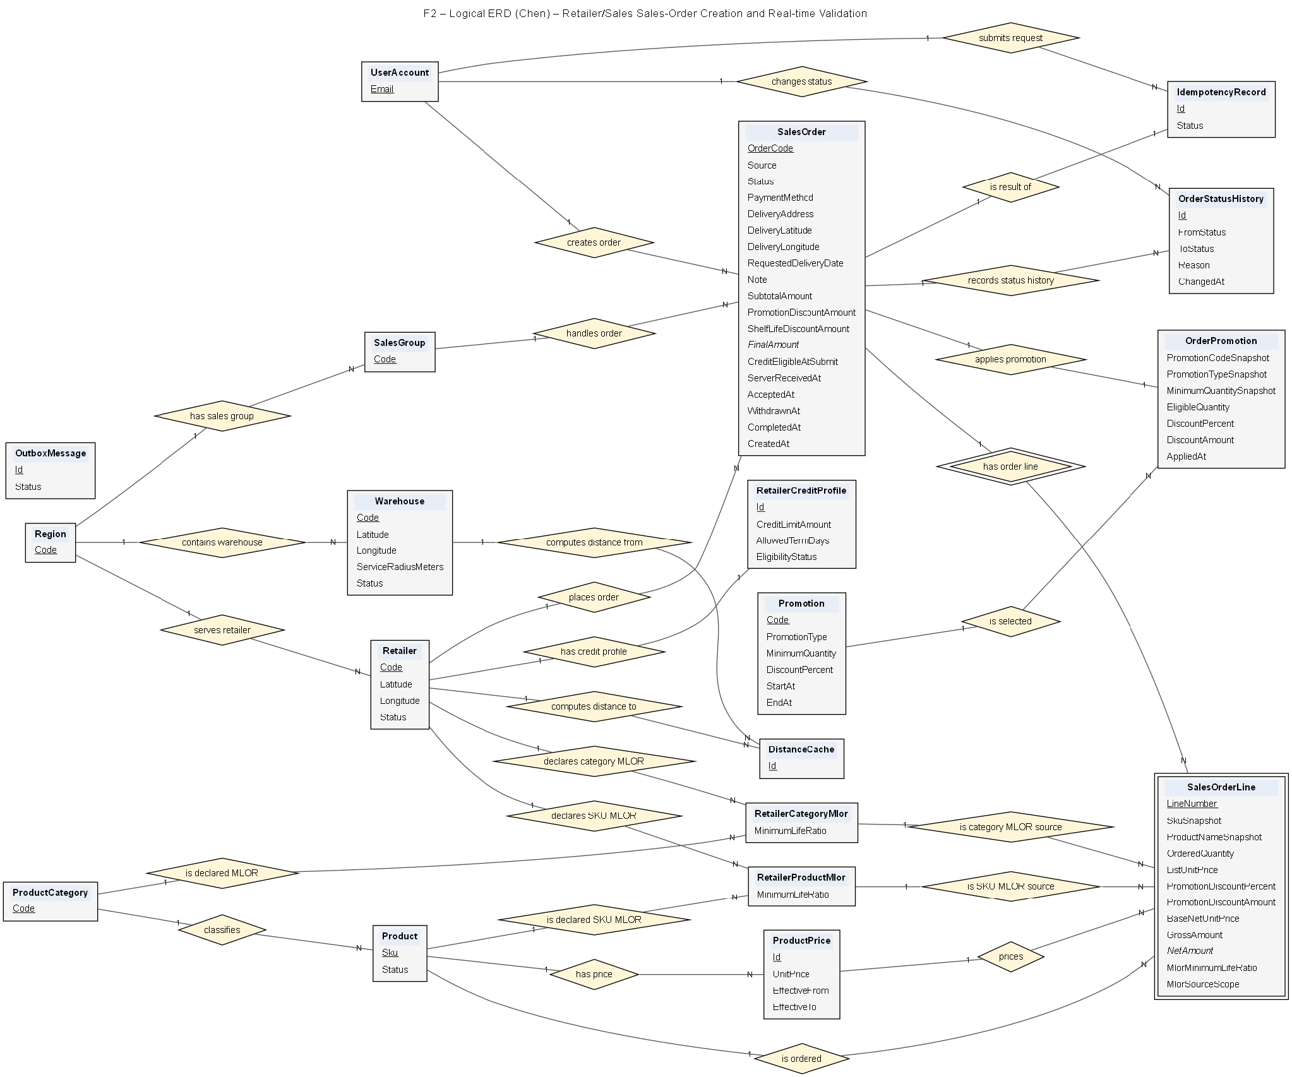
Figure 4.5. Sales Order Creation Logical Entity Relationship Diagram

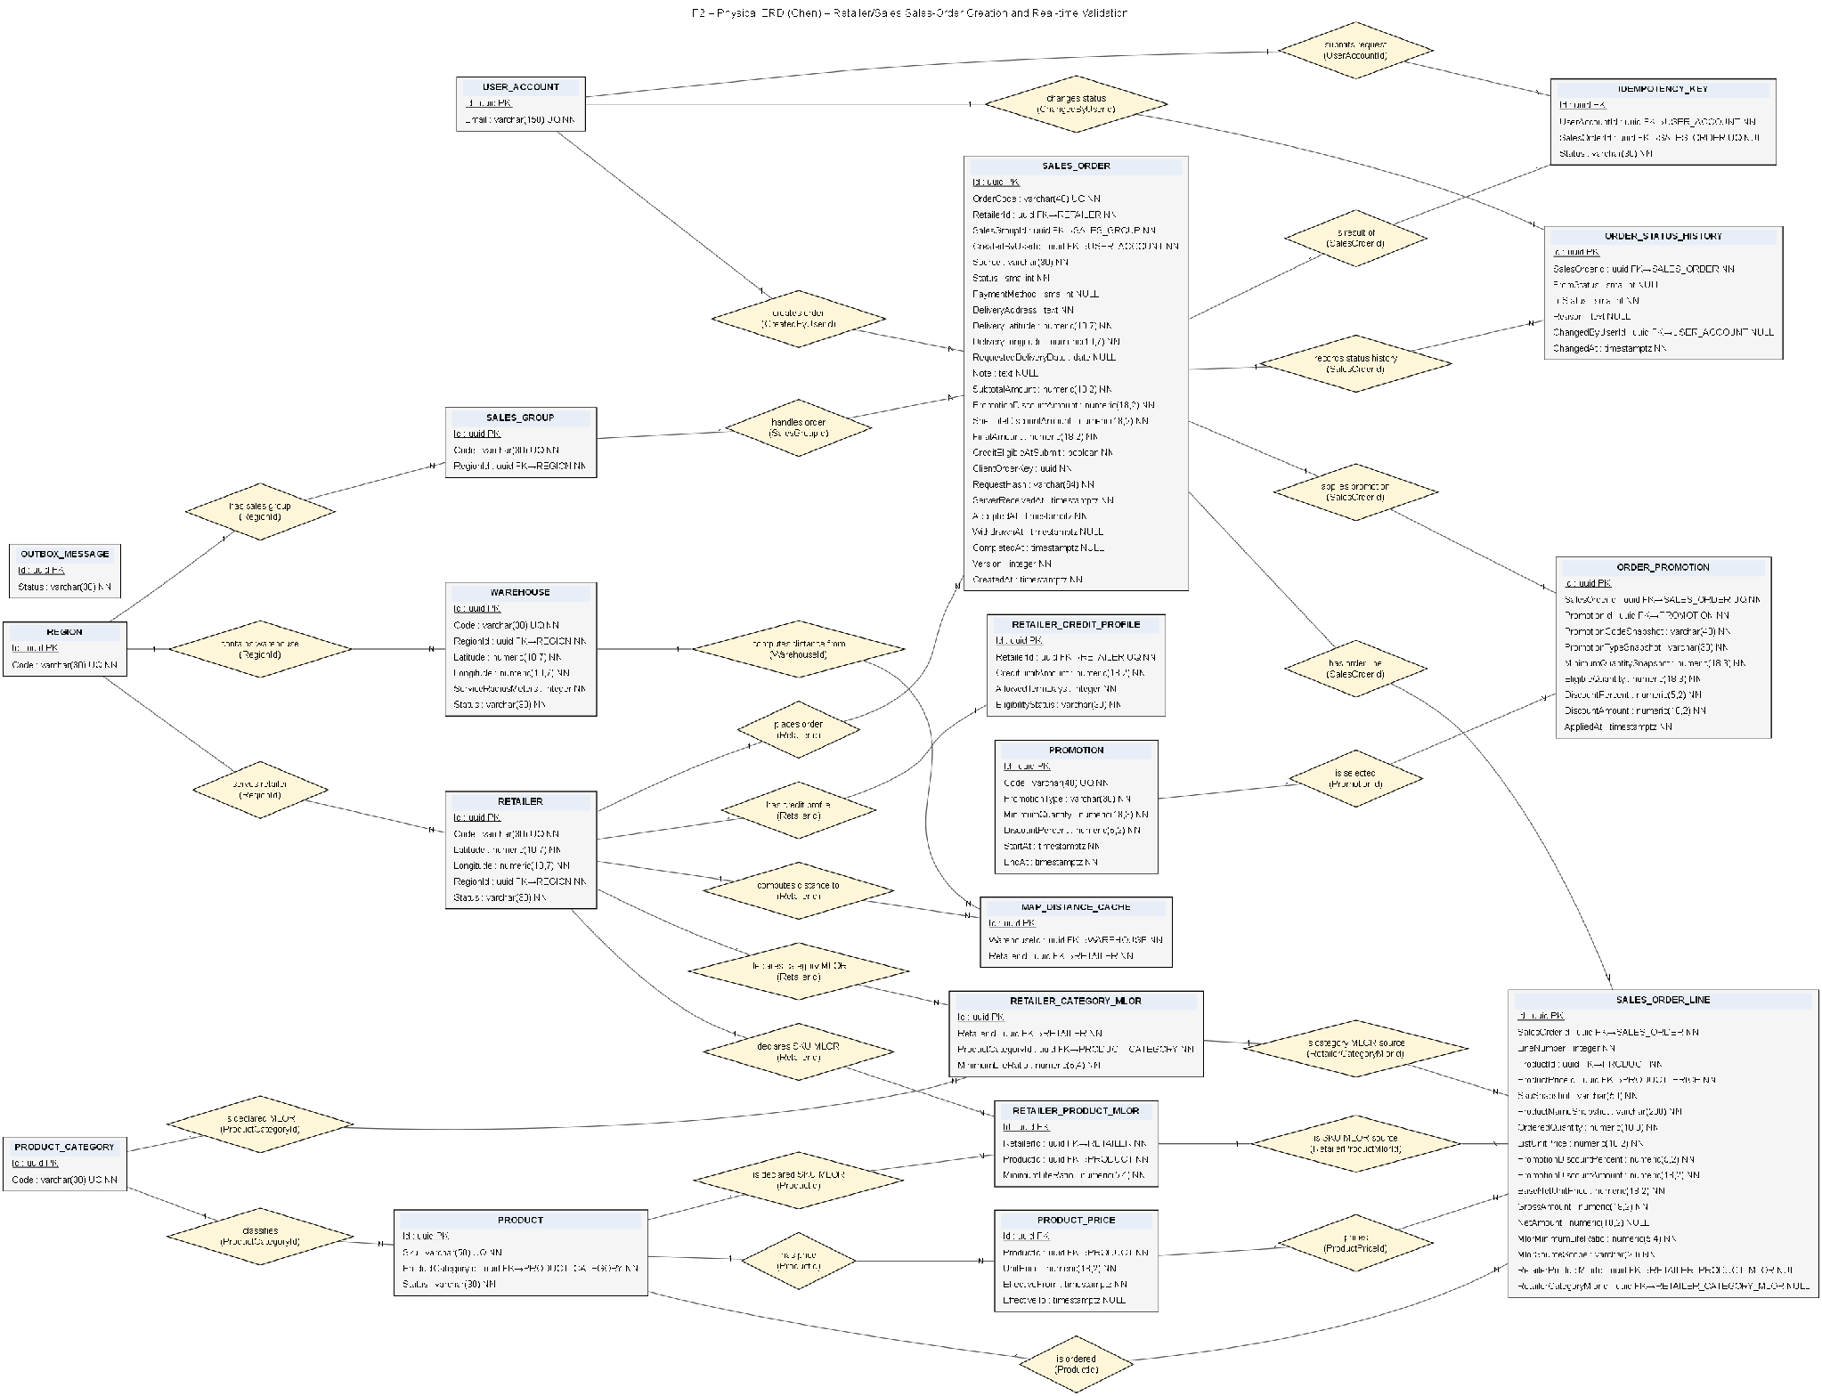
Figure 4.6. Sales Order Creation Physical Entity Relationship Diagram

Table 3.1.5.2. Sales Order Creation entity descriptions
# | Entity | Description
1 | SalesOrder | Represents a sales order with retailer, sales group, creating user, warehouse scope, status, timestamps and totals.
2 | SalesOrderLine | A line of a sales order capturing product, quantity, the selected promotion snapshot, resolved price, effective MLOR and its source.
3 | OrderPromotion | Records a promotion applied to a sales order, preserving the promotion and its effect for audit.
4 | OrderStatusHistory | Keeps the chronological status transitions of a sales order with actor and timestamp.
5 | IdempotencyKey | Stores an idempotency key so repeated order-submission requests are processed exactly once.
6 | OutboxMessage | Buffers a domain event for reliable asynchronous dispatch using the outbox pattern.
7 | MapDistanceCache | Caches computed distances between locations to avoid repeated map-service calls during ordering.
8 | Retailer | Represents a retailer with type, store-size category, purchasing capacity, address, region, contacts and review state.
9 | Product | Represents a sellable SKU referenced by order lines for pricing and MLOR validation.
10 | ProductPrice | Supplies the effective unit price used when an order line is priced.
11 | Promotion | Supplies quantity-promotion terms that may apply to order lines at ordering time.
12 | RetailerProductMlor | Supplies the retailer's per-product minimum shelf-life ratio enforced when validating order lines.
13 | RetailerCategoryMlor | Supplies the retailer's per-category minimum shelf-life ratio enforced when validating order lines.
14 | RetailerCreditProfile | Supplies credit limit and eligibility used to validate credit-based orders at submission.

3.1.5.3 Allocation

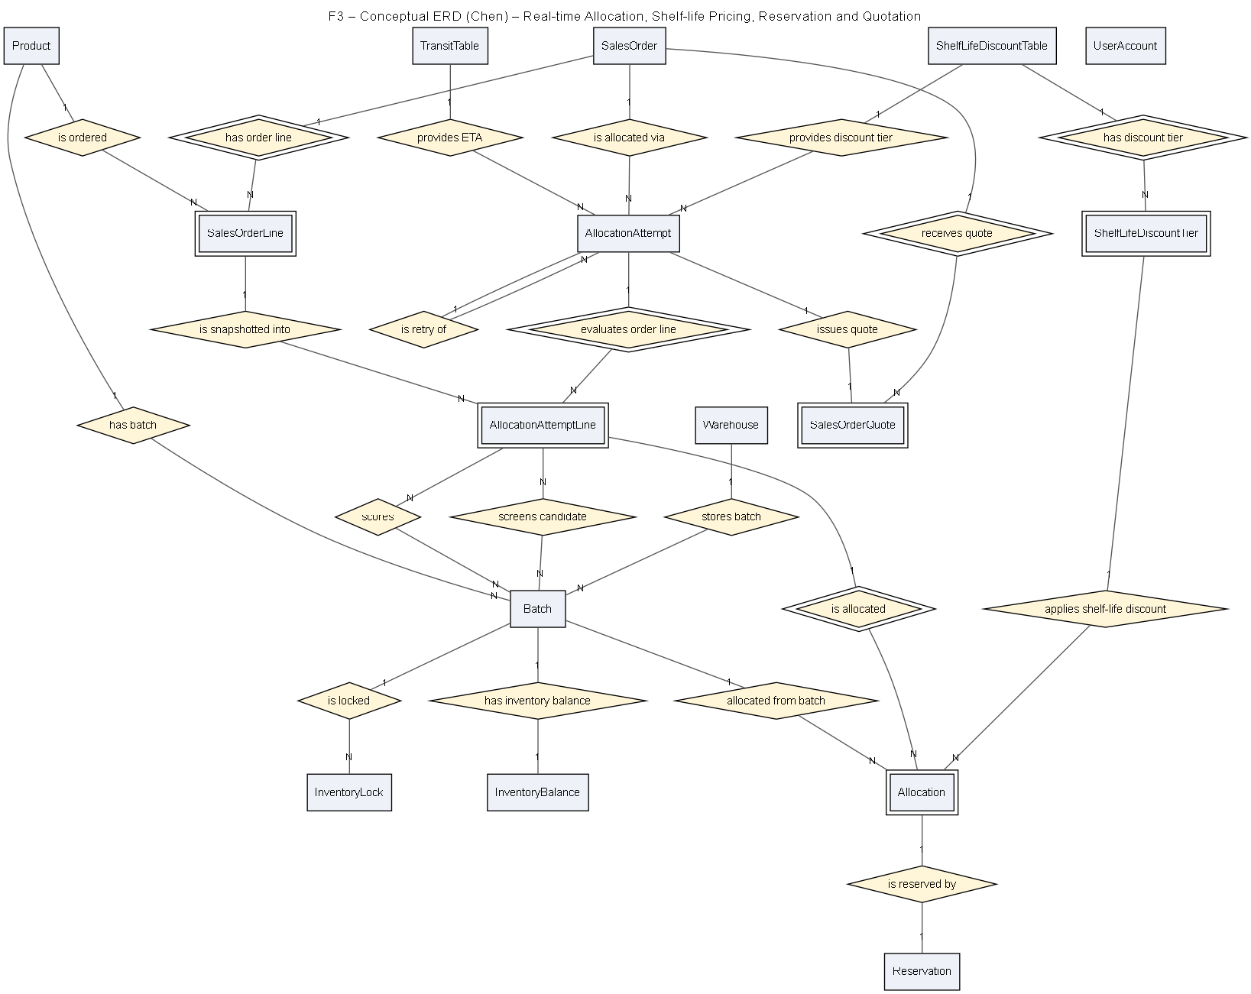
Figure 4.7. Allocation Conceptual Entity Relationship Diagram

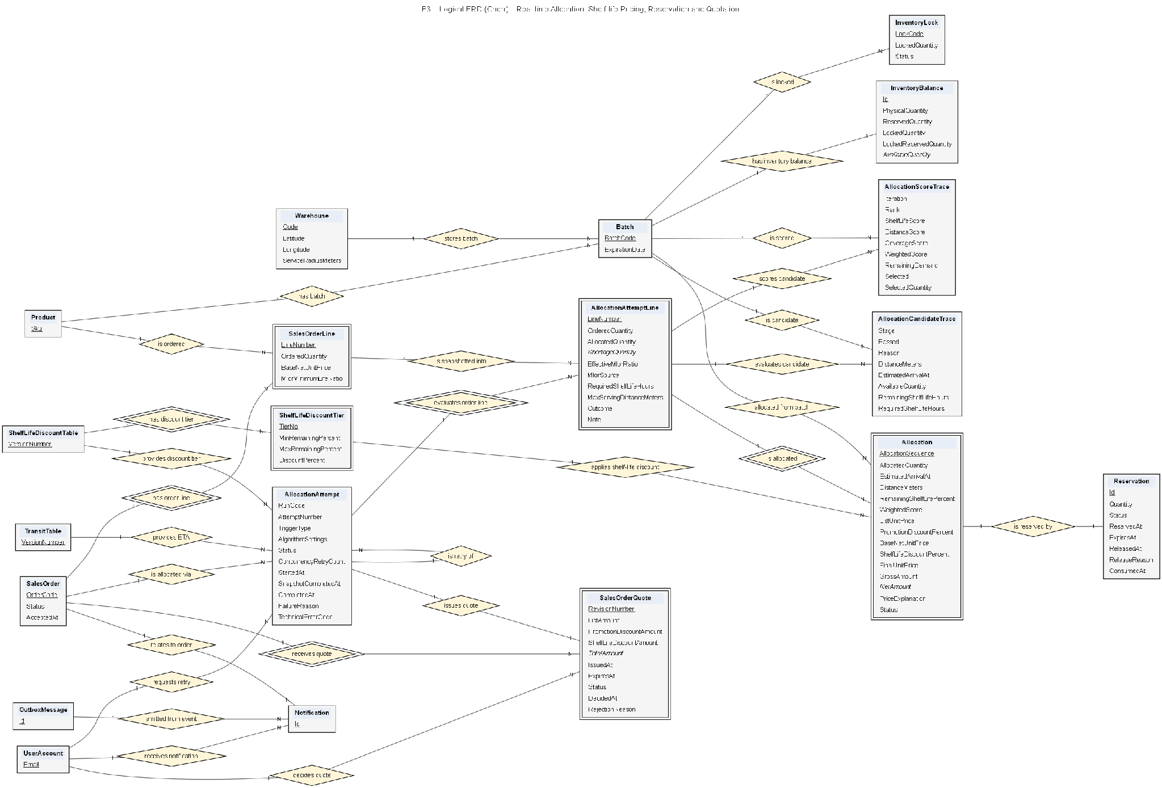
Figure 4.8. Allocation Logical Entity Relationship Diagram

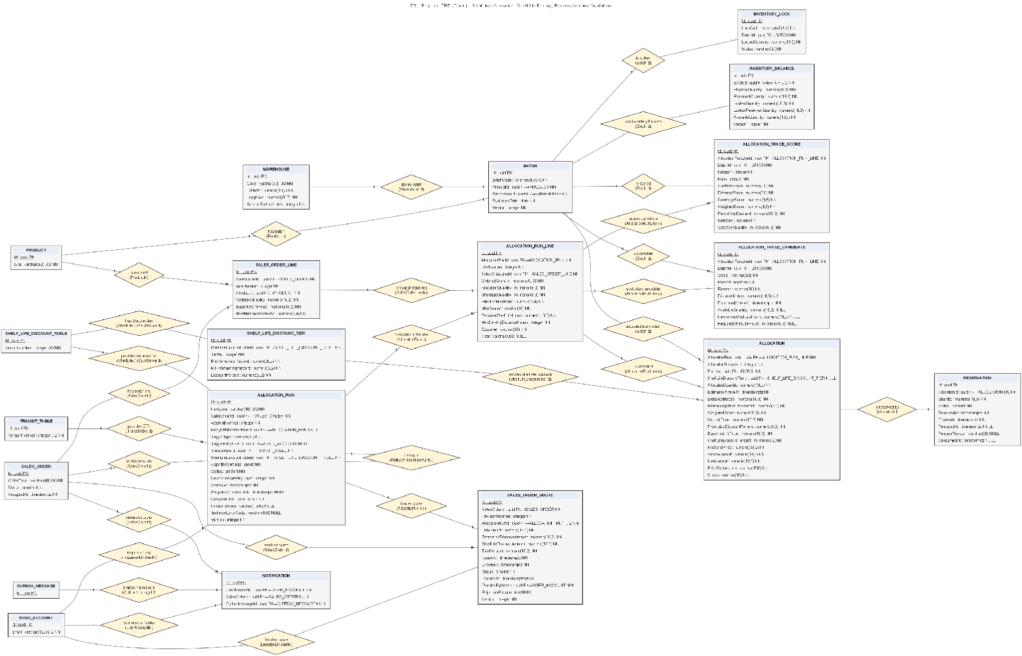
Figure 4.9. Allocation Physical Entity Relationship Diagram

Table 3.1.5.3. Allocation entity descriptions
# | Entity | Description
1 | AllocationRun | Represents one allocation attempt of one sales order: SalesOrderId, AttemptNumber, RetryOf, Status (Processing, Succeeded, OutOfStock, Conflict, TechnicalFailed), AlgorithmSettings snapshot and timestamps.
2 | AllocationRunLine | Snapshots an order line within an allocation attempt including product, demand, resolved price, MLOR.
3 | AllocationTraceCandidate | Records a candidate warehouse-batch considered for an attempt line during allocation, preserving selection context.
4 | AllocationTraceScore | Records the scoring factors applied to a candidate so the allocation decision for each line can be explained.
5 | Allocation | Records a quantity assigned from one batch and warehouse to an attempt line, preserving selection sequence, score and the final allocation price.
6 | Reservation | Records a stock commitment against an allocation fragment and batch, with quantity, reservation and release times and status.
7 | SalesOrderQuote | Represents a quotation revision for an order and allocation proposal, with total amount, issue and expiry times and acceptance details.
8 | Notification | Represents a notification raised by an allocation attempt (for example quotation issued, allocation failed or payment confirmed) delivered to the relevant roles.
9 | SalesOrder | The order being allocated; supplies retailer, warehouse scope and status consumed by the allocation attempt.
10 | SalesOrderLine | The order lines whose demand the attempt allocates against available batches.
11 | Batch | Supplies the stock units, production and expiration dates the attempt allocates from.
12 | InventoryBalance | Supplies available quantity per batch that the attempt consumes when reserving stock.
13 | InventoryLock | Excludes locked quantities from the available pool during allocation.
14 | TransitTable | Supplies distance-band transit days used to evaluate delivery feasibility during allocation.
15 | ShelfLifeDiscountTable | Supplies the versioned discount tiers used to compute shelf-life discount pricing during allocation.
16 | ShelfLifeDiscountTier | Supplies the remaining shelf-life percent ranges and discounts applied to allocated batches.

3.1.5.4 Purchase Order and Shipment

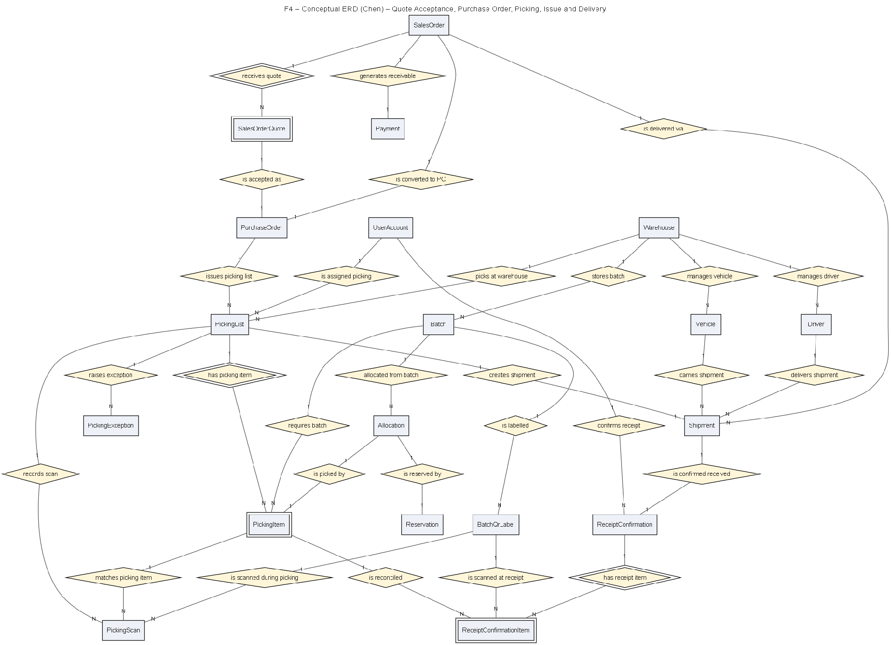
Figure 4.10. Purchase Order and Shipment Conceptual Entity Relationship Diagram

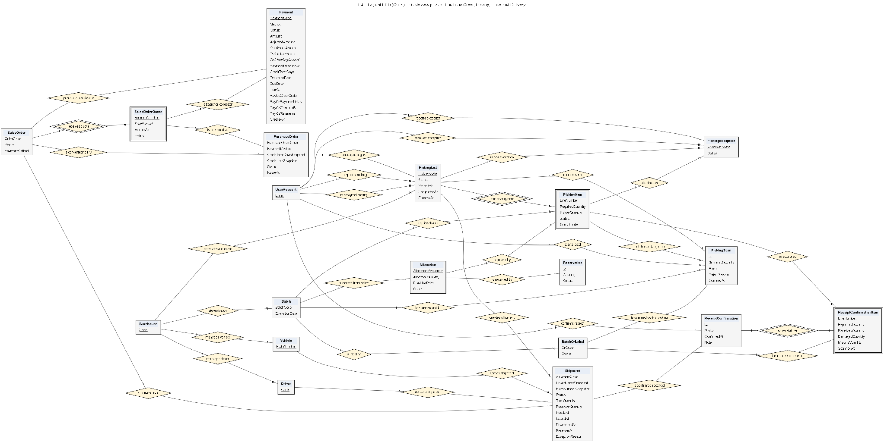
Figure 4.11. Purchase Order and Shipment Logical Entity Relationship Diagram

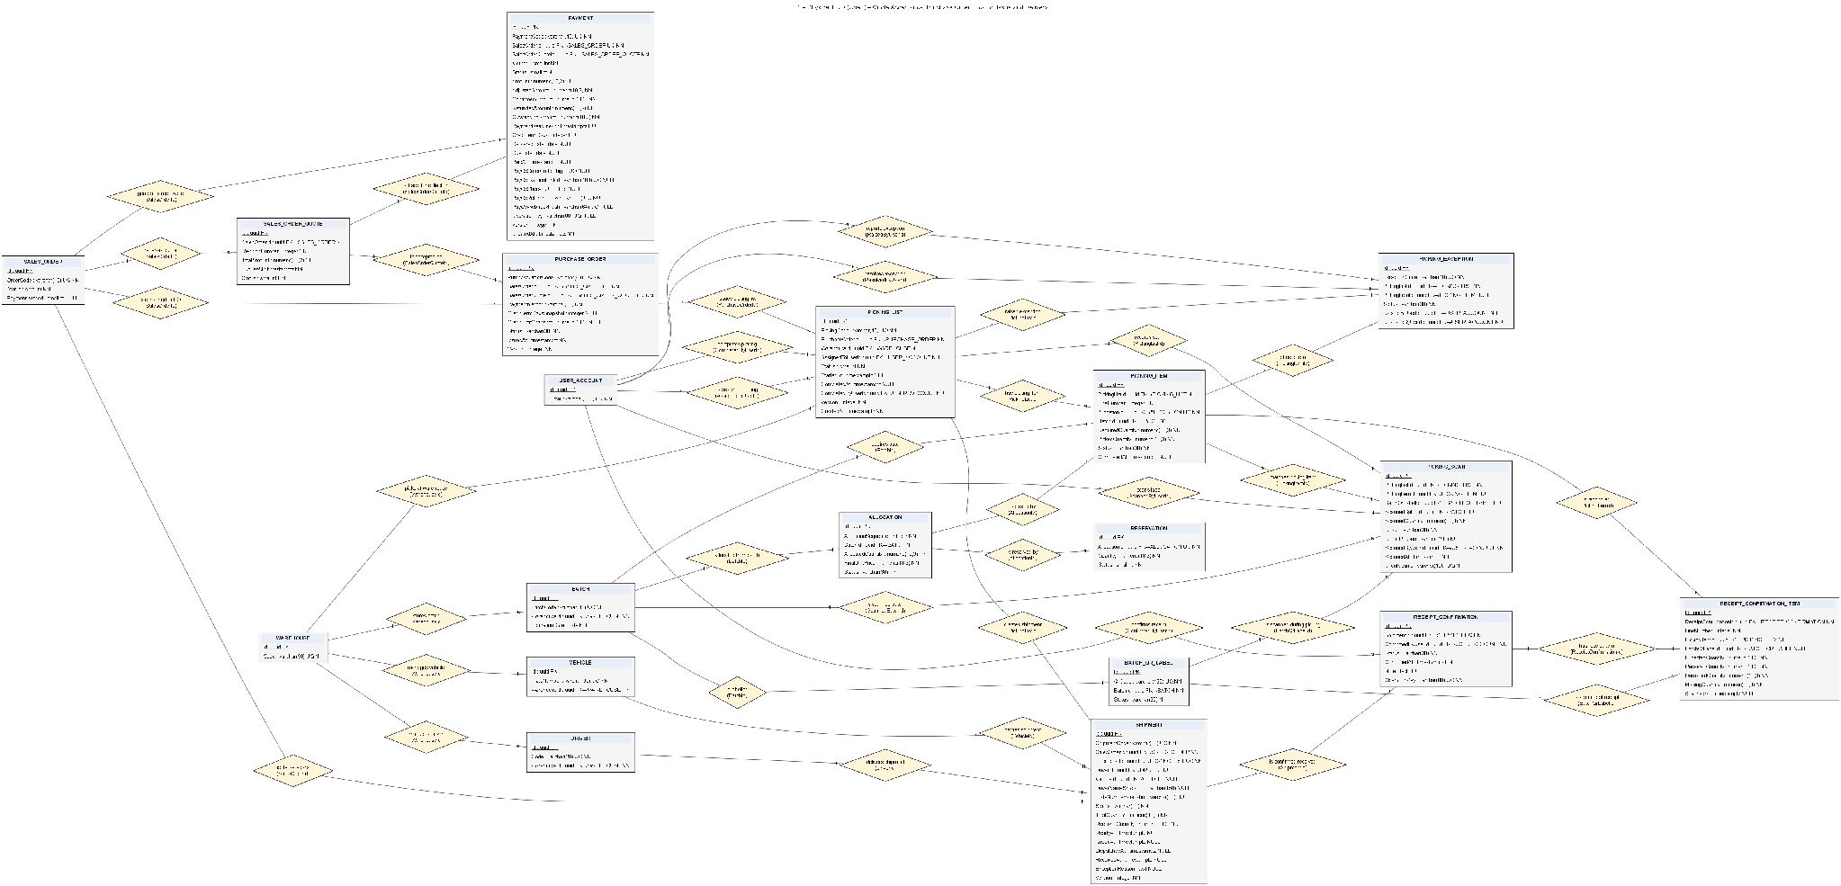
Figure 4.12. Purchase Order and Shipment Physical Entity Relationship Diagram

Table 3.1.5.4. Purchase Order and Shipment entity descriptions
# | Entity | Description
1 | PurchaseOrder | Represents the purchase order created when a retailer accepts a quotation, carrying the order-warehouse portion and expected amount.
2 | Payment | Represents the order's payment obligation and approved allocation proposal, with amount, adjusted and confirmed amounts and method.
3 | PickingList | Represents a warehouse picking document for a purchase order, storing assignment, issue, start and completion details.
4 | PickingItem | Aggregates the quantity to gather for a product and batch on a picking list, with required and picked quantities.
5 | PickingScan | Records a QR scan performed during picking to verify the source batch and label.
6 | Shipment | Represents a warehouse portion of a sales order prepared from a picking list, with optional driver and vehicle assignment and dispatch state.
7 | ReceiptConfirmation | Records a retailer user's receipt confirmation for one shipment and sales order, with time, status and notes.
8 | ReceiptConfirmationItem | Identifies the batch and quantity acknowledged on a receipt confirmation.
9 | PickingException | Records a picking exception such as a shortage or damaged item raised during warehouse picking.
10 | Driver | Represents a delivery driver that can be assigned to shipments.
11 | Vehicle | Represents a delivery vehicle that can be assigned to shipments.
12 | SalesOrder | The order whose accepted quotation drives purchase-order and shipment creation.
13 | SalesOrderQuote | The accepted quotation revision that the purchase order is created from.
14 | Allocation | Supplies the batch-warehouse assignments and final prices consumed when picking and shipping.
15 | Reservation | Supplies the stock commitments released as items are picked and shipped.
16 | Batch | Supplies the physical batches picked and loaded into shipments.
17 | BatchQrLabel | Supplies the QR labels scanned during picking and receipt confirmation.

3.1.5.5 Finance and Loyalty

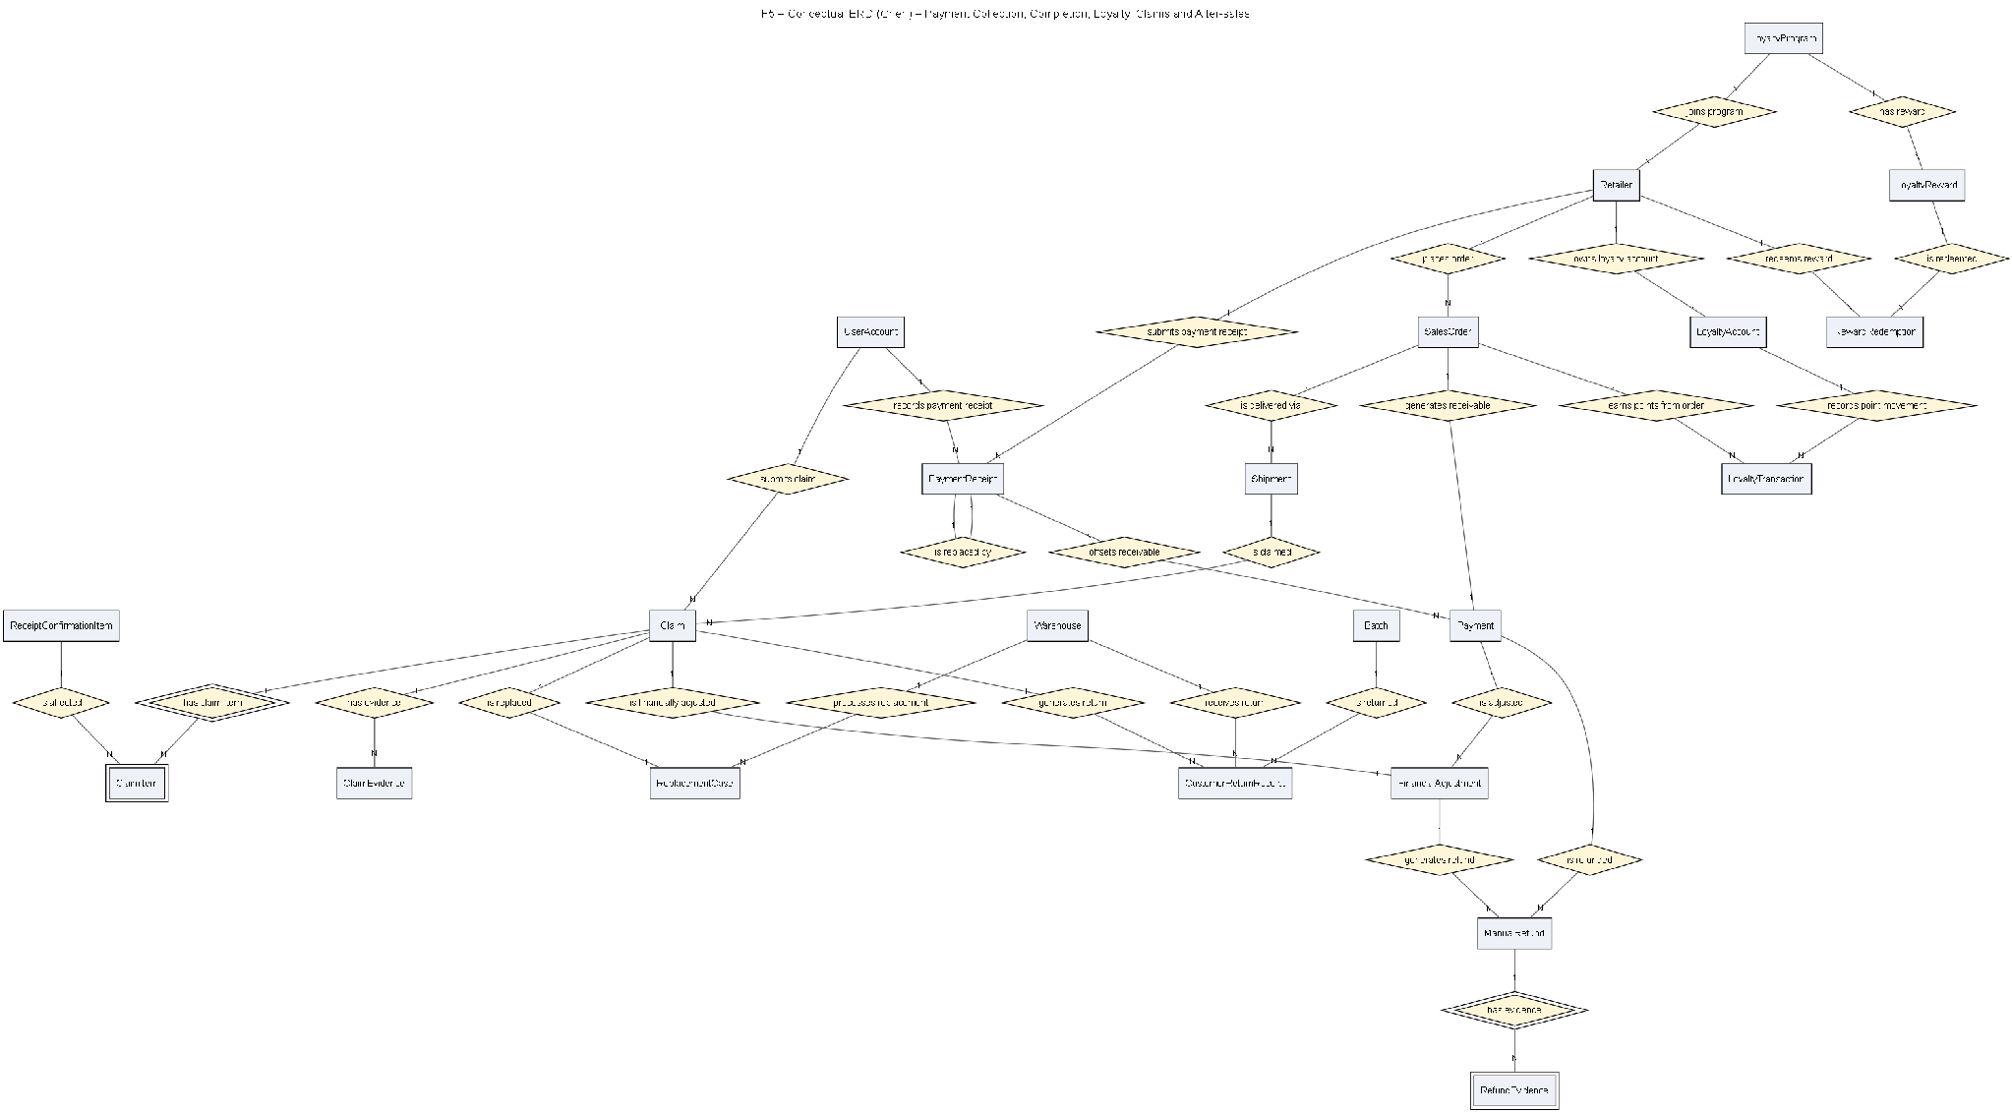
Figure 4.13. Finance and Loyalty Conceptual Entity Relationship Diagram

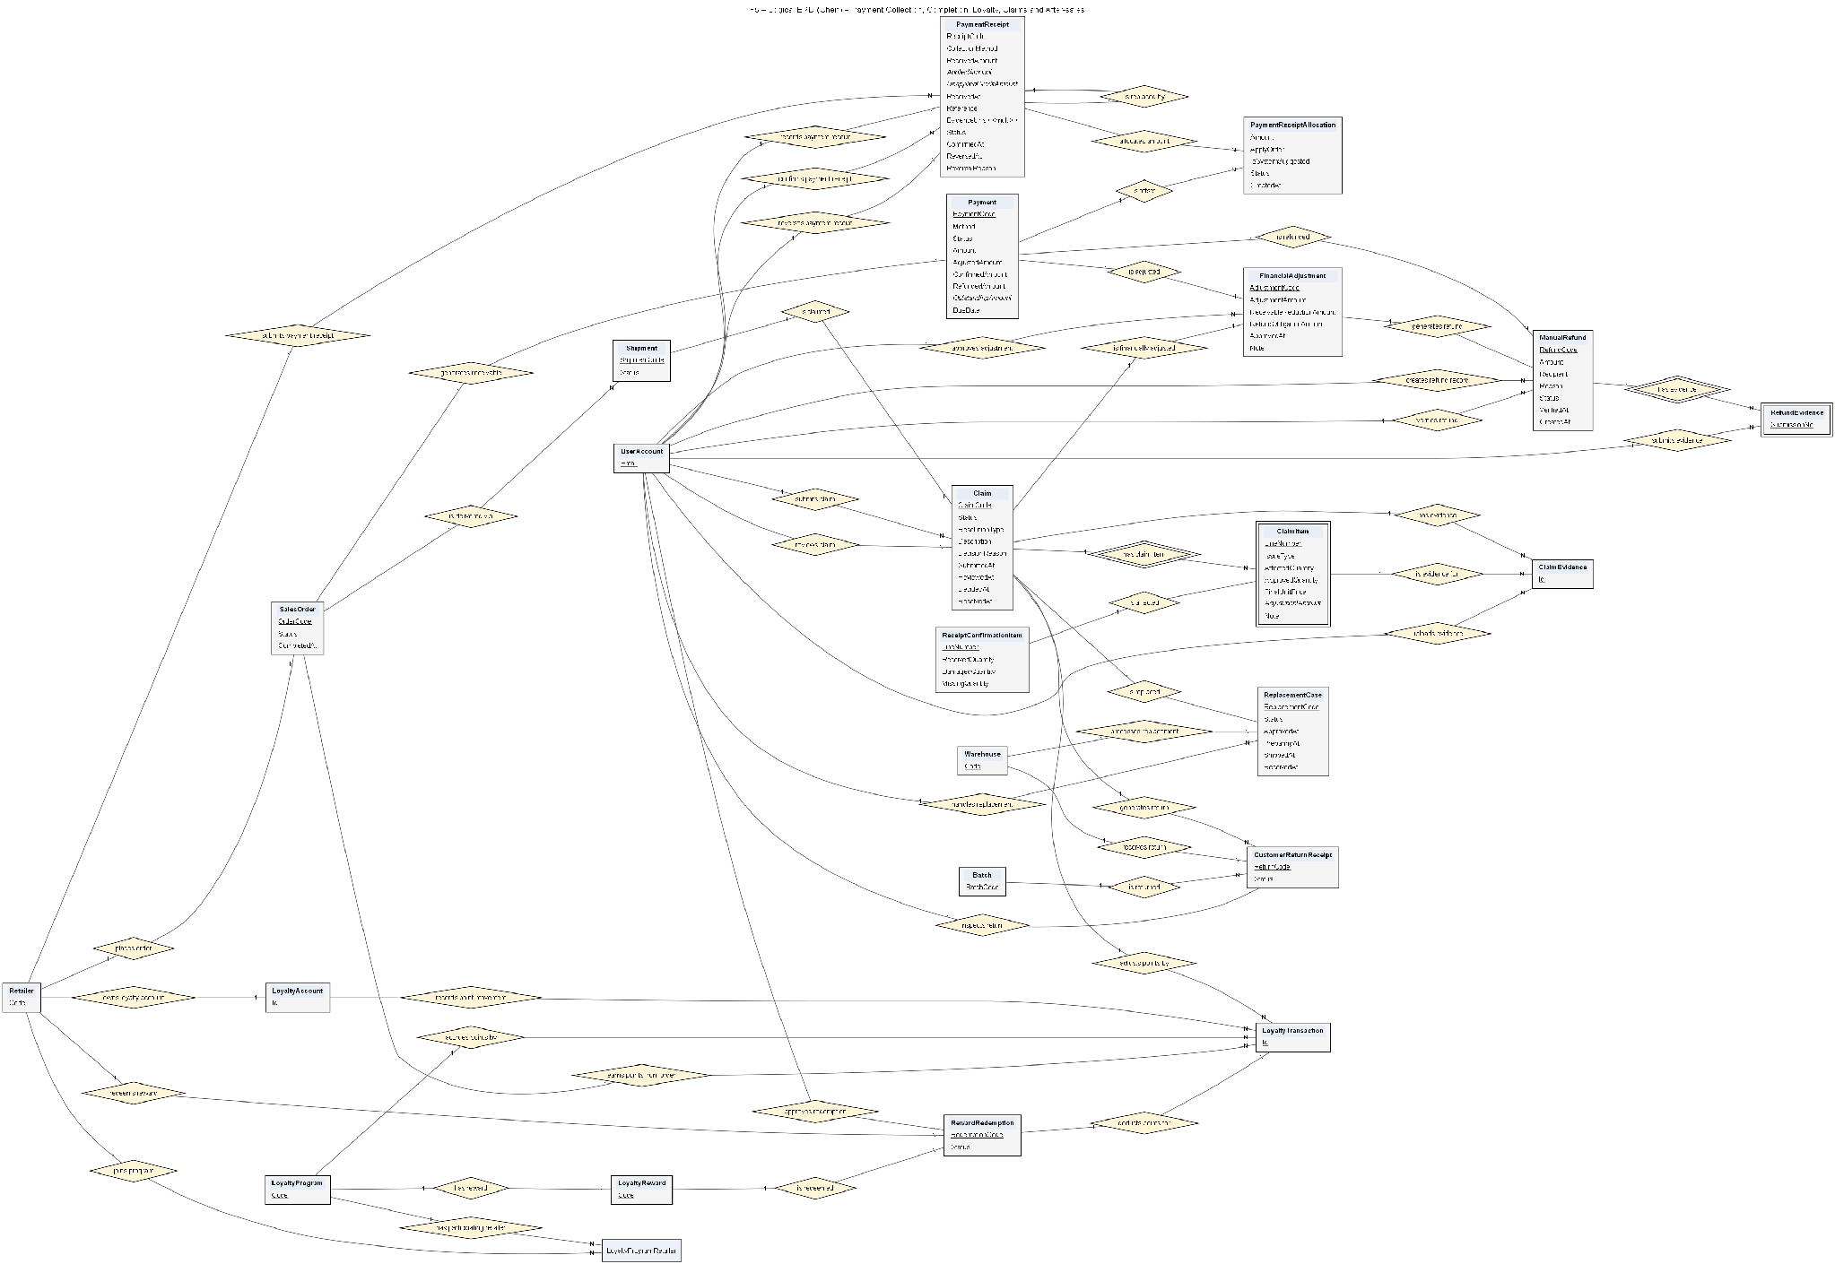
Figure 4.14. Finance and Loyalty Logical Entity Relationship Diagram

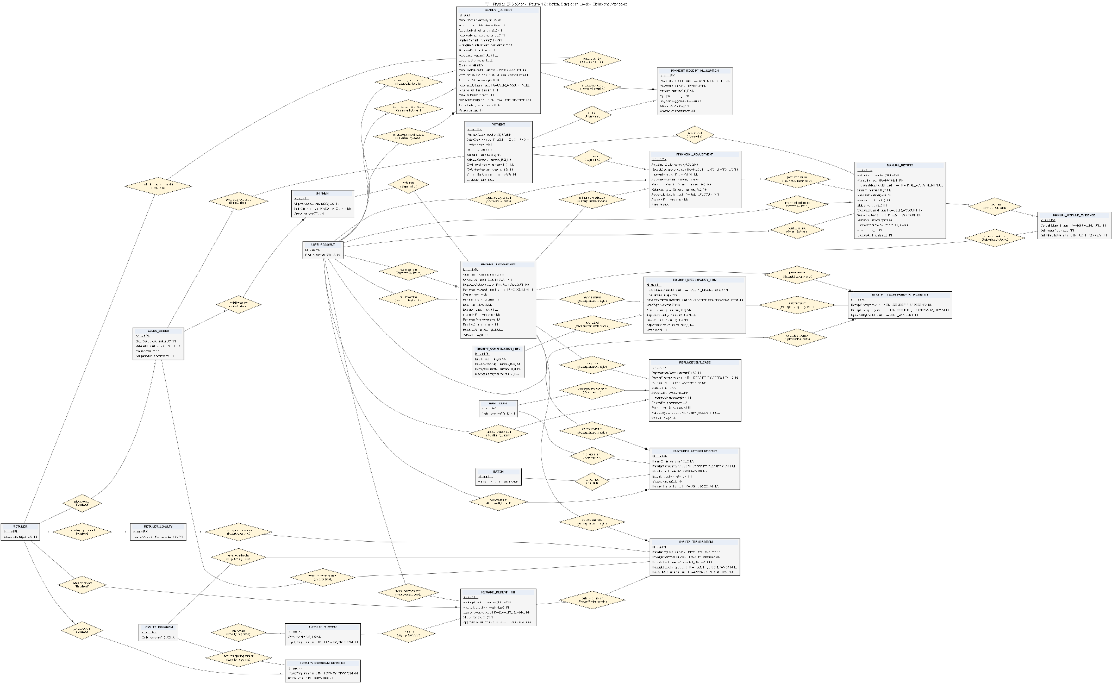
Figure 4.15. Finance and Loyalty Physical Entity Relationship Diagram

Table 3.1.5.5. Finance and Loyalty entity descriptions
# | Entity | Description
1 | PaymentReceipt | Records a received payment against one or more orders, with amount, method, transaction reference and evidence.
2 | PaymentReceiptAllocation | Allocates a payment receipt amount to a specific payment obligation, supporting part-payments across orders.
3 | ReceiptDiscrepancy | Represents a retailer complaint for an order and receipt confirmation, with reporting and reviewing users, status and resolution.
4 | ReceiptDiscrepancyItem | Identifies an affected batch in a complaint with expected and actual quantities, issue type, evidence and notes.
5 | ReceiptDiscrepancyAttachment | Stores an evidence attachment (photo or document) supporting a receipt discrepancy.
6 | FinancialAdjustment | Records a financial adjustment for an accepted complaint item, preserving accepted quantity, amount and the payment affected.
7 | ReplacementCase | Tracks a replacement decision for an accepted complaint, including the replacement order or shipment it triggers.
8 | ManualRefund | Tracks a manual refund through creation, external transfer, evidence submission and verification, referencing the payment and order.
9 | ManualRefundEvidence | Stores an evidence attachment for a manual refund's external transfer.
10 | CustomerReturnReceipt | Records goods returned by a retailer as part of a complaint or replacement resolution.
11 | LoyaltyProgram | Defines a loyalty program with earn and redeem rules and validity.
12 | LoyaltyProgramRetailer | Associates a retailer with a loyalty program.
13 | RetailerLoyalty | Stores a retailer's current and held loyalty points and lifetime earned and redeemed totals, uniquely per retailer.
14 | LoyaltyTransaction | Preserves an auditable earn or redeem entry in the loyalty ledger with amount, reason and resulting balance.
15 | LoyaltyReward | Defines a redeemable loyalty reward or gift with its point cost and availability.
16 | RewardRedemption | Records a retailer's redemption request for a reward, with status through held, used or released.
17 | Payment | The payment obligation reconciled by receipts, adjustments and refunds.
18 | SalesOrder | The order whose receivables, complaints and refunds are processed in this flow.
19 | Retailer | The retailer whose payments, complaints, refunds and loyalty are managed.
20 | Shipment | The shipment referenced by complaints and returns for traceability.
21 | ReceiptConfirmationItem | The confirmed batch and quantity referenced when validating complaints.
22 | Batch | The batch referenced by complaint items, returns and loyalty-affecting adjustments.

3.2 Authentication & User Account

3.2.1 Login with System Account
● Function type: Screen function (see 3.1.2).
● Function trigger:
o Open Login page (on the Mobile App, choose the Staff or Customer tab).
o Enter account credentials and select Login.
● Function description: Authenticates users before allowing access to role-specific FSCM functions.
● Screen layout: see Figures 6 – 7
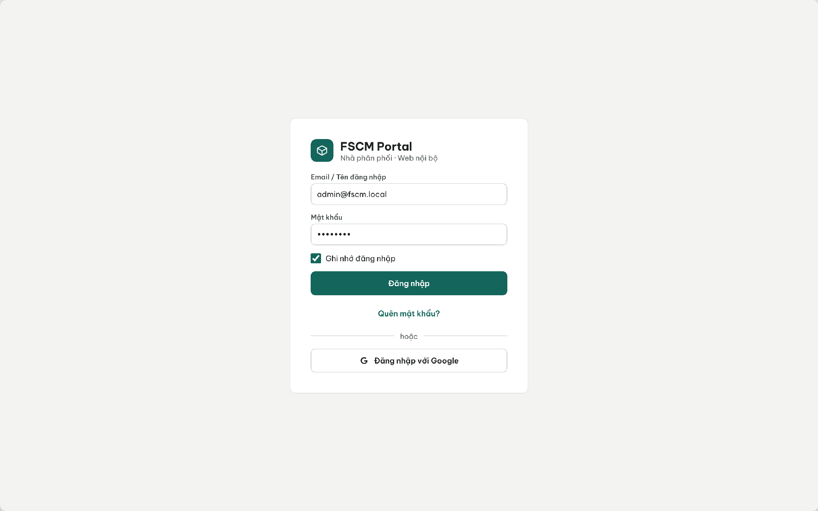
Figure 6. Web Portal – Login (system account or Google sign-in)
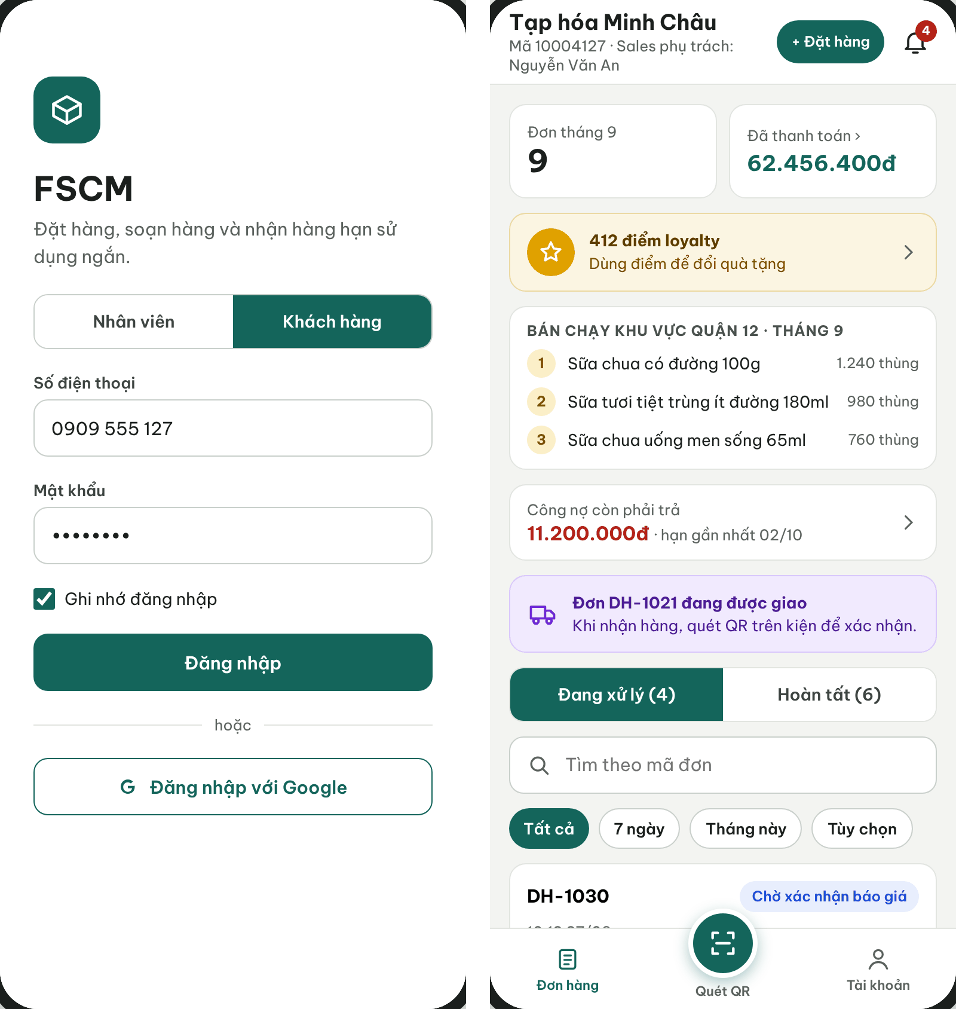
Figure 7. Mobile App – Staff/Customer login tabs and Retailer workspace opened after sign-in
● Function Details:
o Actors: Primary – Administrator, Operator, Sales Manager, Warehouse Keeper, Sales (email + password on the Web Portal or the Staff tab); Retailer (phone number + password on the Customer tab). System – Account Authentication, Retailer First-Login Verification (3.1.4).
o Fields:
▪ Web Portal and Staff tab of the Mobile App: email and password. Customer tab of the Mobile App: phone number and password.
o Data Processing:
▪ Validate credentials and account status through the configured authentication service.
▪ Load authorized role and data scope; open the corresponding interface (on the Mobile App, the Sales, Warehouse or Retailer part).
▪ Reject invalid or inactive credentials without granting access.
▪ On the Customer tab, a first sign-in with the issued password requires OTP verification and a password change before access.
o Business Rules:
▪ Permissions depend on the assigned role and warehouse/sales-area scope.
▪ Session policy (configurable defaults): access token 60 minutes; refresh token 8 hours sliding on the Web Portal and 7 days on the Mobile App; tokens are revoked when the account is deactivated or its password changes; 5 consecutive failed sign-ins lock the account for 15 minutes (MSG004, MSG005, MSG007). Google sign-in is specified in 3.2.2 and is not available on the Customer tab.
o Acceptance Criteria:
AC ID | Acceptance criterion (Given / When / Then) | Ref.
AC-3.2.1-01 | Given an Active staff account, when the user enters the correct email and password, then the system opens only the workspace and data scope of that role within 2 s (NFR-P02). | BR-01, BR-03
AC-3.2.1-02 | Given a wrong password or an inactive account, when the user selects Login, then access is denied with MSG004 or MSG005 and no token is issued. | MSG004, MSG005
AC-3.2.1-03 | Given 5 consecutive failed attempts within 15 minutes, when a sixth attempt is made, then the account is temporarily locked for 15 minutes even if the password is correct. | NFR-S03
AC-3.2.1-04 | Given a Retailer signing in on the Customer tab for the first time with the issued password, when the password is accepted, then the app requires a 6-digit OTP and a new password before any order data is shown. | 3.1.4 #5
AC-3.2.1-05 | Given a valid session, when the account is deactivated by the Administrator, then the next API call is rejected with MSG007 and the user is returned to Login. | BR-77
o Traceability: UC-37, UC-38 | BR-01, BR-03, BR-77 | CR-01, CR-24 | Screens: Login (Web Portal, Mobile App)

3.2.2 Login with Google Account
● Function type: Screen function (see 3.1.2).
● Function trigger:
o Open Login page.
o Select Sign in with Google.
o Choose a Google account in the Google sign-in pop-up.
● Function description: Allows a user to authenticate with a Google account (OpenID Connect) through a sign-in pop-up opened over the Login screen of the Web Portal and the Staff tab of the Mobile App.
● Screen layout: see Figure 8
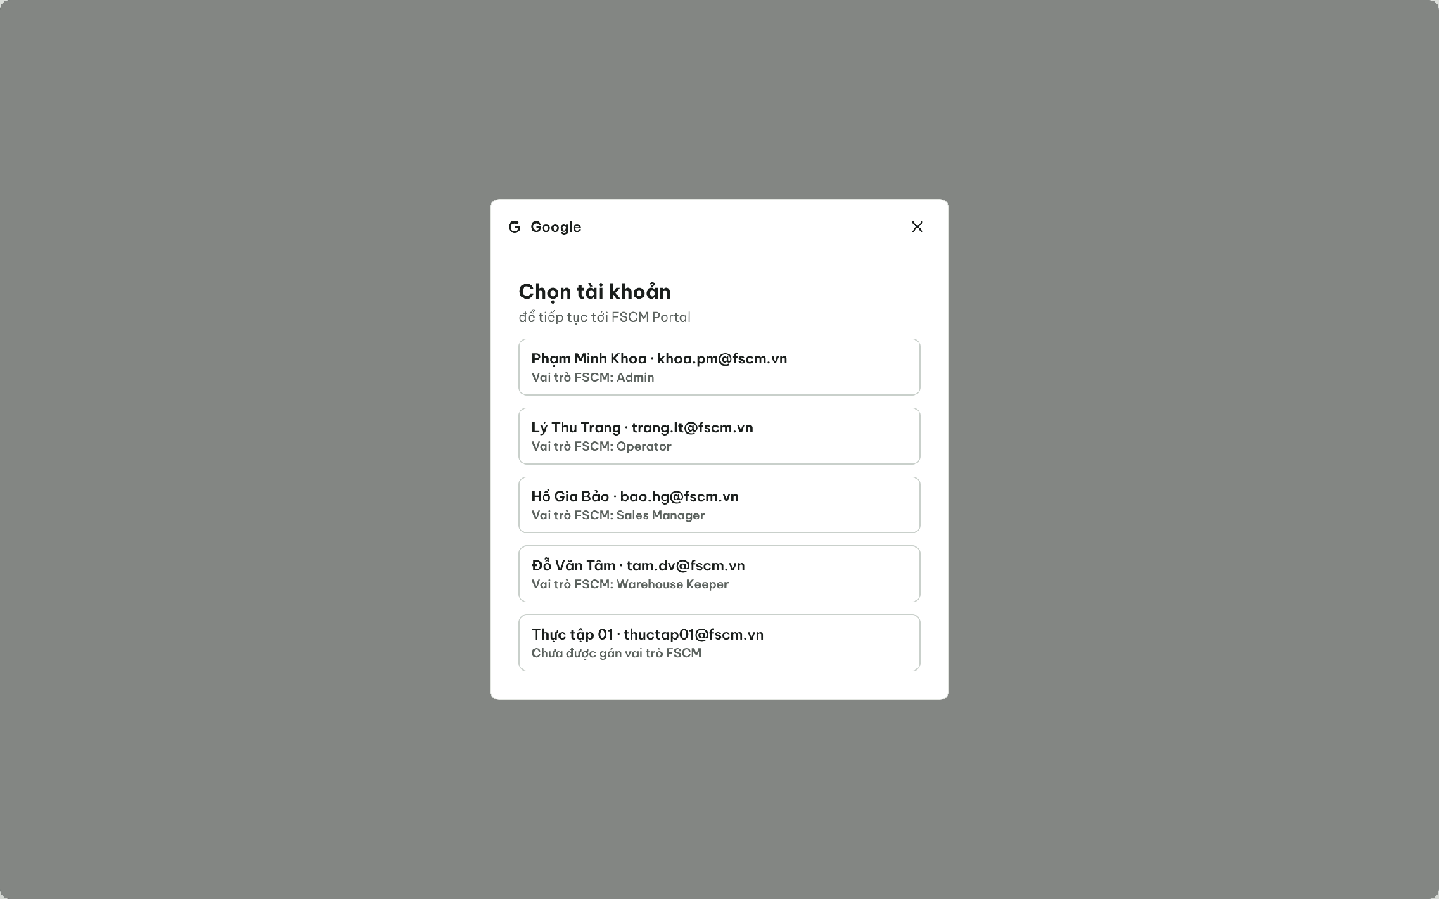
Figure 8. Google account pop-up opened over the Login screen
● Function Details:
o Actors: Primary – staff users (Administrator, Operator, Sales Manager, Warehouse Keeper, Sales). External – Google Identity (OIDC).
o Data Processing:
▪ Open the Google sign-in pop-up over the Login screen; the user chooses a Google account.
▪ Verify the Google ID token (signature, issuer, audience, expiry) and link it to an eligible FSCM user account.
▪ On success, close the pop-up, load the authorized role and data scope and open the corresponding interface.
▪ Deny access if no permitted user account or role exists for that application; the error is shown in the pop-up with Choose another account and Close.
o Business Rules:
▪ Supported method is listed in UC-39.
▪ Account linking: the verified Google e-mail must match (case-insensitively) the e-mail of an existing Active FSCM account; the first successful match stores the Google subject ID on that account. No just-in-time provisioning – an unmatched identity is denied (MSG006) and nothing is created.
o Acceptance Criteria:
AC ID | Acceptance criterion (Given / When / Then) | Ref.
AC-3.2.2-01 | Given a Google account whose email matches an Active staff account, when the user chooses it in the pop-up, then the pop-up closes and the workspace of the linked role opens. | BR-01
AC-3.2.2-02 | Given a Google account with no matching Active FSCM account, when the user chooses it, then access is denied in the pop-up with Choose another account and Close, and no FSCM account is created. | BR-02, BR-77
AC-3.2.2-03 | Given a Google ID token with an invalid signature, issuer or audience, when it is returned to FSCM, then the token is rejected and the attempt is logged. | NFR-S01
AC-3.2.2-04 | Given the Customer tab of the Mobile App, when the Login screen is shown, then the Google option is shown only if the team confirms Google sign-in for Retailers. | BR-04
o Traceability: UC-37, UC-39 | BR-01, BR-02, BR-77 | CR-01, CR-24 | Screens: Login, Google pop-up

3.2.3 Manage User Accounts
● Function type: Screen function (see 3.1.2).
● Function trigger:
o Open User Management.
o Select Create, View, Update or Delete/Deactivate.
● Function description: Maintains system user accounts subject to role-based creation restrictions.
● Screen layout: see Figures 9 – 10
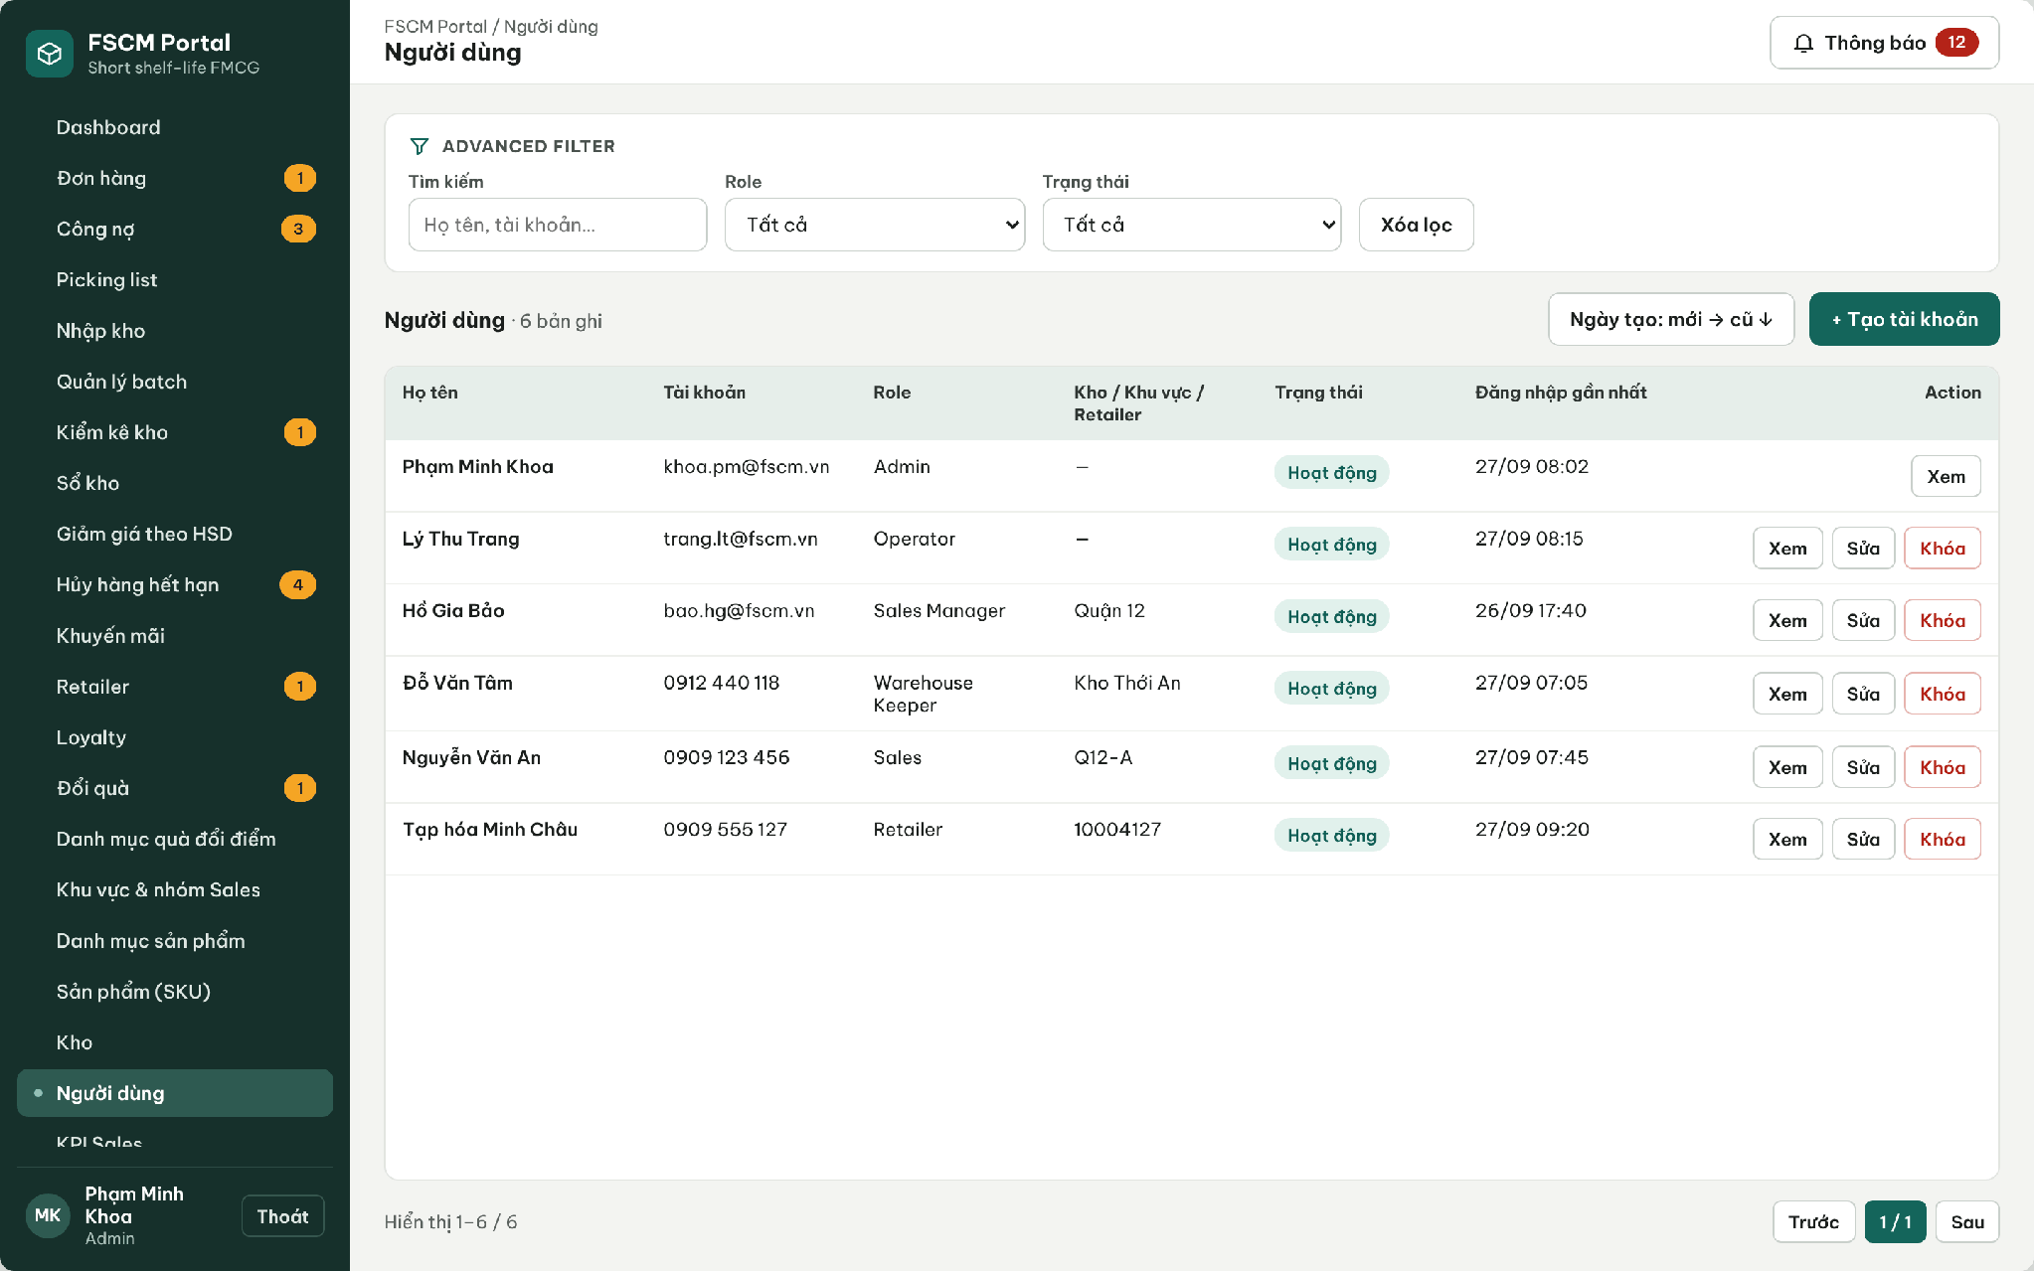
Figure 9. User Management – account list with role and scope
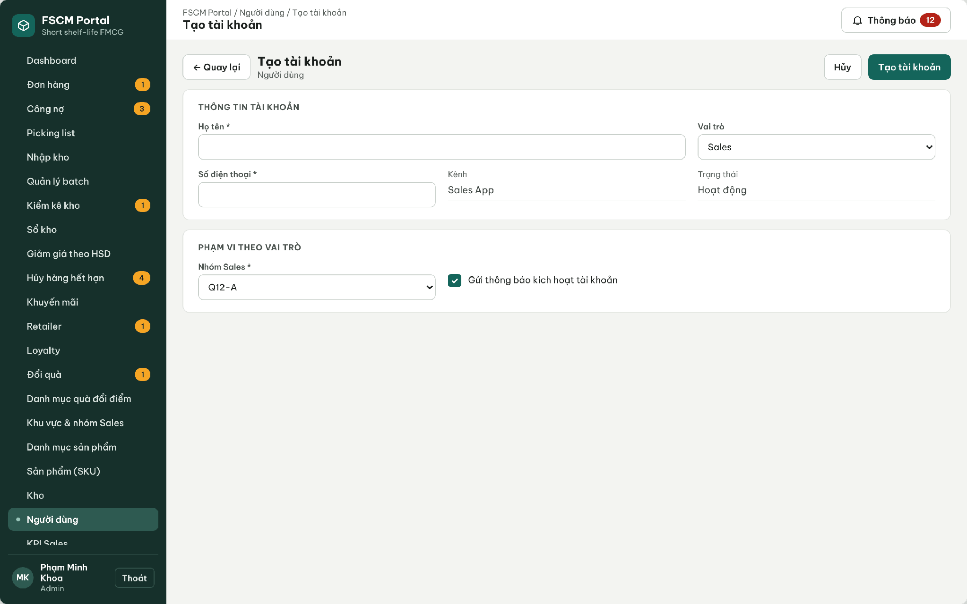
Figure 10. User Management – Create account (company Google account)
● Function Details:
o Actors: Primary – Administrator. System – Retailer Code Assignment (creates Retailer accounts on approval, 3.3.2).
o Fields:
▪ User identity; assigned role; active status; authorized warehouse / sales scope when applicable.
o Data Processing:
▪ Validate the administrator permission and proposed role.
▪ Create or update permitted account fields and assignments.
▪ Enforce deactivation/deletion constraints; record critical actions.
o Business Rules:
▪ Administrators must not freely create restricted actor types without following their approved registration flow.
▪ Role matrix (BR-77): the Administrator may create Operator, Sales Manager, Warehouse Keeper and Sales accounts. Retailer accounts are created only by approving a retailer declaration (3.3.2). Administrator accounts are never created or assigned through the UI (BR-02). A Warehouse Keeper needs at least one warehouse, a Sales account exactly one sales group and a Sales Manager at least one region. An account referenced by any business record is deactivated (Locked), never deleted.
o Acceptance Criteria:
AC ID | Acceptance criterion (Given / When / Then) | Ref.
AC-3.2.3-01 | Given the Create account form, when the Administrator opens the Role list, then Administrator and Retailer are not selectable. | BR-02, BR-77
AC-3.2.3-02 | Given a Warehouse Keeper or Sales account without its required warehouse or sales group, when Save is selected, then the account is not created and MSG001 is shown. | BR-03
AC-3.2.3-03 | Given an account that has created or approved any order, receipt, payment or audit record, when Delete is requested, then the system offers only Deactivate and the history remains attributable. | BR-58, BR-77
AC-3.2.3-04 | Given a valid new staff account, when it is saved, then an activation SMS/e-mail is sent, the action is written to the audit log and the user must set a password at first sign-in. | BR-58
AC-3.2.3-05 | Given an API request from a non-Administrator to create a user, when it reaches the server, then it is rejected with MSG006 regardless of the UI. | CR-01, CR-02
o Traceability: UC-02, UC-54 – UC-57 | BR-01 – BR-03, BR-58, BR-77 | CR-01, CR-02, CR-21 | Screens: User Management

3.3 Retailer Registration & Assessment

3.3.1 Register Retailer and Collect Assessment
● Function type: Screen function (see 3.1.2).
● Function trigger:
o Open an assigned retailer/prospect workflow.
o Enter store details and assessment, then submit.
● Function description: Records retailer registration and prospect information collected by Sales for later review.
● Screen layout: see Figure 11
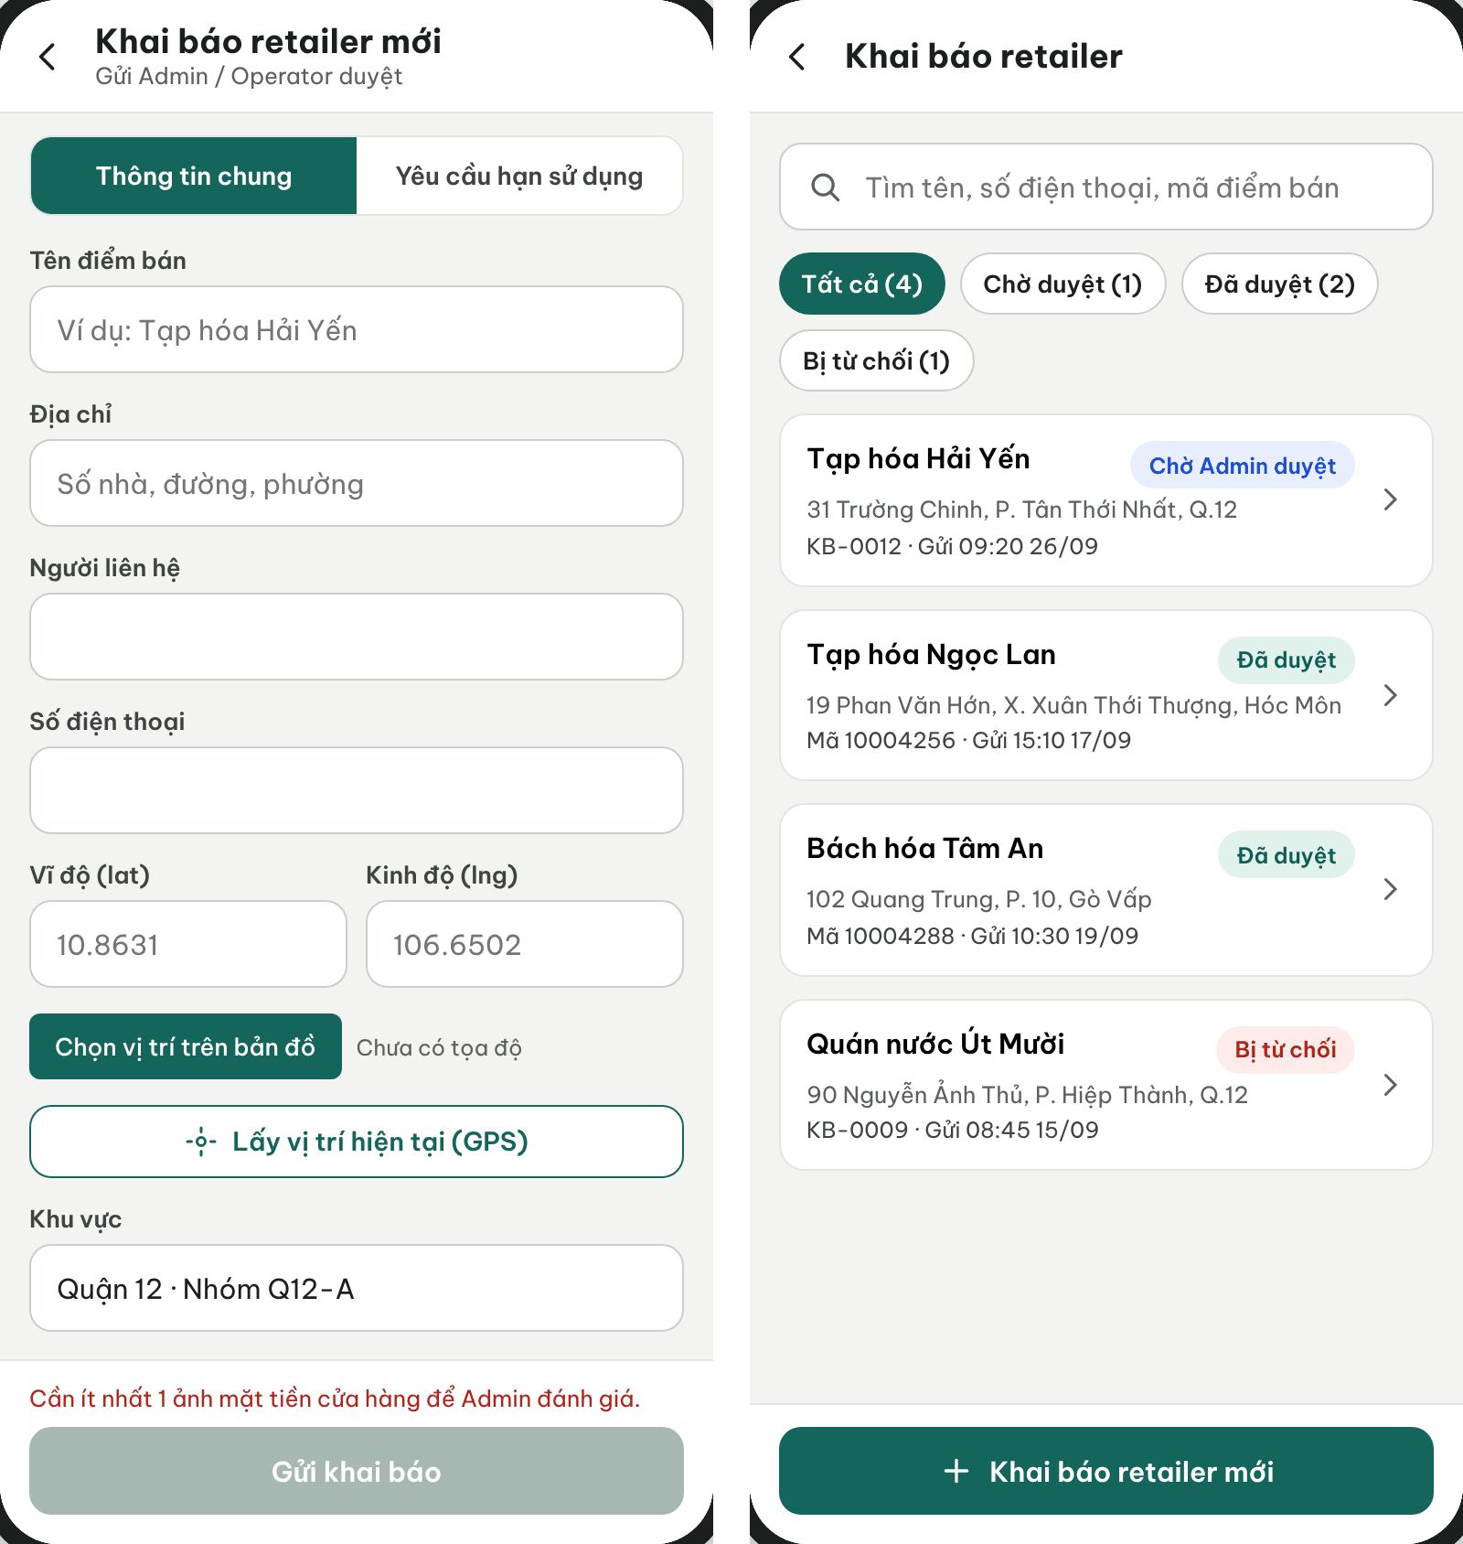
Figure 11. Sales App – Declare retailer and declaration list
● Function Details:
o Actors: Primary – Sales (declares a retailer through General Information and Shelf-life Requirements tabs). Secondary – Operator may enter a declaration on behalf of Sales. System – Potential Classification (3.1.4).
o Fields:
▪ Retailer/store identification and contact information.
▪ Store size, potential revenue estimate, purchasing capacity and assessment notes.
o Data Processing:
▪ Validate required retailer information and prevent duplicate registrations according to configured criteria.
▪ Save the prospect/retailer record together with its assessment fields.
▪ Submit for authorized review before enabling restricted order operations.
o Business Rules:
▪ Assessment information is kept with the Retailer data model.
▪ Mandatory fields: store name, contact person, phone number, address with map location (GPS or map pick), sales area/group, store size, forecast monthly revenue, purchasing capacity and at least one storefront photo. Shelf-life tab: optional Category and SKU MLOR ratios, each strictly between 0 and 1; an SKU entry overrides its Category (BR-11). Duplicate check: same phone number, or the same normalized name and address, among Pending or Active retailers (MSG009). Repeated submission of the same declaration returns the existing record.
o Acceptance Criteria:
AC ID | Acceptance criterion (Given / When / Then) | Ref.
AC-3.3.1-01 | Given a declaration missing any mandatory field or storefront photo, when Sales submits it, then submission is blocked and the missing fields are marked with MSG001. | BR-12
AC-3.3.1-02 | Given an existing Pending or Active retailer with the same phone number, when Sales submits a new declaration, then it is rejected with MSG009 and no second record is created. | BR-12
AC-3.3.1-03 | Given Category 'Sữa chua' = 30% and SKU002 = 25%, when the declaration is saved, then SKU002 resolves to 25% and other yogurt SKUs to 30%. | BR-11
AC-3.3.1-04 | Given an MLOR value of 0% or 100%, when it is entered, then it is rejected with MSG002. | BR-11
AC-3.3.1-05 | Given a valid submission, when the server accepts it, then its status is Pending approval, it cannot receive orders and the Administrator is notified (MSG010). | BR-12, BR-20
o Traceability: UC-15, UC-87 | BR-11, BR-12, BR-20 | CR-01 | Screens: Declare Retailer, Declarations List

3.3.2 Review Retailer Registration and Assessment
● Function type: Screen function (see 3.1.2).
● Function trigger:
o Open pending retailer requests or assessments.
o Review supporting information and record a decision.
● Function description: Reviews retailer activation requests and prospect potential for future prioritization.
● Screen layout: see Figure 12
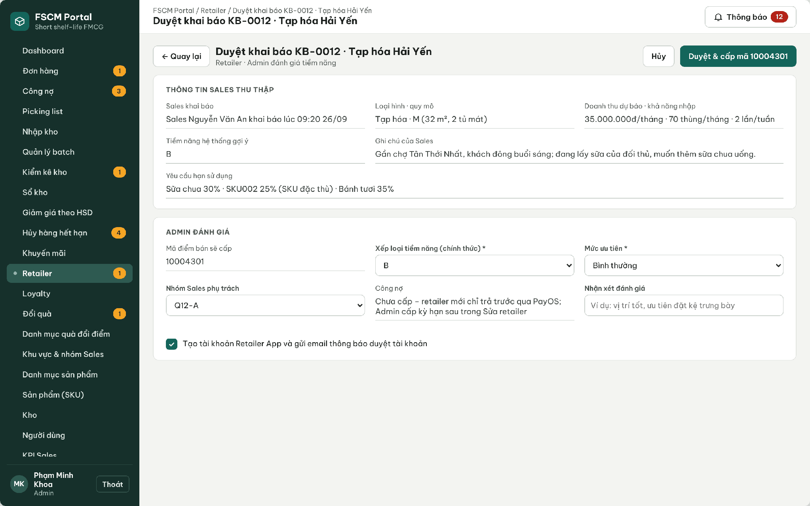
Figure 12. Web Portal – Review declaration, assess potential and issue retailer code
● Function Details:
o Actors: Primary – Administrator (final decision). Secondary – Operator may pre-check a declaration and add review notes but cannot approve or reject. System – Retailer Code Assignment (3.1.4).
o Fields:
▪ Retailer details; assessment values; decision; optional notes.
o Data Processing:
▪ Retrieve pending retailer and assessment information.
▪ Record approval or rejection and update the relevant status.
▪ Make the outcome available to permitted users and maintain traceability.
o Business Rules:
▪ Only authorized reviewers may approve registration.
▪ Assessment: the system suggests potential A/B/C (3.1.4 #6); the Administrator confirms the official class, priority (High / Normal / Watch), responsible sales group and payment term (none, 7, 14 or 30 days; a new retailer defaults to none – BR-13). No numeric scoring threshold is applied in the MVP. Only the Administrator finalizes; rejection requires a reason.
o Acceptance Criteria:
AC ID | Acceptance criterion (Given / When / Then) | Ref.
AC-3.3.2-01 | Given a Pending declaration, when the Administrator approves it, then an 8-digit retailer code is assigned, the Category/SKU MLOR becomes official, the Retailer account is created and an activation SMS is sent (MSG011). | BR-12
AC-3.3.2-02 | Given an Operator account, when it opens a Pending declaration, then Approve and Reject are not available and a direct API call is rejected with MSG006. | BR-12, CR-01
AC-3.3.2-03 | Given a Reject decision without a reason, when it is submitted, then it is blocked with MSG001; with a reason, Sales receives MSG012 and the reason. | BR-12
AC-3.3.2-04 | Given an approved retailer without a payment term, when its first quotation is accepted, then only Prepaid (PayOS) can be chosen. | BR-13, BR-51
AC-3.3.2-05 | Given Approve is submitted twice, when the second request arrives, then the same retailer code is returned and no duplicate account is created. | BR-06
o Traceability: UC-13, UC-64 | BR-06, BR-12, BR-13 | CR-01, CR-21 | Screens: Retailer List, Review Declaration

3.3.3 Manage Retailer Profile
● Function type: Screen function (see 3.1.2).
● Function trigger:
o Open Retailer Management.
o Create, view, update or deactivate an eligible retailer record.
● Function description: Maintains retailer identity, assigned coverage and assessment information.
● Screen layout: see Figure 13
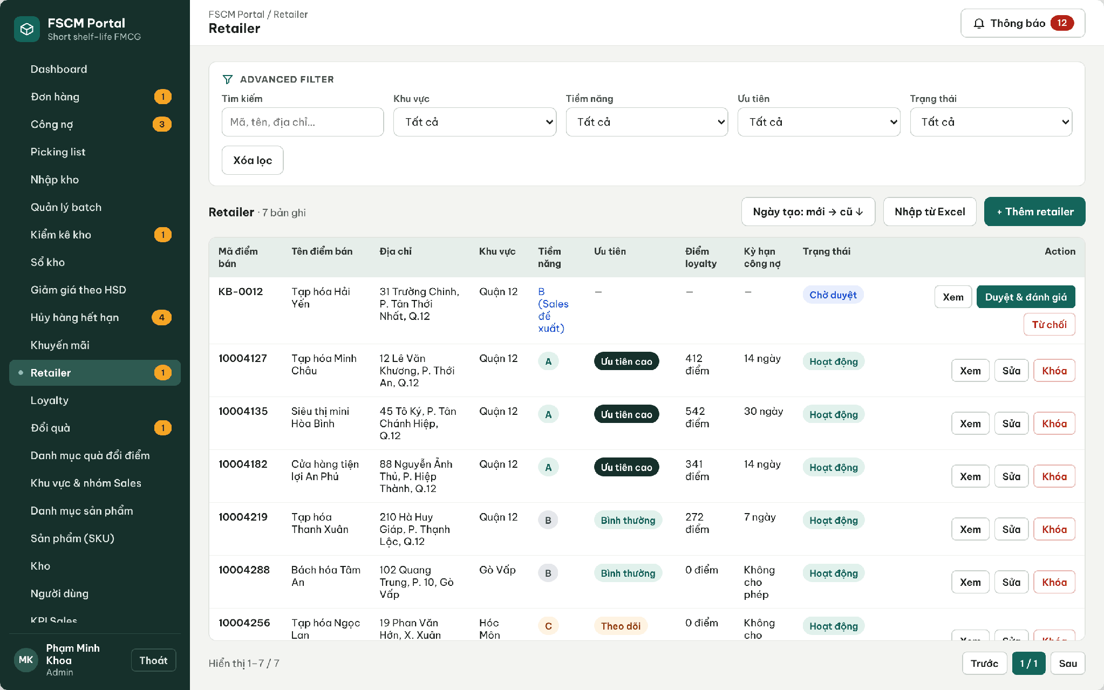
Figure 13. Web Portal – Retailer list with potential, priority, loyalty and payment term
● Function Details:
o Actors: Primary – Administrator. Secondary – Sales Manager and Sales view retailers of their scope (read-only).
o Fields:
▪ Retailer profile; status; region / sales-group assignment; assessment information.
o Data Processing:
▪ Check permission and any active order dependencies.
▪ Save valid changes and preserve relevant order history.
o Business Rules:
▪ Retailer management must not bypass the approval workflow.
▪ A retailer with any order, payment, complaint or loyalty record can only be deactivated (Locked); hard deletion is allowed only for a Rejected declaration with no orders. Deactivation is blocked while the retailer has an order that is not Completed or Cancelled, an outstanding balance or a pending refund. Changes to MLOR or payment term apply only to later orders (BR-57).
o Acceptance Criteria:
AC ID | Acceptance criterion (Given / When / Then) | Ref.
AC-3.3.3-01 | Given a retailer with historical orders, when the Administrator selects Delete, then the system blocks deletion and offers Deactivate. | BR-70
AC-3.3.3-02 | Given a retailer with an order in Delivering status, when Deactivate is selected, then it is rejected with the blocking order listed. | BR-70
AC-3.3.3-03 | Given the payment term changes from 7 to 14 days, when it is saved, then existing orders keep their stored due dates and only later orders use 14 days. | BR-52, BR-57
AC-3.3.3-04 | Given a Sales user outside the retailer's sales group, when the retailer profile API is called, then MSG006 is returned. | BR-03
o Traceability: UC-08, UC-43 – UC-45 | BR-03, BR-12, BR-13, BR-57, BR-70 | CR-01, CR-10 | Screens: Retailer List, Retailer Details

3.4 Product & Category Management

3.4.1 Manage Product Category Tree
● Function type: Screen function (see 3.1.2).
● Function trigger:
o Open Product Category Management.
o Create, update, move or delete a category.
● Function description: Maintains hierarchical product categories for browsing and reporting.
● Screen layout: see Figure 14
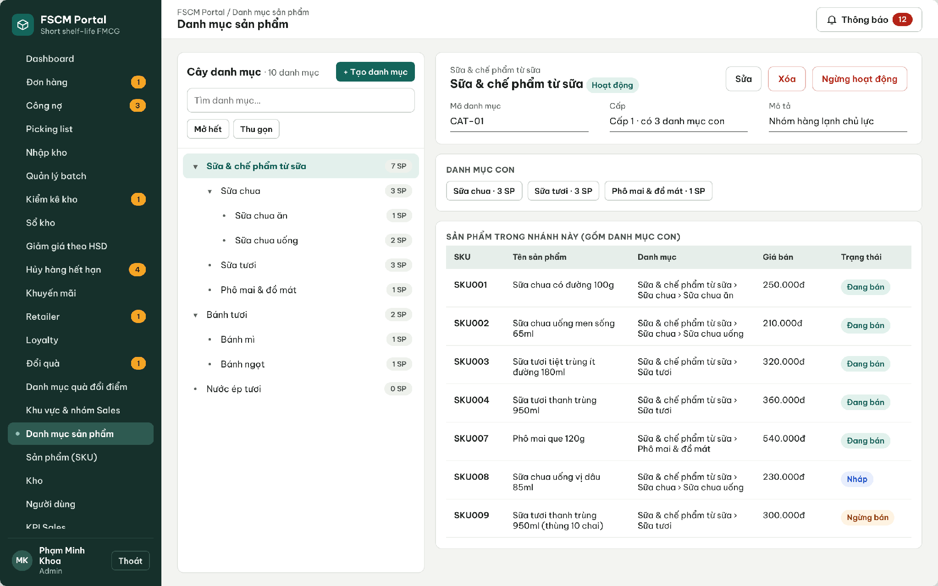
Figure 14. Web Portal – Product category tree
● Function Details:
o Actors: Primary – Administrator.
o Fields:
▪ Category name; parent category; category status (if configured).
o Data Processing:
▪ Validate selected parent and prevent circular parent-child relationships.
▪ Persist the category tree change and refresh product/category views.
▪ Prevent deletion when dependent products or children require retention.
o Business Rules:
▪ A category can have a parent category.
▪ The tree has at most 3 levels and products are assigned only to leaf categories. A category can be deleted only when it has no child category, no product (including Inactive), no promotion, discount rule or retailer MLOR reference; otherwise it can only be deactivated (MSG015). Moving a category is rejected if it would create a cycle or exceed 3 levels; references by ID remain valid after a move.
o Acceptance Criteria:
AC ID | Acceptance criterion (Given / When / Then) | Ref.
AC-3.4.1-01 | Given a category with a child or a product, when Delete is selected, then deletion is blocked with MSG015 and Deactivate is offered. | CR-06
AC-3.4.1-02 | Given a level-3 category, when the Administrator adds a child to it, then the action is rejected because the tree is limited to 3 levels. | CR-06
AC-3.4.1-03 | Given category A is the parent of B, when A is moved under B, then the move is rejected as circular. | CR-06
AC-3.4.1-04 | Given a non-leaf category, when a product is assigned to it, then assignment is rejected. | CR-06
o Traceability: UC-59 – UC-63 | BR-07, BR-11 | CR-06 | Screens: Product Category

3.4.2 Create and Publish Product
● Function type: Screen function (see 3.1.2).
● Function trigger:
o Open Product Management.
o Create a product in Draft status and submit for publication.
● Function description: Maintains SKU information using the Draft, Published and Inactive lifecycle.
● Screen layout: see Figures 15 – 16
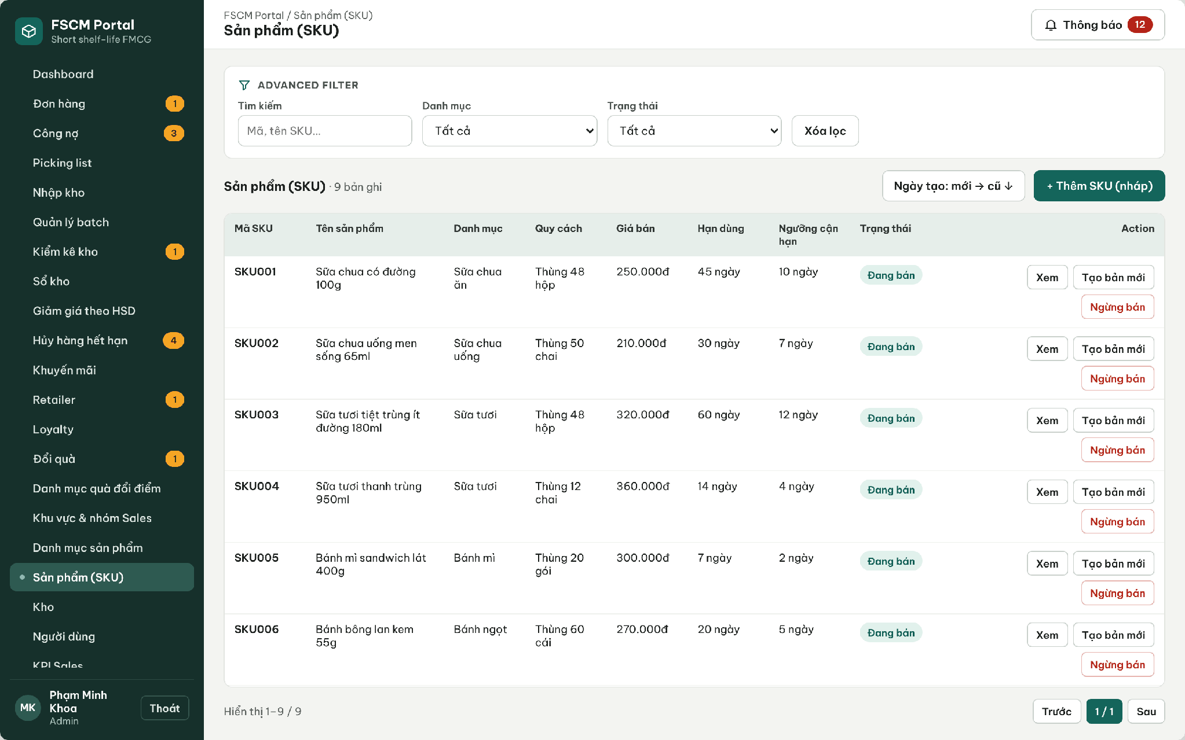
Figure 15. Web Portal – Product (SKU) list with Draft / On sale / Inactive status
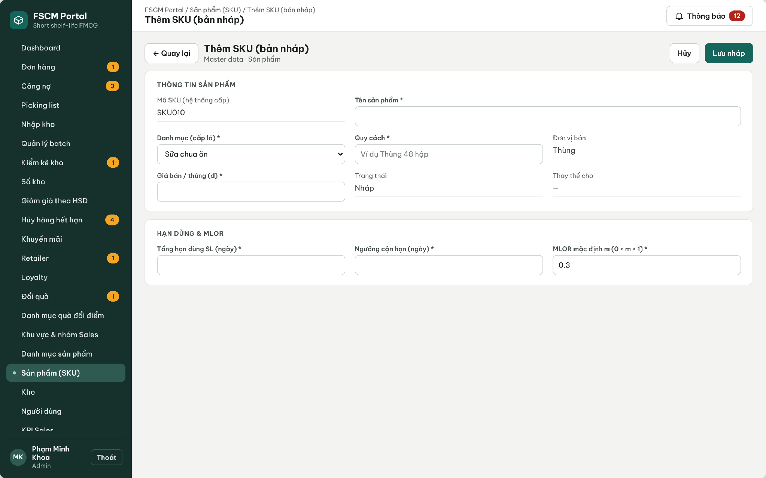
Figure 16. Web Portal – Create SKU (Draft)
● Function Details:
o Actors: Primary – Administrator.
o Fields:
▪ Product identity / SKU; category; selling price; shelf-life information; lifecycle status.
o Data Processing:
▪ Validate mandatory fields and category references.
▪ Save a new product as Draft.
▪ Publish the product once required information is complete.
o Business Rules:
▪ Once Published, product details and public price are locked.
▪ To change a published product or price, mark the prior product Inactive and create a new product.
o Acceptance Criteria:
AC ID | Acceptance criterion (Given / When / Then) | Ref.
AC-3.4.2-01 | Given a Draft product with all mandatory fields (SKU, name, leaf category, packing, price, total shelf life, near-expiry threshold, default MLOR), when Publish is selected, then the status becomes Published and MSG014 is shown. | BR-07
AC-3.4.2-02 | Given a Published product, when any locked field is edited, then the change is rejected with MSG013. | BR-07
AC-3.4.2-03 | Given a Published product, when Create new version is used and the new version is published, then the old product becomes Inactive, historical orders keep their snapshots and the new SKU has no stock or transactions. | BR-07, BR-19
AC-3.4.2-04 | Given a Draft or Inactive product, when Sales searches the catalog or a goods receipt is created, then it is not available. | BR-08
o Traceability: UC-88, UC-90 | BR-06 – BR-08, BR-19 | CR-06, CR-10 | Screens: Product (SKU) List, Create SKU

3.4.3 View Product Catalog and Best-Selling Products
● Function type: Screen function (see 3.1.2).
● Function trigger:
o Open Catalog or a permitted dashboard.
o Filter by product/category or open top-selling list.
● Function description: Shows eligible catalog products and supported best-selling product information.
● Screen layout: see Figure 17
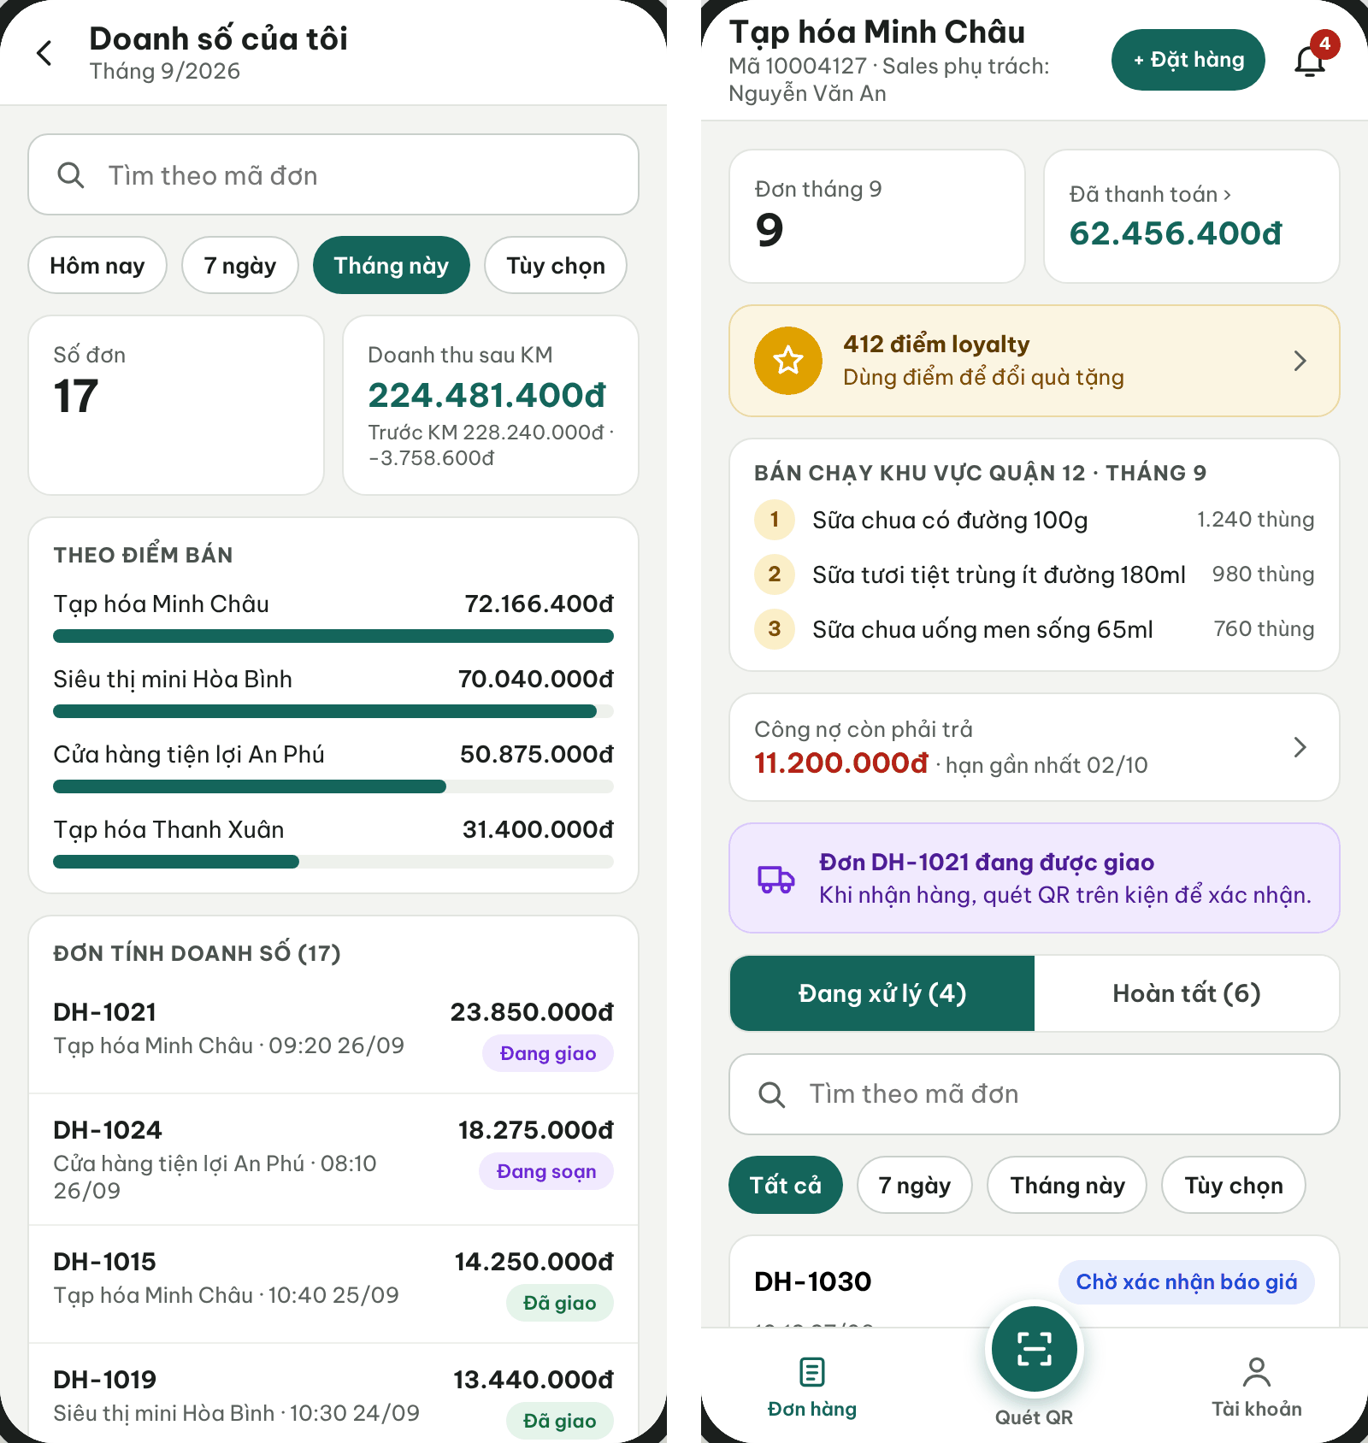
Figure 17. Sales App sales overview and Retailer home with area best sellers
● Function Details:
o Actors: Primary – Sales, Retailer, Administrator. Secondary – Sales Manager (best-selling products of the team).
o Fields:
▪ Product name; category; public price; available stock visibility where authorized; sales ranking.
o Data Processing:
▪ Read publishable/active products within permitted visibility.
▪ Calculate best-selling rank from eligible recorded order data and show the result.
o Business Rules:
▪ Do not expose Draft or Inactive items as purchasable products.
▪ Best-selling rank: total delivered quantity (cartons) per SKU in the selected period (default: current month; options Today, 7 days, This month, Custom), counting only Delivered or Completed orders net of approved adjustments; ties are broken by net revenue, then SKU code. Scope follows the viewer: own area for Sales/Retailer, team for Sales Manager, whole distributor for Administrator.
o Acceptance Criteria:
AC ID | Acceptance criterion (Given / When / Then) | Ref.
AC-3.4.3-01 | Given orders in Cancelled, Withdrawn or OutOfStock status, when the ranking is calculated, then their quantities are excluded. | BR-56
AC-3.4.3-02 | Given two SKUs with equal quantity, when ranked, then the one with higher net revenue is listed first, and if equal, the lower SKU code. | BR-56
AC-3.4.3-03 | Given a Sales user, when the best-selling list is opened, then only data of the user's sales area is aggregated. | BR-03
AC-3.4.3-04 | Given an Inactive product, when the catalog is shown, then it is not offered for ordering but may still appear in historical rankings. | BR-08
o Traceability: UC-71, UC-89 | BR-03, BR-08, BR-56 | CR-01 | Screens: Product Catalog, KPI & Ranking, Dashboard

3.5 Promotion & Batch Discount Management

3.5.1 Manage Promotion Rules
● Function type: Screen function (see 3.1.2).
● Function trigger:
o Open Promotion Management.
o Create, inspect, edit or delete an eligible promotion.
● Function description: Maintains discount configurations applying to a SKU or a SKU group.
● Screen layout: see Figures 18 – 20
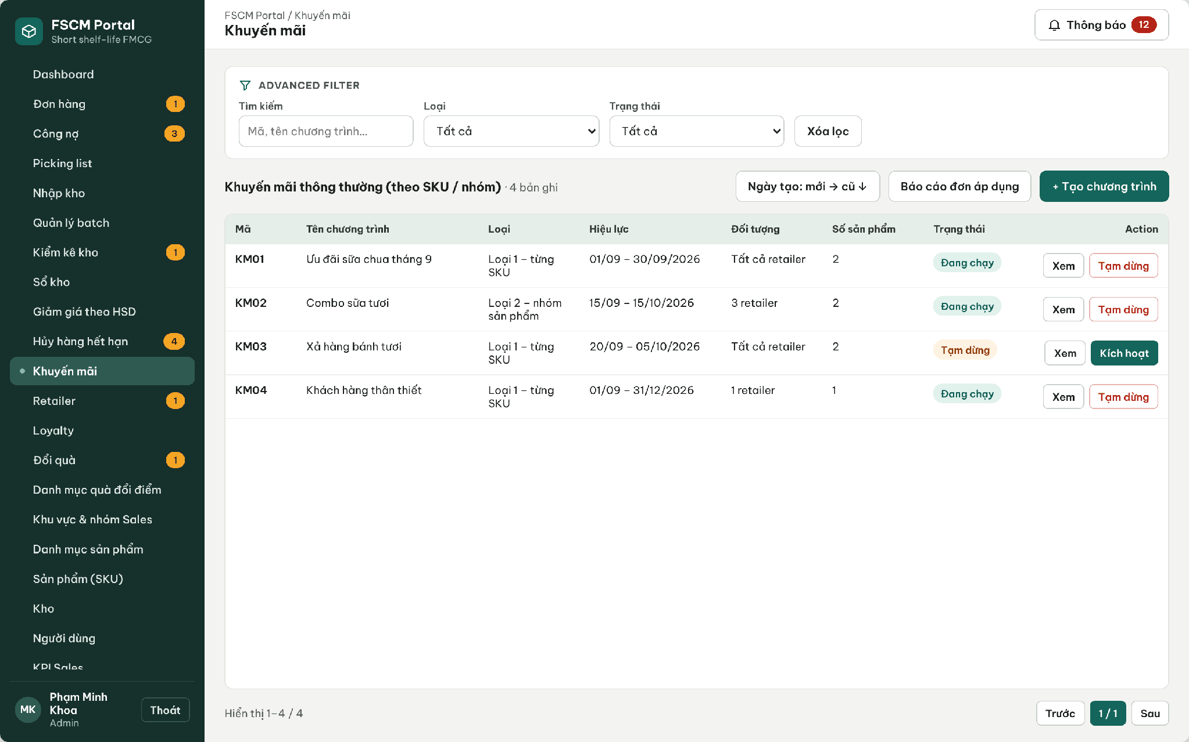
Figure 18. Web Portal – Ordinary promotions by SKU / SKU group
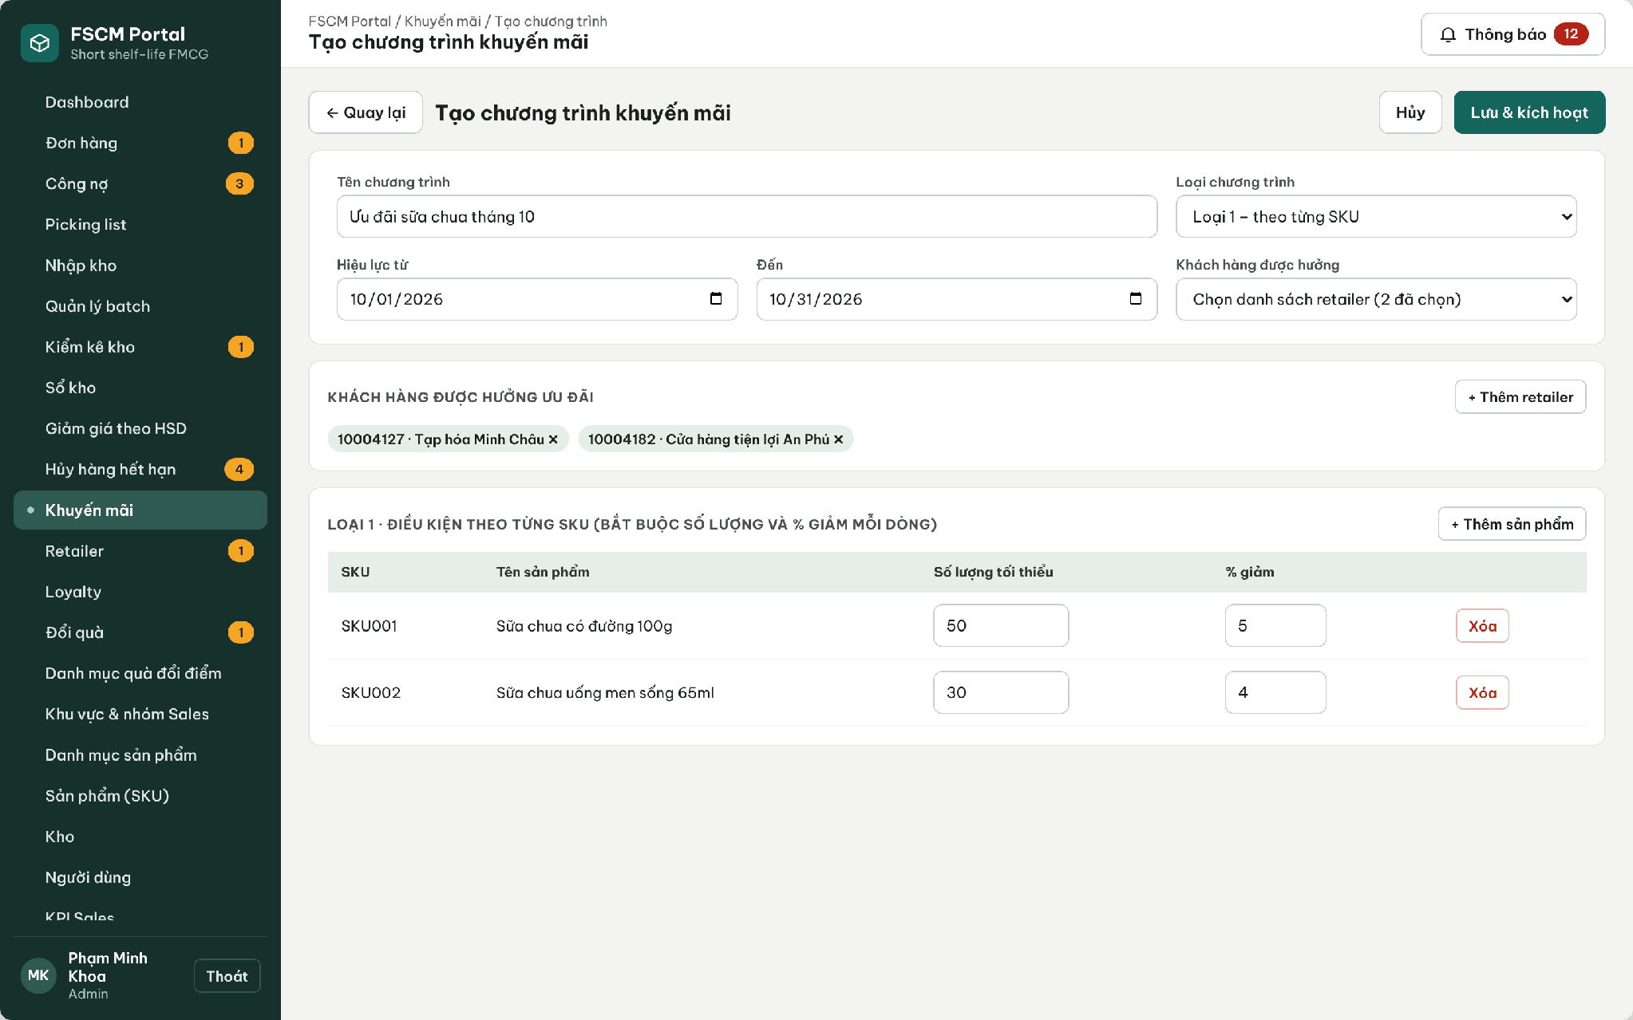
Figure 19. Web Portal – Create promotion
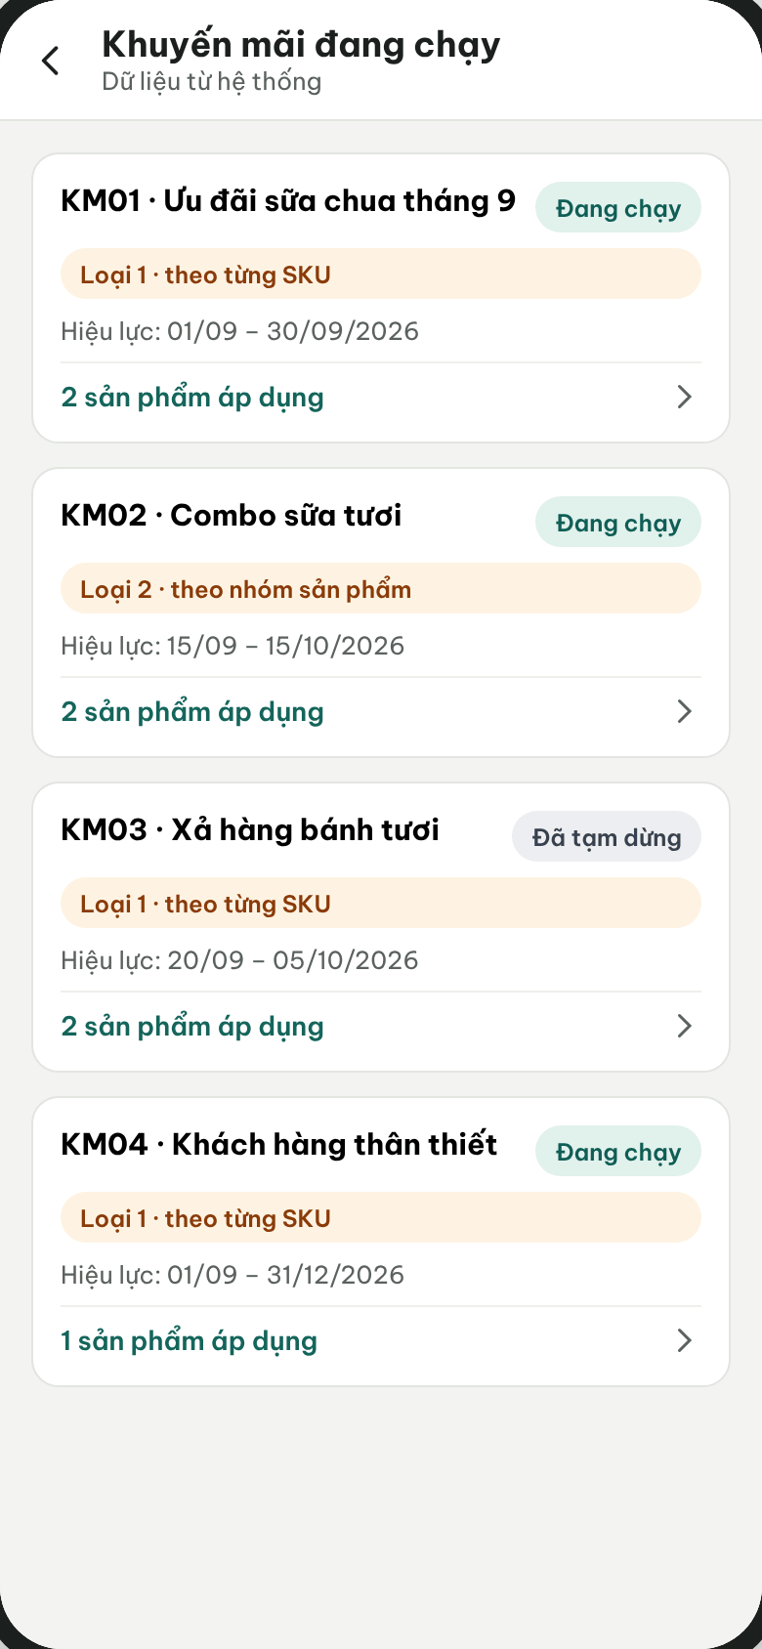
Figure 20. Sales App – Running promotions
● Function Details:
o Actors: Primary – Administrator. Secondary – Sales views running promotions (read-only).
o Fields:
▪ Promotion code and name; validity period; discount configuration; eligible scope.
o Data Processing:
▪ Validate effective period and configuration.
▪ Store eligibility and the official promotion rules.
▪ Restrict updates/deletion when historical orders must retain the original promotion result.
o Business Rules:
▪ Order financial reporting uses revenue after promotions.
▪ Promotions are by SKU or SKU group (quantities of the group in one order are summed). Each order line may use at most one promotion chosen by the customer; ordinary campaigns never change MLOR.
o Acceptance Criteria:
AC ID | Acceptance criterion (Given / When / Then) | Ref.
AC-3.5.1-01 | Given a Type 2 group promotion '10 cartons of A+B → 10%', when one order contains A: 6 and B: 4, then the threshold is met; quantities from different orders or retailers are never combined. | BR-14, BR-15
AC-3.5.1-02 | Given two valid promotions on the same line, when the server prices the order, then only the one with the largest discount amount is applied; ties are resolved by the lower promotion code. | BR-14
AC-3.5.1-03 | Given a paused or expired promotion, when an order is accepted or synchronized, then it is not applied and Sales sees MSG035 if the estimate changes. | BR-14, BR-15
AC-3.5.1-04 | Given a discount of 100% or a fixed-amount discount, when it is saved, then it is rejected (percentage only, strictly below 100%). | BR-79
AC-3.5.1-05 | Given a promotion already used by an order, when it is edited, then historical orders keep the applied promotion snapshot. | BR-19
o Traceability: UC-07, UC-46 – UC-49 | BR-14, BR-15, BR-17, BR-19, BR-79 | CR-10 | Screens: Promotions, Create Promotion, Sales Promotions

3.5.2 Manage Shelf-Life Discount Rules and Batch Pricing
● Function type: Screen function (Shelf-life Discount Rules – Web Portal). Pricing during allocation is automatic – see Expiry Discount Pricing in 3.1.4.
● Function trigger:
o The Administrator opens Shelf-life Discount Rules and creates, edits, pauses or activates a rule.
o The allocation of an SO selects batches for an order line (pricing is then applied automatically).
● Function description: Maintains discount tiers by remaining shelf-life percentage for a Category or SKU and applies the matching tier to each allocated batch after batch selection, so that the quotation shows a traceable price per batch. Added in v1.8 to cover the Registration requirement 'apply the configured remaining-shelf-life discount after selecting batches'.
● Screen layout: see the figure below.
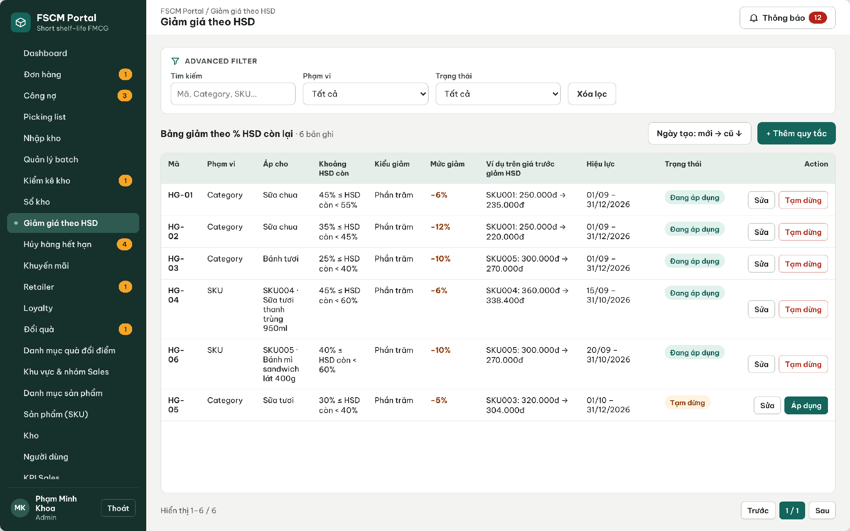
Figure 21. Web Portal – Shelf-life discount rules (percentage by remaining shelf-life range)
● Function Details:
o Actors: Primary – Administrator (rules). System – Expiry Discount Pricing. Secondary – Sales and Retailer view the resulting per-batch prices on quotations and order details.
o Fields:
▪ Rule code (HG-nn); scope (Category or SKU); target; remaining shelf-life range [from %, to %); discount percent; validity; status (Active / Paused).
o Data Processing:
▪ Validate that ranges of the same scope and target do not overlap and that 0 < discount < 100%.
▪ At the allocation pricing point, compute each allocated batch's remaining shelf-life percentage, pick the SKU rule first, else the Category rule (nearest ancestor), else no discount.
▪ Final unit price = base price after ordinary promotion × (1 − tier discount); amounts are rounded to whole VND per batch line; the base price, promotion, tier rule, discount amount and final price are stored per allocated batch.
o Business Rules:
▪ BR-79 and BR-80 apply. A discount never makes an ineligible batch eligible and is not a scoring weight (BR-18).
o Acceptance Criteria:
AC ID | Acceptance criterion (Given / When / Then) | Ref.
AC-3.5.2-01 | Given rule HG-02 (Sữa chua, 35% ≤ remaining < 45%, −12%) and an allocated SKU001 batch with 40% remaining at the pricing point, when the allocation prices the line at a base price of 250,000 VND, then the batch unit price is 220,000 VND and the rule code is stored on the allocation. | BR-79
AC-3.5.2-02 | Given an SKU rule and a Category rule that both match, when the price is calculated, then only the SKU rule is applied. | BR-79
AC-3.5.2-03 | Given list unit price 100,000 VND, ordinary promotion 10% and shelf-life tier 20%, the post-promotion base price is 90,000 VND and the final price is 72,000 VND. Apply the shelf-life percentage to that base; do not deduct the ordinary promotion twice. | BR-79
AC-3.5.2-04 | Given two ranges 40–55% and 50–60% for the same Category, when the second rule is saved, then it is rejected as overlapping. | BR-79
AC-3.5.2-05 | Given a batch with a large tier discount that fails the line MLOR, when the allocation evaluates it, then the batch is still excluded. | BR-18, BR-31
o Traceability: UC-58 (pricing part) | BR-17 – BR-19, BR-79, BR-80 | CR-10 | Screens: Shelf-life Discount Rules; Non-screen: Expiry Discount Pricing

3.6 Purchase Order & Offline Synchronization

3.6.1 Create Sales Order
● Function type: Screen function (see 3.1.2).
● Function trigger:
o Retailer opens the catalog (or Sales opens an assigned retailer) and selects Create Sales Order.
o Select products/quantities and submit or save locally when offline.
● Function description: Creates a sales order with an idempotency key. A valid SO receives DH and AcceptedAt, becomes Allocating and is allocated immediately (3.7.1). No stock is held before allocation commits.
● Screen layout: see Figure 22
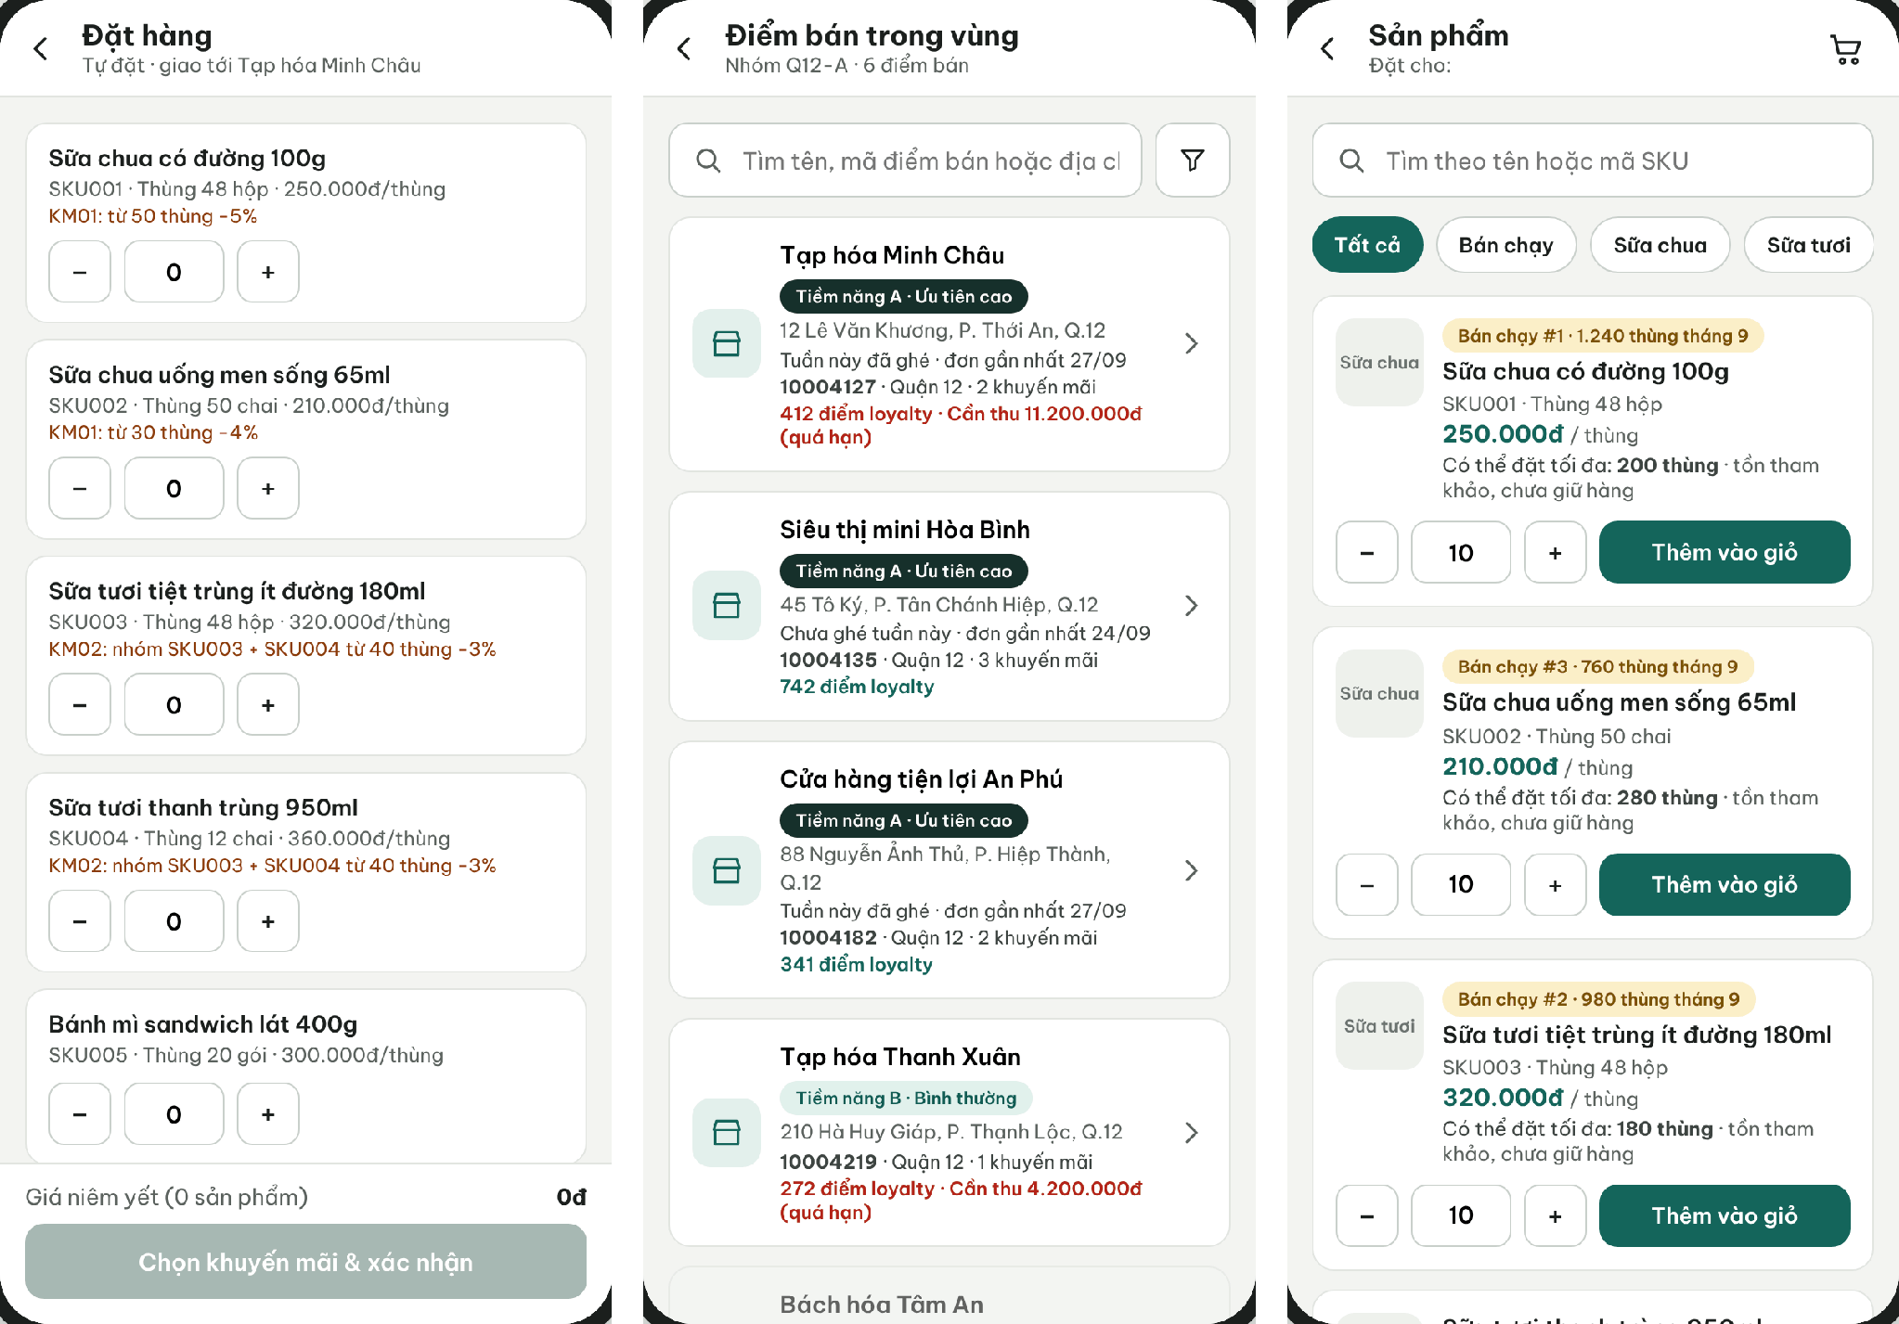
Figure 22. Retailer App self-order catalog, Sales App retailer selection and product list
● Function Details:
o Actors: Primary – Retailer (own orders, online), Sales (assigned retailers, online or offline). System – Promotion Calculation, Order Quantity Limit, Sales Area Restriction, Real-time Allocation Trigger (3.1.4).
o Fields:
▪ Retailer; line ID; SKU/quantity; selected promotion (one per order); effective MLOR and source (server-side); idempotency key. Neither a receive date nor a payment method is chosen; the Retailer chooses the payment method after the quotation (3.6.6).
o Data Processing:
▪ Validate retailer/sales assignment and product eligibility.
▪ Recalculate price and the selected promotion on the server. Availability shown is indicative; no batch is promised.
▪ Sales offline orders are queued with a UUID idempotency key and sent after reconnection (3.6.2).
o Business Rules:
▪ A Retailer orders only for itself; Sales only within permitted retailer coverage.
▪ Published product information and prices cannot be edited in place.
o Acceptance Criteria:
AC ID | Acceptance criterion (Given / When / Then) | Ref.
AC-3.6.1-01 | Given an active retailer, when the Retailer (or Sales in its area) submits an order online, then the server stores AcceptedAt and the DH code, the status becomes Allocating and an allocation attempt starts; no payment is created (MSG026). | BR-20, BR-22, BR-24
AC-3.6.1-02 | Given a retailer outside the Sales area or not Active, when an order is submitted through the app or the API, then it is rejected with MSG006. | BR-20
AC-3.6.1-03 | Given an order, when it is created, then it carries no payment method and no receive date. | BR-21
AC-3.6.1-04 | Given estimated prices on the device, when the server accepts the order, then prices and promotions are recalculated by the server and any difference is shown (MSG035). | BR-15
AC-3.6.1-05 | Given the same request sent twice with one idempotency key, when the server processes it, then exactly one SO exists and the same DH code is returned. | BR-23
o Traceability: UC-21 | BR-04, BR-11, BR-15, BR-20 – BR-24 | CR-08, CR-10 | Screens: Select Retailer, Create Order, Retailer Create Sales Order

3.6.2 Synchronize Offline Purchase Orders
● Function type: Screen function (Sync Queue). Sales sends drafts manually; server validation of each sent order runs automatically – see Offline Order Synchronization in 3.1.4.
● Function trigger:
o Sales opens the Sync Queue while draft orders exist and the network is available.
o Sales taps Send; drafts are never sent automatically.
● Function description: Uploads locally saved orders and exposes their synchronization status.
● Screen layout: see Figure 23
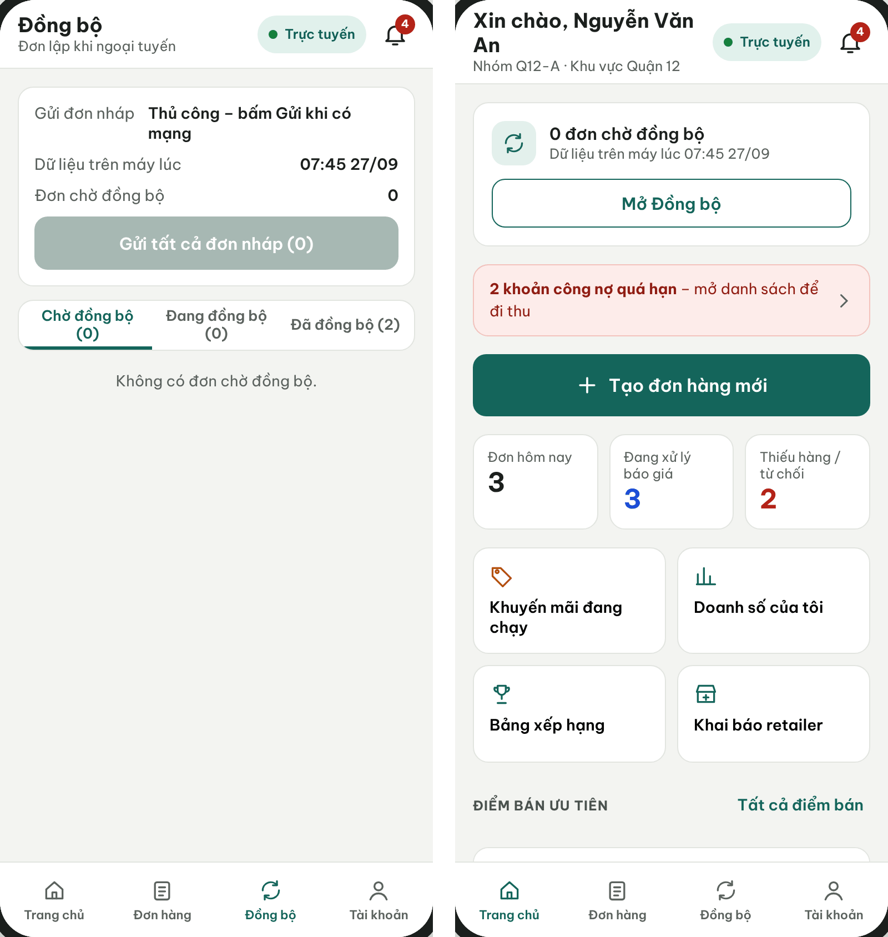
Figure 23. Sales App – Sync Queue and home with sync status
● Function Details:
o Actors: Primary – Sales. System – Offline Order Synchronization (3.1.4).
o Fields:
▪ Local order identifier; sync status; server order reference / error.
o Data Processing:
▪ Transmit queued orders to the backend with idempotency protection.
▪ Revalidate retailer, product, prices and promotions. A valid order receives DH and AcceptedAt at server acceptance and becomes Allocating at once; shortage is decided by its own allocation attempt.
▪ Display accepted/rejected/conflict outcomes without silently overwriting local data.
o Business Rules:
▪ Server validation determines accepted conditions. Price is confirmed by the quotation; no silent price increase or MLOR reduction is allowed.
▪ Drafts are sent only when Sales taps Send. A failed send is retried manually with the same request code and never creates a duplicate order.
o Acceptance Criteria:
AC ID | Acceptance criterion (Given / When / Then) | Ref.
AC-3.6.2-01 | Given 3 offline drafts and restored connectivity, when Sales does not tap Send, then no draft is transmitted. | BR-23
AC-3.6.2-02 | Given a draft sent and the response lost, when Sales retries with the same request code, then exactly one order exists on the server and the same DH code is returned. | BR-23, CR-11, CR-12
AC-3.6.2-03 | Given a price or promotion changed after the draft was cached, when the draft is sent, then the server returns the changed conditions (MSG035) and the order is accepted only after Sales confirms them. | BR-15, BR-17
AC-3.6.2-05 | Given a network failure while sending, when the request does not complete, then the draft stays in Pending sync and the app never shows it as accepted (MSG034). | NFR-O02
o Traceability: UC-80, UC-81 | BR-15, BR-23, BR-24 | CR-11, CR-12 | Screens: Sync Queue

3.6.3 Withdraw Sales Order Request
● Function type: Screen function (Order Details – Withdraw, Mobile – Retailer and Sales).
● Function trigger:
o Retailer or Sales opens an SO whose allocation is not committed and selects Withdraw.
● Function description: Withdraws an SO request before stock is reserved. It replaces the former order review: there is no Approve/Reject of SOs by Administrator or Operator.
● Screen layout: see Figure 24
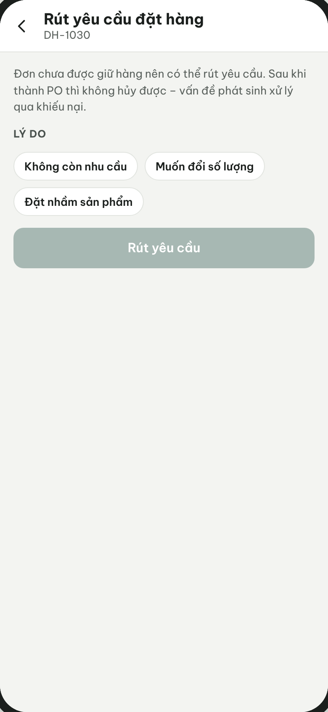
Figure 24. Retailer App – Withdraw sales order request
● Function Details:
o Actors: Primary – Retailer (own SO), Sales (assigned retailers). System – Real-time Allocation Trigger.
o Data Processing:
▪ Allowed while the SO is Allocating and its attempt has not committed; the SO becomes Withdrawn and no stock moves. An attempt that commits first wins: the user then sees Quoted and may reject the quotation (3.6.6).
▪ An offline draft that is not yet synchronised is deleted locally; it never reaches the server.
o Acceptance Criteria:
▪ AC-3.6.3-01: Given an SO in Allocating with no committed reservation, when the Retailer withdraws it, then it becomes Withdrawn and Reserved is unchanged. (BR-26)
▪ AC-3.6.3-02: Given the attempt committed before the withdraw request, when Withdraw is sent, then it is rejected with MSG030 and the SO stays Quoted. (BR-26)
▪ AC-3.6.3-03: Given Withdraw sent twice with the same key, when processed, then one Withdrawn transition and one audit entry exist. (BR-58)
o Traceability: UC-99 | BR-26, BR-58 | CR-14, CR-21 | Screens: Order Details – Withdraw

3.6.4 Cancel Purchase Order with Evidence
● Function type: Screen function (see 3.1.2).
● Function trigger:
o Open an eligible order and select Cancel.
o Enter the reason, attach evidence and confirm.
● Function description: Cancels an eligible order while preserving supporting images or files for audit.
● Screen layout: see Figure 25
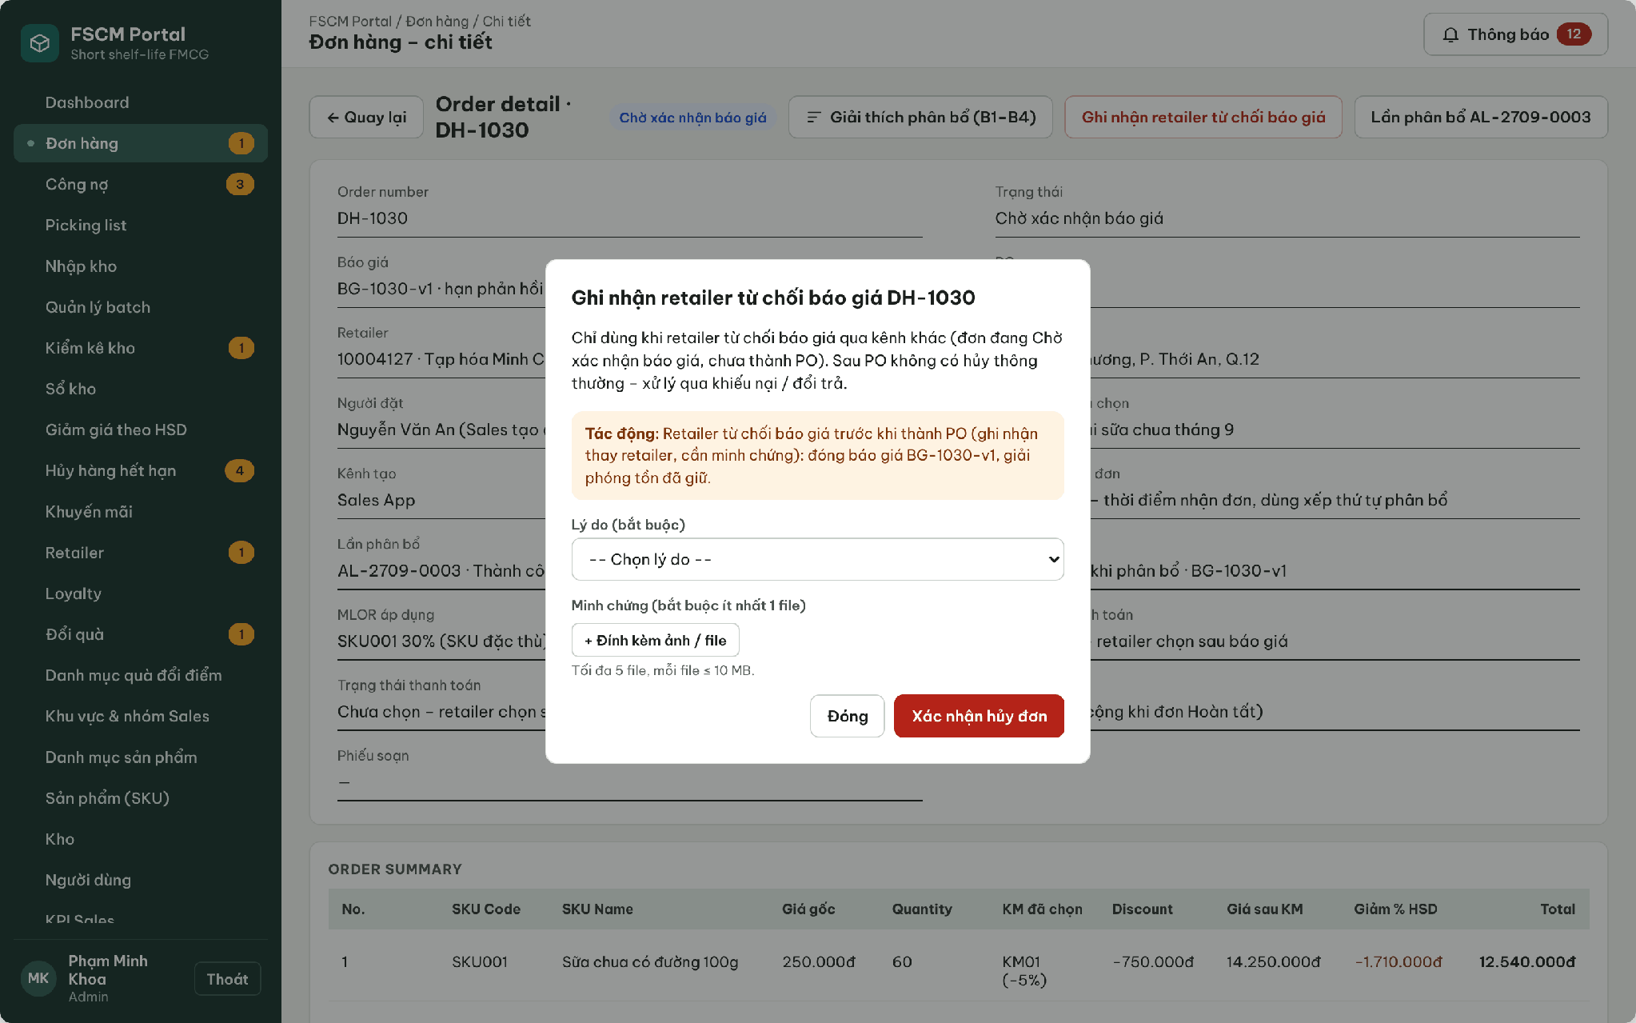
Figure 25. Web Portal – Record retailer quotation rejection with reason and evidence
● Function Details:
o Actors: Primary – Retailer/Sales withdraw while Allocating (3.6.3) or reject a Quoted quotation (3.6.6). Secondary – Administrator/Operator cancel after reservation and before picking. System – Quotation Expiry (automatic release).
o Fields:
▪ Order ID; cancellation reason; attachment(s).
o Data Processing:
▪ Verify permitted cancellation status and the user’s scope.
▪ Persist cancellation evidence metadata and file reference to object storage.
▪ Allocating, not committed → Withdrawn (3.6.3). Quoted → quotation rejection releases the reservation. After reservation and before picking → authorized cancellation releases the reservation and affected picking/shipment records (BR-26).
▪ Quotation rejection or expiry releases the reservation once. Money that arrives late or cannot be applied creates a refund obligation; a Cancelled or Expired SO never revives.
o Business Rules:
▪ Cancellation must be supported by evidence.
▪ Allowed states: Retailer/Sales – Allocating (withdraw) or Quoted (reject); Administrator/Operator – Quoted, PaymentPending or ConvertedToPo before picking starts. Blocked after picking starts and after any dispatch (MSG030). Evidence: 1 – 5 files, JPG/PNG/PDF, ≤ 5 MB each.
o Acceptance Criteria:
AC ID | Acceptance criterion (Given / When / Then) | Ref.
AC-3.6.4-01 | Given an order in Quoted, when the Operator cancels it with a reason and one photo, then it becomes Cancelled, the reservation is released once and the evidence is stored privately in Blob Storage. | BR-26, CR-14
AC-3.6.4-03 | Given a Prepaid order already Paid and not yet picked, when the Operator cancels it, then the reservation is released and a full manual refund obligation is created. | BR-26, BR-66
AC-3.6.4-04 | Given an order with any dispatched shipment, when cancellation is requested, then it is blocked and the user is directed to the complaint/adjustment workflow. | BR-26
AC-3.6.4-05 | Given a 12 MB file or an .exe file, when it is attached, then it is rejected with MSG049. | NFR-S06
o Traceability: UC-78, UC-79 | BR-26, BR-51, BR-66 | CR-14, CR-22 | Screens: Order Details – Cancel; Non-screen: Quotation Expiry

3.6.5 View Order Status and History
● Function type: Screen function (see 3.1.2).
● Function trigger:
o Open Order List or Order History.
o Select an order to inspect its status and timeline.
● Function description: Provides access to permitted historical orders, status transitions and fulfillment details.
● Screen layout: see Figures 26 – 27
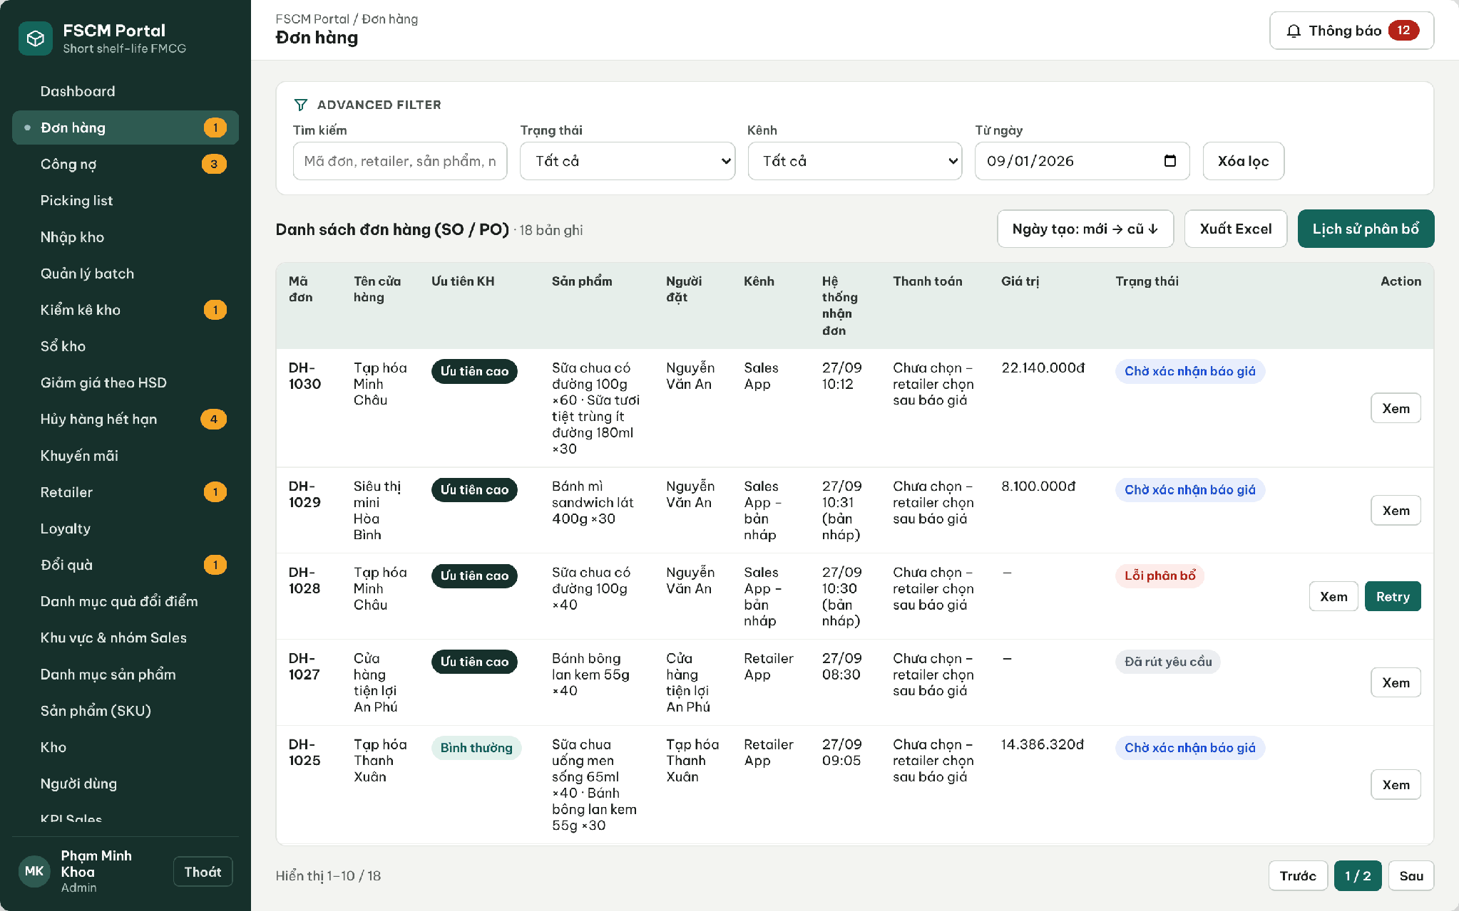
Figure 26. Web Portal – Order list with status filter and allocation history access
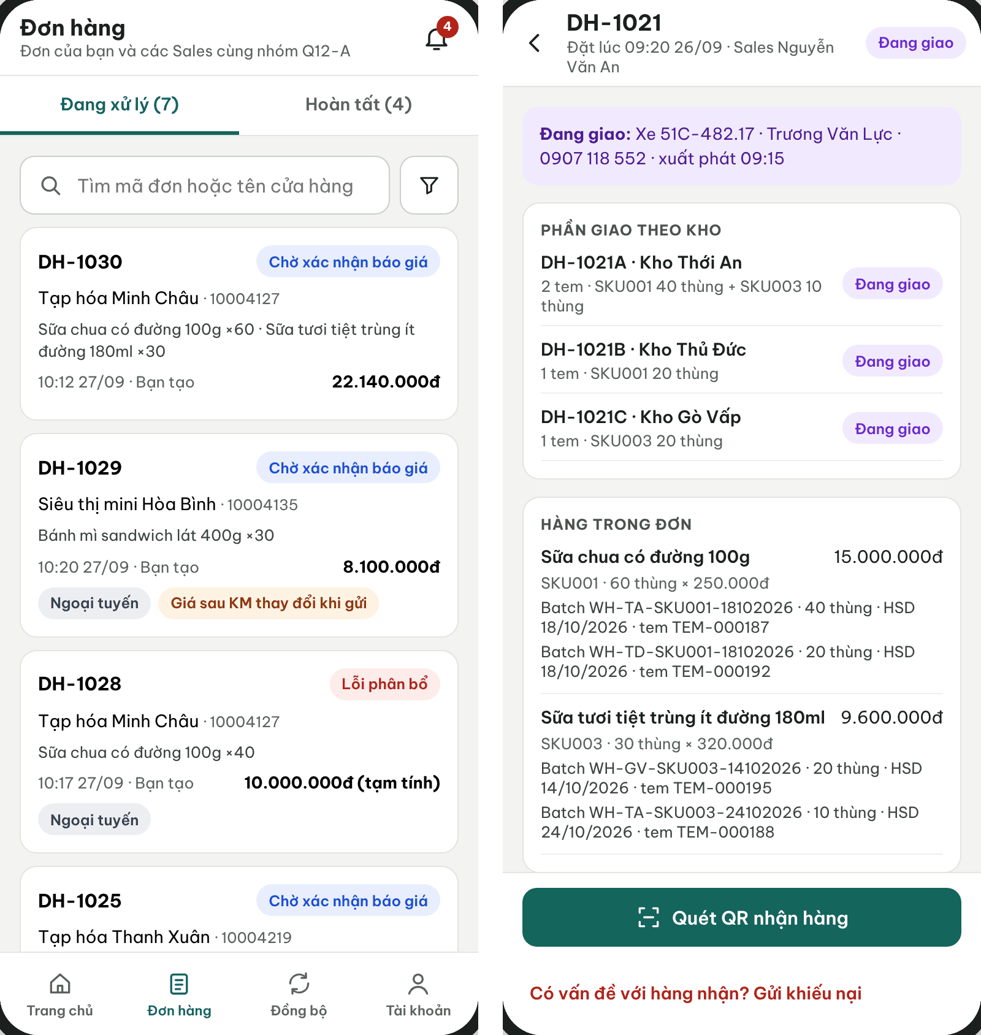
Figure 27. Sales App order list and Retailer order details with shipment status
● Function Details:
o Actors: Primary – Retailer (own orders), Sales (personal and sales-group orders), Sales Manager (team), Administrator and Operator (all orders).
o Fields:
▪ Order reference; items; prices after discount; status history; timestamps.
o Data Processing:
▪ Apply role-based visibility: own retailer / assigned sales scope / privileged management scope.
▪ Retrieve order records and display their recorded processing state.
o Business Rules:
▪ Do not expose unrelated retailers or orders to other Sales groups.
▪ Show the order and its actual shipment/receipt history separately from financial completion. Delivered requires full actual receipt. Completed requires fulfilled delivery or an authorized final resolution of its delivery exceptions, adjusted settlement and no unresolved complaint/refund. A resolved shortage can reach Completed without fabricating received quantities or a historical Delivered event; cancelled orders remain Cancelled (BR-49).
o Acceptance Criteria:
AC ID | Acceptance criterion (Given / When / Then) | Ref.
AC-3.6.5-01 | Given a Sales user in group Q12-A, when the order list is requested, then only orders of the user and the group are returned; a request for another group's order returns MSG006. | BR-03
AC-3.6.5-02 | Given a Retailer, when the order list is opened, then only that retailer's orders are shown, with prices after discount and the status timeline. | BR-03, BR-04
AC-3.6.5-03 | Given full receipt OR finalized authorized delivery-exception resolution, adjusted settlement and no unresolved complaint/refund, the order may become Completed. A resolved shortage retains actual quantities and need not fabricate Delivered; a cancelled order remains Cancelled. | BR-49, BR-70
AC-3.6.5-04 | Given a product renamed by a new version, when an older order is opened, then the product name snapshot of the order is shown. | BR-19
o Traceability: UC-05, UC-22, UC-24, UC-83 | BR-03, BR-19, BR-49 | CR-10 | Screens: Order List, Order Details, Retailer Orders

3.6.6 Respond to Quotation and Choose Payment Method
● Function type: Screen function (Order Details, Choose Payment Method, PayOS Payment – Mobile – Retailer). PO conversion, PayOS webhook handling and quotation expiry run automatically – see PO Conversion and Picking Release and Quotation Expiry in 3.1.4.
● Function trigger:
o Retailer opens the quotation notification or the Order Details of an order awaiting quotation acceptance.
o Accept or reject the quotation; after acceptance choose Prepaid (PayOS) or Credit.
● Function description: Lets the Retailer accept or reject the quotation issued right after a successful allocation, then choose the payment method. Prepaid opens a PayOS link/QR confirmed by webhook; Credit is revalidated on the server. The SO becomes a PO only when Prepaid is Paid or Credit is valid, and only a PO is picked and delivered.
● Screen layout: see Figures 28 – 29
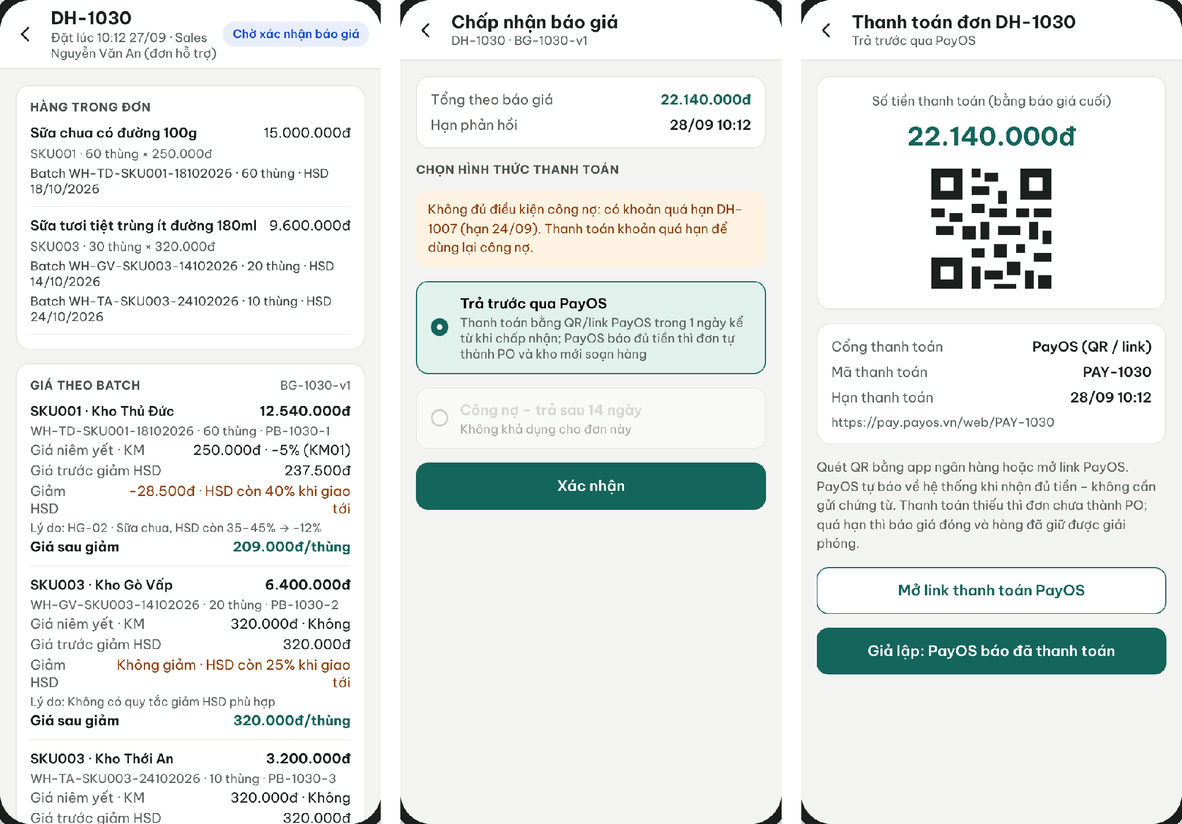
Figure 28. Retailer App – Quotation per batch, payment-method choice and PayOS payment
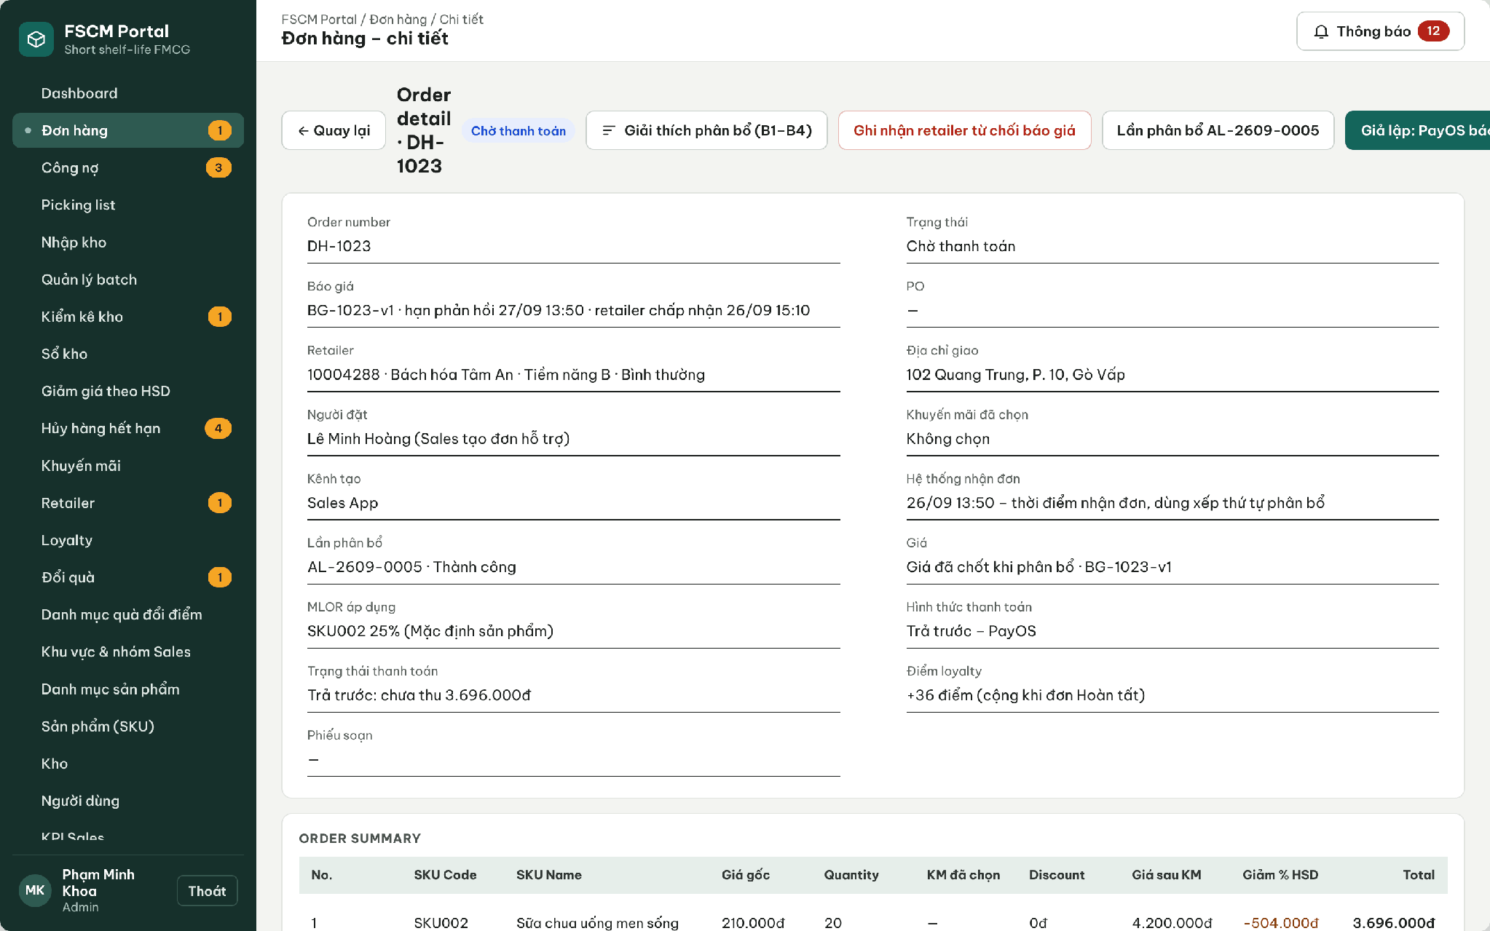
Figure 29. Web Portal – Order awaiting PayOS payment
● Function Details:
o Actors: Primary – Retailer (accepts/rejects, chooses payment method, pays via PayOS). External – PayOS (link/QR, signed webhook). System – PO Conversion and Picking Release, Quotation Expiry (3.1.4).
o Fields:
▪ Quotation and ExpiresAt; final amount; payment method (Prepaid – PayOS / Credit); PayOS reference and payment deadline; payment status; rejection reason.
o Data Processing:
▪ Acceptance must precede ExpiresAt; choosing the method late never restarts it. Prepaid: create Payment and the PayOS link/QR with the configured deadline and the exact quotation amount (PaymentPending). The webhook must verify signature, amount and reference and is safe on replay. Underpayment = PartiallyPaid, no PO. Expiry closes the payment and releases the reservation.
▪ Credit: the server revalidates term, limit, overdue and outstanding. If it fails, no Credit PO is created and the Retailer may still choose Prepaid before ExpiresAt.
▪ Money that arrives after expiry or cannot be applied creates a refund obligation; a released SO is never revived.
▪ PO conversion is idempotent: one PO per SO and one picking list per PO and warehouse, without a second reservation. Rejected or expired quotations release the reservation once.
o Business Rules:
▪ COD and cash are not used. A newly registered retailer has no Credit term and can only pay Prepaid via PayOS.
▪ Picking, dispatch and delivery apply only to POs (BR-45, BR-51, BR-66).
o Acceptance Criteria:
AC ID | Acceptance criterion (Given / When / Then) | Ref.
AC-3.6.6-01 | Given a quotation issued at 29/10 09:00 with ExpiresAt 30/10 09:00, when the Retailer accepts at 30/10 08:50 and chooses the method at 08:55, then ExpiresAt is unchanged; acceptance after 09:00 is rejected (QuoteExpired). | BR-72
AC-3.6.6-02 | Given a retailer without a payment term, when the quotation is accepted, then only Prepaid (PayOS) is offered and a Credit request through the API is rejected. | BR-13, BR-73
AC-3.6.6-03 | Given Credit is chosen by an eligible retailer, when it is confirmed, then the order becomes a PO at once and one picking slip per warehouse is released exactly once. | BR-45, BR-51
AC-3.6.6-04 | Given Prepaid is chosen, when a verified PayOS webhook reports 612,000 VND for a quotation of 612,000 VND, then the payment is Paid and the order becomes a PO; until then no picking list exists. A webhook with a wrong signature or amount is rejected. | BR-51, BR-66
AC-3.6.6-05 | Given ExpiresAt passes without acceptance or Paid payment, when the expiry job runs, then the reservation is released once and the SO becomes QuoteExpired; money received later creates a refund obligation and never revives the SO. | BR-51, BR-72
AC-3.6.6-06 | Given the same PayOS webhook delivered three times, when processed, then one Payment is Paid, at most one PO and one set of order–warehouse picking lists exist. | BR-45, BR-51, BR-72
AC-3.6.6-07 | Given Credit is chosen but the retailer is now overdue, when the server revalidates, then no PO is created and the Retailer can still choose Prepaid before ExpiresAt. | BR-73
o Traceability: UC-34, UC-36, UC-16, UC-92 | BR-13, BR-45, BR-51, BR-66, BR-72, BR-73 | CR-13, CR-18 | Screens: Order Details, Choose Payment Method, PayOS Payment

3.7 FEFO–MLOR Allocation & Availability

3.7.1 Allocate Inventory across Warehouses
● Function type: Non-screen function – runs automatically, no screen of its own (see Real-time Allocation Trigger and Batch Allocation (B1–B4) in 3.1.4).
● Function trigger:
o The server accepts a valid SO (AcceptedAt assigned), or Administrator/Operator retries a TechnicalFailed/Conflict attempt.
● Function description: Allocates one SO across warehouses using hard eligibility checks followed by weighted scoring for each order line, and reserves the whole SO at once when every line is filled.
● Screen layout: Not applicable – non-screen function.
● Function Details:
o Actors: System – Real-time Allocation Trigger, Batch Allocation (B1–B4), Reservation and Quotation, Algorithm Evaluation (3.1.4). Secondary – Administrator/Operator retry failed attempts (3.7.2).
o Fields:
▪ Attempt number; AcceptedAt; line ID; effective MLOR; batch Available and Version; distances; ETA/deadline; price.
o Data Processing:
▪ Process SOs one attempt at a time in AcceptedAt order (ties by order code), against current Available stock.
▪ Filter each line by SKU, expiry, Available, lock, service distance, ETA/deadline and effective MLOR.
▪ Score eligible batches S = 0.5fE + 0.3fD + 0.2fQ by default. Take min(pool stock, remaining need), then recalculate fQ and score. Equal scores use earlier expiry, then shorter distance, then larger Available, then batch code (BR-34).
▪ If any line cannot be fully allocated, the attempt ends OutOfStock and the SO becomes OutOfStock with the list of short SKUs; nothing is reserved. Earlier orders keep their allocations: no replacement, recursive swap or automatic backorder.
o Business Rules:
▪ A higher MLOR does not change order priority. A complete allocation is reserved in one transaction (conditional update on Version/Available, retry ≤ 3, then Conflict); no Administrator review precedes the reservation.
▪ Distance-to-time mapping is configured using TransitTimeRule.
o Acceptance Criteria:
AC ID | Acceptance criterion (Given / When / Then) | Ref.
AC-3.7.1-01 | Given P1/C1/P2/SHORT accepted at 09:00/09:05/09:10/09:15, when each is accepted, then one attempt per SO runs in that order; a duplicate trigger for P1 creates no second attempt. | BR-24, BR-27
AC-3.7.1-02 | Given SHORT needs B: 4 and only 2 eligible cartons remain, when the line cannot be filled, then nothing of SHORT (including line A) is reserved and the SO is OutOfStock (MSG025). | BR-36, CR-09
AC-3.7.1-03 | Given P1 line A needs 6 and batches A1 (S = 0.823, pool 4) and A2 (S = 0.636), when the line is filled, then A1: 4 is taken, fQ and S are recalculated, and A2: 2 is taken. | BR-33, BR-34
AC-3.7.1-04 | Given a batch beyond Dmax = 20 km, expired, locked, or with EXP − ETA below the effective MLOR duration, when candidates are filtered, then it is excluded with a logged reason (MSG022 – MSG024). | BR-31, BR-61, BR-71
AC-3.7.1-05 | Given an attempt finishes, when its result is stored, then OnHand is unchanged, Reserved changed only by a committed Succeeded attempt, and a strict-FEFO comparison on the same eligible data is recorded. | BR-22, BR-41, NFR-D06
AC-3.7.1-06 | Given fulfilling a later SO would require moving an earlier SO’s batch allocation, do not reassign it; return all fragments of the short SO only. | BR-30, BR-36
AC-3.7.1-07 | Given a retry of the same attempt key after OutOfStock, the same result is returned. A new business order receives a new code/time and no carried priority. | BR-23, BR-39
o Traceability: UC-21, UC-12A | BR-24, BR-27–BR-34, BR-36, BR-38 – BR-41, BR-61, BR-71 | CR-07–CR-09 | Non-screen: Real-time Allocation Trigger, Batch Allocation, Reservation and Quotation, Algorithm Evaluation

3.7.2 Commit Reservation, Issue Quotation and Retry Attempts
● Function type: Non-screen function (Reservation and Quotation in 3.1.4) plus screen function Allocation Attempts / Attempt Trace (Web Portal).
● Function trigger:
o An allocation attempt fills every line of its SO (automatic commit).
o Administrator or Operator opens Allocation Attempts and selects Retry on a TechnicalFailed or Conflict attempt.
● Function description: Reserves the complete allocation of one SO atomically and issues its quotation without any approval step; lets Administrator/Operator inspect attempts and retry failed ones.
● Screen layout: see Figures 30 – 31
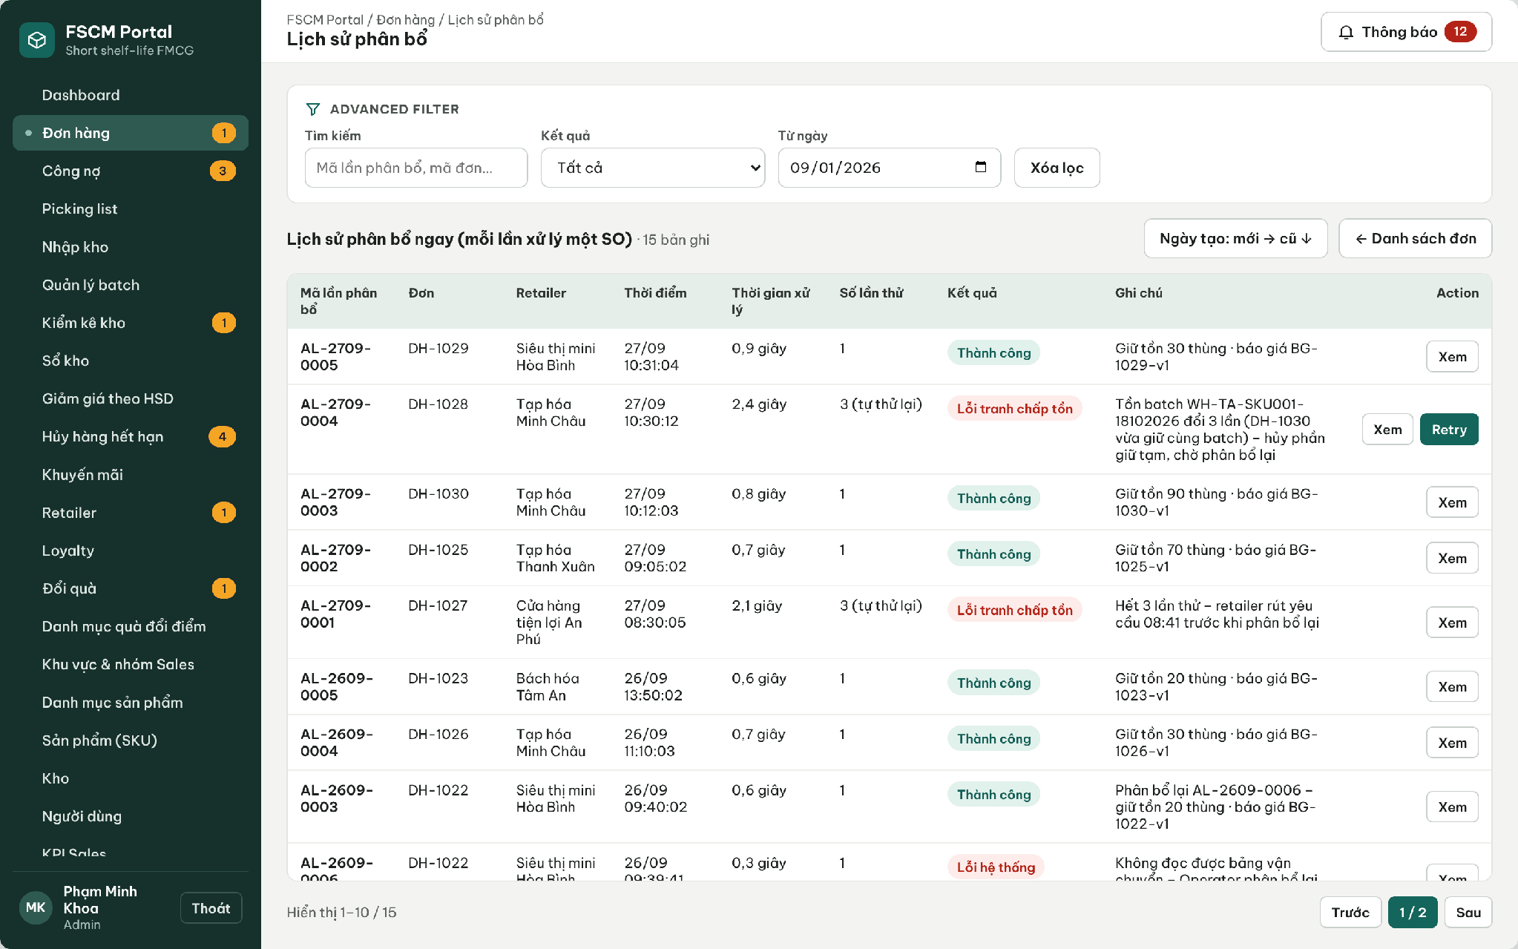
Figure 30. Web Portal – Allocation history: attempts, retries and results
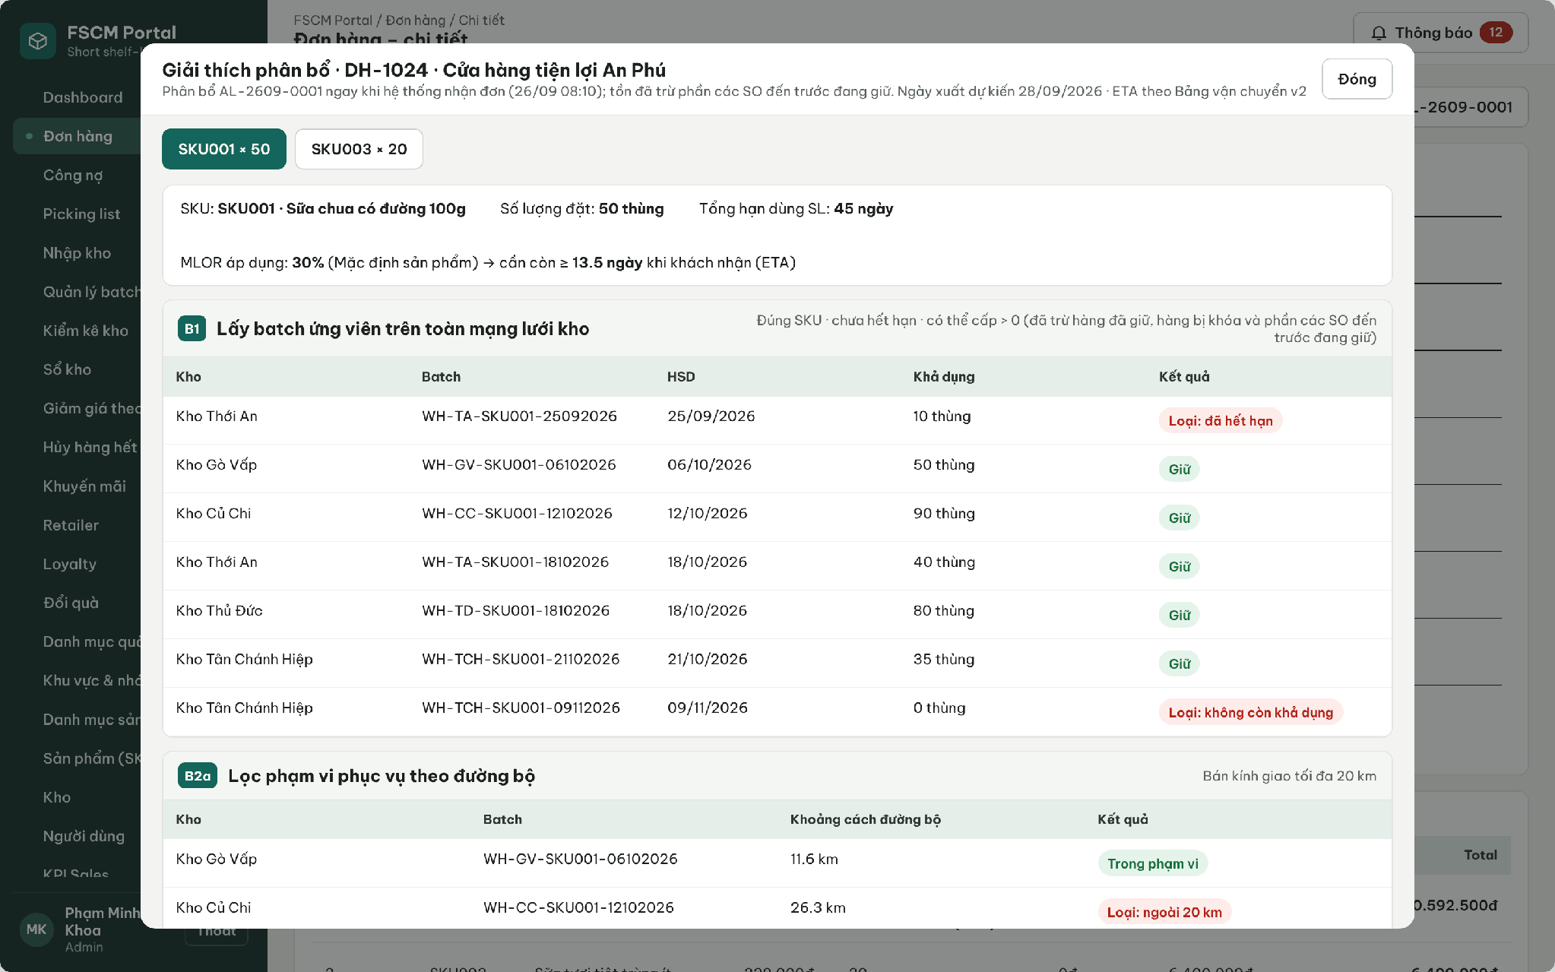
Figure 31. Web Portal – Allocation explanation per order line (B1–B4)
● Function Details:
o Actors: System – Reservation and Quotation. Secondary – Administrator, Operator (view, retry). No role approves an allocation plan or final prices.
o Fields:
▪ Attempt number, RetryOf, status, start/end time; selected batches/warehouses and quantities; line MLOR and source; scores; exclusion reasons (B1–B4); price explanation; quotation amount and ExpiresAt; retry actor/time/reason.
o Data Processing:
▪ In one transaction, for each allocation: conditional update WHERE Version = expected AND Available ≥ qty; increase Reserved and Version. Any failure rolls back the whole SO. Do not hold long database locks while scoring.
▪ On a version conflict re-read and retry up to 3 times; then end Conflict (SO AllocationConflict). A technical error ends TechnicalFailed (SO AllocationFailed).
▪ On success create the quotation (Σ Allocation.NetAmount, ExpiresAt), set the SO to Quoted and notify Retailer/Sales without exposing MLOR or internal scores.
▪ Retry creates a new attempt linked by RetryOf with an idempotency key; a repeated Retry returns the same new attempt.
o Business Rules:
▪ Available = Physical − Reserved − Locked (BR-41/71). No PO, picking list or shipment is created here (3.6.6).
o Acceptance Criteria:
▪ AC-3.7.2-01: Given a fully allocated SO, when the attempt commits, then Reserved increases by the allocated quantities in one transaction and one quotation with ExpiresAt is issued. (BR-38, BR-41)
▪ AC-3.7.2-02: Given 100 concurrent requests on one batch with Available 50, when they commit, then Available never becomes negative and losing attempts retry or end Conflict. (BR-38, CR-07)
▪ AC-3.7.2-03: Given Retry pressed twice on a TechnicalFailed attempt, when processed, then exactly one new attempt and at most one reservation and quotation exist. (BR-38)
▪ AC-3.7.2-04: Given a Sales or Retailer account, when the retry endpoint is called, then MSG006 is returned. (CR-01)
o Traceability: UC-12A | BR-38, BR-40, BR-41 | CR-07, CR-13 | Screens: Allocation Attempts, Attempt Trace; Non-screen: Reservation and Quotation

3.7.3 Estimate Receipt Time by Distance Band
● Function type: Non-screen function – runs automatically, no screen of its own (see Batch Allocation (B1–B5), step B2 in 3.1.4).
● Function trigger:
o A warehouse/batch is evaluated for an order.
● Function description: Calculates a configured approximate receipt time needed by service eligibility and MLOR verification.
● Screen layout: Not applicable – non-screen function.
● Function Details:
o Actors: System – Batch Allocation step B2 (3.1.4). Secondary – Administrator maintains the transit table (3.12.1).
o Fields:
▪ Service distance; configured band; transit/handling time estimate.
o Data Processing:
▪ Select matching admin-configured TransitTimeRule distance band.
▪ Compute estimated arrival from the applicable operational estimate.
▪ Use the estimate for checking MLOR and commitment eligibility.
o Business Rules:
▪ The estimate is not a guaranteed delivery time.
▪ Bands (BR-32): 0 – 10 km = 1 day; > 10 – 20 km = 2 days; > Dmax (default 20 km) = not served. Distance is the shortest road distance between warehouse and retailer locations (3.12.1). Dispatch slots, picking preparation and buffer times are SystemConfiguration values; the MVP uses one dispatch slot per day and no holiday calendar. The table version used is stored on the order line as a snapshot.
o Acceptance Criteria:
AC ID | Acceptance criterion (Given / When / Then) | Ref.
AC-3.7.3-01 | Given a retailer 10.0 km from a warehouse, when ETA is computed, then the 1-day band is used; at 10.1 km the 2-day band is used. | BR-32
AC-3.7.3-02 | Given a retailer 20.1 km away, when the warehouse is evaluated, then it is excluded as not served (MSG024). | BR-31, BR-32
AC-3.7.3-03 | Given the transit table is changed after an order was allocated, when the order is reviewed, then the stored table version remains on the order line. | BR-32, BR-57
o Traceability: UC-85 (input) | BR-31, BR-32, BR-57 | Non-screen: Batch Allocation (B2)

3.7.4 Effective Line MLOR Validation
● Function type: Non-screen function – runs automatically, no screen of its own (see Effective MLOR Resolution in 3.1.4).
● Function trigger:
o Each order line is evaluated when its SO is allocated, and again at dispatch.
● Function description: Determines the effective MLOR of each order line and checks every candidate batch portion against it at the estimated time of receipt.
● Screen layout: Not applicable – non-screen function.
● Function Details:
o Actors: System – Effective MLOR Resolution, Batch Allocation (B3). Secondary – Administrator sees the result in the attempt trace (3.7.2).
o Fields:
▪ Retailer SKU MLOR; retailer Category MLOR; product default MLOR; product shelf life SL; batch EXP; ETA.
o Data Processing:
▪ Determine the effective ratio before filtering: retailer SKU ratio, else retailer Category ratio (nearest ancestor), else product default. Store the value and its source on the order line.
▪ Check EXP − ETA ≥ effective ratio × SL. ETA includes waiting for allocation, preparation, buffer, dispatch slots and transit. Do not compare days directly with a percentage.
▪ Filter, then score. At dispatch, repeat the check with the current ETA; a failure blocks dispatch.
▪ Example: SL 100 days, remaining life 70 days, ETA in 2 days → 68% remaining on receipt. An MLOR of 80% rejects the batch; an MLOR of 60% passes the life check; other eligibility checks still apply. The discount percentage never changes the ratio.
o Business Rules:
▪ BR-11, BR-18, BR-31, BR-61, BR-78 apply.
o Acceptance Criteria:
AC ID | Acceptance criterion (Given / When / Then) | Ref.
AC-3.7.4-01 | Given retailer R2 with Category 30% and SKU_A 80%, when an SKU_A standard line is evaluated, then the effective MLOR is 80% and its source 'SKU' is stored. | BR-11
AC-3.7.4-02 | Given a retailer with no SKU or Category MLOR, when a line is evaluated, then the product default MLOR is used. | BR-11
AC-3.7.4-03 | Given SL = 20 days, MLOR = 30% and EXP − ETA = exactly 6.0 days, when the batch is checked, then it is eligible (equality passes); at 5.9 days it is rejected (MSG022). | BR-61
AC-3.7.4-04 | Given ETA moves later between allocation and dispatch so a batch no longer passes, when dispatch is confirmed, then it is blocked and the shipment goes to exception handling. | BR-46, BR-61
o Traceability: UC-21, UC-87 | BR-11, BR-18, BR-31, BR-61, BR-78 | CR-08 | Non-screen: Effective MLOR Resolution

3.8 Warehouse Receiving & Batch Inventory

3.8.1 Create and Process Goods Receipt
● Function type: Screen function (see 3.1.2).
● Function trigger:
o Open Goods Receiving or a stock-in request.
o Enter or confirm received goods and batch details.
● Function description: Records warehouse stock-in with traceable product, batch, expiry and quantity information.
● Screen layout: see Figures 32 – 33
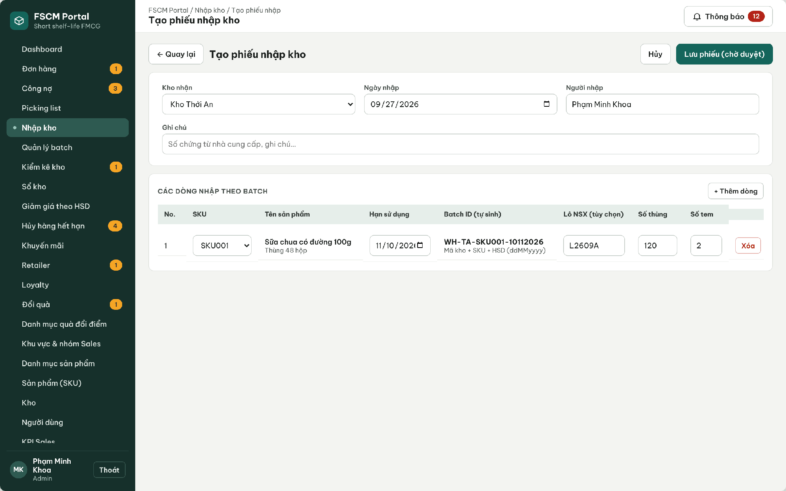
Figure 32. Web Portal – Create goods receipt (pending approval)
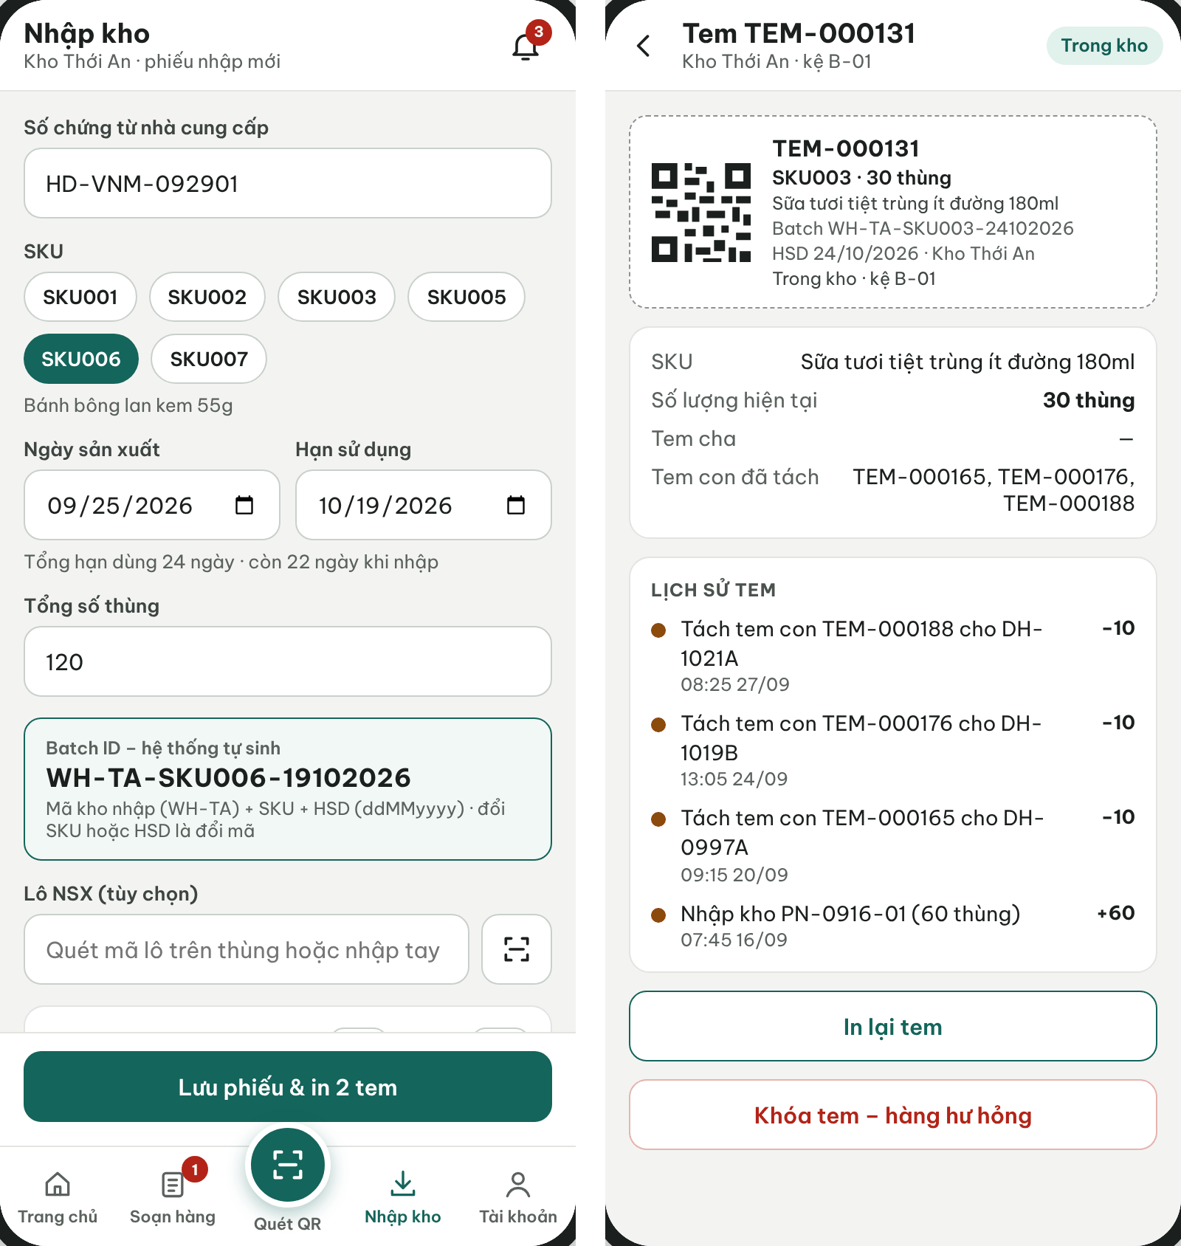
Figure 33. Warehouse App – Goods receipt with generated Batch ID and QR label lookup
● Function Details:
o Actors: Primary – Warehouse Keeper (creates receipts for assigned warehouses). Secondary – Administrator (creates receipts for any warehouse and approves). System – Batch and Label Generation (3.1.4).
o Fields:
▪ Warehouse; product name and SKU; batch identifier; expiration; received quantity.
o Data Processing:
▪ Validate the receiving request and input details.
▪ Create a receipt and receipt lines with the product name visible on the receiving slip.
▪ Post accepted quantities to batch-level inventory and preserve receipt history.
o Business Rules:
▪ Receiving and inventory balances must be traceable by Batch and warehouse.
▪ Workflow: Draft → Pending approval (submitted, MSG017) → Approved (MSG018) or Rejected with reason. OnHand changes only on approval, exactly once. The keeper records the actually counted quantity; a difference from the supplier document is entered as a note and only the counted quantity is posted. Production date must be before expiry and not in the future (MSG016). Receipts with the same warehouse, SKU and expiry are merged into one batch (BR-09).
o Acceptance Criteria:
AC ID | Acceptance criterion (Given / When / Then) | Ref.
AC-3.8.1-01 | Given a submitted receipt of 120 cartons SKU006 with expiry 19/10/2026 at WH-TA, when the Administrator approves it, then OnHand of batch WH-TA-SKU006-19102026 increases by 120 once and QR labels are generated. | BR-09, BR-10, BR-42
AC-3.8.1-02 | Given a receipt still Pending approval, when inventory is viewed, then OnHand has not changed. | BR-42
AC-3.8.1-03 | Given Approve is clicked twice, when both requests are processed, then stock increases only once. | CR-07
AC-3.8.1-04 | Given a second receipt with the same warehouse, SKU and expiry, when it is approved, then it is added to the existing batch rather than creating a new one. | BR-09
AC-3.8.1-05 | Given a Warehouse Keeper of WH-TA, when a receipt for WH-GV is submitted, then it is rejected with MSG006. | BR-03
o Traceability: UC-04, UC-06, UC-11 | BR-03, BR-06, BR-09, BR-10, BR-42 | CR-04, CR-05, CR-16 | Screens: Goods Receipt List, Create Goods Receipt, Warehouse App Receive

3.8.2 View Warehouse Inventory and Batch Details
● Function type: Screen function (see 3.1.2).
● Function trigger:
o Open Warehouse Inventory or scan a batch QR.
● Function description: Displays stock balance, batch expiry, current status and eligible quantities.
● Screen layout: see Figure 34
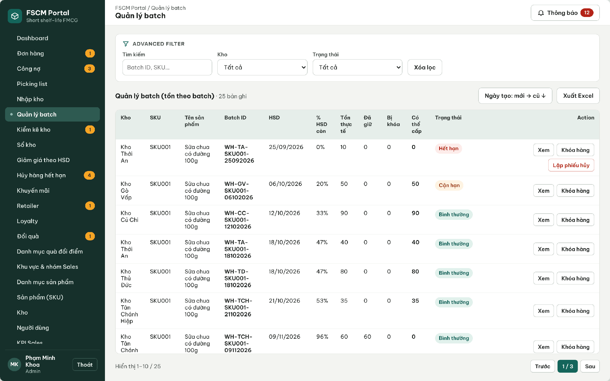
Figure 34. Web Portal – Batch management: OnHand, Reserved, Locked, Available and near-expiry status
● Function Details:
o Actors: Primary – Warehouse Keeper (assigned warehouses), Administrator (all warehouses). System – Expired Batch Detection (3.1.4).
o Fields:
▪ Warehouse; SKU; Batch ID; expiry; OnHand, Reserved and Available; no stock Held stage in this design.
o Data Processing:
▪ Scope inventory query to authorized warehouses.
▪ Retrieve batch-level balances and relevant receiving history.
o Business Rules:
▪ Available = Physical − Reserved − Locked. Each unavailable physical quantity is excluded once; reserved stock affected by a lock is handled under BR-71, not subtracted twice.
▪ Stock lock (BR-71): lock unusable quantity with evidence without reducing OnHand. In Available = OnHand − Reserved − Locked, Locked is only the locked portion outside active Reserved quantity. An overlapping lock flags the affected reservation/order as Needs handling and blocks dispatch but does not deduct availability twice. Resolve/release the reservation before write-off; only Administrator unlocks.
o Acceptance Criteria:
AC ID | Acceptance criterion (Given / When / Then) | Ref.
AC-3.8.2-01 | Given OnHand 50, Reserved 20 and 5 additional locked units outside reservations, Available is 25. If the same locked 5 are entirely within Reserved, Available remains 30 and the affected order is blocked; do not subtract them twice. | BR-41, BR-71
AC-3.8.2-02 | Given a lock that overlaps quantity already reserved for an order, when it is saved, then that order gets the NeedsAttention flag and no shipment of it can be dispatched. | BR-46, BR-71
AC-3.8.2-03 | Given a batch past its expiry date, when the daily detection job runs, then the batch is marked Expired and excluded from allocation and dispatch (MSG019). | BR-43
AC-3.8.2-05 | Given a Warehouse Keeper, when inventory of an unassigned warehouse is requested, then MSG006 is returned. | BR-03
o Traceability: UC-30, UC-33 | BR-03, BR-41, BR-43, BR-71 | CR-07 | Screens: Batch Management, QR Lookup; Non-screen: Expired Batch Detection

3.8.3 Manage Warehouse Inventory Write-Off
● Function type: Screen function (see 3.1.2).
● Function trigger:
o Open Write-off Management.
o Create a write-off with affected batches, reason and supporting evidence.
o An authorized reviewer processes the submitted request.
● Function description: Records proposed removal of unusable or expired batch stock with supporting files.
● Screen layout: see Figures 35 – 36
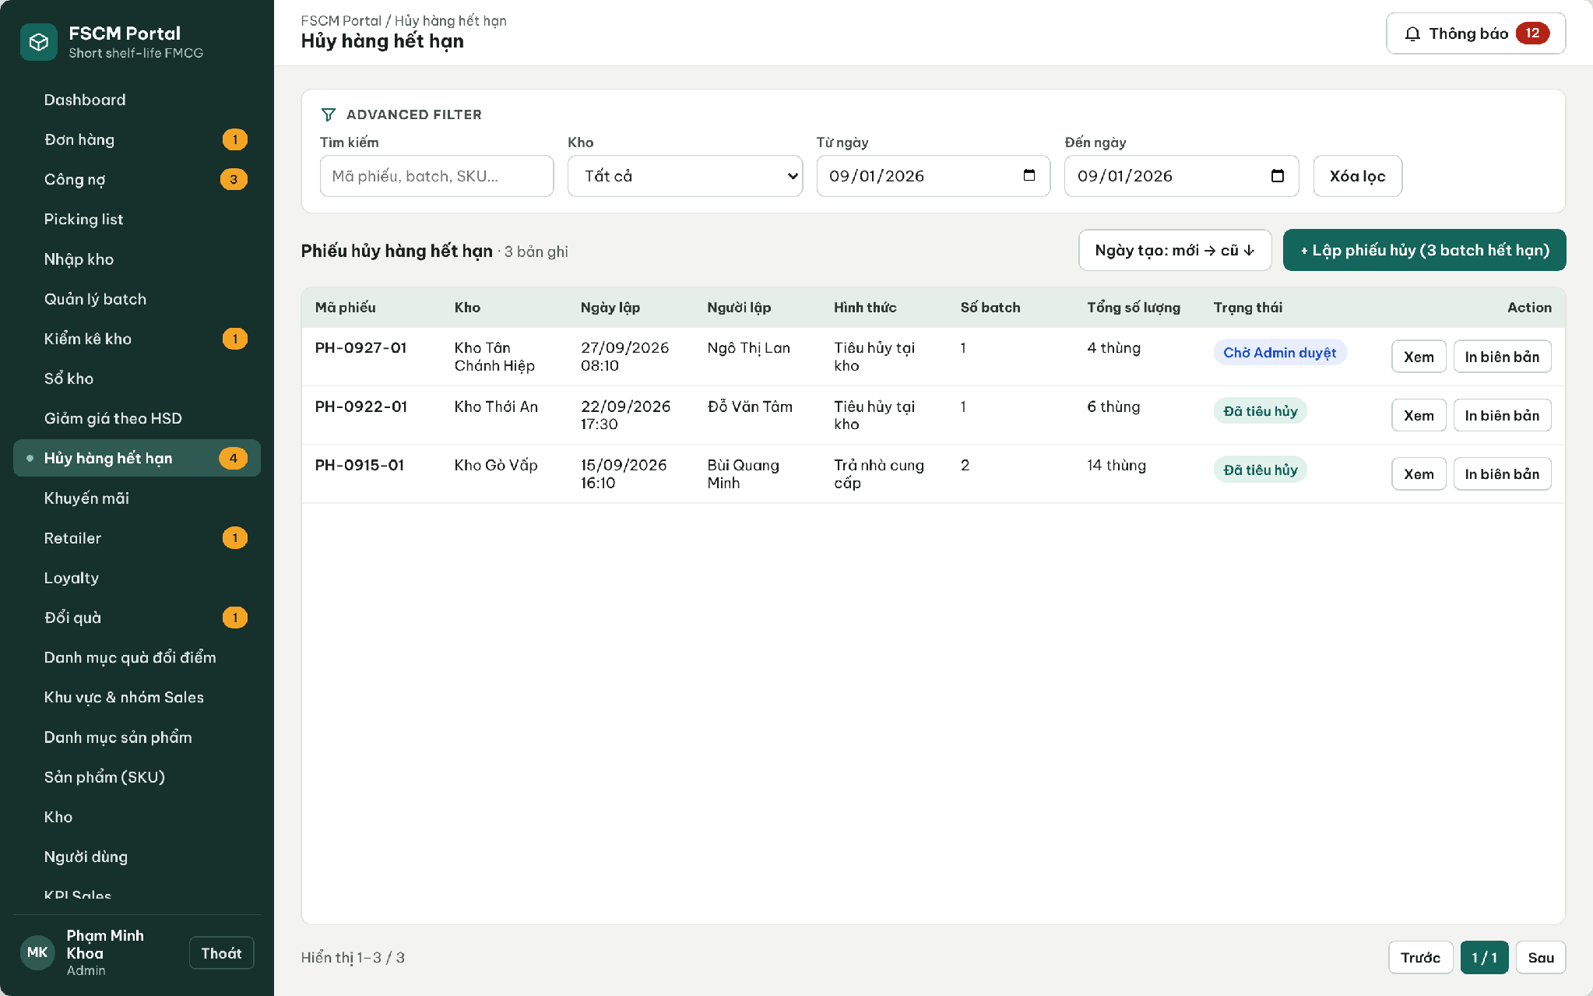
Figure 35. Web Portal – Expired-stock disposal records
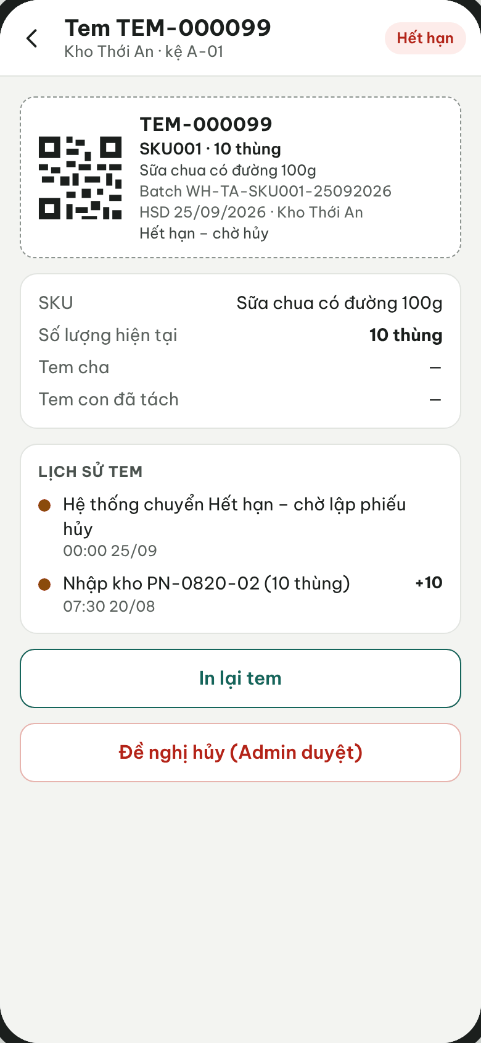
Figure 36. Warehouse App – Expired label with disposal request (Admin approval)
● Function Details:
o Actors: Primary – Warehouse Keeper (creates and submits). Secondary – Administrator (approves or rejects; may also create). System – Write-off Posting (3.1.4).
o Fields:
▪ Affected Batch ID; quantity; reason; evidence attachment; approval status.
o Data Processing:
▪ Validate batch ownership, status and available quantity.
▪ Save request, supporting evidence and audit details.
▪ Apply approved stock reductions while preserving movement traceability.
o Business Rules:
▪ Requests for unapproved write-off must not silently alter confirmed stock balances.
▪ Draft → Pending Admin approval → Approved (stock deducted) or Rejected. Only Administrator approves. Requested quantities may not exceed OnHand − Reserved and may not overlap any unresolved active reservation. Resolve affected order/reservation first, revalidate stock and lock quantities, then deduct the approved quantity and matching lock once. Disposal method and evidence are mandatory (MSG047).
o Acceptance Criteria:
AC ID | Acceptance criterion (Given / When / Then) | Ref.
AC-3.8.3-01 | Given a Pending write-off of 4 cartons, when the Administrator approves it, then OnHand decreases by 4 exactly once and any matching locked quantity is cleared (MSG048). | BR-44, BR-71
AC-3.8.3-02 | Given write-off quantity overlaps unresolved active reservations, submission/posting is rejected even if aggregate physical stock exists. Resolve the reservation first, then revalidate quantities and post exactly once. | BR-44, BR-71, CR-16
AC-3.8.3-03 | Given a Rejected write-off, when inventory is viewed, then no stock quantity has changed. | BR-44
AC-3.8.3-04 | Given a write-off without evidence, when it is submitted, then it is blocked (MSG001). | BR-44, CR-16
o Traceability: UC-65 – UC-70 | BR-43, BR-44, BR-58, BR-71 | CR-16, CR-22 | Screens: Write-off List, Write-off Details; Non-screen: Write-off Posting

3.9 Picking & Retailer Receipt Confirmation

3.9.1 Scan Batch QR and Confirm Picking List
● Function type: Screen function (see 3.1.2).
● Function trigger:
o Open an assigned warehouse picking list.
o Scan the source batch QR and enter the actual picked quantity.
o Confirm completion of the picking list.
● Function description: Fulfills a warehouse picking list by recording actual batch quantities rather than generating a separate Goods Issue document.
● Screen layout: see Figures 37 – 38
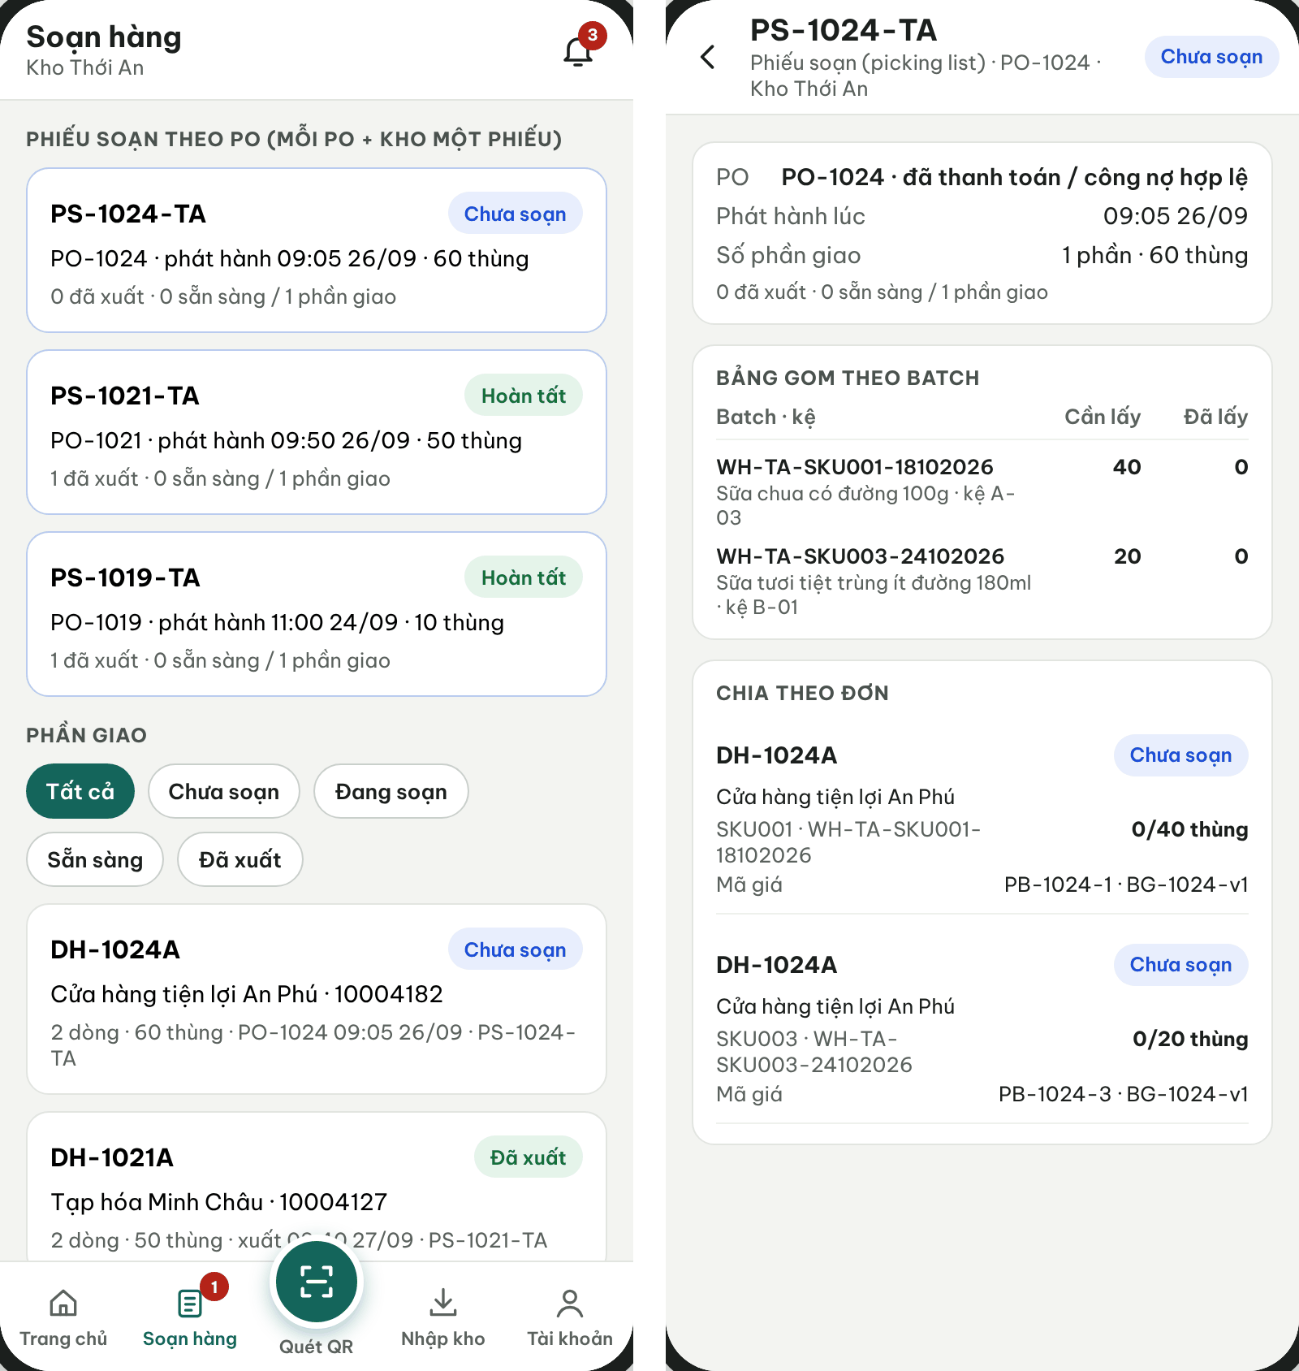
Figure 37. Warehouse App – Picking slips per PO and warehouse with batch lines
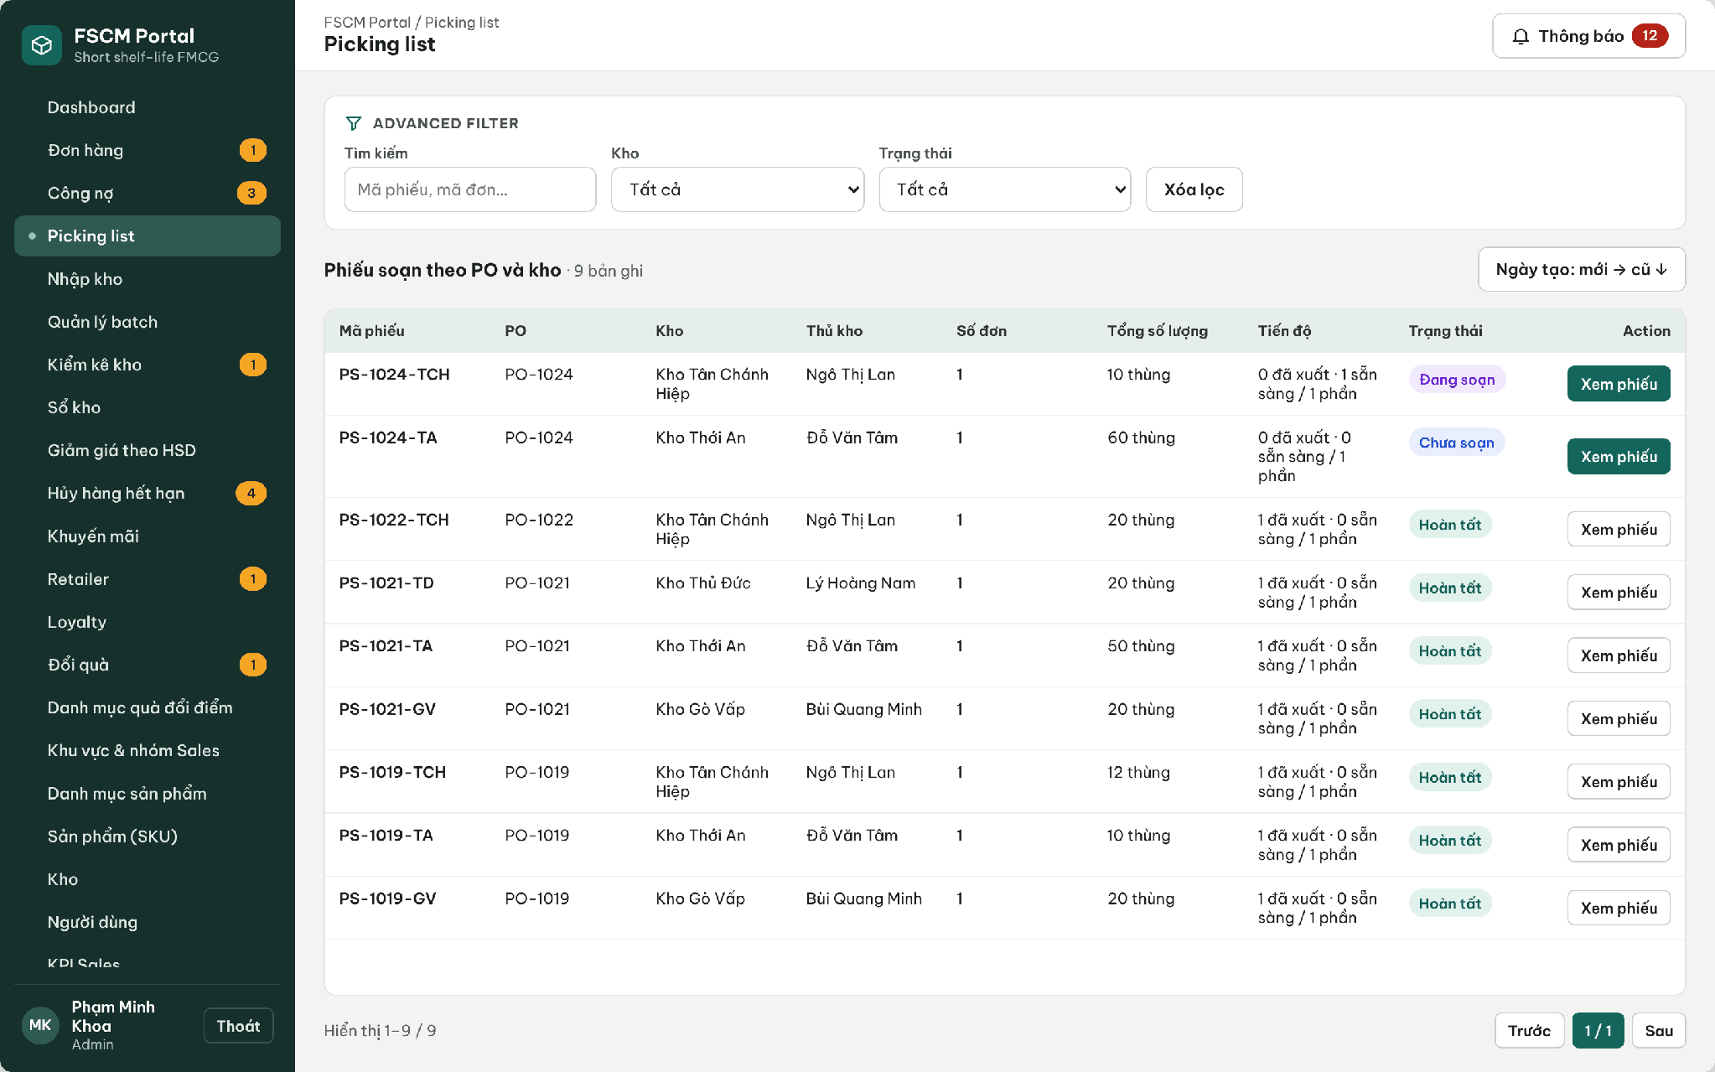
Figure 38. Web Portal – Picking slips per PO and warehouse
● Function Details:
o Actors: Primary – Warehouse Keeper of the warehouse. Secondary – Administrator resolves picking exceptions. System – Portion Ready Confirmation, Dispatch Readiness Check, Dispatch Posting, Label Split (3.1.4).
o Fields:
▪ Picking list item; source batch QR; actual picked quantity; stock-out batch QR.
o Data Processing:
▪ Validate scanned Batch ID against the assigned PickingItem.
▪ When part of a batch is picked, preserve remaining stock and issue a traceable stock-out batch / QR as needed.
▪ Record readiness per expected warehouse portion. Before dispatch recheck PO, Prepaid Paid or valid Credit terms, all warehouses fully ready, no unresolved lock/exception, and valid expiry/ETA/MLOR/deadline. Only successful idempotent dispatch reduces Reserved and OnHand; scanning or picking alone does not issue stock.
o Business Rules:
▪ A PO code alone is not proof of current dispatch eligibility. Every guard in BR-46 must pass at dispatch time. A repeat returns the existing stock-out result without another deduction.
▪ Mismatch: a scan may not exceed the listed quantity and must match warehouse, batch and picking list (MSG038). If fewer cartons can be picked (shortage, damage, wrong label), the keeper records an exception; the order becomes Needs handling, no warehouse ships its portion, and the Administrator either resolves it or cancels the order as an exception before dispatch with a refund obligation if paid (BR-26, BR-46). The keeper cannot substitute another batch.
o Acceptance Criteria:
AC ID | Acceptance criterion (Given / When / Then) | Ref.
AC-3.9.1-01 | Given an order that is not yet a PO, when picking slips are listed, then it does not appear. | BR-45
AC-3.9.1-02 | Given a listed quantity of 40 from label TEM-000118, when the keeper scans a label of another batch, then the scan is rejected with MSG038. | BR-45
AC-3.9.1-03 | Given 10 cartons picked from a 40-carton label, when the scan is confirmed, then a child label of 10 is created linked to the parent and the parent keeps 30. | BR-10, CR-05
AC-3.9.1-04 | Given portion W1 Ready and W2 not Ready, when dispatch of W1 is requested, then it is blocked. | BR-46
AC-3.9.1-05 | Given dispatch is confirmed twice for the same shipment, when processed, then OnHand and Reserved decrease once by the dispatched quantity. | BR-41, BR-47
AC-3.9.1-06 | Given Ready warehouse portions but failed Prepaid/Credit, lock/exception or expiry/ETA/MLOR/deadline guard, block dispatch without deduction. Valid Credit does not require a Prepaid payment. | BR-46, BR-71
o Traceability: UC-31, UC-32 | BR-10, BR-26, BR-41, BR-45 – BR-47 | CR-05, CR-07, CR-13 | Screens: Picking Lists, Picking Details; Non-screen: Portion Ready Confirmation, Dispatch Posting

3.9.2 Confirm Retailer Receipt by QR
● Function type: Screen function (see 3.1.2).
● Function trigger:
o Open an order receipt confirmation.
o Scan the issued stock-out batch QR and confirm received quantity.
● Function description: Reconciles actually received quantities with the batch identifiers issued by the warehouse.
● Screen layout: see Figure 39
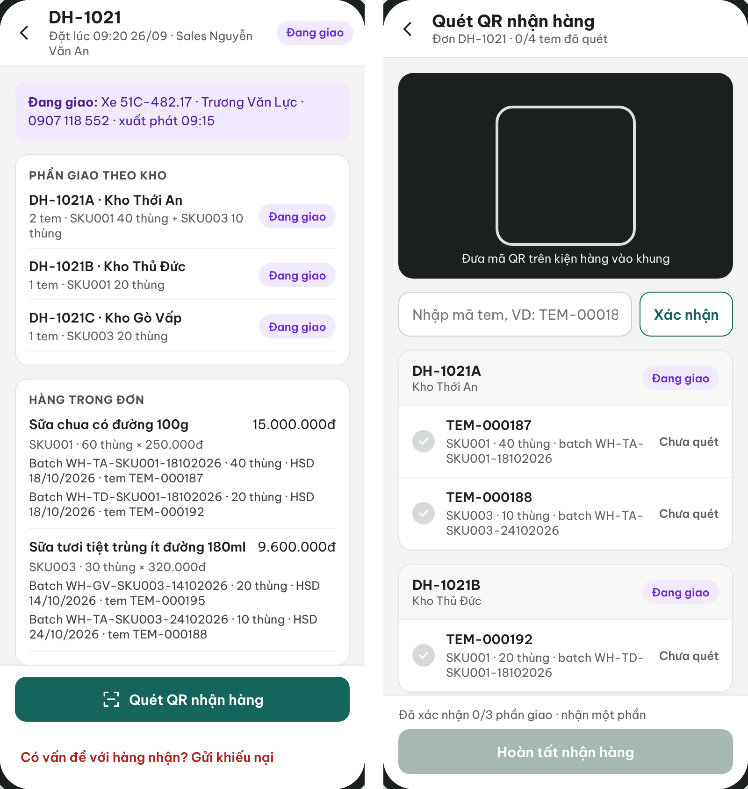
Figure 39. Retailer App – Delivering order with shipments and QR receipt scan
● Function Details:
o Actors: Primary – Retailer. System – Receipt Validation, Order Completion (3.1.4).
o Fields:
▪ Order/shipment; issued QR/batch; dispatched quantity; actual received and damaged quantities; computed missing quantity; receipt actor/time.
o Data Processing:
▪ Check QR label matches a batch issued for the order.
▪ Compare the receipt quantities with the actual dispatched shipment line/batch quantities. A QR scan or confirmation record alone does not establish full receipt.
▪ Preserve mismatch details for any discrepancy workflow.
o Business Rules:
▪ Do not create retail-store inventory.
▪ Each shipment is confirmed once with 0 ≤ damaged ≤ received ≤ dispatched; missing = dispatched − received. Damaged is a subset of received. Delivered requires every portion actually received in full. Missing/damaged quantities retain their actual values and open an exception/complaint; no early completion or points while unresolved. A replay returns the existing confirmation without duplicate effects.
o Acceptance Criteria:
AC ID | Acceptance criterion (Given / When / Then) | Ref.
AC-3.9.2-01 | Given W1 and W2 shipments, W1 confirmation alone does not set Delivered. Both confirmations must show received=dispatched for every line; a confirmed shortage remains an exception. | BR-49
AC-3.9.2-02 | Given a label issued for another retailer's order, when it is scanned, then it is rejected. | BR-49, CR-17
AC-3.9.2-03 | Given dispatched 30, received 28 and damaged 0, confirmation records missing 2 and prompts complaint handling. The order is not Delivered and gets no completion/points until its exception and money are resolved. | BR-49, BR-50, BR-54
AC-3.9.2-04 | Given damaged 3 and received 2, when submitted, then it is rejected because damaged cannot exceed received. | CR-17
AC-3.9.2-05 | Given a confirmation resent after a network error, when processed, then no second receipt, payment due date or loyalty event is created. | BR-47, BR-54
o Traceability: UC-26 | BR-49, BR-50, BR-52, BR-54 | CR-17 | Screens: Retailer Order Details, Scan QR Receipt; Non-screen: Receipt Validation

3.9.3 Report Receipt Discrepancy
● Function type: Screen function (see 3.1.2).
● Function trigger:
o Open a dispatched or received shipment, including zero actual receipt, and select Report Issue.
o Provide quantity/condition and evidence; authorized staff process the report.
● Function description: Reports missing/damaged goods without automatically changing the recorded delivery outcome.
● Screen layout: see Figures 40 – 41
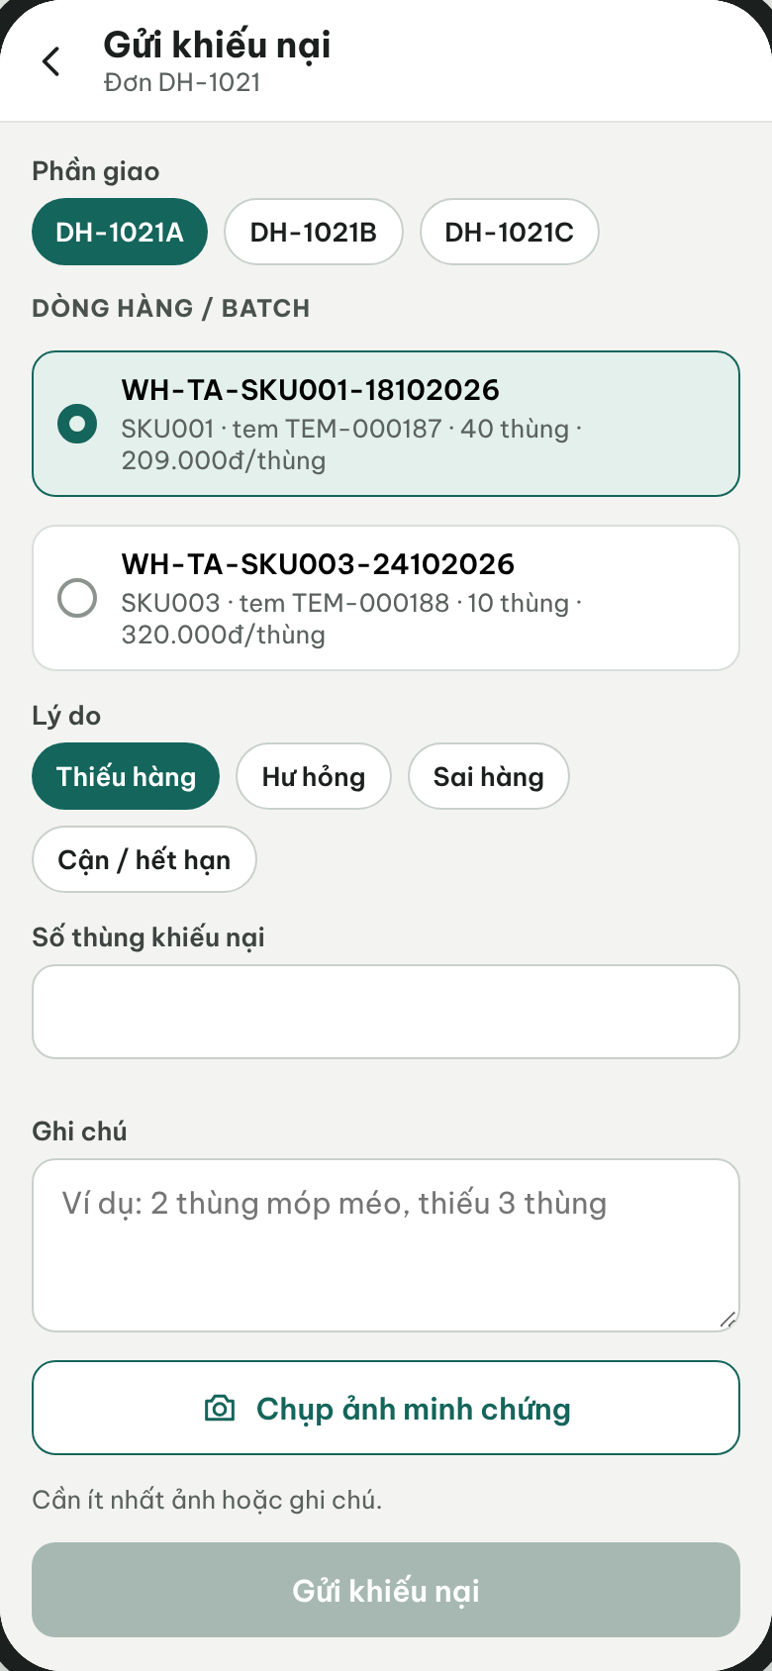
Figure 40. Retailer App – Submit complaint by shipment, line/batch and reason
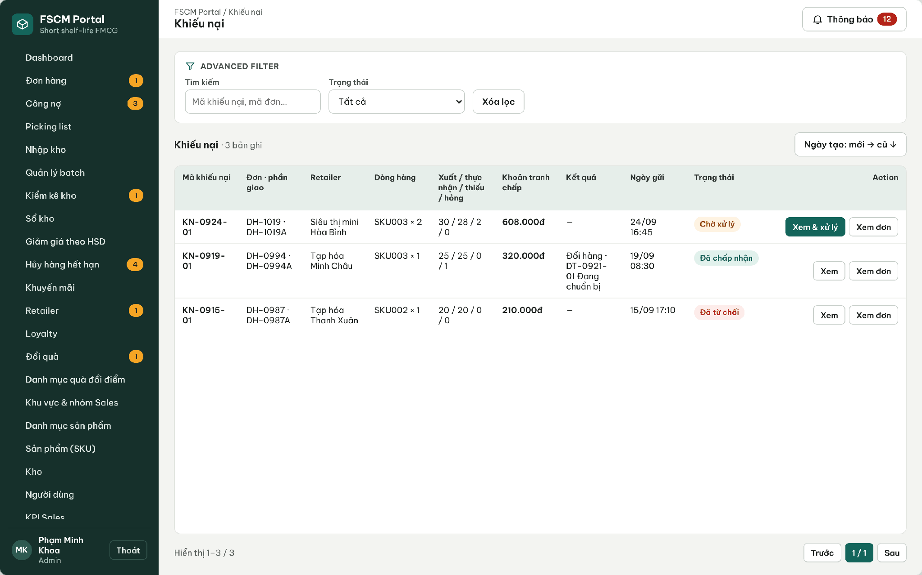
Figure 41. Web Portal – Complaints with dispatched / received / missing / damaged quantities
● Function Details:
o Actors: Primary – Retailer (submits). Secondary – Operator (checks evidence and prepares a recommendation), Administrator (accepts or rejects). System – Complaint Adjustment (3.1.4).
o Fields:
▪ Order; affected batch; affected quantity; issue type; evidence / notes.
o Data Processing:
▪ Validate order and recipient ownership.
▪ Create a separate discrepancy record and route to the Operator.
▪ Track investigation and resolution independently of receipt status.
o Business Rules:
▪ A complaint does not automatically reverse delivery or stock. Track disputed net value; an approved adjustment reduces debt or creates a manual refund obligation.
▪ Financial adjustments and manual refunds follow BR-67–BR-70. Automatic returns, replacement goods and bank settlement are outside scope.
o Acceptance Criteria:
AC ID | Acceptance criterion (Given / When / Then) | Ref.
AC-3.9.3-01 | Given a delivered shipment, when the Retailer submits a complaint for 1 carton of batch A1 with a photo, then a KN record is created with disputed value = 1 × actual net unit price (72,000 VND) and delivery status is unchanged (MSG042). | BR-50, BR-67
AC-3.9.3-02 | Given a complaint quantity greater than the dispatched quantity of that line/batch, when submitted, then it is rejected. | CR-17
AC-3.9.3-03 | Given a complaint under review on a credit order, when overdue reminders run, then the disputed portion is excluded and the undisputed debt keeps its due date. | BR-52, BR-67
AC-3.9.3-04 | Given a complaint is submitted, when it is saved, then physical stock is not changed. | BR-50, CR-17
o Traceability: UC-17, UC-29 | BR-50, BR-52, BR-67 – BR-70 | CR-17 | Screens: Submit Complaint, Complaint List; Non-screen: Complaint Adjustment

3.10 Payment & Loyalty Management

3.10.1 Record Order Payment
● Function type: Screen function (see 3.1.2).
● Function trigger:
o A verified PayOS webhook confirms a Prepaid payment; or the Operator/Sales records a payment receipt against open Credit invoices.
● Function description: Records Prepaid payments confirmed by PayOS and Credit payment receipts that can cover several invoices, allow partial payment and keep any remainder as UnappliedCredit; receipts can be reversed with a reason.
● Screen layout: see Figures 42 – 44
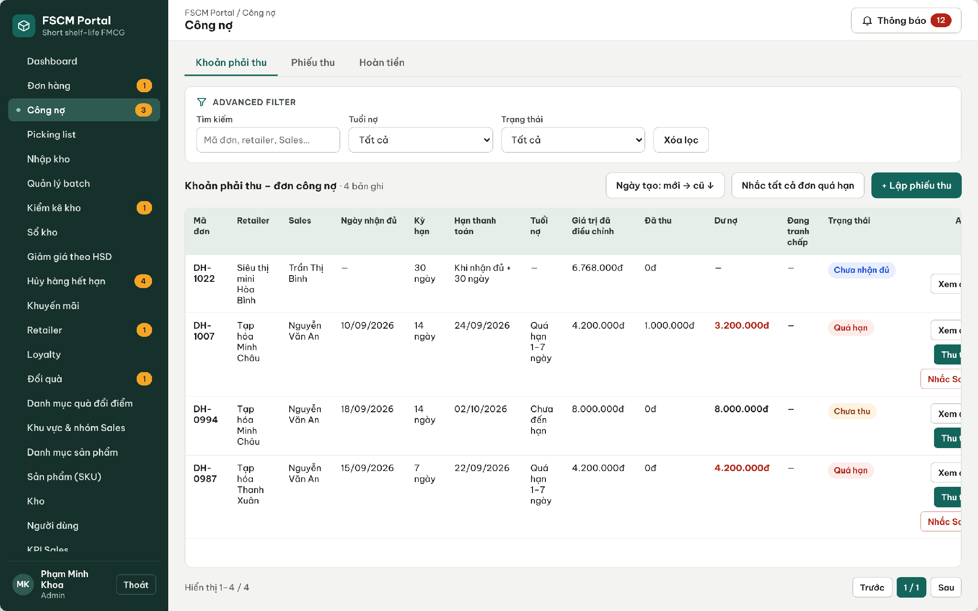
Figure 42. Web Portal – Receivables of credit orders: due date, adjusted value, collected, disputed
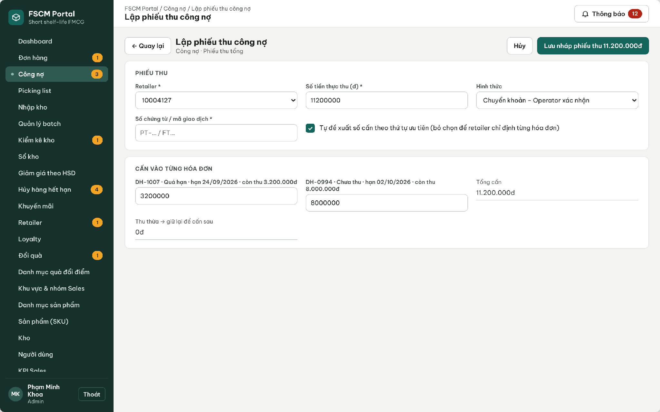
Figure 43. Web Portal – Create payment receipt allocated across invoices
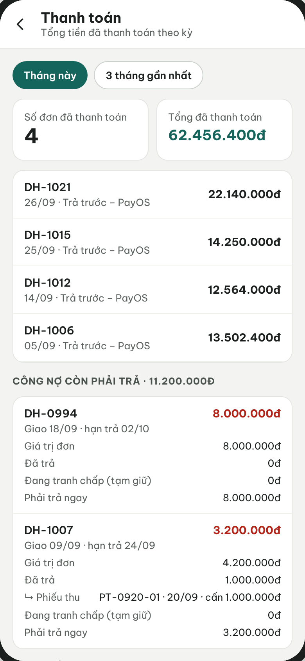
Figure 44. Retailer App – Payments and outstanding credit
● Function Details:
o Actors: Primary – Operator (records and confirms payment receipts). Secondary – Sales (records receipts for assigned retailers), Retailer (pays via PayOS or transfer, views obligations). External – PayOS. System – Debt Due Date and Status (3.1.4).
o Fields:
▪ Payment receipt: amount, reference, evidence, received date; allocation lines (invoice, amount); UnappliedCredit; status (Draft, Confirmed, Reversed with reason). Prepaid: PayOS reference and status.
o Data Processing:
▪ Check the receipt reference for duplicates; Σ allocated ≤ amount received and each line ≤ the invoice balance.
▪ Allow partial payment; the remainder of a receipt stays UnappliedCredit and can be allocated later. A reversal restores the invoice balances. Prepaid payments are confirmed only by the verified PayOS webhook.
▪ Update the Payment record independently of the SalesOrder status.
o Business Rules:
▪ Prepaid is paid via PayOS after quotation acceptance and before the PO; Credit is paid after receipt within the snapshotted term. COD and cash are not used. Paid cancellations/accepted claims use BR-66–BR-70.
▪ Manual refund evidence and approval follow BR-66–BR-70. PayOS reconciliation is limited to webhook verification.
o Acceptance Criteria:
AC ID | Acceptance criterion (Given / When / Then) | Ref.
AC-3.10.1-01 | Given a credit order fully received on 18/09 with a 14-day term, when the due date is computed, then it is 02/10. | BR-52
AC-3.10.1-02 | Given invoices of 5,000,000 and 3,000,000 VND and a receipt of 6,000,000 VND, when the receipt is allocated 5,000,000 + 1,000,000, then the first is Paid, the second PartiallyPaid with 2,000,000 VND outstanding. | BR-52, BR-69
AC-3.10.1-03 | Given an unpaid credit order past its due date, when the 08:00 job runs, then it is Overdue and Sales and the Operator are notified (MSG044). | BR-53
AC-3.10.1-04 | Given a collection submitted twice, when processed, then one payment record exists. | CR-19
AC-3.10.1-05 | Given an order still Awaiting final price, when a payment is attempted, then it is rejected. | BR-66
o Traceability: UC-16, UC-23, UC-35, UC-36, UC-91 (PayOS, payment receipt) | BR-51 – BR-53, BR-66, BR-69 | CR-18, CR-19 | Screens: Receivables, Order Details – Collect payment, Retailer Payments; Non-screen: Debt Due Date and Status

3.10.2 View Retailer Loyalty Points
● Function type: Screen function (see 3.1.2).
● Function trigger:
o Open the Retailer loyalty screen or assigned retailer view.
● Function description: Displays retailer point balance and available loyalty benefits.
● Screen layout: see Figures 45 – 46
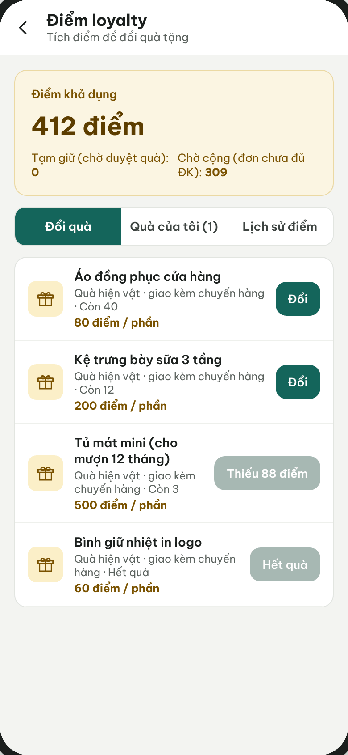
Figure 45. Retailer App – Loyalty points, gifts and point history
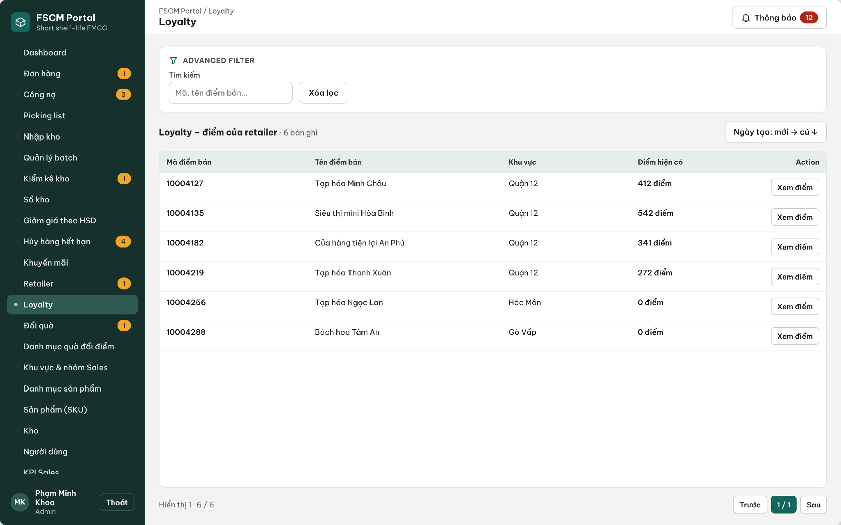
Figure 46. Web Portal – Retailer loyalty points
● Function Details:
o Actors: Primary – Retailer (own points). Secondary – Sales (retailer currently served), Administrator (all retailers).
o Fields:
▪ Retailer loyalty balance; earned and redeemed points; transaction history.
o Data Processing:
▪ Retrieve the retailer loyalty summary and transactions.
▪ Restrict Sales visibility to the currently assigned retailer.
o Business Rules:
▪ Loyalty transactions must retain an auditable earn/redeem history.
o Acceptance Criteria:
AC ID | Acceptance criterion (Given / When / Then) | Ref.
AC-3.10.2-01 | Given points earned, held, used and corrected, when the Retailer opens the loyalty screen, then available points = total − held and every movement shows its source order or request. | BR-54, BR-55
AC-3.10.2-02 | Given a Sales user not assigned to the retailer, when its loyalty is requested, then MSG006 is returned. | BR-03
AC-3.10.2-03 | Given a negative corrected balance, when it is displayed, then it is shown as negative and redemption buttons are disabled. | BR-54
o Traceability: UC-76, UC-82 | BR-03, BR-54, BR-55 | CR-20 | Screens: Retailer Loyalty, Loyalty (Portal)

3.10.3 Redeem Loyalty Reward / Points
● Function type: Screen function (see 3.1.2).
● Function trigger:
o Retailer requests a reward; Sales may apply a permitted loyalty benefit.
o Administrator reviews a reward request when approval is required.
● Function description: Supports reward redemption and loyalty-program management for retailers.
● Screen layout: see Figures 47 – 48
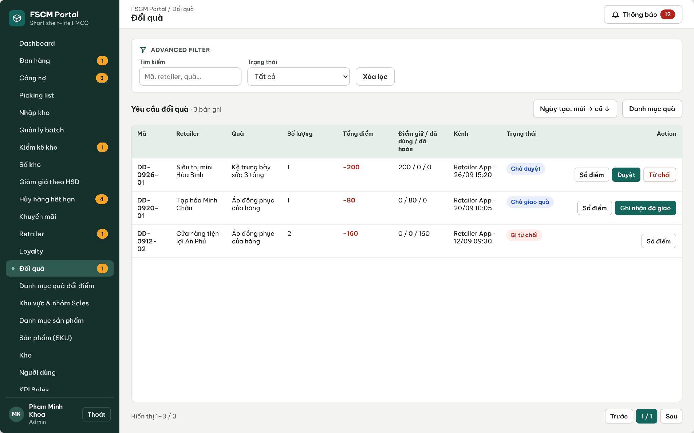
Figure 47. Web Portal – Gift redemption requests (held / used / released points)
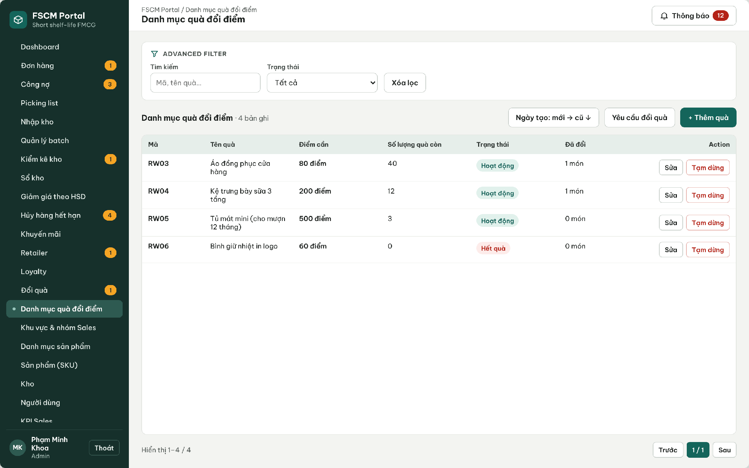
Figure 48. Web Portal – Gift catalog
● Function Details:
o Actors: Primary – Retailer (requests a gift). Secondary – Administrator (manages the gift catalog, approves/rejects, records delivery and completion). System – Gift Redemption Points (3.1.4).
o Fields:
▪ Reward; required points; retailer balance; request status; approval information.
o Data Processing:
▪ Verify reward eligibility and sufficient available points.
▪ Request holds the required points and gift stock. Approval keeps those holds while the gift awaits delivery. Authorized completion of an actually delivered request converts held points to used once. Rejected/cancelled uncompleted requests release their holds once; no additional purchase points are earned by reversal.
▪ Preserve an audit entry and communicate the outcome.
o Business Rules:
▪ The Admin manages the reward catalog and reviews redemptions.
▪ Apply BR-54–BR-55 and BR-70. Test award/correction idempotency and redemption with a negative corrected balance.
▪ Pending approval (points/gift held) → Awaiting delivery (approved; holds retained) → Delivered → Completed (authorized fulfillment confirmation; held points become used). Rejection/cancellation before completion releases unused holds only after validating the actual fulfillment stage. Preserve actor/time and idempotency. Whether Retailer confirmation is mandatory remains the source decision in 5.5 R-16; this revision does not add a new actor/use case.
o Acceptance Criteria:
AC ID | Acceptance criterion (Given / When / Then) | Ref.
AC-3.10.3-01 | Given 412 available points and a 200-point gift with stock, when the Retailer requests it, then 200 points and 1 gift are held and available points become 212 (MSG046). | BR-55, BR-75
AC-3.10.3-02 | Given 112 available points and a 200-point gift, when the request is made, then it is rejected with MSG045. | BR-75
AC-3.10.3-03 | Given a Pending request, when the Administrator rejects it, then the 200 held points and the gift stock are released exactly once. | BR-55, BR-75
AC-3.10.3-04 | Given a corrected balance of −6 points, when any redemption is requested, then it is blocked. | BR-54
AC-3.10.3-05 | Given approval is retried, one approval exists and point/gift holds remain. Given authorized completion after actual delivery is retried, held points become used and gift issuance is finalized once. | BR-55, BR-75
AC-3.10.3-06 | Given approval but gift not yet completed, required points remain held. Authorized completion of actual delivery consumes them once; rejected/cancelled unused uncompleted fulfillment releases holds once. | BR-55, BR-75
o Traceability: UC-77, UC-96, UC-97 | BR-54, BR-55, BR-70, BR-75 | CR-20 | Screens: Gift Redemption, Gift Catalog, Retailer Loyalty; Non-screen: Gift Redemption Points

3.10.4 Review Disputes and Record Financial Adjustments or Refunds
● Function type: Screen function (Complaint Details, Refunds – Web Portal). Adjustment posting runs automatically – see Complaint Adjustment in 3.1.4.
● Function trigger:
o The Operator or Administrator opens a complaint awaiting decision, or a refund record awaiting transfer or verification.
o A paid order is cancelled before dispatch (refund obligation created automatically).
● Function description: Decides complaints, posts approved financial adjustments, and tracks manual refunds from obligation to verified completion without transferring bank funds.
● Screen layout: see the figures below.
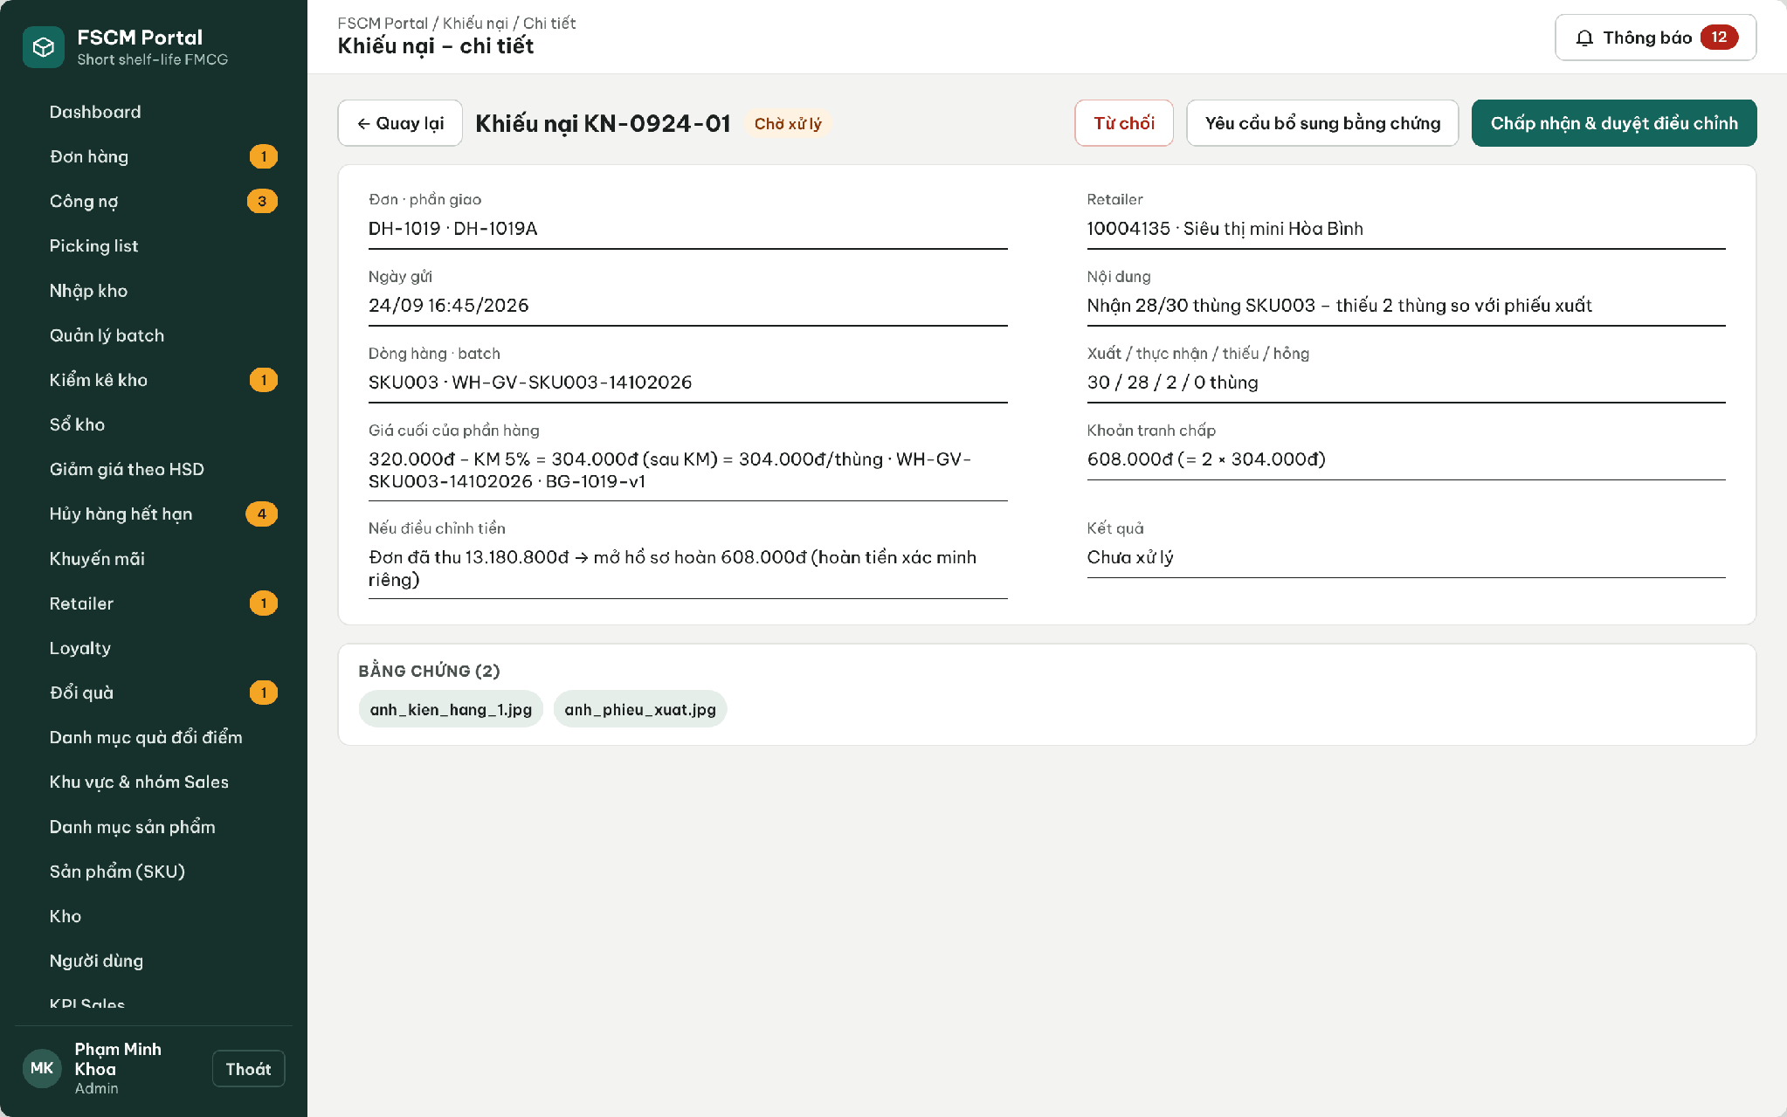
Figure 49. Web Portal – Complaint decision with disputed value and impact
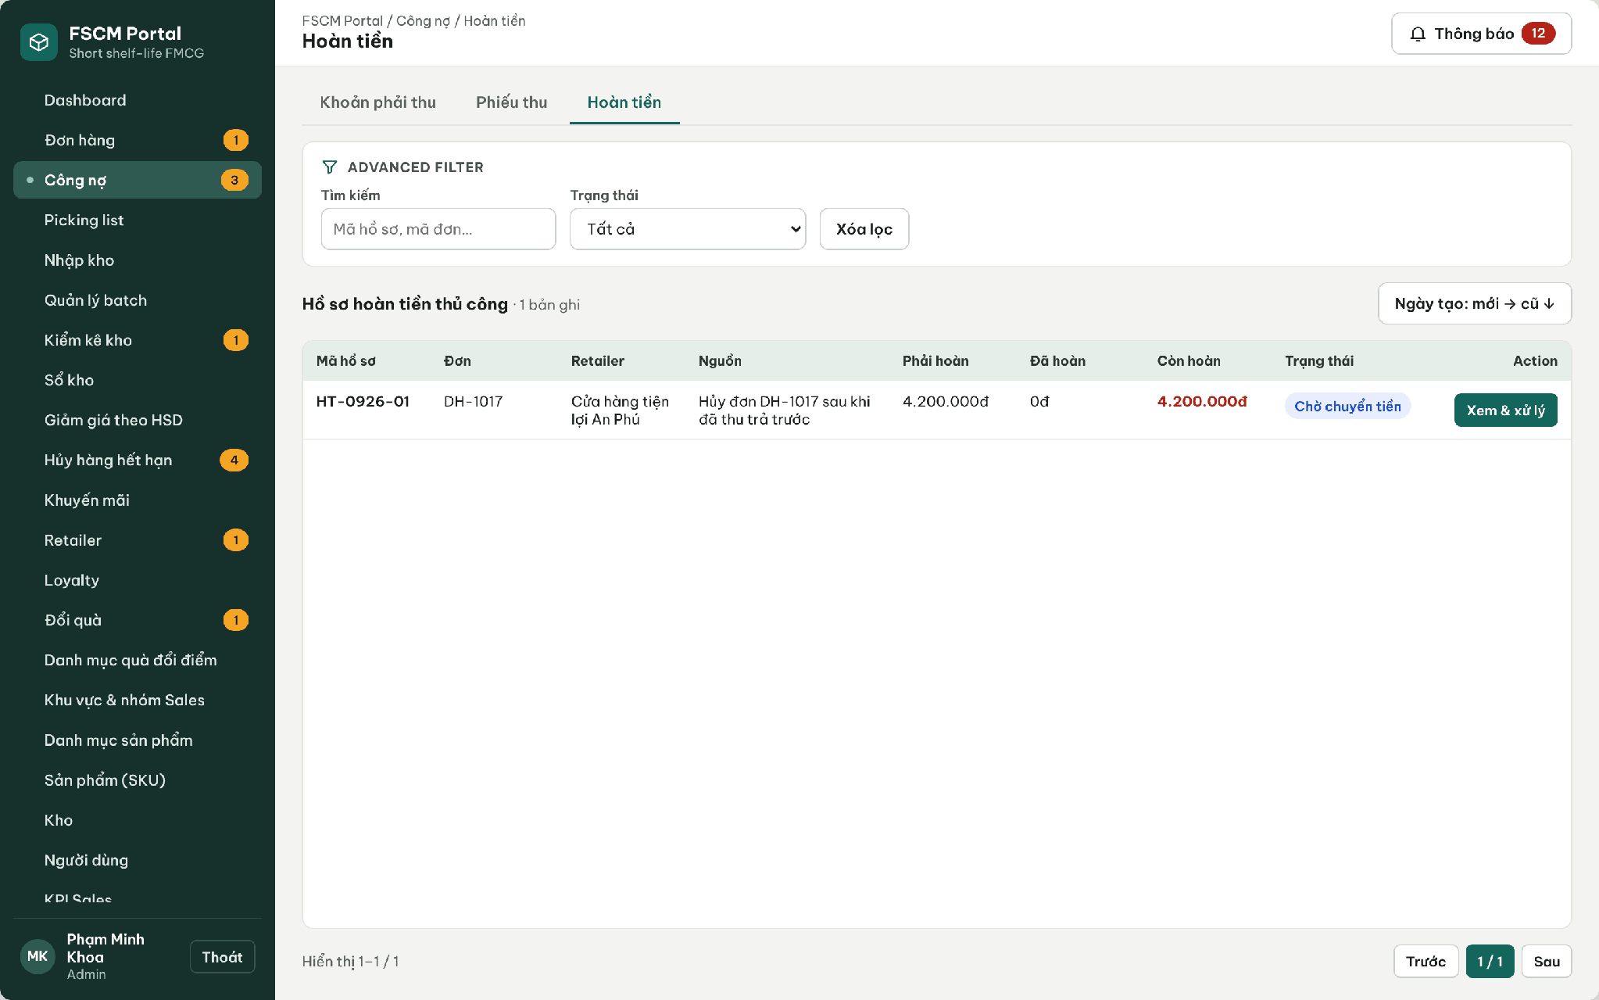
Figure 50. Web Portal – Refund records
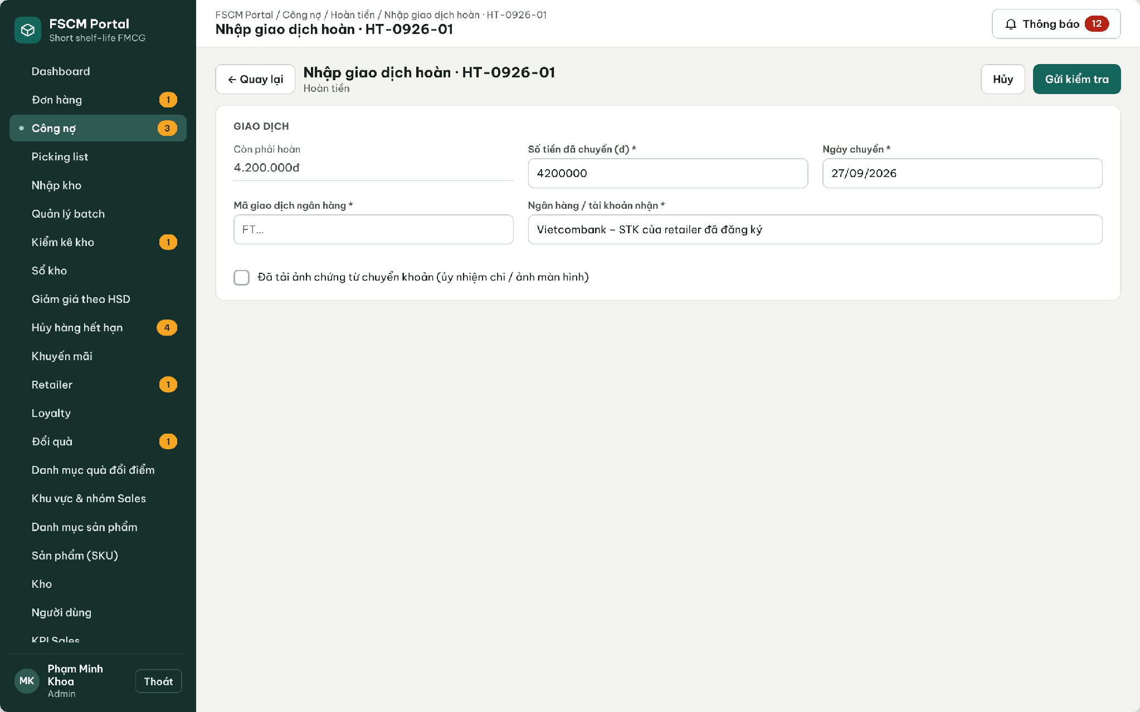
Figure 51. Web Portal – Refund record: enter transfer and evidence for Administrator verification
● Function Details:
o Actors: Primary – Administrator (approves adjustments, verifies refund evidence). Secondary – Operator (reviews complaints, records the external transfer and evidence). Retailer – views disputed, adjusted, payable and refund status separately.
o Fields:
▪ Complaint, shipment, line/batch, accepted affected quantity, actual net unit price, adjustment amount, decision and reason; refund record (HT-code), source, refund due, refunded, transaction reference, evidence, status.
o Data Processing:
▪ A pending complaint separates its net disputed value from undisputed debt. Acceptance posts an approved adjustment; rejection restores the original obligation and records how collection resumes. Undisputed debt keeps its due date.
▪ For the same shipment line/batch, cumulative approved missing quantity cannot exceed dispatched − received and damaged quantity cannot exceed received. Deduct prior approved adjustments and cap total value at the remaining unadjusted batch-line value, using its retained net price/rounding. Confirmed excess money creates a refund obligation, not proof of a completed refund.
▪ Paid cancellation before dispatch requires a full manual refund. A short order before allocation has collected amount zero.
▪ Refund lifecycle (BR-74): Pending refund → Awaiting verification (transfer and evidence entered) → Refunded (Administrator verified); a rejected evidence moves the record to Needs supplement while the obligation remains.
▪ Once fulfillment is received or its exception is finally resolved, adjusted money is settled and no complaint/refund remains open, evaluate Completed and award points once on the retained eligible purchase value (F5). Later decisions append only the linked point difference, not another award. Never fabricate full receipt, return stock automatically or repeat the correction at refund verification.
o Business Rules:
▪ BR-50, BR-54, BR-66 – BR-70, BR-74 apply.
o Acceptance Criteria:
AC ID | Acceptance criterion (Given / When / Then) | Ref.
AC-3.10.4-01 | Given P1 paid 612,000 VND and an accepted post-completion complaint for A1 at 72,000 VND, obligation becomes 540,000 VND and refund due 72,000 VND. Under an explicitly snapshotted 10,000-VND demo program target changes 61→54; under baseline 100,000 VND it changes 6→5. Apply only the program’s linked correction. | BR-54, BR-68, BR-69
AC-3.10.4-02 | Given the complaint is on an unpaid credit order, when it is accepted, then the receivable is reduced and no refund record is created. | BR-69
AC-3.10.4-03 | Given a refund record in Awaiting verification, when the Administrator rejects the evidence with a reason, then the status is Needs supplement and refund due is unchanged. | BR-74
AC-3.10.4-04 | Given refund due of 72,000 VND, when a second refund record or a total above 72,000 VND is entered, then it is rejected. | BR-69, BR-74
AC-3.10.4-05 | Given the refund is verified, when ledgers are reconciled, then net collected = 540,000 VND, balance = 0 and no further point correction is made. | BR-69, BR-70
AC-3.10.4-06 | Given an approved adjustment, when inventory is viewed, then no stock is returned automatically. | BR-68
AC-3.10.4-07 | Given dispatched 10, received 0, missing up to 10 may be approved at retained net price. Damaged cannot exceed received; cumulative quantity/value cannot exceed the remaining unadjusted batch-line entitlement. No stock is returned. | BR-68
AC-3.10.4-08 | Given a finalized shortage decision and all adjusted money/refunds settled with no open complaint, the order may become Completed under F5 without changing received quantity. Points use eligible adjusted value once; run closure alone or uploaded refund evidence is insufficient. | BR-49, BR-54, BR-70
o Traceability: UC-17, UC-93, UC-94 | BR-50, BR-54, BR-66 – BR-70, BR-74 | CR-17, CR-19, CR-20 | Screens: Complaint Details, Refunds, Refund Details; Non-screen: Complaint Adjustment

3.11 Sales Groups & Operational Reporting

3.11.1 Manage Sales Groups and Coverage
● Function type: Screen function (see 3.1.2).
● Function trigger:
o Open Sales Group Management.
o Create, update, view or delete a permitted sales group.
● Function description: Maintains regional Sales-group membership and retailer coverage.
● Screen layout: see Figure 52
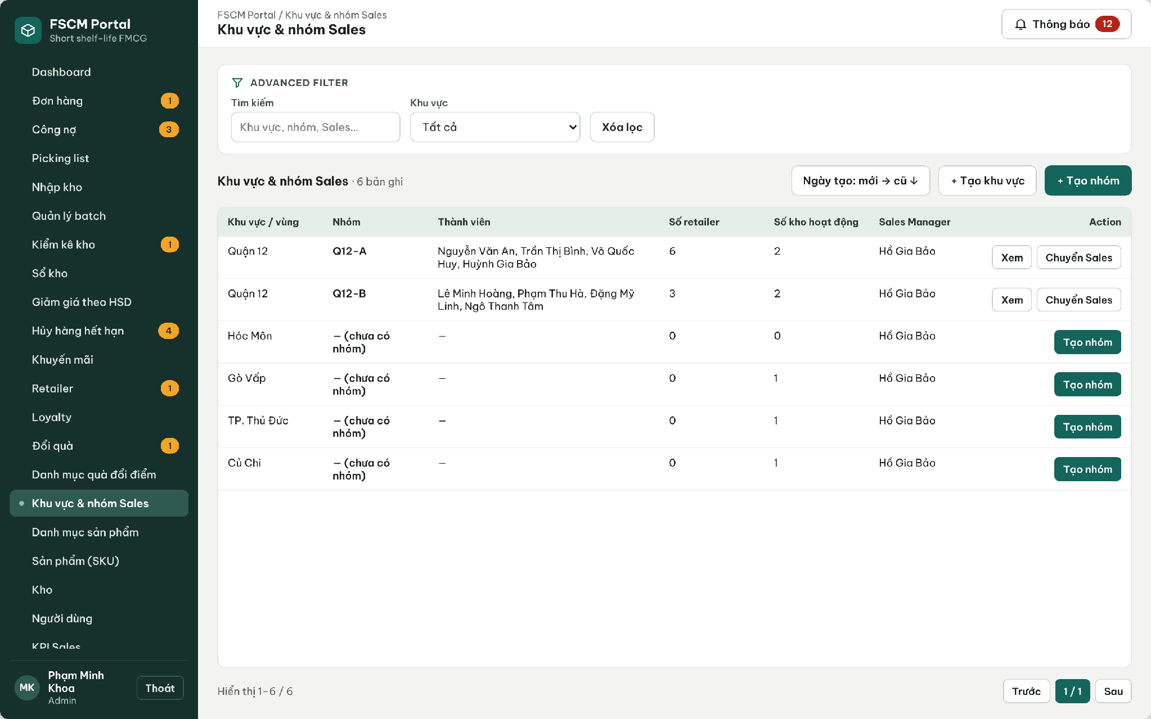
Figure 52. Web Portal – Sales regions and groups
● Function Details:
o Actors: Primary – Sales Manager (regions, groups, member and retailer assignments of own regions). Secondary – Administrator (all regions).
o Fields:
▪ Sales group; sales region; member assignments; assigned retailers.
o Data Processing:
▪ Validate the manager’s organization scope.
▪ Update memberships and assignments with dependent data checks.
▪ Apply the new coverage to Sales order visibility.
o Business Rules:
▪ Sales users may operate only within permitted personal and group scope.
▪ A sales group can be deleted only when it has no members and no assigned retailers; otherwise members and retailers must be reassigned first. Reassigning a Sales user or a retailer changes visibility for later actions only; historical orders keep their creator and group snapshot for performance attribution.
o Acceptance Criteria:
AC ID | Acceptance criterion (Given / When / Then) | Ref.
AC-3.11.1-01 | Given a group with members, when Delete is selected, then it is blocked until members and retailers are reassigned. | BR-03
AC-3.11.1-02 | Given Sales A moved from Q12-A to Q12-B, when Q12-A performance is reported for last month, then A's earlier orders remain attributed to A and Q12-A. | BR-56
AC-3.11.1-03 | Given a Sales Manager of Quận 12, when a group in Gò Vấp is edited through the API, then MSG006 is returned. | BR-03
AC-3.11.1-04 | Given a retailer reassigned to Q12-B, when a Q12-A member opens it, then it is no longer listed. | BR-03, BR-20
o Traceability: UC-18, UC-19, UC-40 – UC-42 | BR-03, BR-20, BR-56 | CR-01 | Screens: Regions & Sales Groups

3.11.2 View Sales and Management Dashboards
● Function type: Screen function (see 3.1.2).
● Function trigger:
o Open the role-specific dashboard.
o Select supported reporting filters.
● Function description: Displays order KPIs, net revenue after discounts and authorized performance summaries.
● Screen layout: see Figures 53 – 55
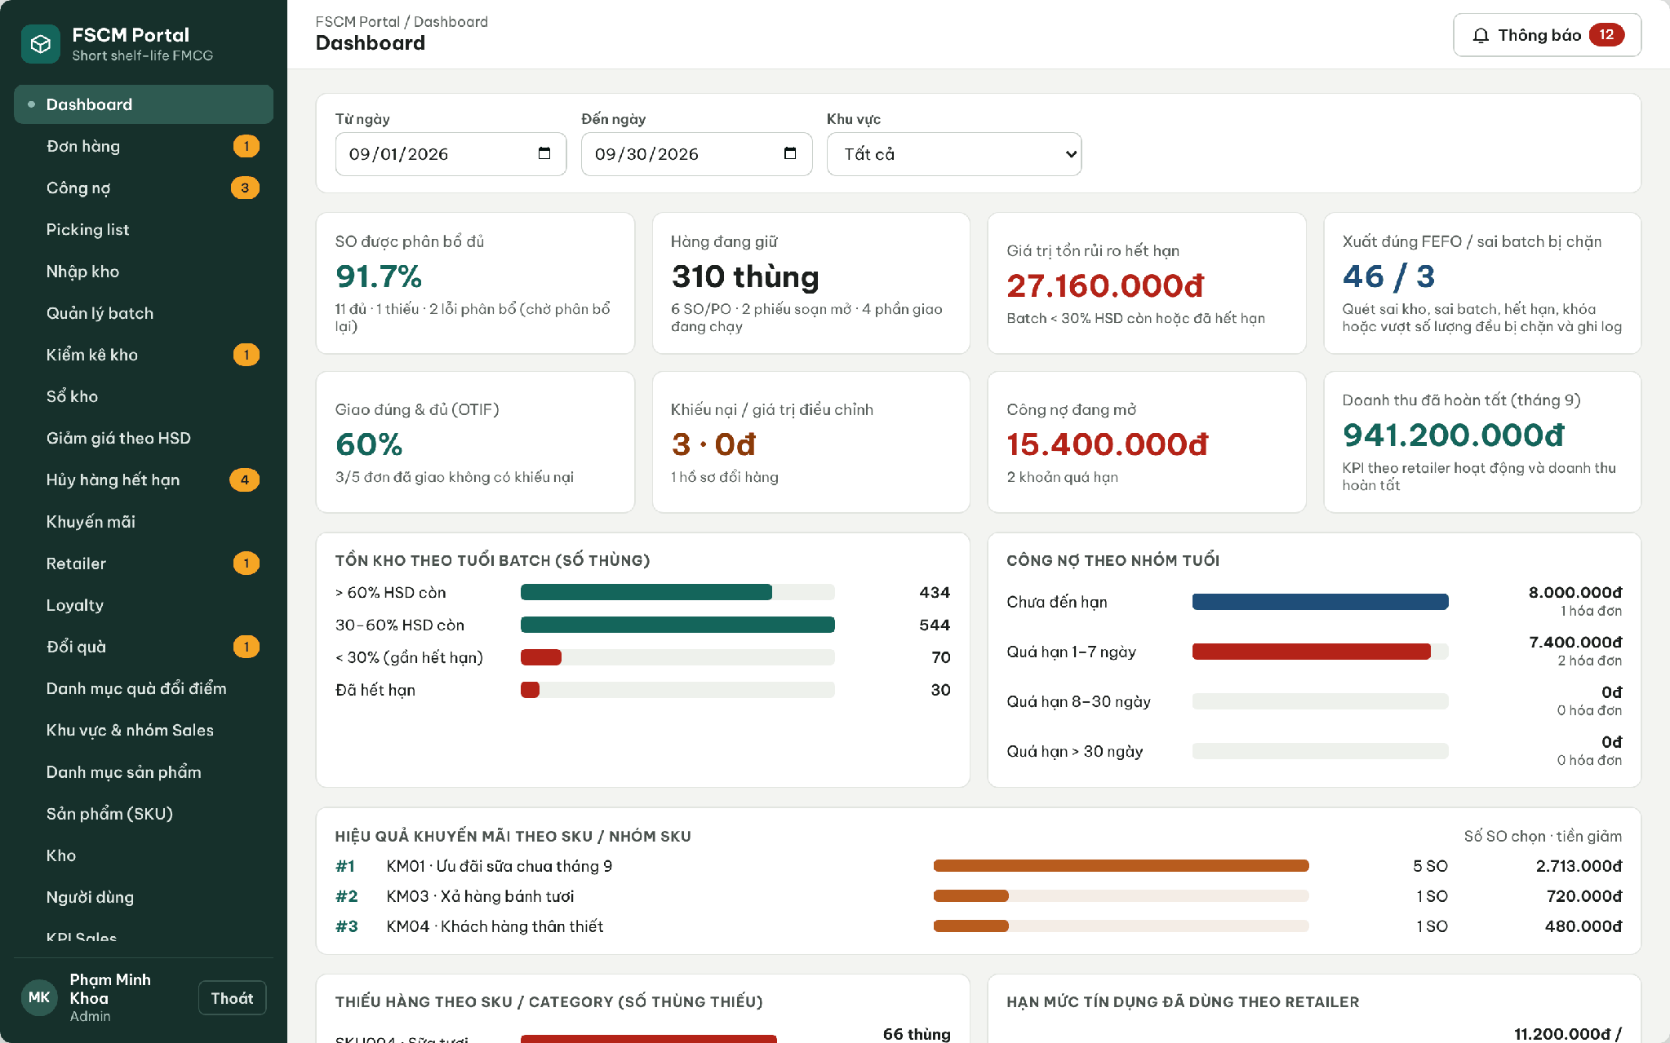
Figure 53. Web Portal – Administrator dashboard
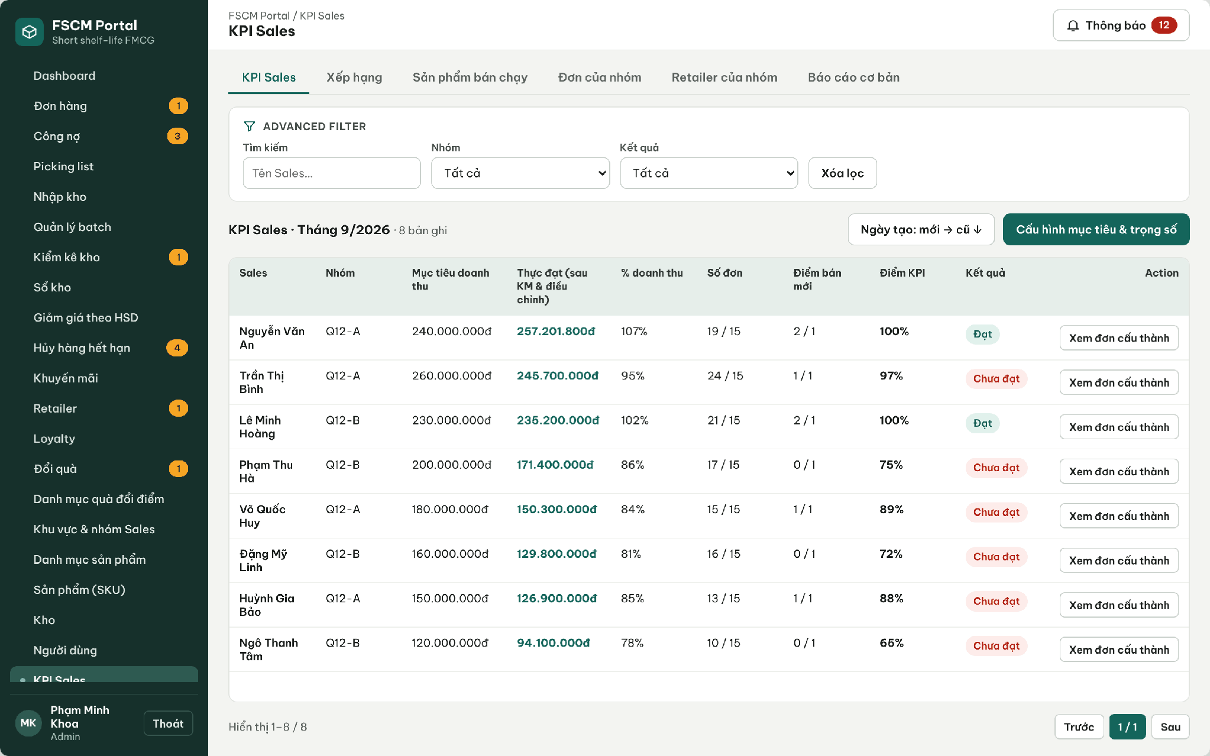
Figure 54. Web Portal – Sales KPI with targets, net revenue and score
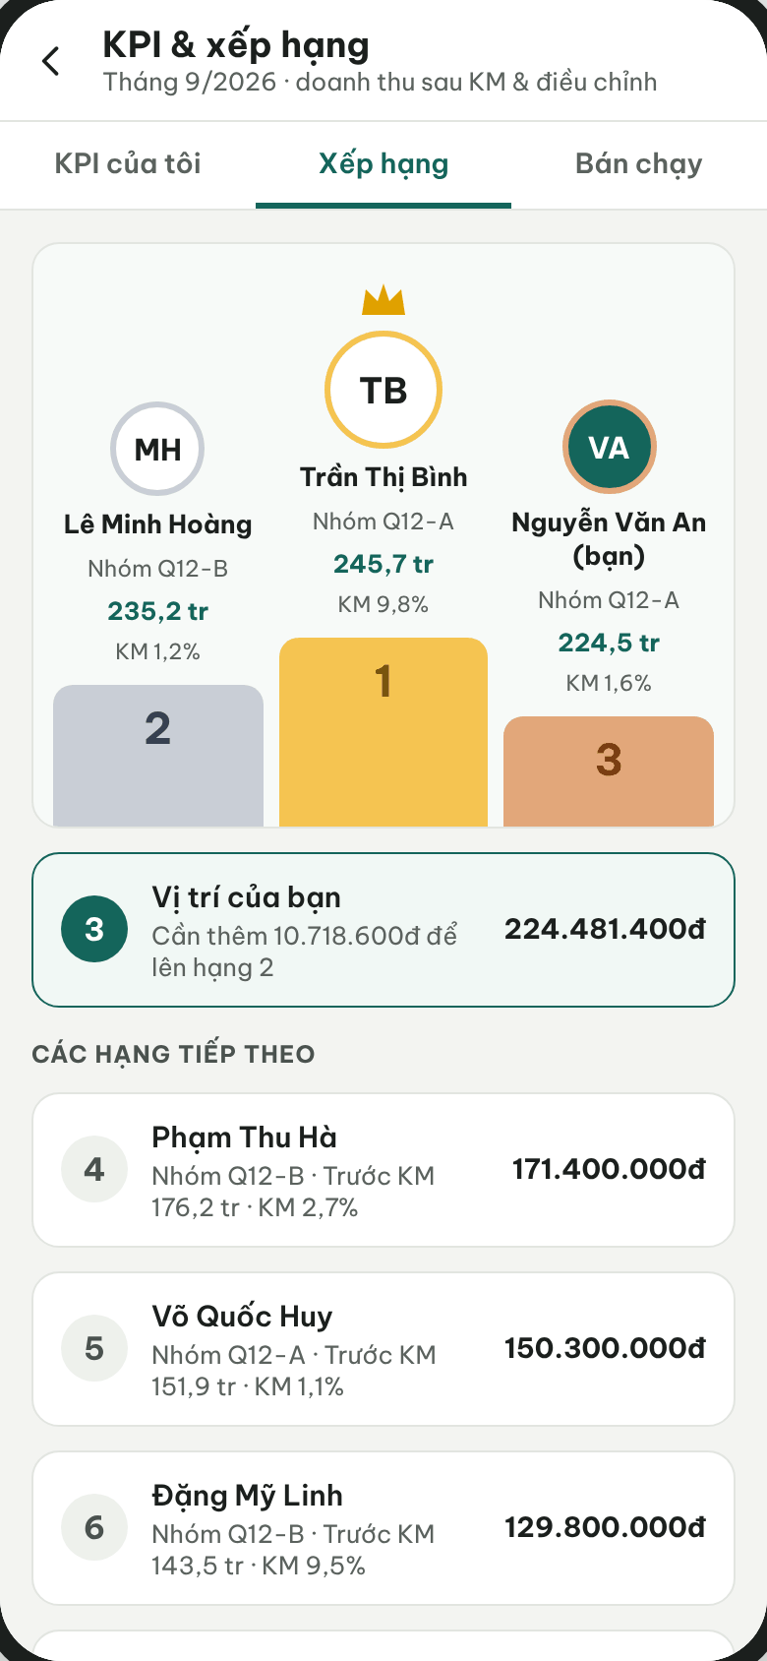
Figure 55. Sales App – Ranking
● Function Details:
o Actors: Primary – Administrator (system dashboard), Sales Manager (team KPI and ranking), Sales (own KPI and ranking). Secondary – Retailer (own spending summary, UC-84). System – Net Revenue and KPI Calculation (3.1.4).
o Fields:
▪ Reporting period; net revenue; order counts / values; sales leaderboard; best-selling products.
o Data Processing:
▪ Aggregate relevant order and transaction data within the requester’s scope.
▪ Deduct applied promotion discounts in revenue calculations.
▪ Show Sales Manager team indicators and Admin system indicators; display best-selling products where supported.
o Business Rules:
▪ Revenue must be calculated after promotion discounts.
▪ KPI score = 70% × min(net revenue / revenue target, 1) + 15% × min(orders / order target, 1) + 15% × min(new retailers / new-retailer target, 1); weights and targets are configured per period. Result is Achieved when the score is 100%. Revenue is recognized on the Delivered date at approved net value after promotions, shelf-life discounts and approved adjustments; Cancelled, Rejected, Insufficient-stock and not-yet-Delivered orders are excluded. Filters: Today, 7 days, This month, custom range; region and group.
o Acceptance Criteria:
AC ID | Acceptance criterion (Given / When / Then) | Ref.
AC-3.11.2-01 | Given revenue attainment 95%, orders 24/15 and new retailers 1/1, when the KPI score is computed, then it is 0.7 × 0.95 + 0.15 + 0.15 = 96.5% (displayed 97%) and Not achieved. | BR-56
AC-3.11.2-02 | Given an order of 612,000 VND later adjusted by −72,000 VND, when revenue is reported, then 540,000 VND is counted. | BR-56, BR-69
AC-3.11.2-03 | Given an order with two shipments, when dashboards count orders, then it is counted once. | BR-56
AC-3.11.2-04 | Given a Sales user, when the ranking is opened, then the user's own figures are shown and other users' order details are not accessible. | BR-03
AC-3.11.2-05 | Given a dashboard for one month of 10,000 orders, when it is loaded, then it responds within 3 s (p95). | NFR-P04
o Traceability: UC-01, UC-09, UC-20, UC-25, UC-27, UC-72, UC-73, UC-75, UC-84 | BR-03, BR-56 | Screens: Dashboard, KPI Sales, Sales Ranking; Non-screen: Net Revenue and KPI Calculation

3.12 System Configuration & Notifications

3.12.1 Manage Warehouse Location and Service Configuration
● Function type: Screen function (see 3.1.2).
● Function trigger:
o Open Warehouse / System Configuration.
o Edit service-distance settings or location through the configured map view.
● Function description: Maintains warehouse visualization and distance-based receipt-estimation parameters.
● Screen layout: see Figures 56 – 57
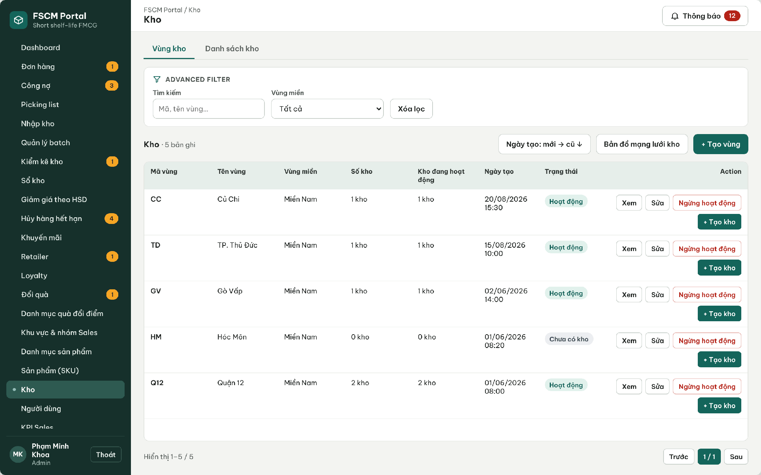
Figure 56. Web Portal – Warehouses with type, address, coordinates and keeper
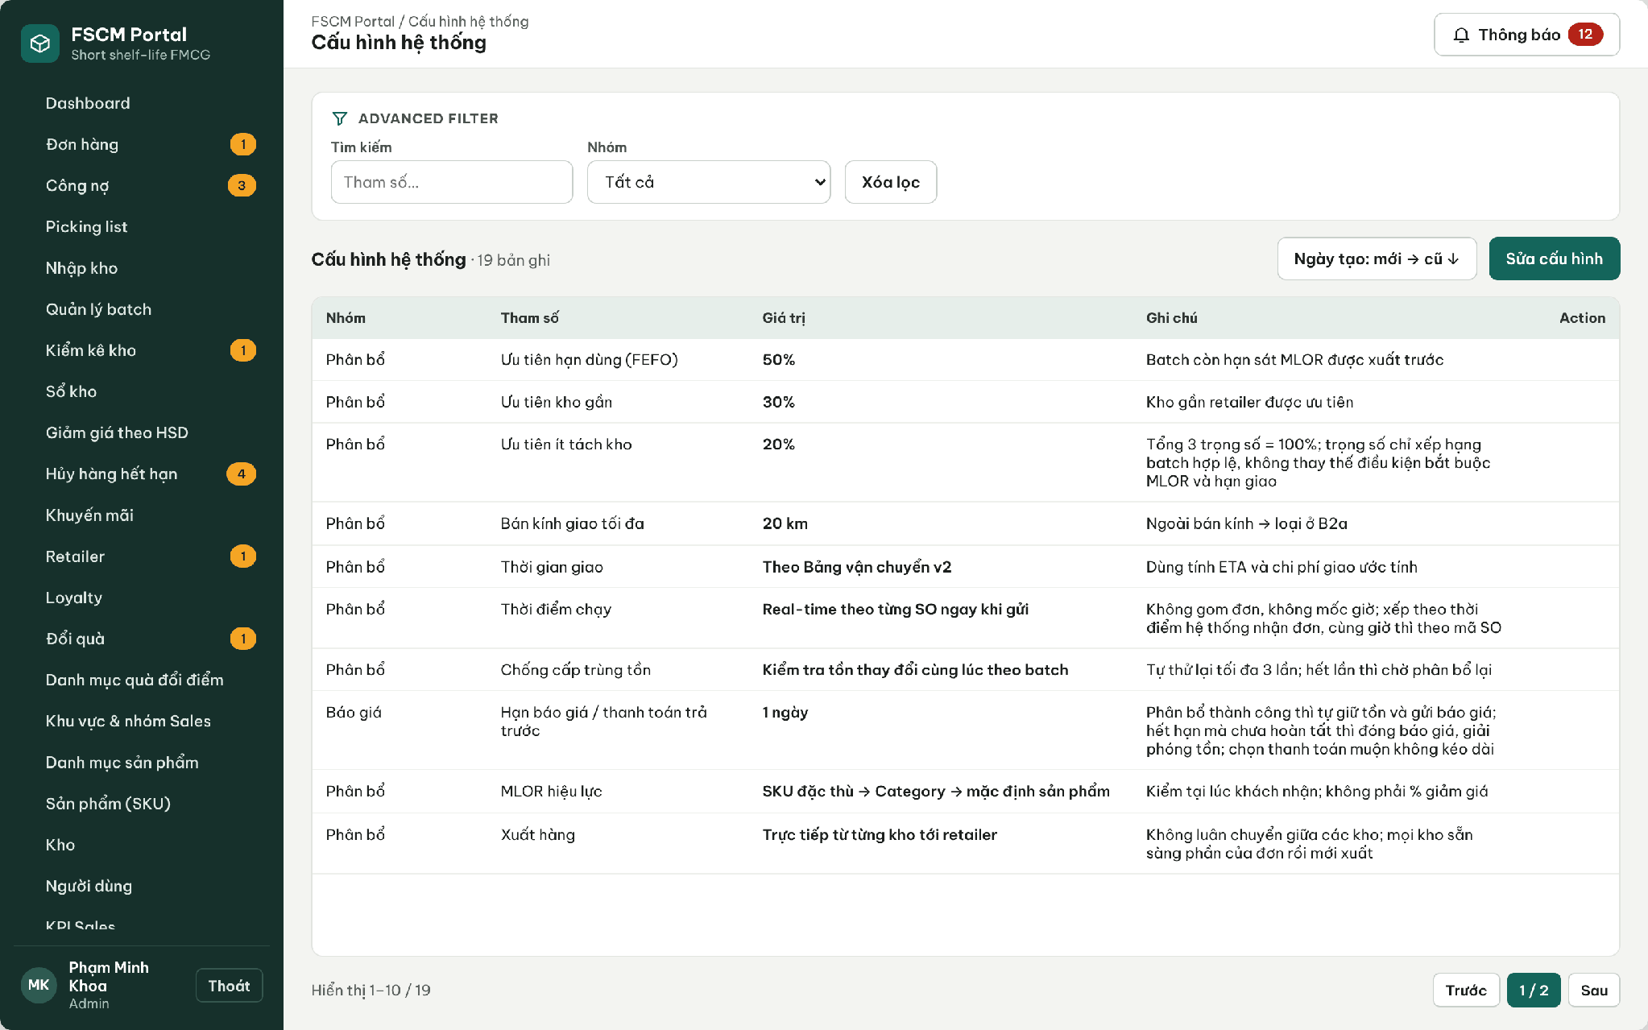
Figure 57. Web Portal – System configuration (allocation, quotation, pricing, loyalty, credit)
● Function Details:
o Actors: Primary – Administrator (warehouses, map locations, service distance, transit table, allocation weights, schedule and quotation deadline). Secondary – Operator may view the transit table.
o Fields:
▪ Warehouse address / map location; service distance; transit time bands; allocation settings.
o Data Processing:
▪ Resolve and save map-derived geographic information for configured warehouses.
▪ Validate distance-band coverage and service constraints.
▪ Use updated values for subsequent estimates and allocation attempts.
o Business Rules:
▪ Map coordinates need not be manually displayed or entered as latitude and longitude.
▪ Map: OpenStreetMap base tiles; locations are picked on the map or by device GPS and stored in MapLocation; offline map selection uses a coordinate grid. Distance: shortest road distance computed server-side on the road graph (Dijkstra), recomputed when a location changes; no external routing or traffic API. Only the Administrator may change these values. Weights follow BR-33 (default 0.5 / 0.3 / 0.2, non-negative, sum = 1); changes apply only to later runs (BR-57).
o Acceptance Criteria:
AC ID | Acceptance criterion (Given / When / Then) | Ref.
AC-3.12.1-01 | Given weights 0.5, 0.3 and 0.3, when they are saved, then they are rejected because the sum is not 1. | BR-33
AC-3.12.1-02 | Given Dmax changed from 20 to 15 km while an allocation attempt is running, when that attempt continues, then it uses its snapshot value of 20 km; the next attempt uses 15 km. | BR-28, BR-57
AC-3.12.1-03 | Given a warehouse location moved on the map, when it is saved, then road distances to retailers are recalculated before the next allocation attempt. | BR-32
AC-3.12.1-04 | Given an Operator, when the configuration save API is called, then MSG006 is returned. | CR-01
AC-3.12.1-05 | Given any configuration change, when it is saved, then the old value, new value, actor and time are in the audit log. | BR-58
o Traceability: UC-03, UC-50 – UC-53, UC-95 | BR-28, BR-32, BR-33, BR-57, BR-58 | CR-10, CR-21 | Screens: Warehouses, System Configuration

3.12.2 Send Operational Notifications
● Function type: Non-screen function – runs automatically, no screen of its own (see Operational Notifications in 3.1.4).
● Function trigger:
o An eligible order, approval, inventory or loyalty event occurs.
● Function description: Creates and dispatches user-facing operational notifications.
● Screen layout: Not applicable – non-screen function.
● Function Details:
o Actors: System – Operational Notifications (3.1.4). Recipients – all six human roles according to the matrix below. External – Azure Notification Hubs.
o Fields:
▪ Recipient; event type; notification content; related business reference.
o Data Processing:
▪ Resolve intended recipients using role and assignment information.
▪ Persist notification records and attempt push delivery through the configured notification service.
▪ Record outcomes without changing the source transaction success state.
o Business Rules:
▪ Azure Notification Hubs is the external push delivery service listed in the system context.
▪ Matrix: quotation issued and expiry reminder → Retailer/Sales; allocation OutOfStock/Conflict/TechnicalFailed → Sales and Administrator/Operator; PayOS payment confirmed/expired → Retailer/Operator; PO/picking release → Warehouse Keeper; picking or shipment exception → Operator/Administrator; Delivering → Retailer/Sales; complaint/refund outcome → Retailer; overdue 08:00 → Sales/Operator.
o Acceptance Criteria:
AC ID | Acceptance criterion (Given / When / Then) | Ref.
AC-3.12.2-01 | Given a quotation is sent, when the event is committed, then an in-app notification is stored for the Retailer and Sales within 10 s and a push is requested. | NFR-P07
AC-3.12.2-02 | Given Azure Notification Hubs is unavailable, when a push fails, then it is retried after 1, 5 and 15 minutes and the quotation remains valid. | NFR-R06
AC-3.12.2-03 | Given a Warehouse Keeper of WH-TA, when a PO with portions only in WH-GV is released, then the WH-TA keeper is not notified. | BR-03
AC-3.12.2-04 | Given the same event processed twice, when notifications are created, then only one notification per recipient exists. | CR-23
o Traceability: UC-83 (status updates) | BR-53 | CR-23 | Non-screen: Operational Notifications

3.13 Delivery Operations

3.13.1 Process Delivery Assignment
● Function type: Screen function (Order Details – Assign vehicle, Start delivery, Record delivery failure – Web Portal).
● Function trigger:
o A PO shipment is Ready (all warehouse portions picked) and the Operator assigns a vehicle and delivery person.
o After dispatch confirmation the Operator selects Start delivery; on a failed attempt the Operator selects Record delivery failure.
● Function description: Assigns a vehicle and delivery person to each warehouse shipment, tracks Delivering, and records failed delivery attempts with reason and evidence. There is no driver account or app and no route optimization (BR-05, LI-04).
● Screen layout: see the figures below.
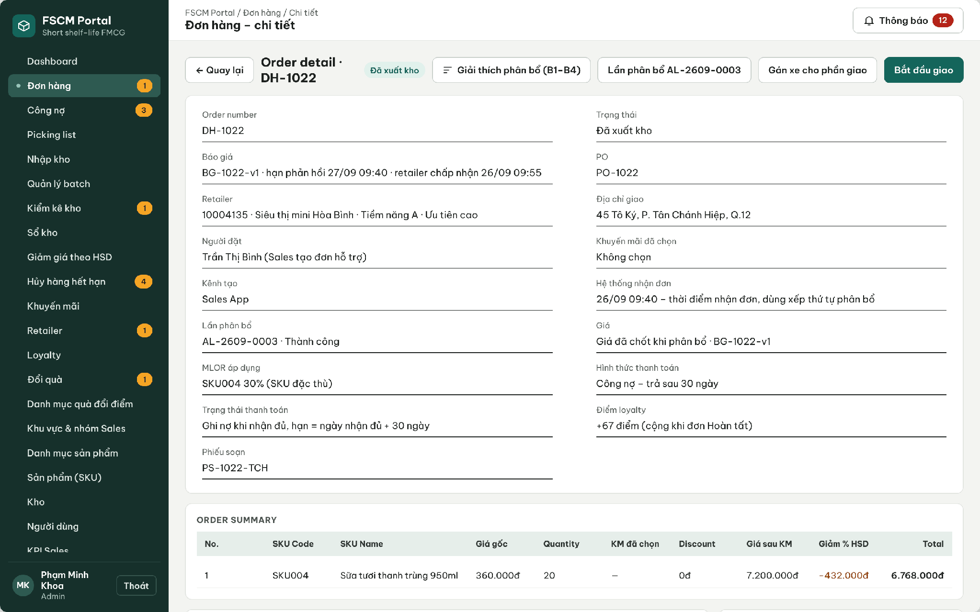
Figure 58. Web Portal – Issued order with Assign vehicle and Start delivery
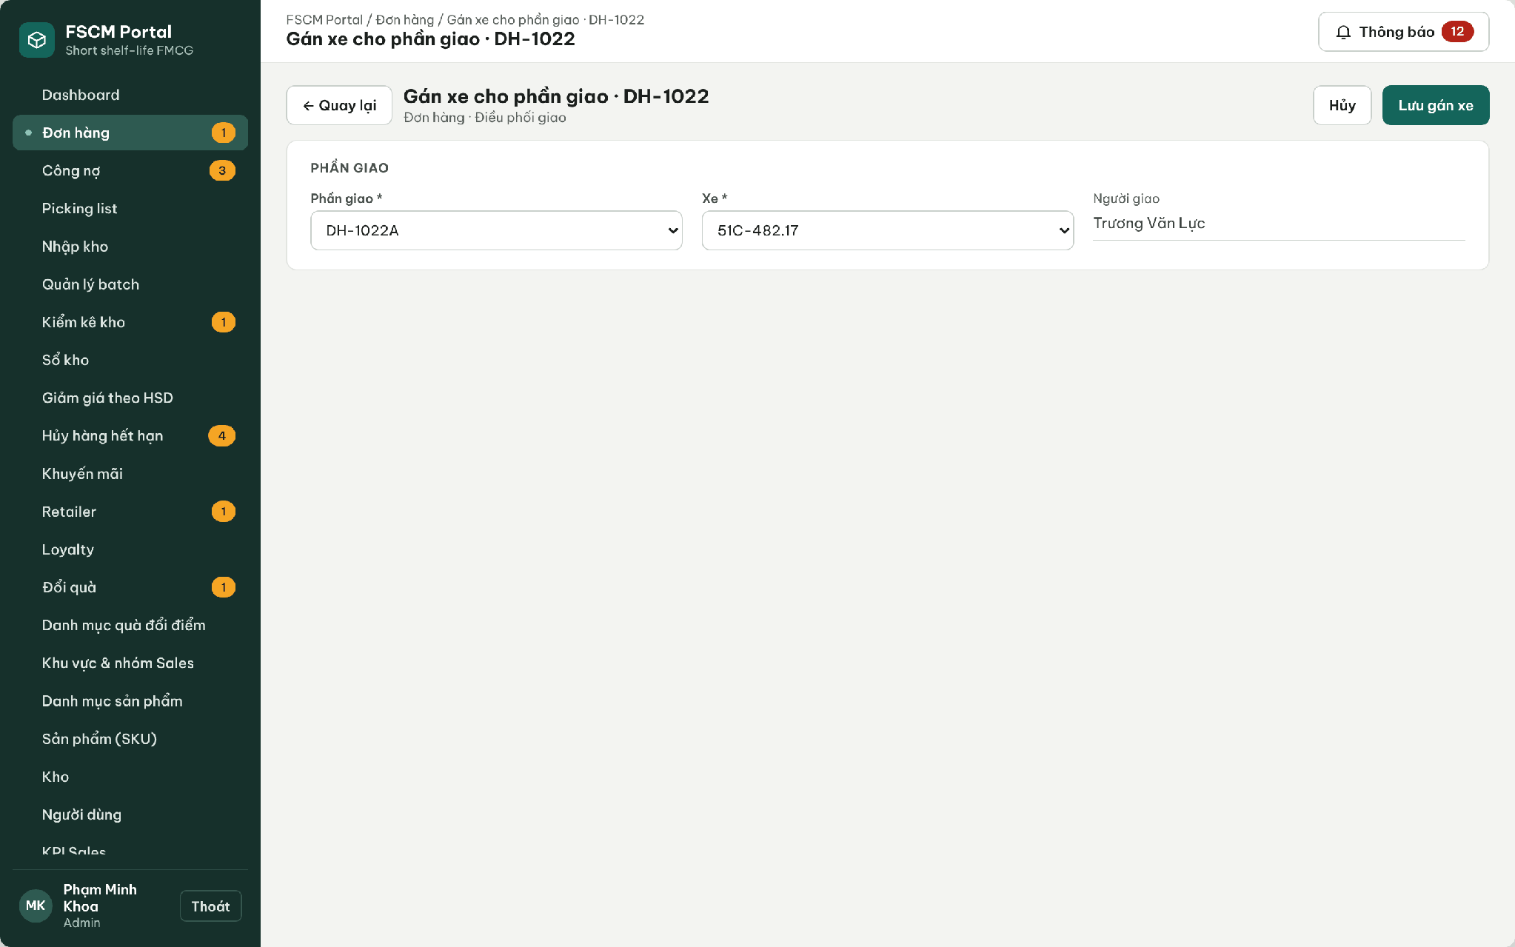
Figure 59. Web Portal – Assign vehicle and delivery person to a shipment
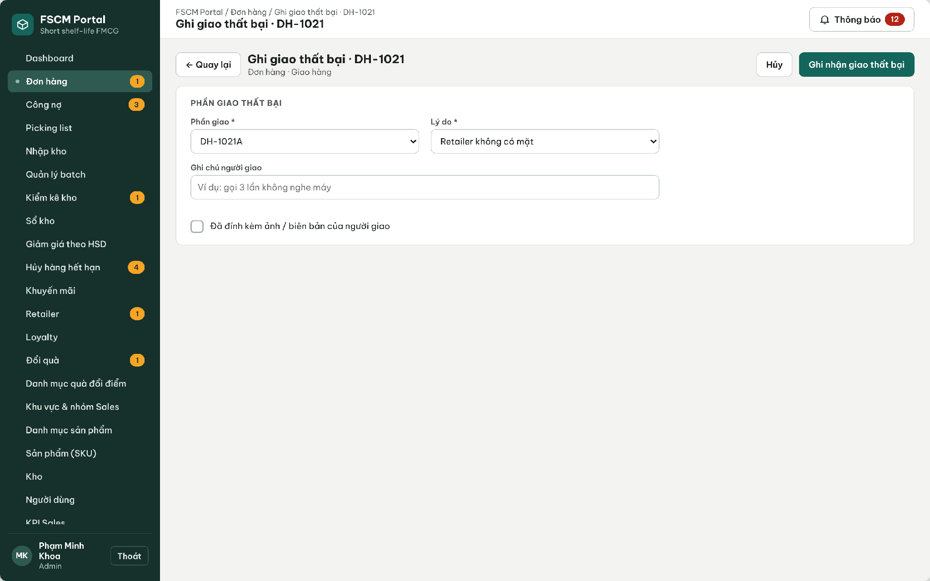
Figure 60. Web Portal – Record delivery failure with reason and evidence
● Function Details:
o Actors: Primary – Operator. Secondary – Administrator (resolves failed deliveries and exceptions). Warehouse Keeper confirms dispatch (3.9.1). Retailer confirms receipt (3.9.2).
o Fields:
▪ Shipment (order–warehouse portion); vehicle (licence plate) and delivery person from master data, stored as a snapshot; assignment time; delivery status; failure reason (Retailer absent, Retailer refused, Wrong address, Other); notes; evidence photo.
o Data Processing:
▪ Allow assignment only for shipments of a PO; one active assignment per shipment; changing the vehicle before dispatch replaces the assignment and keeps history.
▪ Start delivery sets the shipment to Delivering only after its dispatch has been confirmed; the order is Delivering when its dispatched shipments are on the way.
▪ Record delivery failure sets the shipment to Delivery failed with reason and evidence; no automatic refund, stock restoration, Delivered status or loyalty posting occurs.
▪ The Administrator decides the outcome: a new delivery attempt of the same shipment if ETA, deadline and MLOR are still met, or an exception settlement under BR-26/BR-66 – BR-69.
o Business Rules:
▪ BR-05, BR-46 – BR-49 and BR-76 apply. Delivery arrival is an estimate, not a guarantee.
o Acceptance Criteria:
AC ID | Acceptance criterion (Given / When / Then) | Ref.
AC-3.13.1-01 | Given a shipment of a sales order that is not yet a PO, when assignment is attempted, then it is rejected. | BR-45, BR-76
AC-3.13.1-02 | Given an assigned vehicle 51C-482.17 and delivery person, when the assignment is saved, then the licence plate and person name are stored as a snapshot on the shipment (MSG040). | BR-48
AC-3.13.1-03 | Given a shipment whose dispatch is not confirmed, when Start delivery is selected, then it is blocked. | BR-47, BR-76
AC-3.13.1-04 | Given a failed attempt with reason 'Retailer absent' and a photo, when it is recorded, then the shipment is Delivery failed, the order is not Delivered, and no refund or stock movement is created. | BR-49, BR-76
AC-3.13.1-05 | Given a vehicle or delivery person marked inactive in master data, when the assignment list is opened, then it is not selectable. | BR-05
o Traceability: UC-14, UC-74 | BR-05, BR-26, BR-46 – BR-49, BR-76 | Screens: Order Details – Delivery Assignment, Record Delivery Failure

4. Non-Functional Requirements

4.1 External Interfaces
• User interfaces: FSCM provides a Web Portal (React/TypeScript) for administrative, warehouse, finance and delivery-coordination work and one Flutter Mobile App for Sales Representatives, Warehouse Keepers and Retailers, which opens the part for the signed-in role. Each interface displays only the functions and data permitted by the signed-in role. Supported clients: Web Portal on the latest two versions of Chrome and Edge at 1366 × 768 or larger; Mobile App on Android 10 (API 29) or later with screen widths of 360 – 430 dp (iOS 15+ build optional). The user interface language is Vietnamese; business codes and amounts follow 5.1. Accessibility target: WCAG 2.1 AA text contrast (≥ 4.5:1) and touch targets ≥ 48 dp (NFR-U05).
• Authentication interface: users sign in with Google Identity (OpenID Connect); FSCM verifies the ID token (signature, issuer, audience, expiry) and issues its own access and refresh tokens (lifetimes in NFR-S04). Account linking follows 3.2.2 (existing Active account with matching e-mail; no just-in-time provisioning).
• Database interface: FSCM uses Azure Database for PostgreSQL as the authoritative store for business data, including product/category and batch records, sales orders and quotations, inventory balances and locks, reservations and picking records, payments, adjustments and refunds, retailer assessments, loyalty transactions and audit history. Application components access the database only through authorized server-side services. SQLite on the Mobile App holds only authorized offline reference data and pending Sales drafts (CR-25).
• File-storage interface: FSCM uses Azure Blob Storage (private container) for evidence images and files, including cancellation, write-off, complaint, delivery-failure, storefront and refund evidence. Accepted types are JPG, PNG and PDF, at most 5 MB per file and 5 files per record, validated by extension and file signature. Files are read only through short-lived SAS links (valid ≤ 15 minutes) issued to authorized users. The application never deletes evidence linked to a stock or financial record (NFR-S06, NFR-R08).
• Push-notification interface: FSCM uses Azure Notification Hubs (FCM for Android, APNs for iOS) for push delivery; every notification is also stored in-app. Events and recipients follow the matrix in 3.12.2. Push requests are retried 3 times (after 1, 5 and 15 minutes); the target is ≥ 95% of pushes handed to the hub within 60 s of the business event (NFR-P07).
• Camera/QR interface: The Mobile App uses the device rear camera to scan batch QR labels during receiving lookup, picking and retailer receipt; a manual label-code field is provided when scanning fails. The QR payload contains only the label code (TEM-000000); the server resolves the batch, quantity and expected context and records the quantity or mismatch. Camera permission is requested at the first scan; a hand-held scanner acting as keyboard input is optional.
• Payment interface: Prepaid payment uses PayOS: FSCM creates a payment link/QR with the exact quotation amount and deadline; PayOS sends a signed webhook which FSCM verifies (signature, amount, reference) idempotently before marking the payment Paid. Credit payments are recorded as payment receipts by authorized staff (3.10.1). No COD or cash.
• Map and distance interface: Warehouse and retailer locations are maintained on an OpenStreetMap base map (or a coordinate grid when offline) and stored as MapLocation. Service distance is the shortest road distance computed server-side on the road graph (Dijkstra) and recalculated when a location changes; no external routing or traffic service is used. Distance bands and ETA follow BR-32; the estimate is not a guaranteed delivery time.
• Network interface: All client–server traffic uses HTTPS (TLS 1.2 or later). Mobile Sales-order creation remains possible offline; drafts are sent only when Sales taps Send (BR-23). Synchronization identifiers and conflict handling are specified in 4.2.6.
• Operations interface: Secrets, connection strings and signing keys are stored in Azure Key Vault and never in source code or mobile caches (CR-24). Azure Monitor / Application Insights collects availability tests, request latency, errors and job outcomes used to measure the NFRs below.

4.2 Quality Attributes
The following quality attributes apply to the FSCM Web Portal, Mobile App and backend services. Each requirement states a metric, a threshold and a measurement method. Thresholds are the v1.8 baseline targets for the reference test environment and workload below; they are configurable test targets agreed for Review 2, not claims of achieved results. Reference workload: 5 warehouses, 1,000 SKUs, 20,000 batches, 100 user accounts (50 concurrent), 1,000 orders per day with an average of 5 lines, and evidence files up to 5 MB.

4.2.1 Usability
ID | Requirement | Metric | Threshold | Measurement method
NFR-U01 | Role-based navigation: each role sees only the screens and actions of the Screen Authorization matrix (3.1.3). | Share of (role, screen/action) pairs that match 3.1.3 | 100% | Checklist of 3.1.3 executed for the 6 roles on the Review build; any extra or missing item is a defect.
NFR-U02 | Task efficiency for core field tasks. | Median task time on a test device | Create a 5-line online order ≤ 3 min; confirm receipt of a 3-label shipment ≤ 2 min; pick a 10-line slip ≤ 10 min; review and approve one order ≤ 1 min | Moderated usability test, 5 participants per role, scripted tasks, stopwatch; results recorded in Report 5.
NFR-U03 | Learnability and satisfaction. | Unassisted task completion rate; System Usability Scale (SUS) | ≥ 90% of scripted main tasks completed without help; mean SUS ≥ 70 | Same usability session as NFR-U02, SUS questionnaire after the session.
NFR-U04 | Feedback and input guidance: every create/update/approval, scan, upload, payment and sync action shows success, validation error or failure without implying completion before the server confirms it. | Share of actions showing a 5.3 message next to the action or field | 100% of actions in 3.2 – 3.13; result shown ≤ 1 s after the server response | UI review against 5.3 and widget/E2E tests asserting the message code.
NFR-U05 | Supported clients and accessibility. | Rendering on supported browsers/devices; Lighthouse accessibility score; contrast ratio | No layout defect on Chrome/Edge (latest 2) at ≥ 1366 × 768 and Android 10+ at 360 – 430 dp; Lighthouse accessibility ≥ 85 on Login, Orders, Allocation Attempts and Receivables; text contrast ≥ 4.5:1 | Manual cross-browser/device check; Lighthouse CI; contrast checker on the design tokens.

4.2.2 Reliability
ID | Requirement | Metric | Threshold | Measurement method
NFR-R01 | Availability of the API and Web Portal during the test, review and defense period. | Monthly availability = successful health checks / total checks | ≥ 99.0%, excluding announced maintenance (≤ 2 h per week, 22:00 – 06:00 ICT) | Azure Monitor availability test calling /health every 5 minutes; monthly report.
NFR-R02 | Recoverability of business data. | Recovery point objective (RPO); recovery time objective (RTO) | RPO ≤ 24 h; RTO ≤ 4 h | Azure PostgreSQL automated backups with 7-day point-in-time restore; one restore drill before Council 1.1 with timed steps.
NFR-R03 | Stock and financial consistency under concurrency. | Negative Available/OnHand; duplicate reservations, dispatches, receipts, payments, refunds or point awards | 0 in all runs | Integration test with 50 parallel requests including duplicates (approval, dispatch, payment, receipt, refund, redemption) followed by invariant SQL queries.
NFR-R04 | Idempotent scheduled jobs (00:00 expiry detection, quotation expiry, PayOS payment expiry, 08:00 overdue). | Duplicate business effects after re-running a job for the same period | 0; exactly one AllocationRun per date | Job re-execution tests; unique constraints on attempt keys and job-period keys.
NFR-R05 | Real-time allocation attempt completion. | Attempts reaching a terminal status; alert time | 100% of accepted SOs get an attempt that ends Succeeded, OutOfStock, Conflict or TechnicalFailed with a recorded reason; alert on TechnicalFailed or when the allocation queue waits longer than the configured threshold; ≤ 3 conflict retries. | Inject computation/database failure and verify persisted attempt status/timestamps and the Azure Monitor alert.
NFR-R06 | Integration failure handling (Google Identity, PayOS, Blob Storage, Notification Hubs). | False success confirmations while a dependency is unavailable | 0; push retried 3 times (1, 5, 15 min); upload failures leave the business action unsaved or pending | Fault-injection tests that disable each dependency in the test environment.
NFR-R07 | Defect quality at release (Report 2, 1.2). | Open Critical/High defects; system-test pass rate; MTTR for Critical defects | 0 open Critical/High; ≥ 90% of system cases pass with 100% of mandatory main paths; Critical MTTR ≤ 1 working day during Sprint 3 | Defect tracker and Report 5 test results for the tagged release.
NFR-R08 | Evidence and audit retention. | Evidence/audit records deleted by the application | 0; no purge job in the MVP; delete requests on linked evidence are rejected | Code review of delete endpoints; integration test attempting deletion.

4.2.3 Performance
ID | Requirement | Metric | Threshold | Measurement method
NFR-P01 | API response time at the reference workload. Named profile: SRS/R5 API profile. BM01 N3/N4 are separate smaller review profiles, not the same pass criterion. | 95th-percentile (p95) server response time; error rate | Reads (catalog, order list/details, inventory, receivables) ≤ 1.0 s; writes (order submit, review, scan, payment, receipt) ≤ 2.0 s; error rate < 1% | k6 load test, 50 virtual users for 10 minutes against the staging API; Application Insights.
NFR-P02 | Sign-in time. | p95 time from Login to role workspace | ≤ 2.0 s for system accounts (excluding user time in the Google sign-in pop-up) | k6 scenario and manual timing on a test device.
NFR-P03 | Real-time FEFO–MLOR allocation and reservation. | AcceptedAt → Quoted duration per SO; stock integrity under concurrency | p95 ≤ 5 s from AcceptedAt to Quoted for an SO of 5 lines over 20,000 batches in 5 warehouses; 100 concurrent requests on one batch never make Available negative | Timed attempts on the generated reference dataset and a concurrency test; timestamps in the attempt log.
NFR-P04 | Dashboards and reports. | p95 load time | ≤ 3.0 s for one month with 10,000 orders | k6 scenario on dashboard and KPI endpoints.
NFR-P05 | QR scan validation. | p95 time from scan to validation result (online) | ≤ 1.5 s | Instrumented mobile test on Android 10 device over 4G profile.
NFR-P06 | Offline queue and synchronization. | Local queue capacity; time to send drafts; catalog refresh time | ≥ 200 drafts stored; 20 drafts sent ≤ 60 s on 4G; catalog cache refresh ≤ 30 s | Device test with SQLite queue fixture and network profile.
NFR-P07 | Notification latency. | Time from committed event to in-app record and to hub hand-off | In-app ≤ 10 s; push hand-off ≤ 60 s for ≥ 95% of events | Timestamps of outbox, notification and hub response in logs.
NFR-P08 | Resource headroom and monitoring. | Average API CPU at reference load; slow queries; 5xx rate alert | CPU < 70%; queries > 1 s logged; alert when 5xx > 2% over 5 minutes | Azure Monitor metrics and alert rules; PostgreSQL slow-query log.

4.2.4 Security
ID | Requirement | Metric | Threshold | Measurement method
NFR-S01 | Server-side authentication and authorization on every protected endpoint, including role and data scope (warehouse, region, sales group, retailer). | Unauthorized or cross-scope requests accepted | 0; unauthenticated → 401, unauthorized/cross-scope → 403 (MSG006) | Automated authorization matrix test: 6 roles × all endpoints × own/other scope.
NFR-S02 | Transport security. | Protocols accepted; plain HTTP access | TLS 1.2+ only; HTTP redirected to HTTPS; HSTS enabled | testssl.sh / SSL Labs scan of the API and Portal hosts.
NFR-S03 | Credential protection. | Password storage; lockout; OTP rules | Passwords hashed with ASP.NET Core Identity PBKDF2; ≥ 8 characters with letters and digits; 5 failures → 15-minute lockout; OTP 6 digits, valid 5 minutes, ≤ 5 attempts, resend after 60 s | Unit/integration tests of the identity configuration; database inspection shows no plain passwords.
NFR-S04 | Session and token lifetime. | Access/refresh token lifetime; revocation delay | Access 60 min; refresh 8 h sliding (Portal) / 7 days (Mobile); deactivation or password change revokes tokens at the next request | Token inspection and integration test after deactivation.
NFR-S05 | Secret management. | Secrets in repositories, logs or mobile storage | 0; secrets only in Azure Key Vault; tokens on the device only in secure storage (Keystore/Keychain) | gitleaks scan in CI; log review; mobile storage inspection.
NFR-S06 | File upload security. | Rejected invalid files; access without authorization | 100% of non-JPG/PNG/PDF or > 5 MB files rejected (MSG049); private container; SAS links ≤ 15 min; malware scanning outside MVP scope (accepted risk) | Upload tests with invalid type/size/signature; anonymous blob access test.
NFR-S07 | Encryption at rest. | Encryption setting of PostgreSQL and Blob Storage | Enabled (AES-256, platform-managed keys) | Azure configuration review recorded in Report 5.
NFR-S08 | Auditability of critical actions (BR-58). | Critical actions with an audit entry (actor, time, action, reason) | 100%; audit log append-only (no update/delete API) | Integration tests assert an audit row for each critical action type.
NFR-S09 | Common web vulnerabilities. | OWASP ZAP baseline findings | 0 High; Medium findings documented with a decision | ZAP baseline scan of Portal and API before each review build.

4.2.5 Data Integrity and Traceability
ID | Requirement | Metric | Threshold | Measurement method
NFR-D01 | Financial accuracy of prices, adjustments and refunds. | Difference between quotation total and the sum of its batch lines; BR-69 formula test coverage | 0 VND difference; amounts are whole VND, rounded half-up per batch line; 100% of BR-69 formulas unit-tested including boundary values | xUnit tests with the P1/C1/P2 examples of the five-flow workbook and generated cases.
NFR-D02 | Snapshot immutability. | Historical prices, MLOR, promotion, tier rule and transit snapshots changed by later configuration | 0 | Regression test that changes configuration after orders exist and compares snapshots.
NFR-D03 | Batch-level traceability. | Links retrievable from a QR label | 100% of labels resolve receipt → batch → allocation → reservation → picking → dispatch → receipt → complaint in one trace call | Integration test on seeded end-to-end data.
NFR-D04 | Loyalty correctness. | Orders with more than one initial award; corrections without a linked source | 0 duplicate initial awards or unlinked corrections; initial earning follows valid Completed under BR-49, including finally resolved delivery exceptions with adjusted eligible value. | Ledger invariant tests including replayed events.
NFR-D05 | Configuration validation. | Invalid values accepted | 0: MLOR ratio strictly between 0 and 1; weights ≥ 0 summing to 1 (± 0.001); Dmax 1 – 100 km; discounts 0 < % < 100; non-overlapping tier ranges | Validation unit tests and API tests.
NFR-D06 | Algorithm evaluation against strict FEFO (Registration NFR). | Complete/short orders, average distance, warehouses per order, attempt time – for both methods on identical eligible data | Comparison produced for every evaluation dataset; 0 eligibility violations (expiry, MLOR, radius, deadline) for either method; no global-optimality claim | Algorithm Evaluation function (3.1.4 #19) output and Report 5 analysis.

4.2.6 Offline Operation and Synchronization
ID | Requirement | Metric | Threshold | Measurement method
NFR-O01 | Offline order capture with cached data. | Ability to create and save a draft without connectivity; cache age shown | 100% of Create Order steps work offline; cache age shown; warning when cache is older than 24 h | Device test in airplane mode.
NFR-O02 | Local queue durability. | Drafts lost after app kill or device restart | 0 of 20 forced terminations | Device test killing the app during save and send.
NFR-O03 | Duplicate prevention. | Server orders created when the same draft (UUID idempotency key) is sent repeatedly | Exactly 1 for 10 repeated sends | API test replaying the same request code (BR-23).
NFR-O04 | Conflict handling. | Drafts accepted with changed price, promotion, MLOR or retailer status without Sales confirmation | 0; changed conditions shown with MSG035 and require confirmation | Integration test changing server data between cache and send.
NFR-O05 | Local data protection and expiry. | Data stored on the device; stale drafts | Only authorized reference data and own drafts; drafts older than 7 days are flagged Stale and must be refreshed before sending; no automatic deletion | Mobile storage inspection and device test with an aged draft.

5. Requirement Appendix

5.1 Business Rules
These rules are aligned with the 02/11/2026 baseline: real-time per-SO allocation with no cutoff, order review or plan approval; Retailer self-ordering; PayOS Prepaid and Credit; payment receipts with partial payment. Near-expiry offers are out of scope.
ID | Rule Definition
A. Accounts, roles and data scope
BR-01 | FSCM has six business roles: Administrator, Operator, Sales Manager, Warehouse Keeper, Sales Representative (Sales) and Retailer. Each user account holds exactly one role.
BR-02 | Administrator accounts are pre-provisioned at deployment. No screen may create an Administrator account or assign the Administrator role to an existing user.
BR-03 | Data scope is enforced by the server: Sales see only retailers of their assigned sales area and group; Warehouse Keepers see only their assigned warehouses; Sales Managers see only their regions and groups; Retailers see only their own orders, payments, complaints and loyalty records.
BR-04 | Retailers cannot self-register. An Active Retailer places its own sales orders online; Retailers also track orders, confirm receipt, file complaints, view payment obligations and redeem loyalty points.
BR-05 | Delivery persons do not have FSCM accounts. Vehicles (identified by licence plate) and delivery persons are master data maintained by the Administrator and selected by the Operator.
B. Master data and identifiers
BR-06 | Server-generated business codes are unique and not reused. Key examples: SKU000 (product), WH-XX (warehouse), {warehouse}-{SKU}-{expiry ddMMyyyy} (batch), TEM-000000 (QR quantity label), DH-000000 (order), OFF-{device}-0000 (offline order), PN-{yyMMdd}-{nn} (goods receipt), PH-{yyMMdd}-{nn} (write-off), KN-{yyMMdd}-{nn} (complaint), KM-000 (ordinary campaign), LP-000 (loyalty program) and QUA-000 (gift). An allocation attempt is identified by its SO code and attempt number; it is not a stock document. Identifier formatting details belong to the data dictionary.
BR-07 | A product follows the lifecycle Draft → Published → Inactive. Only Draft products can be edited. A Published product (name, price, shelf life, default MLOR) cannot be edited in place; a change is made by deactivating it and creating a new product from it.
BR-08 | Only Published products can be received, promoted and ordered. Inactive products remain visible in historical records only.
BR-09 | Stock of the same warehouse, SKU and expiration date forms one batch. Further receipts with the same three values are added to that batch; the batch code always uses the expiration date, never the receipt date.
BR-10 | Every received quantity is identified by QR labels linked to exactly one batch. When a label is split, the child labels keep the parent reference and their total quantity equals the parent quantity.
BR-11 | MLOR duration = effective line ratio × product shelf life. Standard lines use the retailer's SKU-level MLOR, else its Category-level MLOR (nearest ancestor), else the product default (BR-78). Ratios must be strictly between 0 and 1; all durations use the same unit.
BR-12 | A potential retailer declared by Sales (including forecast revenue, store size and purchasing capacity) must be approved by the Administrator before it becomes active; approval assigns the retailer code. Only active retailers can receive orders.
BR-13 | Each retailer has one payment term: none, 7, 14 or 30 days. Credit is allowed only for retailers with a term; a newly registered retailer has no term until the Administrator assigns one.
C. Pricing and promotions
BR-14 | Promotions are created by the Administrator for a SKU or a category group with a validity period and can be paused. Paused or expired promotions are not applied.
BR-15 | Prices calculated when an order is created, including offline estimates on the device, are provisional. The server recalculates prices and promotions when it accepts or synchronizes the order; device values are never final.
BR-17 | Order lines use ordinary campaign pricing. Allocation prices the actual eligible batches and the quotation fixes the official price. No silent price increase or switch of conditions is allowed.
BR-18 | Discounts do not waive expiry, distance, ETA/deadline or effective MLOR checks and are not scoring weights.
BR-19 | Store line ID, selected promotion and price, default/effective MLOR and source, allocated batch/quantity and configuration as historical snapshots. Later changes do not silently rewrite an order line.
D. Order capture and review
BR-20 | An Active Retailer may create its own SO; Sales create SOs only for active retailers in their assigned area. Orders for retailers outside the area are blocked on the device and rejected by the server.
BR-21 | Orders contain distinct SKU lines with quantity, effective MLOR and at most one selected promotion. No receive date and no payment method are chosen at creation; the Retailer chooses Prepaid or Credit after the quotation (BR-51). Credit requires a retailer term.
BR-22 | Creating or synchronizing an SO does not hold stock. Stock is reserved only when the allocation attempt of that SO commits (BR-38). Stock shown before allocation is indicative only.
BR-23 | Offline orders are stored in the device queue with a UUID idempotency key and a temporary OFF code. The server assigns the DH code on acceptance; repeated submissions with the same key never create a second order.
BR-24 | Order priority is AcceptedAt assigned by the server when it accepts a valid SO, not the device creation time. Equal times are ordered by order code.
BR-26 | Retailer/Sales may withdraw an SO while its allocation is not committed (Withdrawn) or reject a Quoted quotation. After reservation and before picking, an authorized cancellation releases reservations and affected picking/shipment records. Once picking has started or any portion is dispatched, cancellation is blocked and the complaint/adjustment workflow applies.
E. Real-time allocation
BR-27 | Each SO with AcceptedAt gets its own allocation attempt; attempts are processed in AcceptedAt order (ties by order code). There is no daily run, cutoff or batch of orders.
BR-28 | An attempt snapshots the configuration it uses (weights, Dmax, transit table, MLOR). A duplicate trigger or retry with the same key returns the existing attempt.
BR-29 | Candidates are retrieved per order line, preserving order-line ID, retailer, effective MLOR, deadline and ETA.
BR-30 | Orders follow BR-24 priority. Higher MLOR or order value gives no priority; later orders cannot take or reassign allocations already reserved for earlier orders.
BR-31 | Each candidate must match SKU, be issuable and unexpired, have positive Available quantity, be within Dmax (default 20 km), meet the deadline, and satisfy EXP − ETA ≥ effective line ratio × SL.
BR-32 | ETA = first dispatch slot after picking preparation and buffer time + transit days from the shared transit table: 0–10 km = 1 day; >10–20 km = 2 days; beyond Dmax = not served. The same table is used by every function, is versioned by effective date and is copied to the order as a snapshot.
BR-33 | Score eligible batches using S = wE·fE + wD·fD + wQ·fQ. fE = clamp(1 − (L − M)/(SL − M), 0, 1), where L = EXP − ETA and M is the effective line MLOR duration; fD = clamp(1 − distance/Dmax, 0, 1); fQ = min(Available quantity, remaining line need)/remaining line need, only while need > 0. Default weights 0.5/0.3/0.2 are nonnegative and sum to 1. Clamp confines a score to 0–1.
BR-34 | The highest-scoring batch is taken first for min(Available quantity, remaining need); fQ and S are recalculated after each take. Ties are broken by earlier expiry/ETA, then shorter distance, then larger Available, then batch code. One order line may use several batches and warehouses.
BR-36 | No partial fulfillment: if any line remains short, the attempt ends OutOfStock, the SO becomes OutOfStock with the short SKUs listed and nothing is reserved. Earlier orders keep their reservations. No automatic backorder or relaxed MLOR.
BR-38 | Reserve a complete allocation in one transaction by conditional update on Version and Available; any failure rolls back the whole SO. A version conflict retries up to 3 times, then the attempt ends Conflict; a technical error ends TechnicalFailed. Success issues one quotation with ExpiresAt.
BR-39 | A shortage purchase request must be placed as a new SO with a new order code and server acceptance timestamp; it receives no previous-run priority and is not automatically transferred. A technical retry with the same idempotency key returns the original SO/result and does not create a new business order.
BR-40 | Retain every attempt with per-line quantities/batches/scores, MLOR and source, prices, exclusion reasons (B1 – B4), status, retries and conflicts. History is kept per attempt; there is no run closure.
F. Warehouse and stock
BR-41 | Available = Physical − Reserved − Locked, where Locked means locked quantity outside active reservations. A physical quantity overlapping Reserved and a stock lock is excluded once through Reserved and flagged for resolution, not subtracted a second time as Locked. Reservation increases only on a committed allocation attempt, release decreases Reserved, and confirmed dispatch decreases OnHand and Reserved once. Capture, sync and allocation scoring do not change balances; only a committed attempt changes Reserved.
BR-42 | Stock enters a warehouse only through an approved goods receipt (PN). Internal transfers and near-expiry rotation between warehouses are out of scope.
BR-43 | A nightly job classifies near-expiry and expired batches. Expired batches cannot be allocated or dispatched and leave stock only through a write-off.
BR-44 | A write-off (PH) requires a reason, evidence and authorized approval; stock is reduced only after approval.
BR-45 | One PickingList is created per PO and warehouse from Reserved allocations, only after the SO becomes a PO. Each scan must match the warehouse, batch and picking list and must not exceed the listed quantity; the Warehouse Keeper cannot substitute batches.
BR-46 | Revalidate at dispatch: the order is a PO; Prepaid is Paid or Credit conditions remain valid; every expected warehouse portion is fully ready; no unresolved stock lock or fulfillment exception; batches still meet expiry, current ETA, MLOR and deadline. Any failure blocks dispatch; damage/shortage sets Needs handling and prevents shipment of all not-yet-dispatched portions until authorized resolution.
BR-47 | Dispatch confirmation is recorded once even if submitted again. The order becomes Issued only when every shipment of the order has been dispatched.
G. Delivery, receipt and complaints
BR-48 | Each warehouse portion of an order is a separate shipment with its own vehicle and delivery person chosen from master data and stored as a snapshot. Delivery arrival is an estimate, not a guarantee.
BR-49 | Retailer confirms actual receipt per shipment/batch once: 0 ≤ damaged ≤ received ≤ dispatched; missing = dispatched − received. Delivered requires full actual receipt of every portion, not just confirmation records. Missing/damage opens an exception with no early completion/points. Following F5, Completed requires either full receipt or authorized final resolution of delivery exceptions, plus settled adjusted money and no unresolved complaint/refund. Preserve actual quantities; resolved shortage may become Completed without inventing Delivered. Cancelled orders stay Cancelled. Later valid claims preserve completion history and create separate adjustment/refund/point records.
BR-50 | Complaints reference shipment, allocated line/batch, affected quantity and evidence. A complaint does not automatically reverse delivery or change physical stock. Separate its disputed net value from current collection while under review; only an approved decision posts a financial adjustment or creates a manual refund obligation (BR-67–BR-69).
H. Payment and credit payment
BR-51 | Payment methods are Prepaid (PayOS) and Credit; no COD or cash. SO creation chooses no method. After the quotation the Retailer accepts and chooses. Prepaid Paid (verified webhook) or valid Credit creates one PO and releases picking. Rejection or expiry releases the reservation; money arriving late creates a refund obligation.
BR-52 | Snapshot the Credit term on the PO; later retailer changes do not alter it. DueDate = DeliveredDate + term, where DeliveredDate is full actual receipt or the authorized final resolution of a delivery exception. Prepaid creates no receivable.
BR-53 | A daily job at 08:00 marks unpaid receivables past their due date as Overdue and notifies the responsible Sales and the Operator.
I. Loyalty
BR-54 | Earned points = floor(adjusted eligible purchase amount ÷ snapshotted program conversion), baseline 100,000 VND per point. Post once when Order Completed conditions under BR-49 hold: full receipt or finally resolved fulfillment exception, settled adjusted money and no unresolved complaint/refund. Exclude value removed by approved missing/damaged adjustments. Later financial decisions post only the linked point correction; refund verification does not correct again. Negative balance blocks new redemptions. Workbook 10,000-VND examples require that explicit program snapshot.
BR-55 | Gift request holds points and gift stock. Approval retains the holds while awaiting fulfillment. At authorized completion after actual gift delivery, consume held points once (F5 step 16). Rejection/cancellation of an uncompleted request releases valid unused holds once, without creating earned points. Preserve ledger/actor/time. Mandatory Retailer confirmation is a pending cross-source actor decision (R-16), not silently introduced here.
J. Reporting, configuration and audit
BR-56 | Revenue and Sales performance use the approved net order value after discounts and accepted financial adjustments, for eligible Sales-created orders. Exclude cancelled, rejected and unfulfilled orders; retain adjustment history rather than silently rewriting earlier records.
BR-57 | Changes to allocation weights, service distance, transit table, quotation expiry and loyalty rate apply only to later orders and allocation attempts; existing records keep their snapshots.
BR-58 | Retailer and write-off approvals or rejections, allocation attempts, retries and conflicts, reservations, stock movements, payments, loyalty movements and configuration changes record the actor, time, action and reason in the audit log.
BR-61 | For every batch portion, EXP − ETA must be at least the effective ratio × product shelf life. Use consistent time units, include all waiting and handling time, and evaluate again at dispatch. Equality is eligible.
BR-66 | An OutOfStock SO collects nothing. After quotation acceptance a Prepaid SO is PaymentPending and becomes a PO, with picking, only when PayOS confirms Paid. A paid order cancelled before dispatch creates a full manual refund obligation.
BR-67 | Record a complaint’s disputed value using affected quantity and the actual allocated net unit price after discounts. Separate disputed and undisputed balances while reviewing; the disputed portion is not chased as overdue. Rejection restores the amount and resumes collection with a recorded reason and due-date handling; no automatic overdue penalty is applied for the review interval.
BR-68 | For a shipment line/batch, cumulative approved missing quantity ≤ dispatched − received and cumulative approved damaged quantity ≤ received. Account for prior adjustments and cap cumulative money at the original line value; each new decision ≤ remaining unadjusted value. Use retained allocated net price and documented rounding, evidence and actor/time. A dispatched quantity received as zero can still support a missing adjustment. Never automatically return stock.
BR-69 | Adjusted amount = original approved amount − approved adjustments. Outstanding = max(0, adjusted amount − confirmed payments). Collectible now = max(0, outstanding − pending disputed net value). Refund due = max(0, confirmed payments − adjusted amount − completed refunds). Authorized staff execute refunds externally and record evidence; Admin confirms completion. Pending/Completed status stays visible and retries cannot duplicate effects.
BR-70 | Retain linked immutable receipt, payment, adjustment, refund and point histories. AllocationRun closure differs from Order Completed; open refund/financial records remain visible after run closure. Pending refunds/unresolved complaints block initial Completed. A valid later complaint may open a separate adjustment/refund while preserving historical completion. Uploading evidence does not mean Refunded; only Admin verification does.
K. Rules added in v1.8 (scope reconciliation)
BR-71 | Assigned Warehouse Keeper or Administrator may lock unusable batch quantities with reason/evidence, without changing OnHand. Locked in BR-41 excludes quantities already counted in Reserved. If a physical lock affects reserved stock, flag the linked order Needs handling and block dispatch without subtracting it twice. Resolve/release the affected reservation before write-off and clear corresponding locks once. Only Administrator unlocks; implementation must represent affected quantities without requiring a new business entity.
BR-72 | Quotation deadline = ExpiresAt set when the quotation is issued; the PayOS payment deadline follows configuration and never exceeds ExpiresAt. Late method selection never extends it. At expiry release the reservation once; money received later creates a refund obligation and never revives the SO.
BR-73 | Credit eligibility (term, limit, overdue, outstanding, retailer Active) is re-checked on the server when the Retailer chooses Credit. If it is no longer valid, no Credit PO is created; the Retailer may choose Prepaid (PayOS) within the remaining deadline or the order expires.
BR-74 | Manual refund lifecycle: PendingRefund → AwaitingVerification (external transfer reference and evidence entered by authorized staff) → Refunded (Administrator verified). Rejected evidence moves the record to EvidenceRejected with a reason; the obligation remains and the same record is resubmitted. The sum of refunds for an order never exceeds Refund due (BR-69).
BR-75 | Pending holds required points/gift stock. Administrator approval → Approved with holds retained; authorized delivery recording → Delivered; authorized completion after actual delivery → Completed and held-to-used once. Validate state, scope, actual fulfillment and idempotency. Rejection/cancellation of unused uncompleted fulfillment releases points/gift holds once; completed requests are not simply hold-released. Negative corrected balance blocks new requests. Retailer-versus-staff completion authority is recorded as a pending cross-source decision in R-16.
BR-76 | Delivery assignment: the Operator assigns one vehicle and one delivery person (active master data) to each shipment of a PO and stores them as a snapshot. Delivering is set only after dispatch confirmation. A failed attempt is recorded as a shipment Exception with reason and evidence; it does not set Delivered, post points, refund money or restore stock. The Administrator decides a new attempt (only if deadline, ETA and MLOR are still met) or an exception settlement under BR-26 and BR-66 – BR-69.
BR-77 | User accounts: the Administrator creates Operator, Sales Manager, Warehouse Keeper and Sales accounts; Retailer accounts are created only by approving a retailer declaration; Administrator accounts follow BR-02. Required scope: Warehouse Keeper ≥ 1 warehouse, Sales exactly 1 sales group, Sales Manager ≥ 1 region. An account referenced by any business record is deactivated, never deleted; deactivation revokes active sessions.
BR-78 | Effective MLOR resolution for standard lines: retailer SKU-level MLOR, else retailer Category-level MLOR of the nearest ancestor category, else the product default MLOR. The value and its source are stored on the order line (refines BR-11 and BR-78).
BR-79 | Pricing order: list price → best ordinary promotion of the line (BR-14) → base price → batch selection meeting all eligibility rules → shelf-life tier discount of the allocated batch at the allocation pricing point (SKU rule before Category rule; no matching tier = 0%) → final price. Promotion and tier discounts are percentages strictly below 100% and are applied successively, never added. Amounts are whole VND rounded half-up per batch line. Each allocated batch stores list, base and final price, rule codes and discount amounts.
BR-80 | Shelf-life tier discounts (BR-79) apply to standard lines after batch selection. Discount tiers never relax expiry, MLOR, radius or deadline checks.

5.2 Common Requirements
ID | Description
CR-01 | FSCM must enforce role-based permissions and assigned warehouse, region, sales-group and retailer data scopes on the server, not only in the interface.
CR-02 | Only pre-provisioned Administrator accounts may hold Administrator privileges; the user interface must not allow creation of additional Administrator accounts.
CR-03 | All business records must use unique server-generated identifiers; internal identifiers use UUID, and displayed business codes must follow configured naming rules without reuse.
CR-04 | Batch codes must follow WarehouseCode–SKU–Expiry(ddMMyyyy); receipts for the same warehouse, SKU and expiration date are consolidated according to the approved batch rule.
CR-05 | QR labels must identify the associated batch quantity and preserve parent-child traceability when quantities are split.
CR-06 | Product categories must support parent-child hierarchy; Published products and their published prices cannot be edited in place and must be replaced using the Inactive/new-product lifecycle.
CR-07 | All stock-affecting operations must validate nonnegative eligible availability and apply transactional concurrency protection to prevent duplicate allocation or negative balances.
CR-08 | Allocation must respect expiry, serviceability, ETA/deadline and effective line MLOR. Allocation never changes retailer master MLOR.
CR-09 | If any line remains unfilled, the SO becomes OutOfStock and the list of short SKUs is returned. No Reserved quantity is held for it; partial fulfillment and automatic backorders are excluded.
CR-10 | Order prices, discounts, product names and allocation/configuration inputs used for decisions must be recorded as historical snapshots.
CR-11 | Offline Sales orders must be stored in a local queue with unique idempotency keys and clearly distinguish local creation, synchronization and server acceptance states.
CR-12 | On synchronization the server must revalidate current retailer eligibility, inventory, prices and promotions; repeated requests must not create duplicate orders.
CR-13 | SO creation creates no stock commitment. Only a committed allocation attempt reserves stock; picking lists are released only when the SO becomes a PO. Physical stock decreases on confirmed dispatch, not on allocation or a picking scan.
CR-14 | Cancelled orders must record a reason and linked evidence files, with inventory release governed by the order stage; already dispatched stock is not automatically restored.
CR-16 | Only authorized staff may approve goods receipts and write-offs; a write-off must have evidence, validate eligible quantities and adjust stock only after all required approvals.
CR-17 | Receipt and complaint quantities must reference dispatched shipment/order-line/batch quantities. No automatic stock reversal or retailer inventory is created. Approved complaint decisions may reduce receivables or require manual refund records under BR-67–BR-69.
CR-18 | Payment status must be independent of order status; Credit due dates = DeliveredDate + the term snapshotted on the PO (7, 14 or 30 days).
CR-19 | Payment receipts may cover several invoices and allow partial payment; any remainder becomes UnappliedCredit and an incorrect receipt is reversed with a reason. Authorized staff record receipts and externally executed refunds with evidence and duplicate protection.
CR-20 | Post initial points once at Completed under BR-49 after full receipt or finally resolved fulfillment exception, adjusted settlement and no unresolved complaint/refund. Retain actual quantities and apply later source-linked corrections only; negative corrected balance blocks new redemption.
CR-21 | Critical approvals, rejections, stock movements, order transitions, payments and administrative changes must retain actor, time, action and relevant reasons in audit records.
CR-22 | Uploaded images and documents must be validated and stored through authorized file access; relational records retain the attachment association.
CR-23 | Background jobs must identify near-expiry and expired batches, overdue payments and notification events without bypassing authorization or transaction rules.
CR-24 | All protected client-server communications must use HTTPS; tokens, secrets and connection strings must not be exposed in mobile caches, logs or source code.
CR-25 | PostgreSQL is the authoritative business database; SQLite is limited to authorized offline reference data and pending Sales orders.

5.3 Application Messages List
# | Message code | Message Type | Context | Content
1 | MSG001 | Validation | Required field missing | Please complete the required fields.
2 | MSG002 | Validation | Invalid field value | The entered value is invalid.
3 | MSG003 | Validation | Duplicate business code | This code already exists.
4 | MSG004 | Authentication | Invalid credentials | Invalid username or password.
5 | MSG005 | Authentication | Inactive account | This account is inactive. Contact an administrator.
6 | MSG006 | Authorization | Role or data scope denied | You do not have permission to perform this action.
7 | MSG007 | Authentication | Session expired | Your session has expired. Please sign in again.
8 | MSG008 | User management | Restricted Administrator creation | Additional Administrator accounts cannot be created here.
9 | MSG009 | Retailer | Duplicate retailer | A retailer with matching information already exists.
10 | MSG010 | Retailer | Pending retailer assessment | Retailer assessment submitted for review.
11 | MSG011 | Retailer | Retailer request approved | Retailer request approved.
12 | MSG012 | Retailer | Retailer request rejected | Retailer request rejected. Review the reason.
13 | MSG013 | Product | Published product edit | Published products cannot be edited. Create a new version.
14 | MSG014 | Product | Product published | Product published successfully.
15 | MSG015 | Product | Category dependency | This category cannot be deleted while it has dependent records.
16 | MSG016 | Goods receipt | Missing batch expiry | Batch expiration date is required.
17 | MSG017 | Goods receipt | Receipt submitted | Goods receipt submitted for approval.
18 | MSG018 | Goods receipt | Receipt approved | Goods receipt approved and inventory updated.
19 | MSG019 | Inventory | Batch expired | This batch has expired and cannot be allocated.
20 | MSG020 | Inventory | Insufficient available quantity | The available batch quantity is insufficient.
21 | MSG021 | Inventory | Concurrent inventory change | Inventory changed during processing. Please retry.
22 | MSG022 | Allocation | MLOR not satisfied | No eligible batch satisfies the required remaining shelf life.
23 | MSG023 | Allocation | Delivery deadline exceeded | No eligible stock can meet the requested receipt deadline.
24 | MSG024 | Allocation | Service radius exceeded | No eligible warehouse serves this delivery location.
25 | MSG025 | Allocation | Full-order allocation failed | The order is out of stock: one or more lines cannot be fully allocated. No stock is held.
26 | MSG026 | Order | Order submitted | Sales order submitted; allocation is in progress.
27 | MSG027 | Order | Order withdrawn | Sales order request withdrawn.
28 | MSG028 | Order | Allocation failed | Allocation could not complete (conflict or technical error). Staff can retry.
29 | MSG029 | Order | Cancellation evidence required | Provide a cancellation reason and required evidence.
30 | MSG030 | Order | Cancellation not permitted | This order cannot be cancelled at its current stage.
31 | MSG031 | Offline sync | Order saved offline | Order saved on this device. It has not been submitted to the server.
32 | MSG032 | Offline sync | Synchronization started | Synchronizing pending orders…
33 | MSG033 | Offline sync | Synchronization successful | Order synchronized. Awaiting server processing or approval.
34 | MSG034 | Offline sync | Synchronization failed | Synchronization failed. Check the connection and retry.
35 | MSG035 | Offline sync | Server data changed | Order details changed after server validation. Review the updated result.
36 | MSG036 | Promotion | Batch discount requires confirmation | Review and confirm the batch discount before activation.
37 | MSG037 | Promotion | Promotion not applicable | This promotion is not applicable to the selected items.
38 | MSG038 | Picking | Incorrect QR batch | Scanned QR code does not match the assigned batch.
39 | MSG039 | Picking | Picking confirmed | Picking confirmed and dispatch recorded.
40 | MSG040 | Delivery | Delivery assignment saved | Delivery assignment saved successfully.
41 | MSG041 | Receipt | Receipt confirmed | Order receipt confirmed successfully.
42 | MSG042 | Complaint | Complaint submitted | Your complaint has been submitted for review.
43 | MSG043 | Payment | Payment recorded | Payment receipt recorded and allocated successfully.
44 | MSG044 | Payment | Payment overdue | This order payment is overdue.
45 | MSG045 | Loyalty | Insufficient points | Insufficient loyalty points for this reward.
46 | MSG046 | Loyalty | Redemption requested | Reward redemption request submitted.
47 | MSG047 | Write-off | Write-off exceeds availability | Write-off quantity exceeds eligible available stock.
48 | MSG048 | Write-off | Write-off approved | Write-off approved and inventory updated.
49 | MSG049 | File upload | Invalid attachment | The attachment type or size is not supported.
50 | MSG050 | System | Unexpected error | An unexpected error occurred. Please try again.
53 | MSG053 | Allocation | Allocation conflict | Stock changed during reservation; the attempt ended Conflict and can be retried.

5.4 Traceability Matrix
Table 5.4.1 synchronizes use cases, functional requirements and rules for the six cross-cutting topics; Table 5.4.2 lists, for every function in 3.2 – 3.13, its use cases, rules and screens. Each function also carries its own acceptance criteria (AC-x.y.z-nn), which are the test basis for Report 5.
Table 5.4.1. Topic traceability – allocation, approval, reservation, payment, refund and loyalty
Topic | Use cases | Functional requirements | Business / common rules | Consistency fixes in v1.9
Allocation | UC-85, UC-86, UC-87 | 3.7.1, 3.7.3, 3.7.4; 3.1.4 #12 – #15, #19 | BR-24, BR-27–BR-34, BR-36, BR-39–BR-41, BR-61, BR-71, BR-78; CR-07–CR-09 | AcceptedAt order; no earlier-order replacement; OutOfStock without partial reservation; shortage purchase is a new SO.
Allocation, reservation and retry | UC-10, UC-12, UC-85 | 3.6.3, 3.7.2 | BR-24, BR-27, BR-38, BR-40, BR-58; CR-07, CR-13 | Real-time per-SO attempt, atomic reservation, retry ≤ 3 then Conflict; Admin/Operator retry only, no approval.
Reservation | UC-85, UC-92 | 3.7.2, 3.6.6, 3.6.4 | BR-22, BR-38, BR-41, BR-45, BR-72; CR-07, CR-13 | Reservation and quotation right after allocation; picking only after the payment gate creates the PO; no cancelled-order revival.
Payment | UC-16, UC-23, UC-34 – UC-36, UC-91, UC-92 | 3.6.6, 3.10.1 | BR-13, BR-51 – BR-53, BR-66, BR-72, BR-73; CR-18, CR-19 | Prepaid via PayOS webhook, Credit revalidated, PO term snapshot; payment receipts across invoices with partial payment.
Refund and adjustment | UC-17, UC-29, UC-93, UC-94 | 3.9.3, 3.10.4, 3.6.4 | BR-26, BR-50, BR-66 – BR-70, BR-74; CR-17, CR-19 | Separate missing/damaged caps and value remainder; actual quantities retained. Finalized financial exceptions can complete under F5. Manual refund requires Admin verification and remains visible after run closure.
Loyalty | UC-76, UC-77, UC-82, UC-96, UC-97 | 3.10.2, 3.10.3, 3.10.4 | BR-54, BR-55, BR-70, BR-75; CR-20 | Completion/earning follows F5 including resolved exceptions. Gift holds remain through approval and become used at actual fulfillment completion. Mandatory Retailer confirmation remains a recorded actor decision, not a new UC.

Table 5.4.2. Function → use case → rule → screen traceability
Function | Use cases | Rules | Screens / non-screen functions | Acceptance criteria
3.2.1 Login with System Account | UC-37, UC-38 | BR-01, BR-03, BR-77 ; CR-01, CR-24 | Screens: Login (Web Portal, Mobile App) | AC-3.2.1-01 – 05
3.2.2 Login with Google Account | UC-37, UC-39 | BR-01, BR-02, BR-77 ; CR-01, CR-24 | Screens: Login, Google pop-up | AC-3.2.2-01 – 04
3.2.3 Manage User Accounts | UC-02, UC-54 – UC-57 | BR-01 – BR-03, BR-58, BR-77 ; CR-01, CR-02, CR-21 | Screens: User Management | AC-3.2.3-01 – 05
3.3.1 Register Retailer and Collect Assessment | UC-15, UC-87 | BR-11, BR-12, BR-20 ; CR-01 | Screens: Declare Retailer, Declarations List | AC-3.3.1-01 – 05
3.3.2 Review Retailer Registration and Assessment | UC-13, UC-64 | BR-06, BR-12, BR-13 ; CR-01, CR-21 | Screens: Retailer List, Review Declaration | AC-3.3.2-01 – 05
3.3.3 Manage Retailer Profile | UC-08, UC-43 – UC-45 | BR-03, BR-12, BR-13, BR-57, BR-70 ; CR-01, CR-10 | Screens: Retailer List, Retailer Details | AC-3.3.3-01 – 04
3.4.1 Manage Product Category Tree | UC-59 – UC-63 | BR-07, BR-11 ; CR-06 | Screens: Product Category | AC-3.4.1-01 – 04
3.4.2 Create and Publish Product | UC-88, UC-90 | BR-06 – BR-08, BR-19 ; CR-06, CR-10 | Screens: Product (SKU) List, Create SKU | AC-3.4.2-01 – 04
3.4.3 View Product Catalog and Best-Selling Products | UC-71, UC-89 | BR-03, BR-08, BR-56 ; CR-01 | Screens: Product Catalog, KPI & Ranking, Dashboard | AC-3.4.3-01 – 04
3.5.1 Manage Promotion Rules | UC-07, UC-46 – UC-49 | BR-14, BR-15, BR-17, BR-19, BR-79 ; CR-10 | Screens: Promotions, Create Promotion, Sales Promotions | AC-3.5.1-01 – 05
3.5.2 Manage Shelf-Life Discount Rules and Batch Pricing | UC-58 (pricing part), UC-85 | BR-17 – BR-19, BR-79, BR-80 ; CR-10 | Screens: Shelf-life Discount Rules; Non-screen: Expiry Discount Pricing | AC-3.5.2-01 – 05
3.6.1 Create Purchase Order for Retailer | UC-21 | BR-11, BR-15, BR-20 – BR-24, BR-29 ; CR-08, CR-10 | Screens: Select Retailer, Create Order | AC-3.6.1-01 – 05
3.6.2 Synchronize Offline Purchase Orders | UC-80, UC-81 | BR-15, BR-23, BR-24, BR-27 ; CR-11, CR-12 | Screens: Sync Queue | AC-3.6.2-01 – 05
3.6.3 Process Purchase Order Request | UC-10, UC-12 | BR-26, BR-58 ; CR-14, CR-21 | Screens: Order List, Order Details | AC-3.6.3-01 – 05
3.6.4 Cancel Purchase Order with Evidence | UC-78, UC-79 | BR-26, BR-28, BR-51, BR-66 ; CR-14, CR-22 | Screens: Order Details – Cancel; Non-screen: Quotation Expiry | AC-3.6.4-01 – 05
3.6.5 View Order Status and History | UC-05, UC-22, UC-24, UC-83 | BR-03, BR-19, BR-49 ; CR-10 | Screens: Order List, Order Details, Retailer Orders | AC-3.6.5-01 – 04
3.6.6 Respond to Quotation and Choose Payment Method | UC-34, UC-36, UC-16, UC-92 | BR-13, BR-45, BR-51, BR-66, BR-72, BR-73 ; CR-13, CR-18 | Screens: Order Details, Choose Payment Method, PayOS Payment | AC-3.6.6-01–07
3.7.1 Allocate Inventory across Warehouses | UC-85 (input) | BR-24, BR-27–BR-34, BR-36, BR-39–BR-41, BR-61, BR-71; CR-07–CR-09 | Non-screen: Daily Order Consolidation, Batch Allocation, Algorithm Evaluation | AC-3.7.1-01–07
3.7.2 Commit Reservation, Issue Quotation and Retry Attempts | UC-85 | BR-38, BR-40, BR-41 ; CR-07, CR-13 | Screens: Allocation Attempts, Attempt Trace; Non-screen: Reservation and Quotation | AC-3.7.2-01 – 05
3.7.3 Estimate Receipt Time by Distance Band | UC-85 (input) | BR-31, BR-32, BR-57 ; Non-screen: Batch Allocation (B2) |  | AC-3.7.3-01 – 03
3.7.4 Effective Line MLOR Validation | UC-85, UC-86, UC-87 | BR-11, BR-18, BR-31, BR-61, BR-78 ; CR-08 | Non-screen: Effective MLOR Resolution | AC-3.7.4-01 – 05
3.8.1 Create and Process Goods Receipt | UC-04, UC-06, UC-11 | BR-03, BR-06, BR-09, BR-10, BR-42 ; CR-04, CR-05, CR-16 | Screens: Goods Receipt List, Create Goods Receipt, Warehouse App Receive | AC-3.8.1-01 – 05
3.8.2 View Warehouse Inventory and Batch Details | UC-30, UC-33 | BR-03, BR-41, BR-43, BR-71 ; CR-07 | Screens: Batch Management, QR Lookup; Non-screen: Expired Batch Detection | AC-3.8.2-01 – 05
3.8.3 Manage Warehouse Inventory Write-Off | UC-65 – UC-70 | BR-43, BR-44, BR-58, BR-71 ; CR-16, CR-22 | Screens: Write-off List, Write-off Details; Non-screen: Write-off Posting | AC-3.8.3-01 – 04
3.9.1 Scan Batch QR and Confirm Picking List | UC-31, UC-32 | BR-10, BR-26, BR-41, BR-45 – BR-47 ; CR-05, CR-07, CR-13 | Screens: Picking Lists, Picking Details; Non-screen: Portion Ready Confirmation, Dispatch Posting | AC-3.9.1-01–06
3.9.2 Confirm Retailer Receipt by QR | UC-26 | BR-49, BR-50, BR-52, BR-54 ; CR-17 | Screens: Retailer Order Details, Scan QR Receipt; Non-screen: Receipt Validation | AC-3.9.2-01 – 05
3.9.3 Report Receipt Discrepancy | UC-17, UC-29 | BR-50, BR-52, BR-67 – BR-70 ; CR-17 | Screens: Submit Complaint, Complaint List; Non-screen: Complaint Adjustment | AC-3.9.3-01 – 04
3.10.1 Record Order Payment | UC-16, UC-23, UC-35, UC-36, UC-91 | BR-51 – BR-53, BR-66, BR-69 ; CR-18, CR-19 | Screens: Receivables, Order Details – Collect payment, Retailer Payments; Non-screen: Debt Due Date and Status | AC-3.10.1-01 – 05
3.10.2 View Retailer Loyalty Points | UC-76, UC-82 | BR-03, BR-54, BR-55 ; CR-20 | Screens: Retailer Loyalty, Loyalty (Portal) | AC-3.10.2-01 – 03
3.10.3 Redeem Loyalty Reward / Points | UC-77, UC-96, UC-97 | BR-54, BR-55, BR-70, BR-75 ; CR-20 | Screens: Gift Redemption, Gift Catalog, Retailer Loyalty; Non-screen: Gift Redemption Points | AC-3.10.3-01–06
3.10.4 Review Disputes and Record Financial Adjustments or Refunds | UC-17, UC-93, UC-94 | BR-50, BR-54, BR-66 – BR-70, BR-74 ; CR-17, CR-19, CR-20 | Screens: Complaint Details, Refunds, Refund Details; Non-screen: Complaint Adjustment | AC-3.10.4-01–08
3.11.1 Manage Sales Groups and Coverage | UC-18, UC-19, UC-40 – UC-42 | BR-03, BR-20, BR-56 ; CR-01 | Screens: Regions & Sales Groups | AC-3.11.1-01 – 04
3.11.2 View Sales and Management Dashboards | UC-01, UC-09, UC-20, UC-25, UC-27, UC-72, UC-73, UC-75, UC-84 | BR-03, BR-56 ; Screens: Dashboard, KPI Sales, Sales Ranking; Non-screen: Net Revenue and KPI Calculation |  | AC-3.11.2-01 – 05
3.12.1 Manage Warehouse Location and Service Configuration | UC-03, UC-50 – UC-53, UC-95 | BR-28, BR-32, BR-33, BR-57, BR-58 ; CR-10, CR-21 | Screens: Warehouses, System Configuration | AC-3.12.1-01 – 05
3.12.2 Send Operational Notifications | UC-83 (status updates) | BR-53 ; CR-23 | Non-screen: Operational Notifications | AC-3.12.2-01 – 04
3.13.1 Process Delivery Assignment | UC-14, UC-74 | BR-05, BR-26, BR-46 – BR-49, BR-76 ; Screens: Order Details – Delivery Assignment, Record Delivery Failure |  | AC-3.13.1-01 – 05

5.5 Scope Reconciliation with Registration
Source of truth: the 02/11/2026 final flow decisions (5 main flows after Review 2). Registration v1.8, Report 1 v1.7 and BM01 are compared against it. Removed by that baseline: the 00:00 daily run and cutoff, order review and allocation-plan approval, near-expiry offers and fixed-amount discounts.
# | Registration item (V10 / v1.8) | SRS v1.9 coverage | Status | Resolution / action
R-01 | Six human roles; Retailers track, confirm receipt and complain, but do not order or manage store inventory. | 2.1; BR-01, BR-04; 3.2, 3.6.5, 3.9 | Aligned | No change.
R-02 | Admin manages users, master data, MLOR and pricing settings; Administrator accounts pre-provisioned. | 3.2.3, 3.4, 3.5.2, 3.12.1; BR-02, BR-77 | Aligned (refined) | Role matrix and deactivate-not-delete rule added (BR-77).
R-03 | There is no daily cutoff: each valid SO is allocated in real time after it receives AcceptedAt. | 3.1.4 #12; 3.6.1 – 3.6.3; 3.7.1; BR-24/27; NFR-R05 | Replaced by 02/11 baseline | The 00:00 run, the cutoff timestamps and order review are removed. Allocation is per SO in AcceptedAt order.
R-04 | Retailer MLOR by Category with SKU priority, product default otherwise. | UC-87; 3.1.4 #13; BR-11, BR-78; 3.7.4 | Gap fixed | BR-11 previously named only retailer–SKU MLOR; BR-78 adds the Category level; RetailerProductMLOR updated.
R-05 | Shared-pool allocation, full-order plan, no earlier-order reassignment. | 3.7.1; BR-29–BR-36 | Aligned to F3 | Earlier orders remain unchanged; rollback only the short SO. Conditional offer scope remains separately pending in R-07.
R-06 | F3 steps 24–25 exclude batch swaps to rescue later orders. | BR-30/36 | Corrected to main flow | Remove one-level replacement, 20-attempt search and replacement logs. Proposal recalculation and renewed approval are also removed; only retry of a failed attempt remains.
R-07 | Shelf-life tier pricing; separate MLOR-overriding offer is not in the five flows. | 3.5.2; BR-79 | Removed from scope (02/11 baseline) | Near-expiry offers (UC-86) are out of scope. Only percentage shelf-life tiers remain.
R-08 | F2 step 11 explicitly uses percentage-only discounts; Registration wording also mentions fixed amount. | 3.5.2; BR-79; AC-3.5.1-04 | Percentage design retained; source difference open | Do not add fixed discount in this revision. Preserve <100%, no zero-price and existing half-up rounding. Record the Registration discrepancy for explicit scope decision; neither source is silently rewritten.
R-09 | Allocation reserves and quotes automatically; accepted quotation and the payment gate create PO/picking. | 3.6.6; 3.7.2; BR-45/51/66/72/73 | Aligned to F3/F4 | Only PO conversion creates picking/expected shipment portions; reservation and quotation do not. Keep method and quotation idempotency.
R-10 | All warehouses ready, live dispatch guards and actual full receipt for Delivered. | 3.9.1–3.9.2; BR-46/47/49 | Clarified to F4 | Payment/Credit, locks, exception and current eligibility are revalidated at dispatch. Confirmation record alone is not full receipt. Resolved shortage may complete under F5 without fake Delivered.
R-11 | Stock locking and write-off without double deduction. | 3.8.2–3.8.3; BR-41/71 | Clarified to F1 | Locked in the availability equation excludes reserved overlap. Flag affected reservations and block dispatch; resolve reservation before write-off. This is a quantity definition, not a mandatory new ERD table.
R-12 | Prepaid via PayOS and Credit; payment receipts across invoices with partial payment. | 3.6.6; 3.10.1; BR-51/52 | Existing main-flow design retained | Bank-transfer proof and manual verification are replaced by the PayOS webhook. Cash collection is removed (baseline: no cash, no COD).
R-13 | Separate Prepaid deadline, timely transaction and Credit term origin. | BR-52/72; AC-3.6.6-07 | Aligned to F4/F5 | Timely actual transfer may be verified late while SO/reservation and safe fulfillment remain valid (EX10). No PO until verification and no revival after cancellation. Credit due origin is actual receipt or finalized exception resolution, with term snapshot.
R-14 | Complaint financial adjustments and manual refunds. | 3.10.4; BR-68/70/74 | Clarified to F5 | Cap cumulative missing/damaged quantities separately. Evidence upload is not refunded money. Run closure does not hide obligations; later valid claims keep completion history and correct money/points once.
R-15 | Operator assigns vehicles and delivery persons, handles delivery exceptions. | 3.13.1; BR-05, BR-48, BR-76 | Gap fixed | 3.13.1 was PENDING; now fully specified with assignment, Delivering, Delivery failed and Admin resolution.
R-16 | Gift holds, authorized fulfillment completion and receipt actor. | 3.10.3; BR-55/75; UC-97 | F5 timing aligned; actor decision pending | F5 step 16 consumes held points on completion after actual delivery, not approval. Retain existing authorized completion actor pending agreement with Report 1 FR-15, which calls for Retailer confirmation. Do not add a new Retailer UC/diagram transition without that decision.
R-17 | Sales declares retailer profiles through General Information and Shelf-life Requirements tabs, including business potential. | 3.3.1, 3.3.2 | Aligned (refined) | Mandatory fields and duplicate criteria specified.
R-18 | Offline drafts using cached data; manual submission after reconnection; confirm changed server-validated conditions. | 3.6.2; BR-15, BR-23; NFR-O01 – O05 | Aligned | No change.
R-19 | Completed, resolved delivery exceptions and once-only points. | BR-49/54/70; 3.10.2–3.10.4 | F5 path aligned; cross-source difference recorded | Full receipt or finalized authorized fulfillment-exception resolution, adjusted settlement and no open complaint/refund permit Completed under F5 step 12/H18. Preserve actual quantities; cancelled orders stay Cancelled. Registration/R1 full-receipt wording needs cross-document agreement, not fabricated receipt. Baseline 100,000 VND/point remains; workbook 10,000 example uses a named illustrative program snapshot.
R-20 | Measurable NFRs and comparable evaluation profiles. | NFR-P01/P03/R05/D06 | Profiles distinguished | SRS/R5: 50 users/10 min, read≤1s/write≤2s; 300×5 lines/20,000 batches/5 warehouses≤5min. BM01 N3 100×10/500≤120s and N4 20 users/15min≤2s are separate review profiles. Midnight computation ends at persisted proposal, not approval/Closed.
R-21 | Technology: React/TypeScript, Flutter + SQLite, ASP.NET Core, PostgreSQL, Google Identity (OIDC), PayOS, Key Vault, Blob Storage, Azure Monitor. | 4.1 | Gap fixed | Key Vault and Azure Monitor added to the external interfaces.
R-22 | Exclusions: internal transfers, automatic backorders, route optimization, retailer-store inventory, automated returns and bank refunds. | 1; BR-36, BR-42, BR-68, BR-76 | Aligned | No change.
R-23 | F3 requires new SO after shortage; no carried priority. | BR-27/39; AC-3.7.1-07 | Corrected to main flow | New purchase request gets new code/time. Retry of the original idempotency key returns the original SO; no automatic next-run entitlement.
R-24 | Review proposals versus confirmed requirements | R-07/R-08/R-16/R-19; five-flow references | Decision register | Checklist suggestions are not automatically baseline changes. Keep percentage-only discounts and conditional-offer IDs; record open fixed-discount, offer-scope and mandatory Retailer-gift-confirmation decisions. Align the explicit F4/F5 operational exceptions and flag conflicting higher-level wording for agreement.
R-25 | Embedded diagrams and source figures | Figures 1–60 and external diagram sources | Images unchanged in this text revision | Screen layouts in 3.2 – 3.13 are captured from FSCM_Prototype_Prod_v1.3, which follows the 02/11/2026 flows.

